Tick ( ✓ ) the correct boxes.
1 | 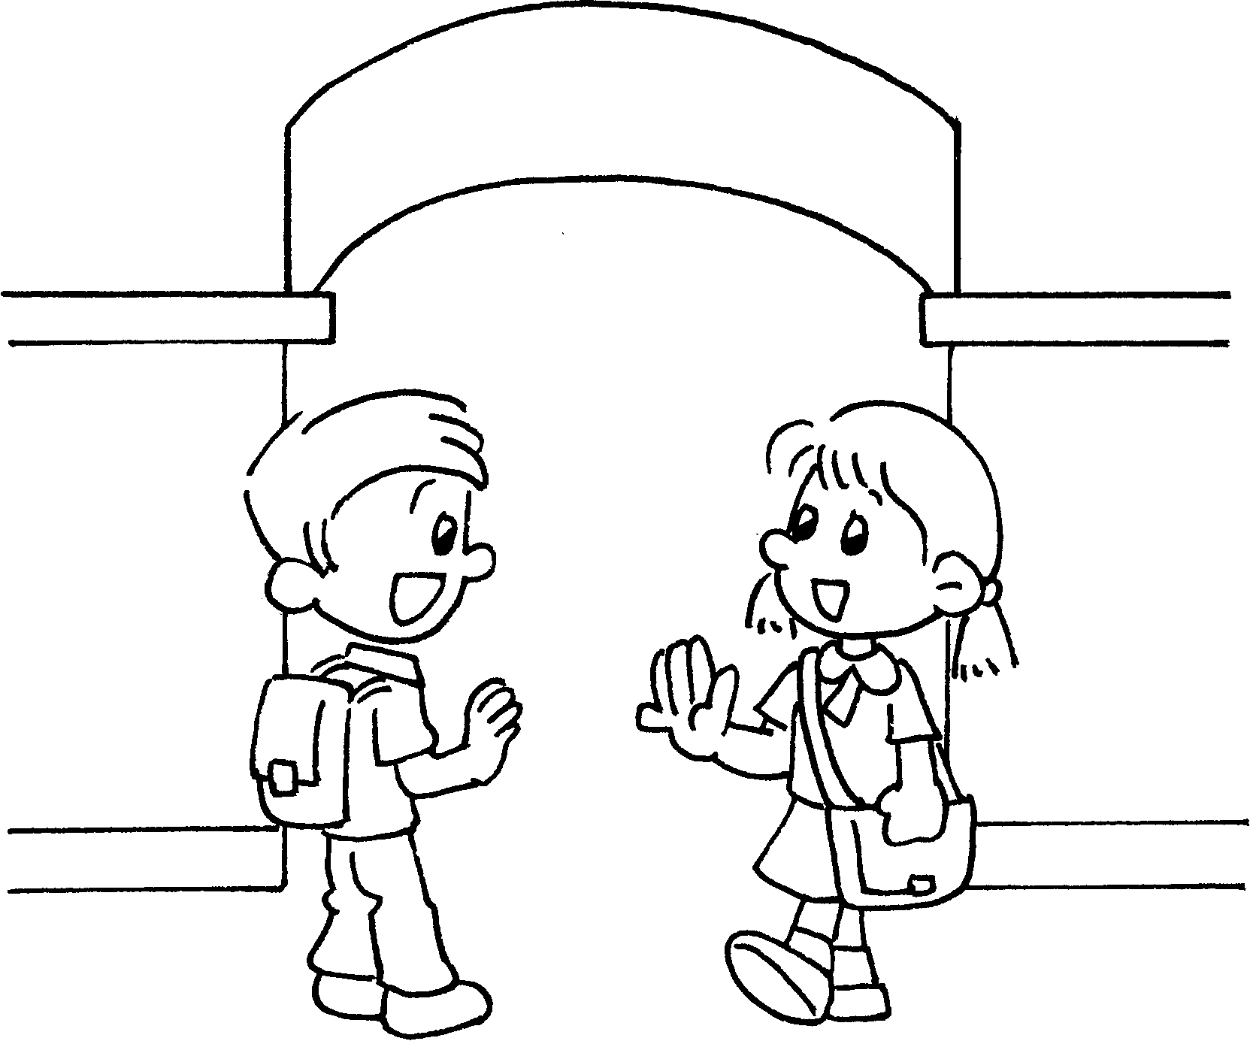
2 | 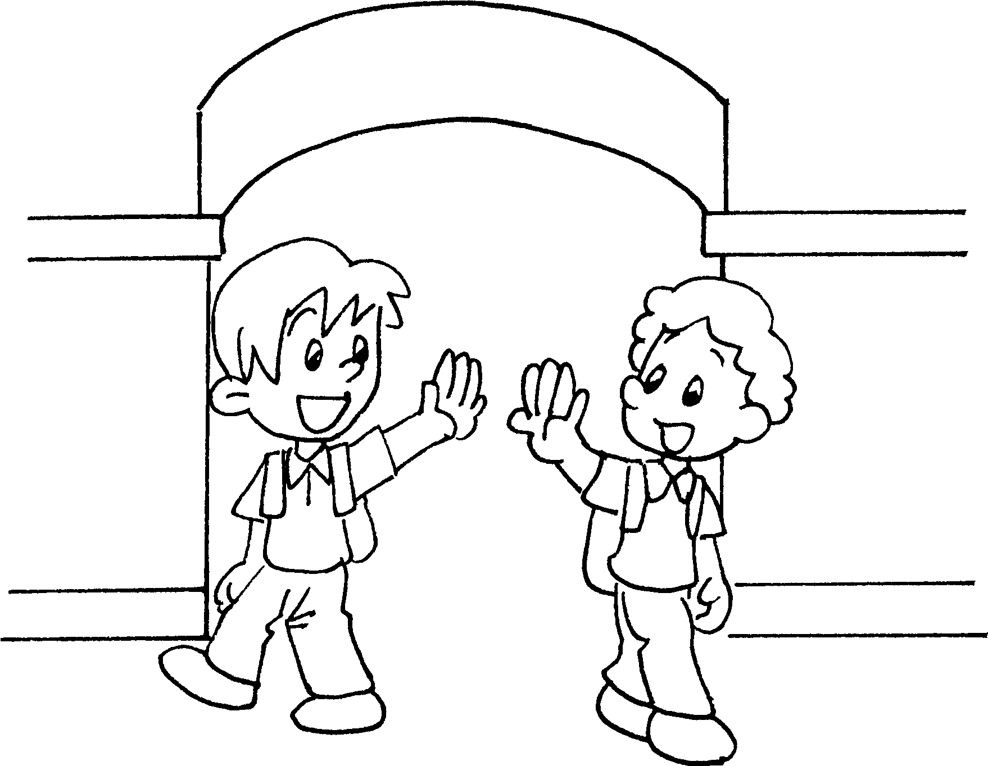
3 | 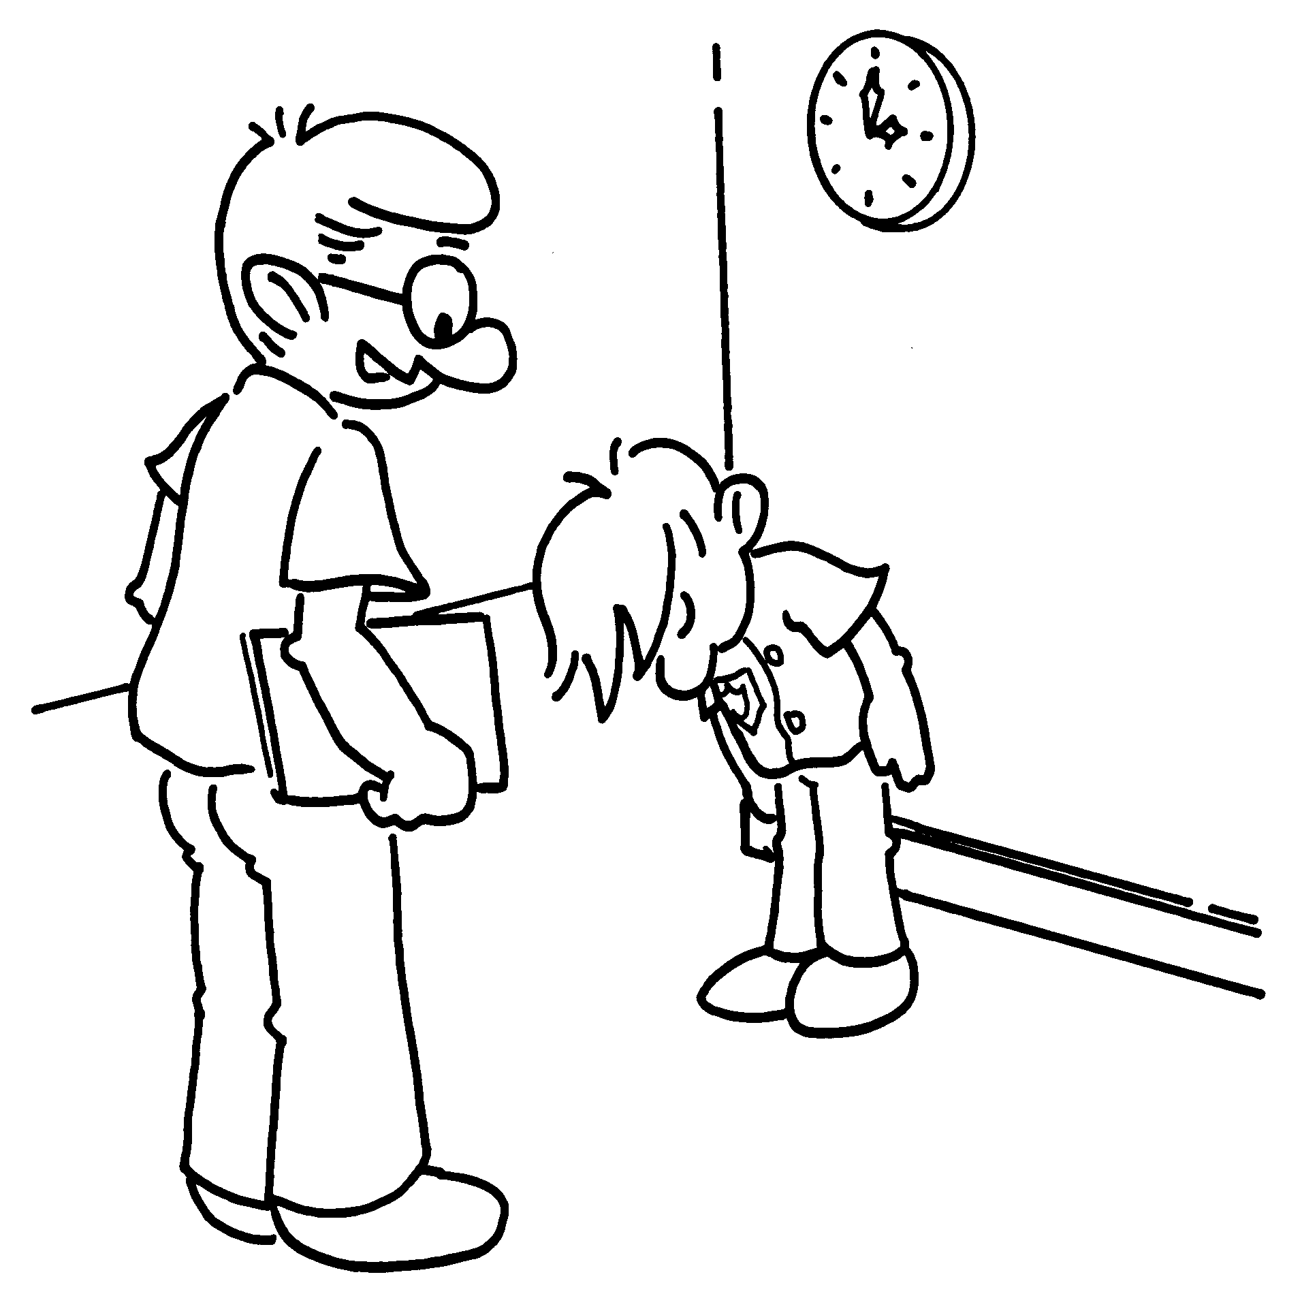
Good morning, Kate.
Good morning, Tom.
Good afternoon, Tom.
Goodbye, Tom.
Good morning, Jack.
Good afternoon, Jack.
Goodbye, Jack.
Good afternoon, Bob.
Good morning, Mr Lam.
Good afternoon, Mr Lam.
Goodbye, Mr Lam.
Goodbye, Andy.

Book 1A Chapter 1 Graded Worksheets

Worksheet 1⬇
1  Good morning, Tom.
Good afternoon, Tom.
Goodbye, Tom.
2 Good morning, Jack.
Good afternoon, Jack.
 Goodbye, Jack.
3 Good morning, Mr Lam.
 Good afternoon, Mr Lam.
Goodbye, Mr Lam.

