Fill in the missing letters.
Good morning, Kate.
Good morning, Tom.
Good afternoon, Tom.
Goodbye, Tom.
Good morning, Jack.
Good afternoon, Jack.
Goodbye, Jack.
Goodbye, Andy.
1 | 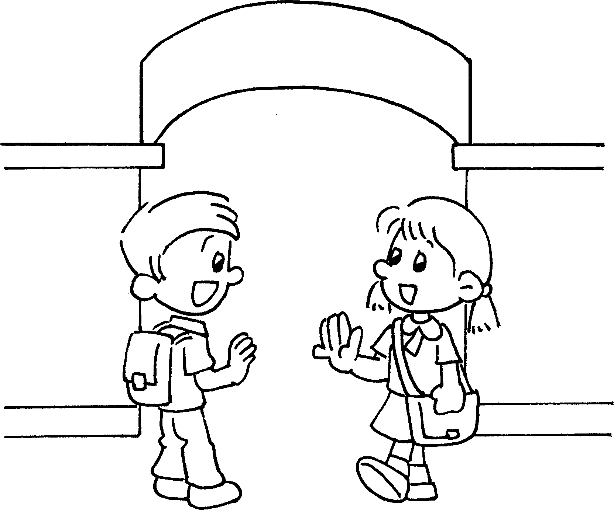
2 | 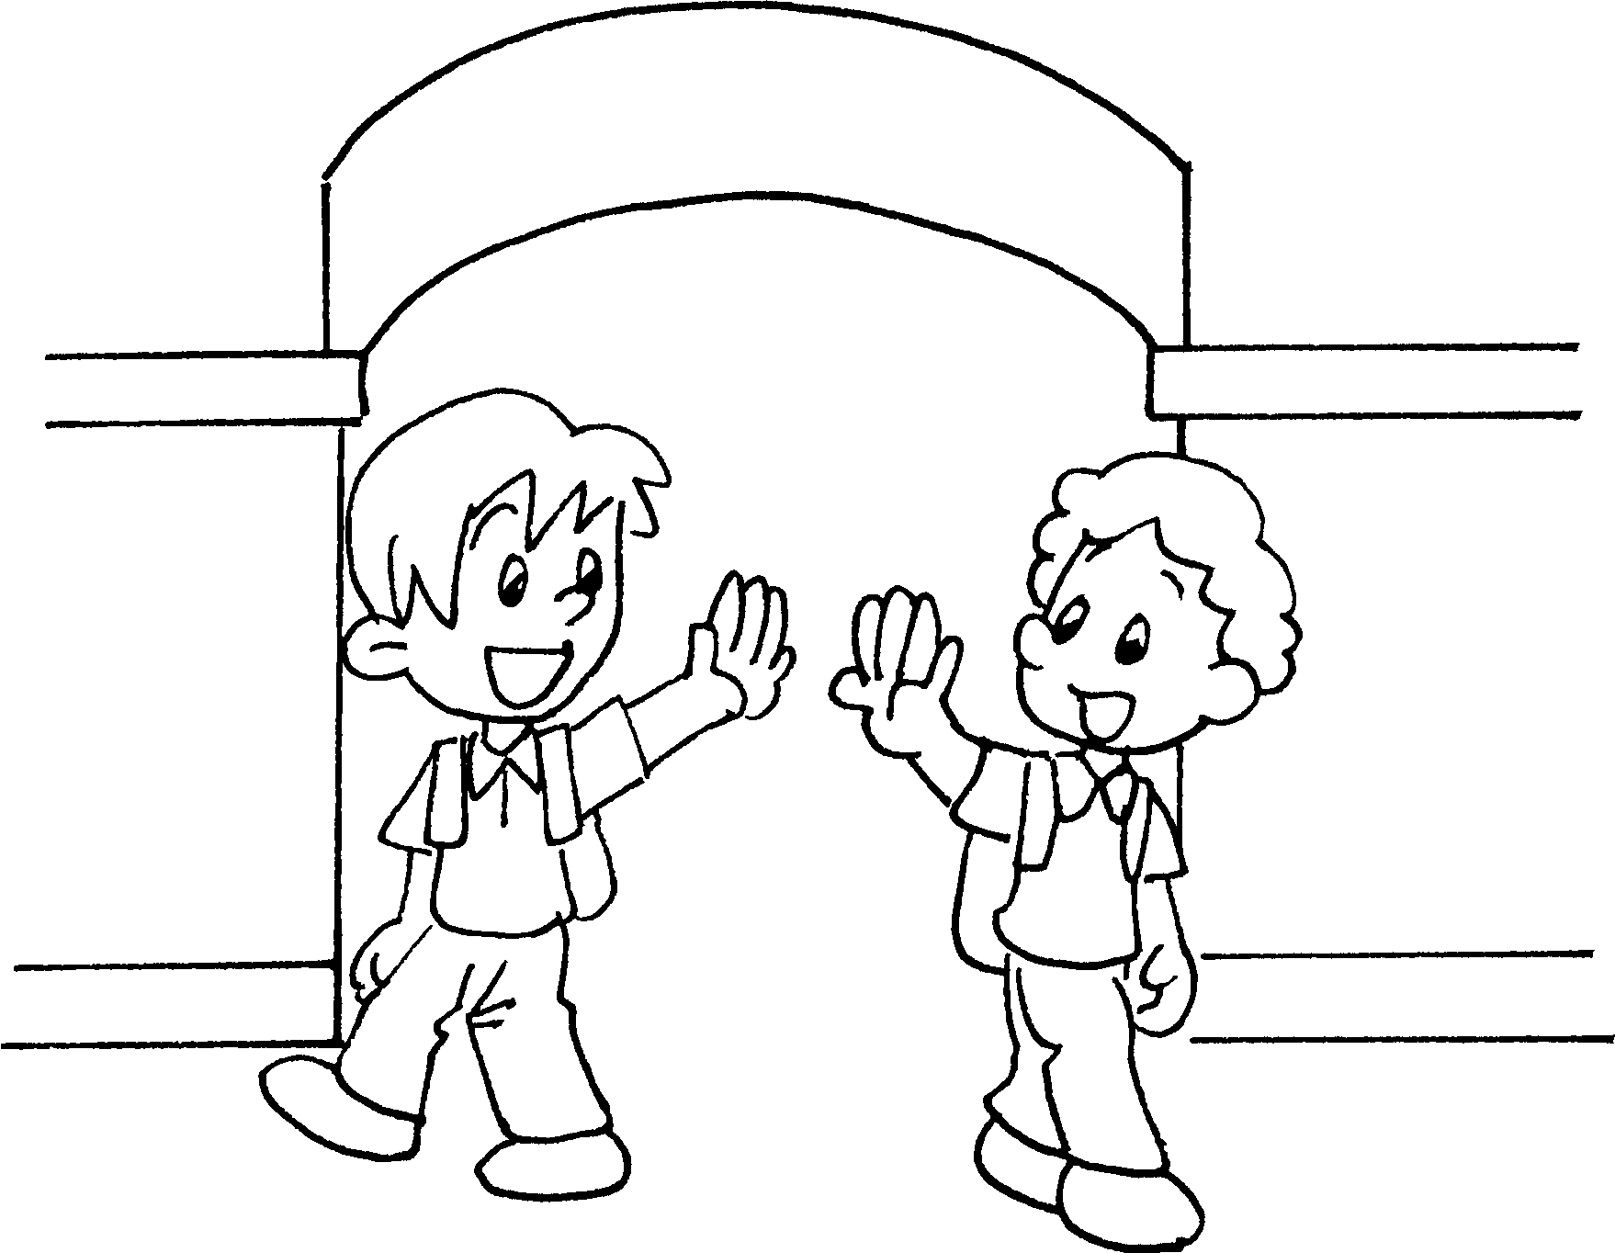
3 | 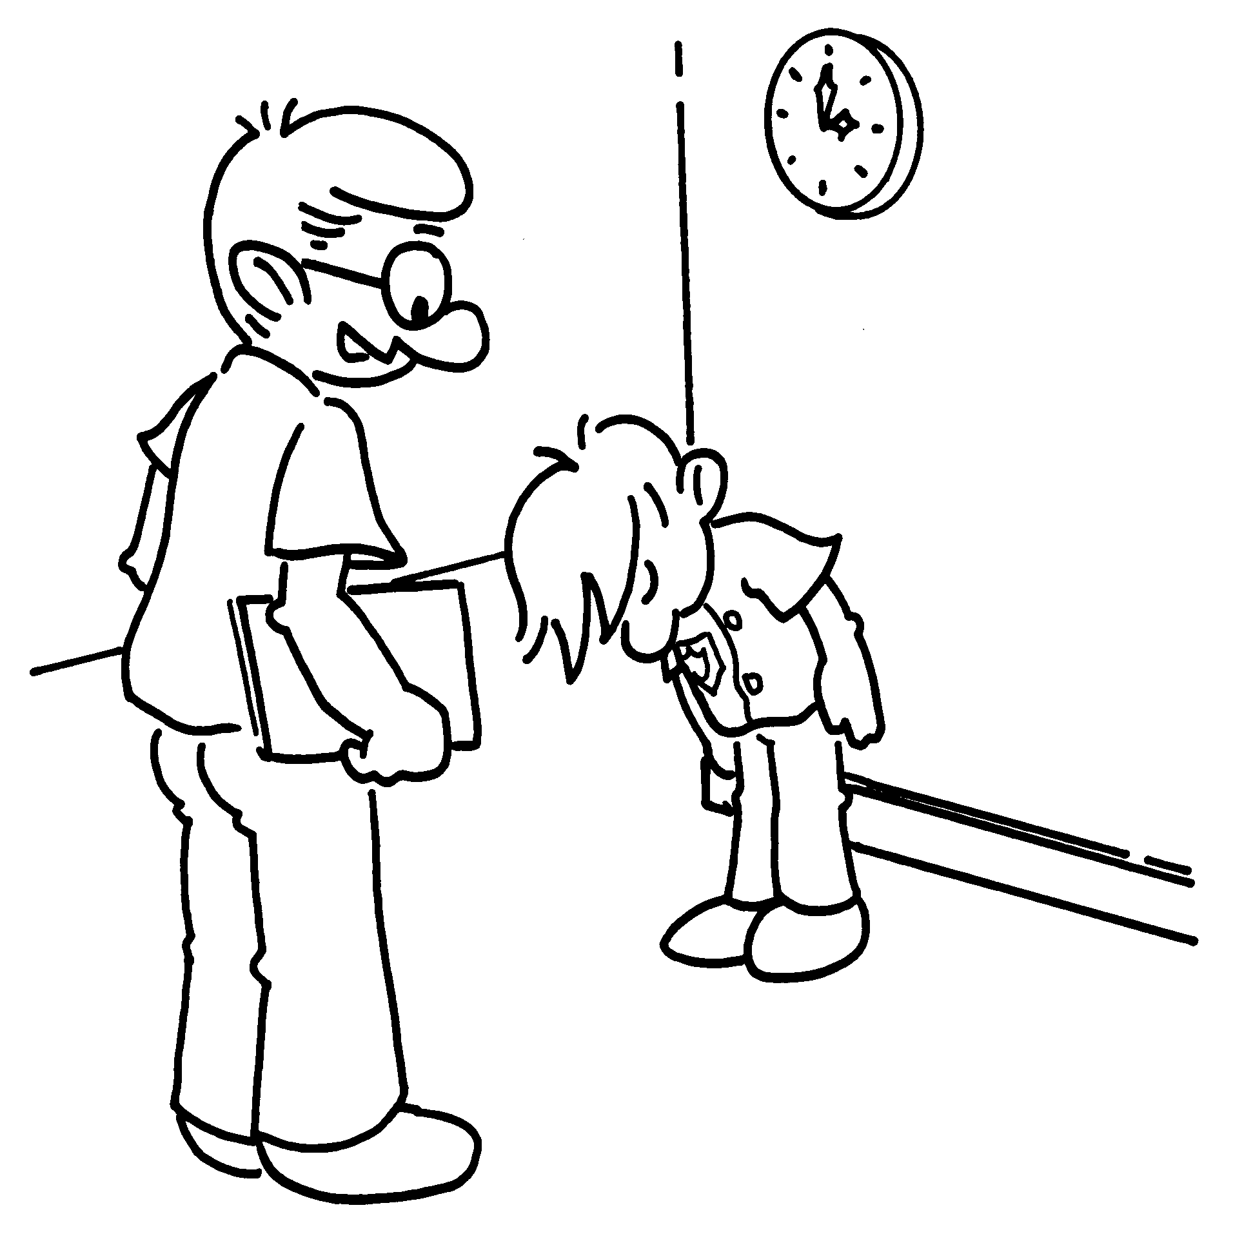
Good morning, Kate.
Good __ __ __ __ __ __ __ , Tom.
G __ __ __ __ __ __ , Jack.
Good afternoon, Bob.
Good __ __ __ __ __ __ __ __ __ , Mr Lam.
Goodbye, Andy.

Book 1A Chapter 1 Graded Worksheets

Worksheet 1⬇⬇

Good m o r n i n g , Tom.
- G o o d b y e , Jack.
- Good a f t e r n o o n , Mr Lam.

