Fill in the missing words.
1 | 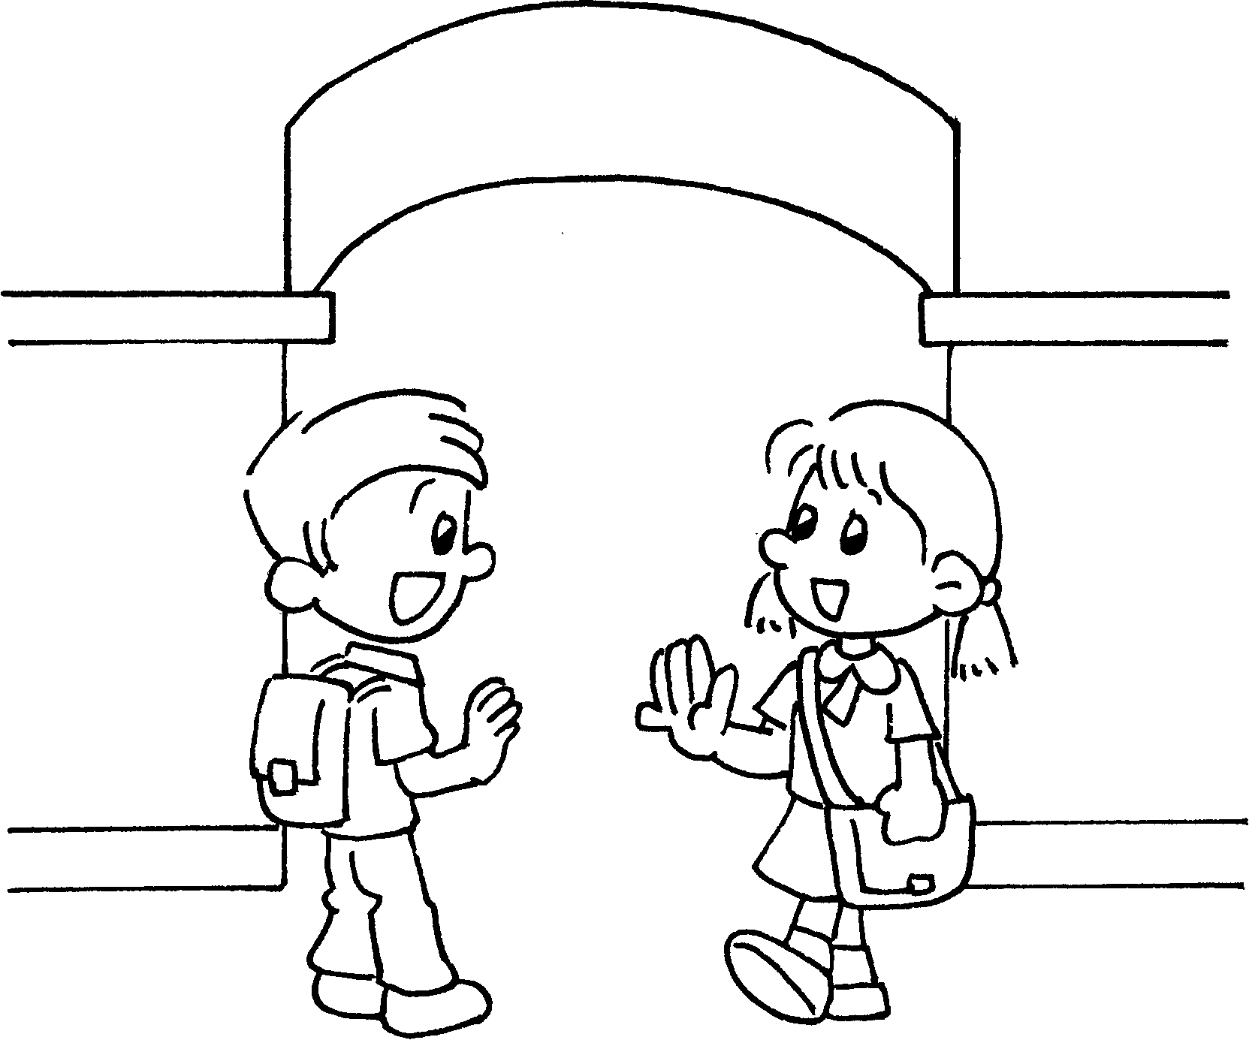 | Good morning, Kate.  Good _______________ , Tom.
2 | 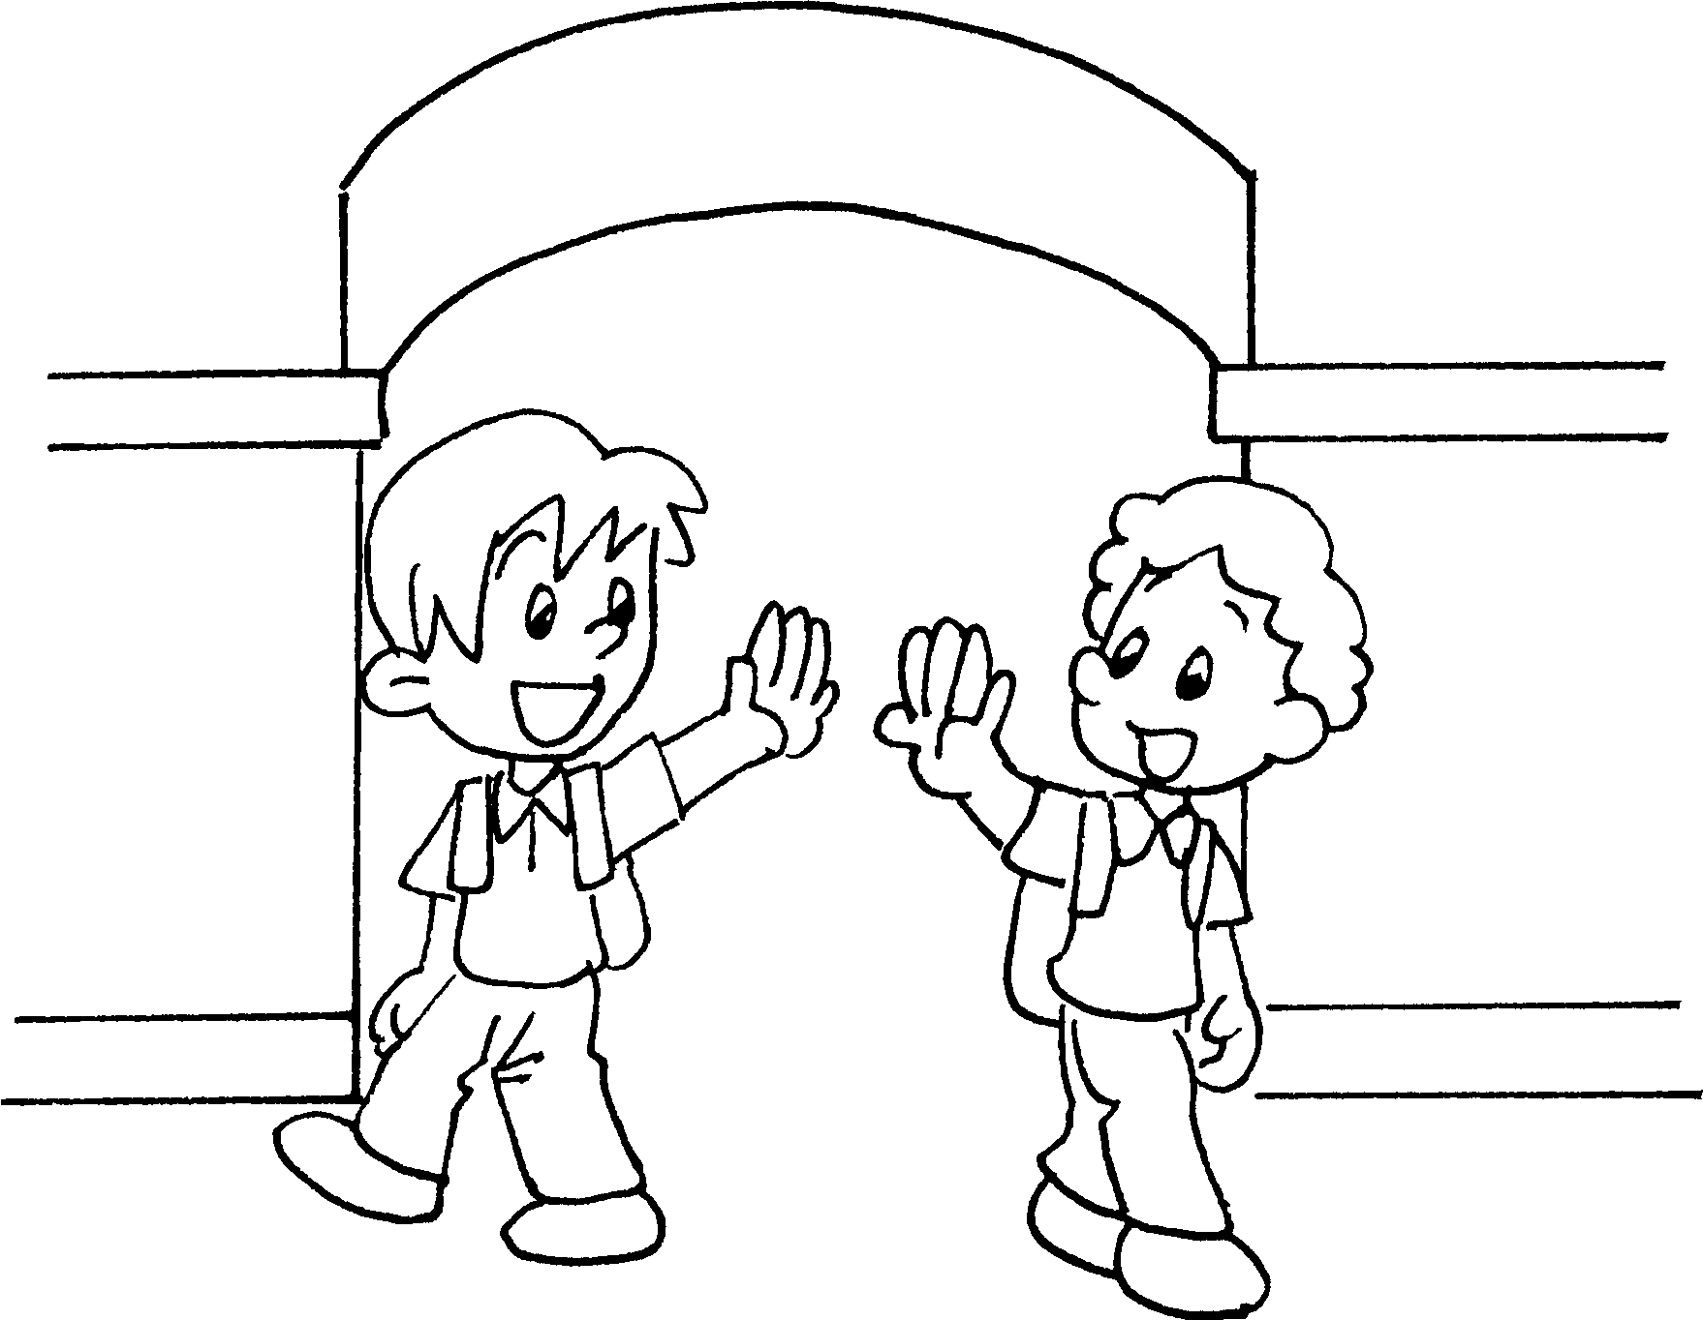 | _______________ , Jack.  Goodbye, Andy.
3 | 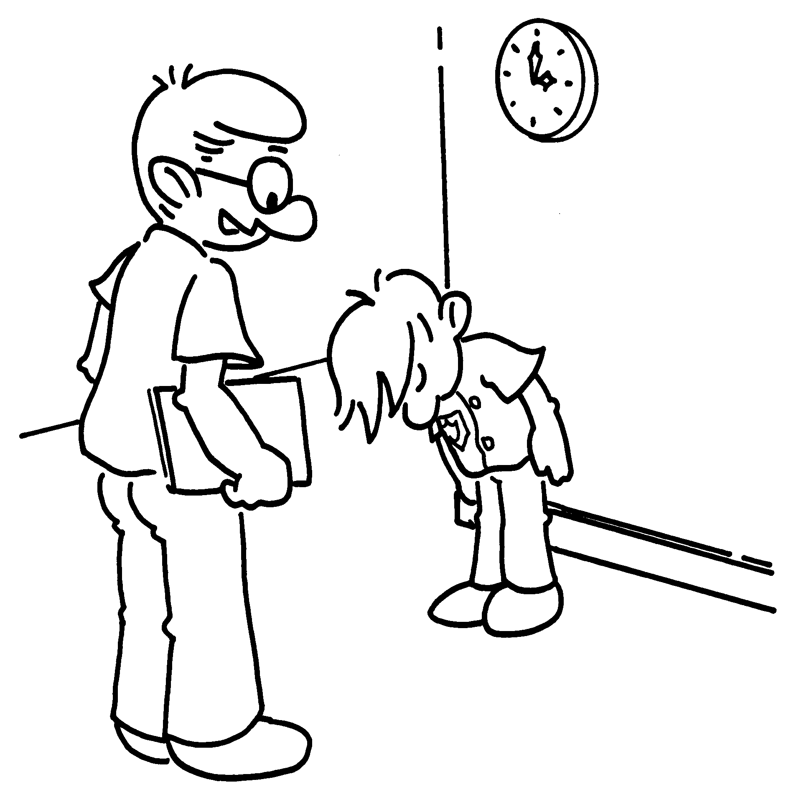 | Good afternoon, Bob.  _________ _________________ ,  Mr Lam.


Book 1A Chapter 1 Graded Worksheets

Worksheet 1⬇⬇⬇

morning
- Goodbye
- Good afternoon

