Tick ( ✓ ) the correct boxes.
1 | 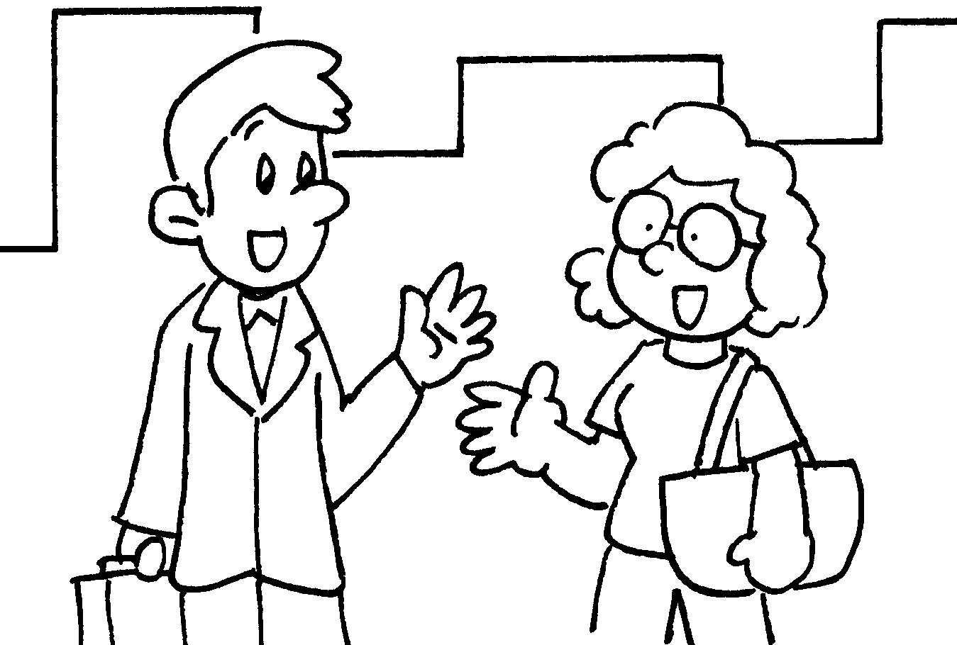
2 | 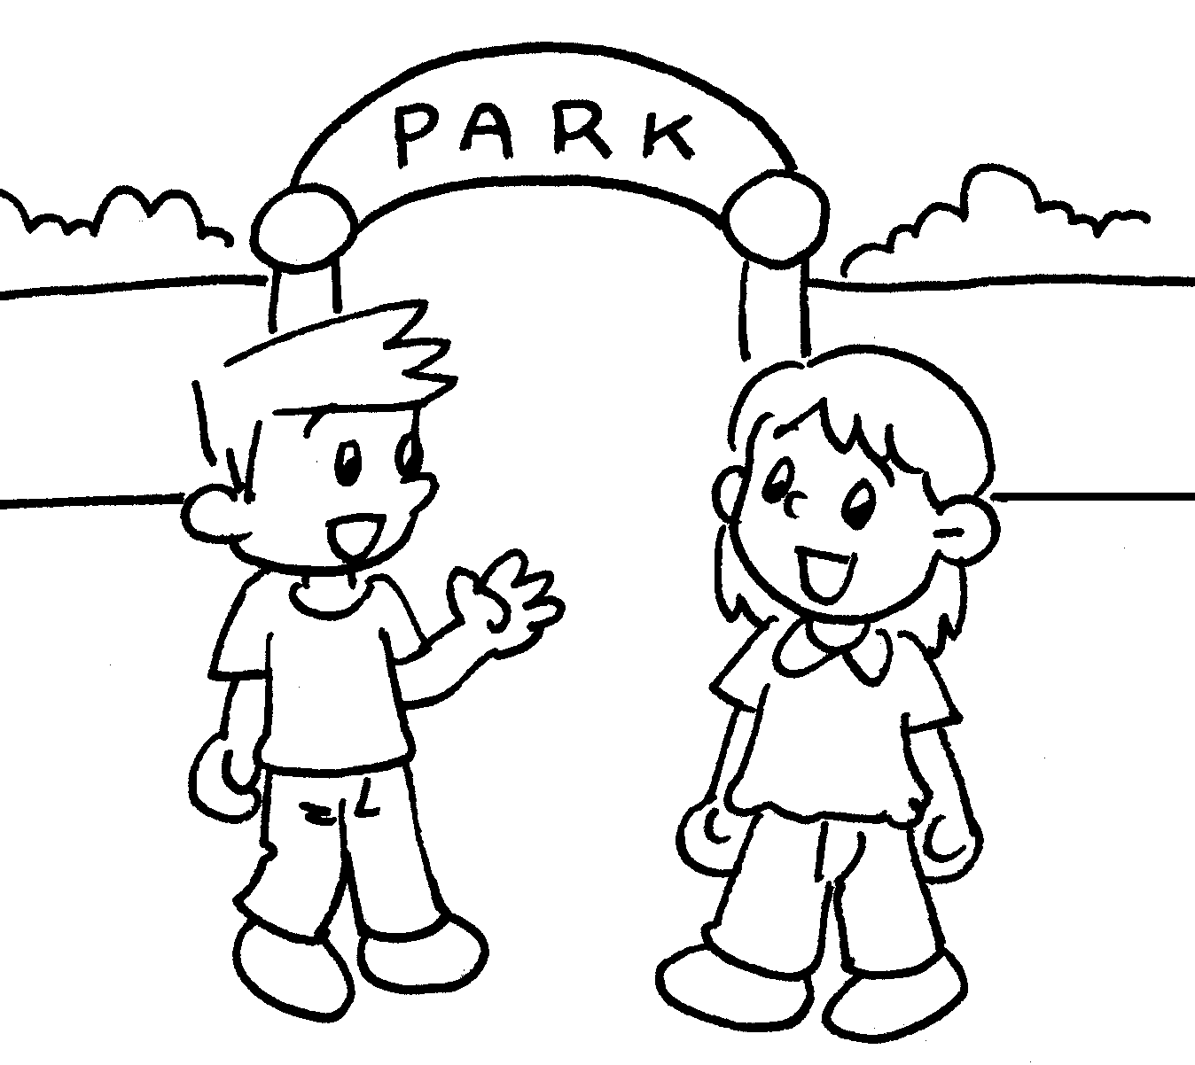
3 | 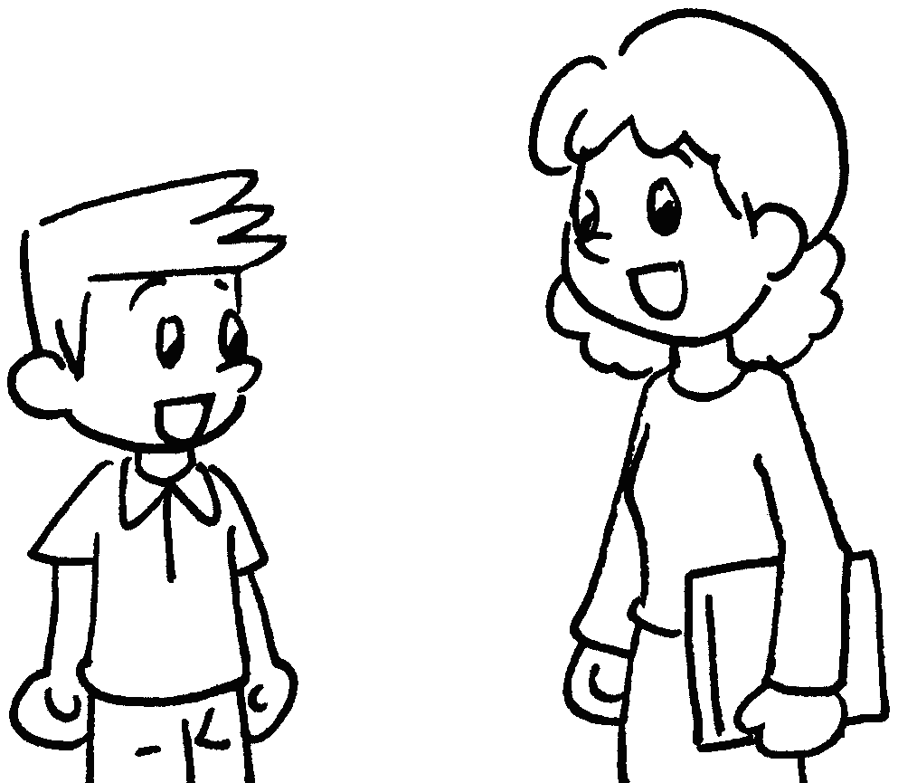
Hello! Nice to meet you.
I am fine, thank you.
How are you?
Hi! My name is John.
Goodbye.
Hello! My name is John.
Hi!
Hello! Nice to meet you.
Hi, John! Nice to meet you.
Johnn
John


Book 1A Chapter 1 Graded Worksheets
Worksheet 2⬇
1  Hello! Nice to meet you.
I am fine, thank you.
2 How are you?
 Hi! My name is John.
3 Goodbye.
 Hello! My name is John.

