Hello! Nice to meet you.
I am fine, thank you.
How are you?
Hi! My name is John.
Hi!
Hello! Nice to meet you.
Johnn
John

Choose and write.
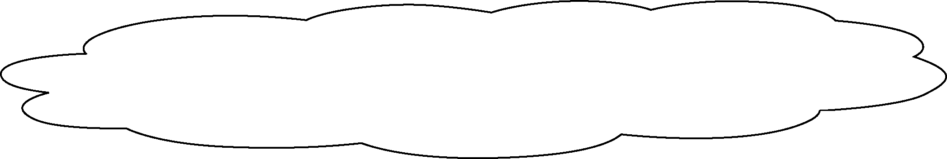
Hi, John! Nice to meet you.
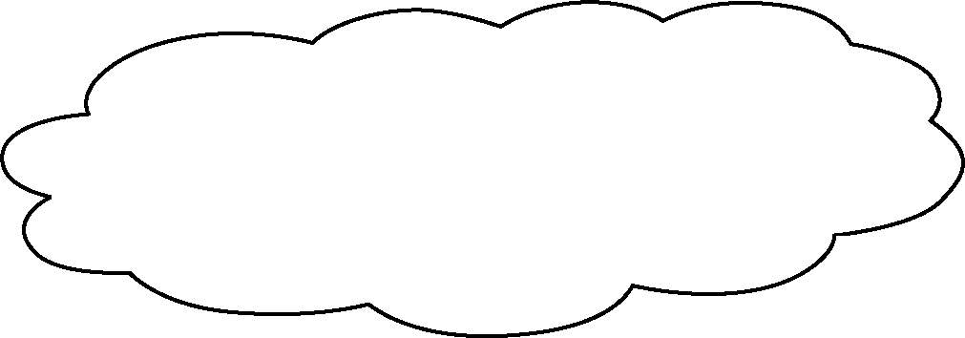
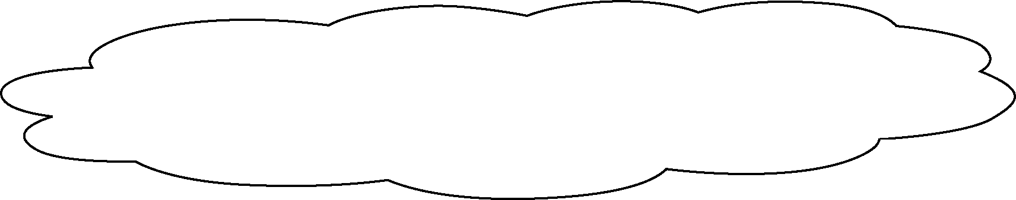
Hi! My name is John.
Hello! Nice to meet you.

1 | Mr Wong  Hi!  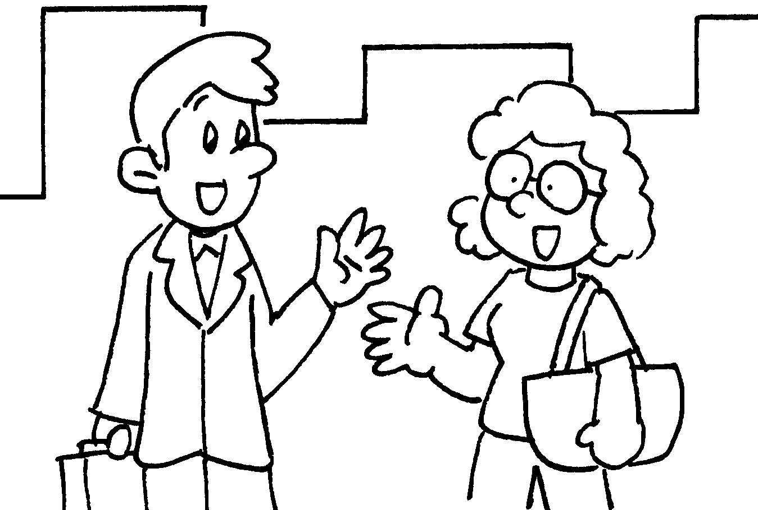 | Miss Ho
2 | 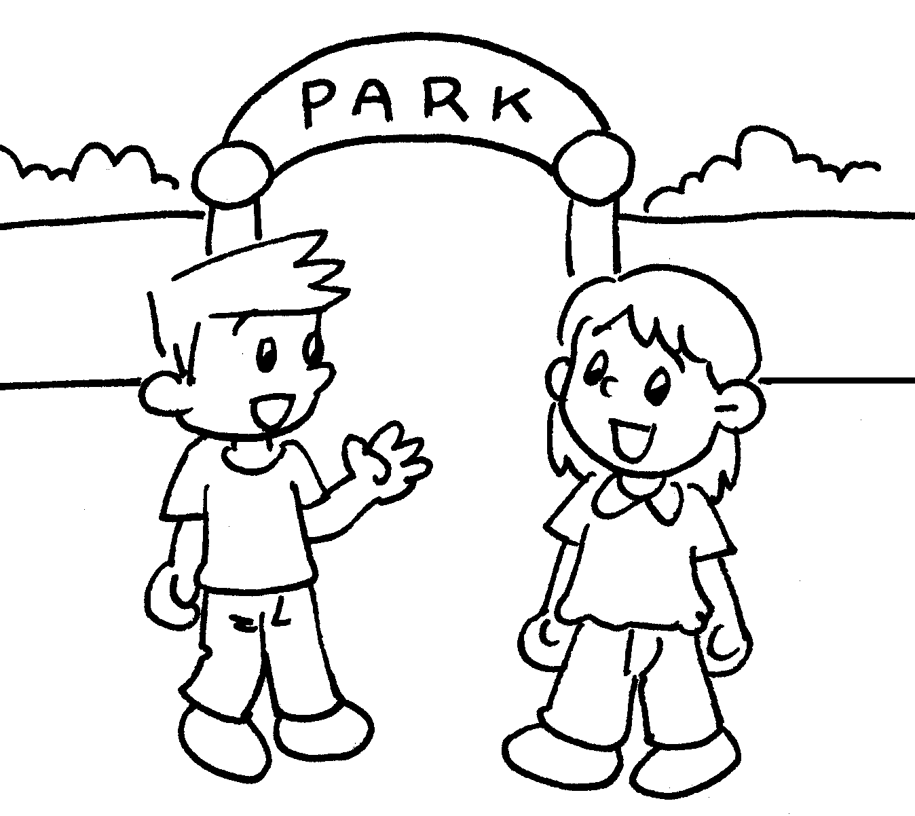  Ann  Miss Li | Hello! Nice to meet you.
3 | 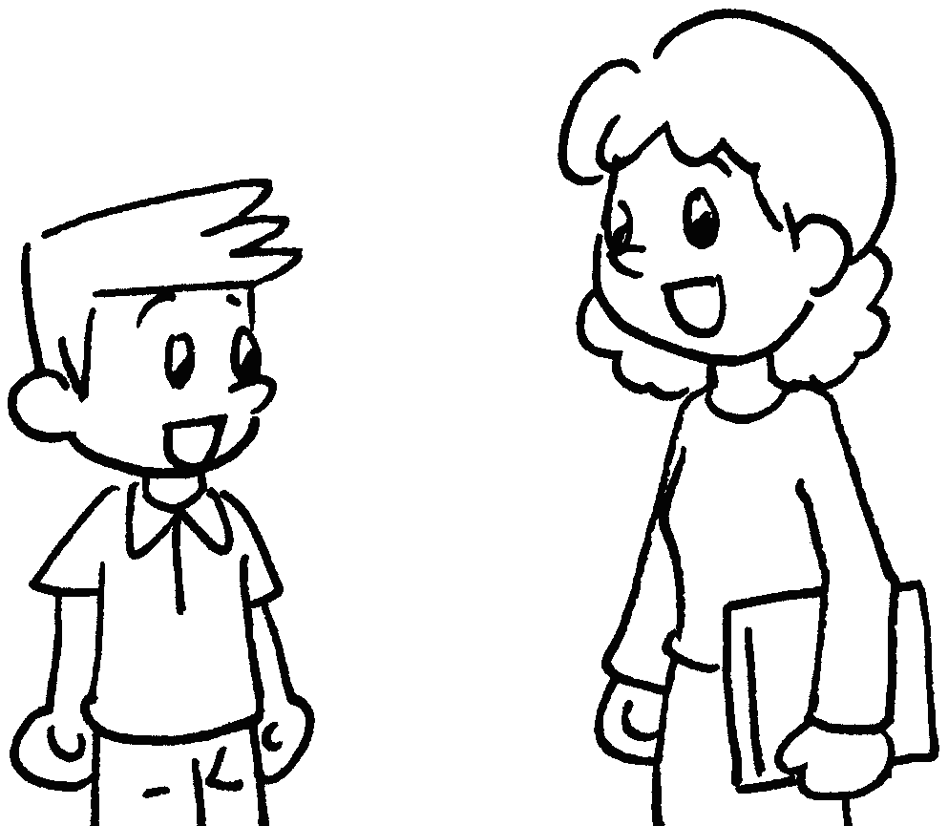
Hello! My name is John.
Johnn
John


Book 1A Chapter 1 Graded Worksheets
Worksheet 2⬇⬇
1 Miss Ho : Hello! Nice to meet you.
2 John : Hi! My name is John.
3 Miss Li : Hi, John! Nice to meet you.

