Tick ( ✓ ) the correct boxes.
1 | How are you?  How old are you?  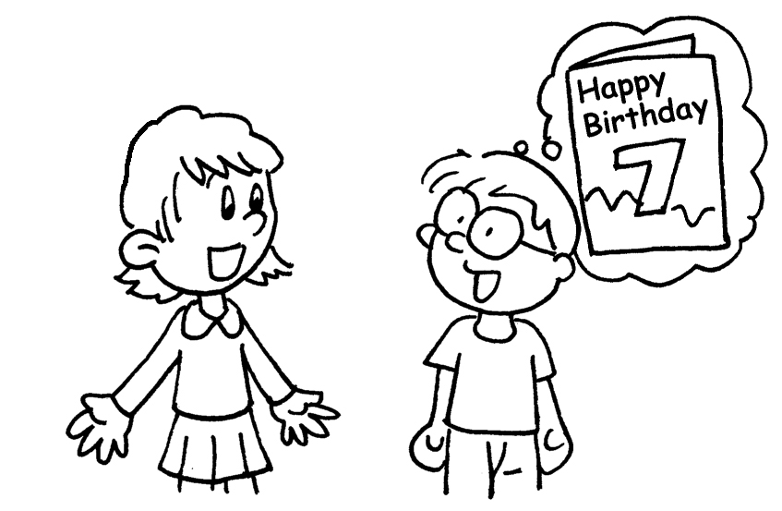  How old are you? | I am seven years old.
2 | 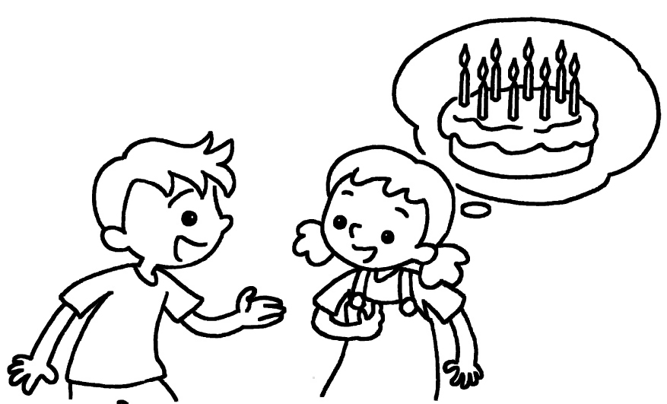 | I am fine, thank you.  I am eight years old.
3 | How old are you?  How are you?  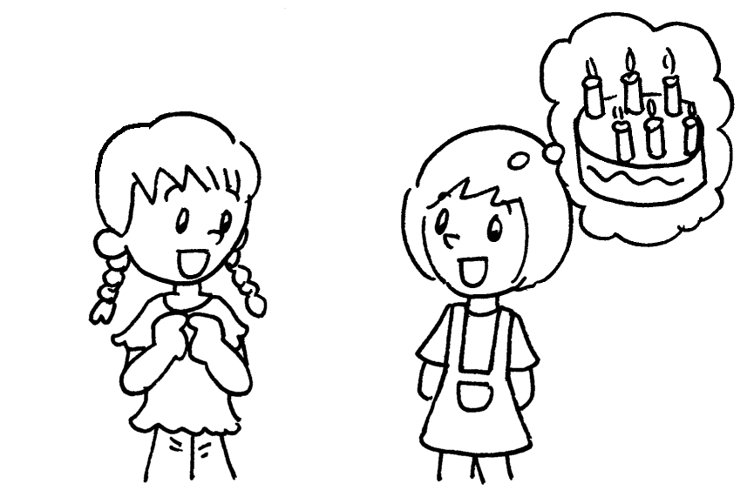 | I am six years old.  I am seven years old.



Book 1A Chapter 1 Graded Worksheets

Worksheet 3⬇
1 How are you?
 How old are you?
2 I am fine, thank you.
 I am eight years old.
3  How old are you?
How are you?
 I am six years old.
I am seven years old.

