
Choose and write.
How old years old
1 | 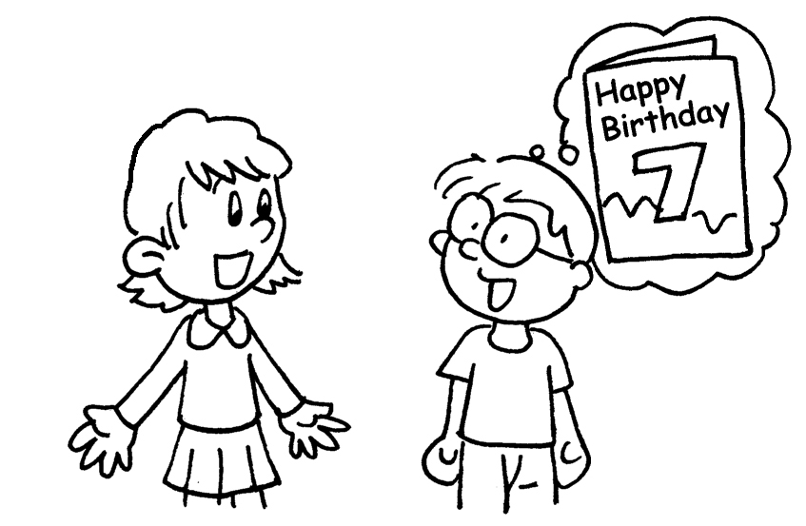  B  A  A | A : are you?  B : I am seven years old.
2 | 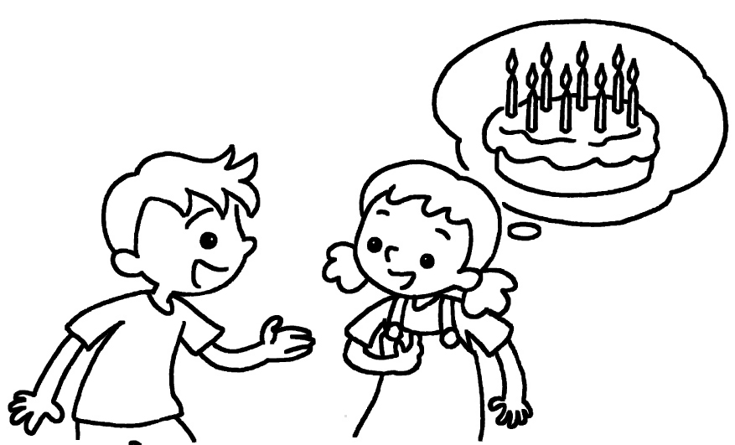  B  A | A : How old are you?  B : I am eight .
3 | 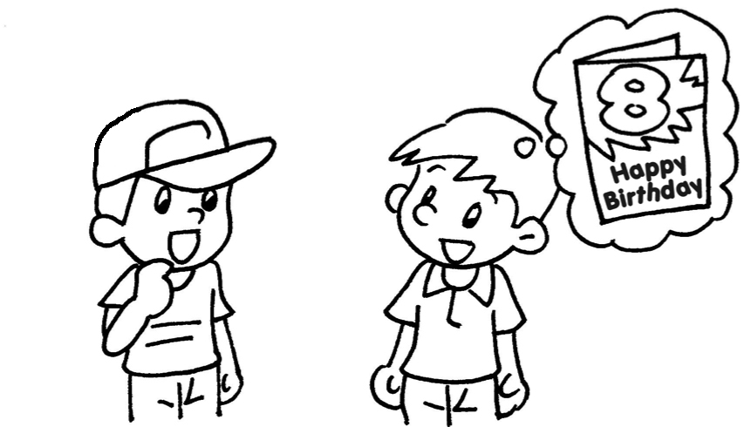  B | A : are you?  B : I am eight years old.
4 | 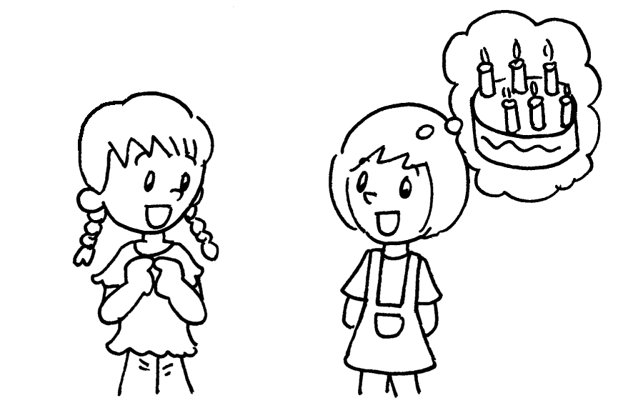  A  B  Book 1A Chapter 1  Remedial Worksheets  Worksheet 3  1 How old  2 years old  3 How old  4 years old | A : How old are you?  B : I am six .

Book 1A Chapter 1 Graded Worksheets

Worksheet 3⬇⬇
- How old
- years old
- How old
- years old

