Finish the questions and answers.
A
B
1 | 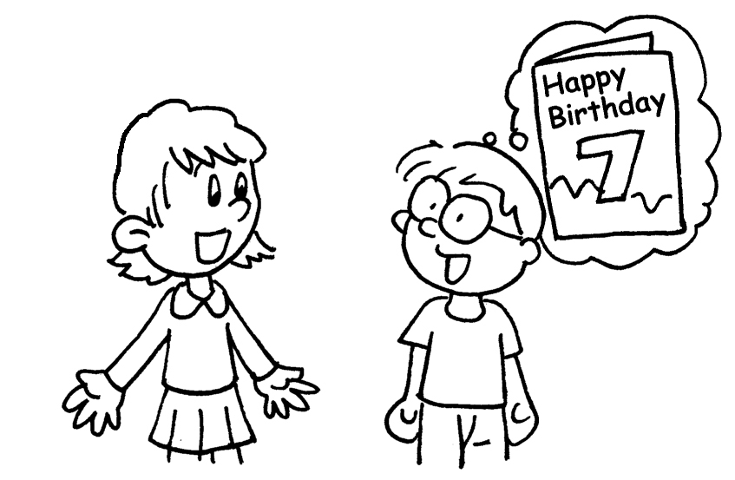  A | A : H o are you?  B : I am seven years old.
2 | 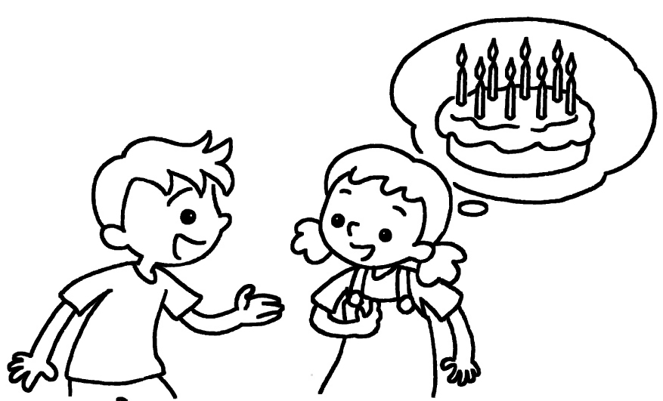  B | A : _______ _______ are you?  B : I am eight _________ ______ .
3 | 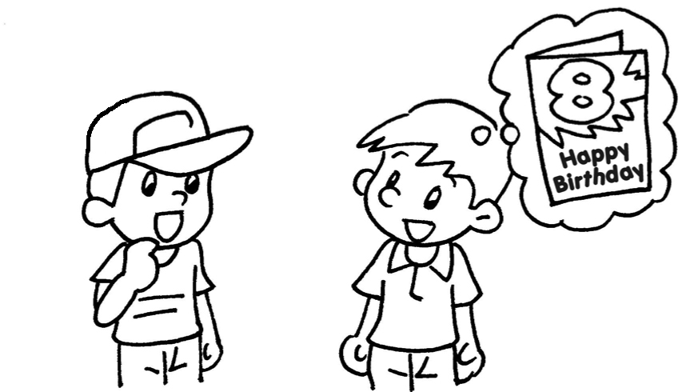  A  B | A : ______ ______ ______ you?  B : _____ ______ eight _________  _______ .
4 | 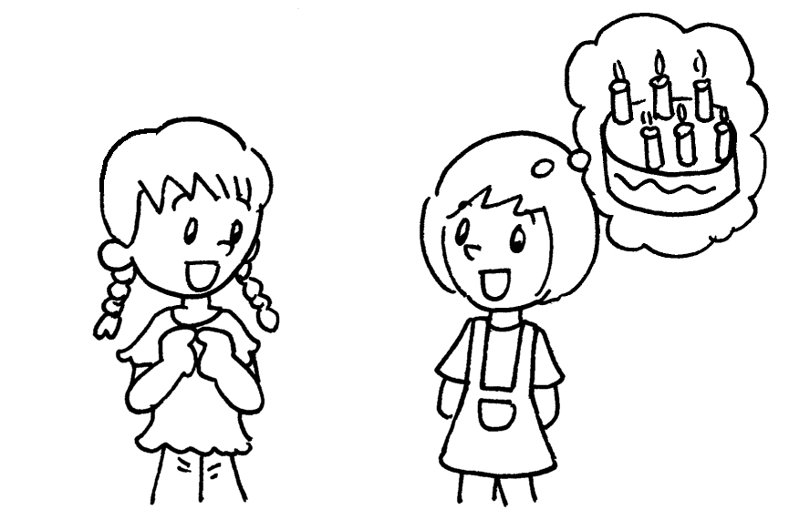  A  B | A : ___________________________  B : ___________________________________  ___________________________


Book 1A Chapter 1 Graded Worksheets

Worksheet 3⬇⬇⬇
- How old
- How old
years old
- How old are
I am years old
4 How old are you?
I am six years old.

