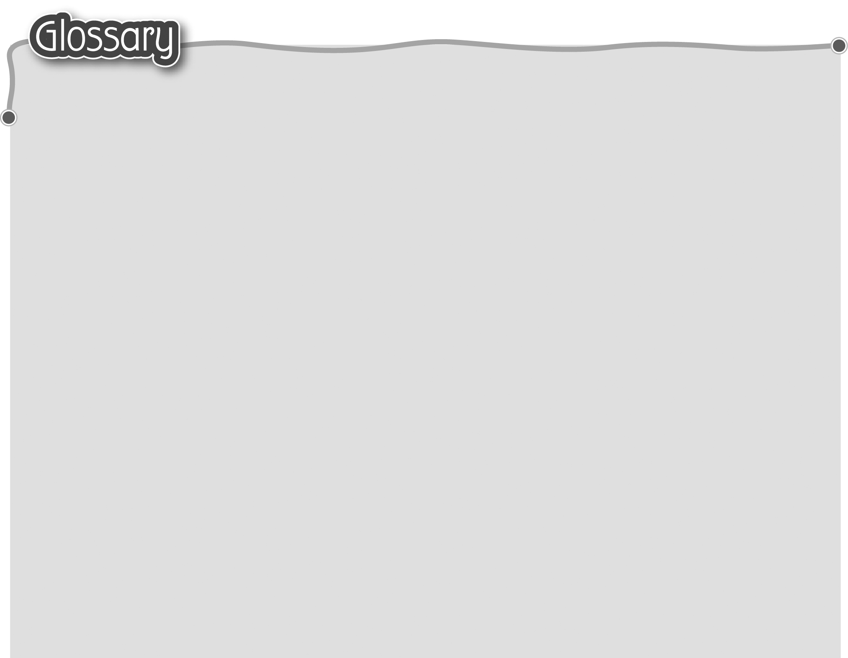
1 on … way (p.10) 途中 12 now (p.11) 現在
The words marked with * have different meanings in other
contexts. You can look up those meanings in a dictionary.

2 school (p.10) 學校 13 children (p.11) 小孩子們
3 he (p.10) 他 14 classroom (p.11) 課室
4 meet (p.10) 遇見/碰到 15 hello (p.11) 你好
5 new (p.10) 新 16 Happy birthday! (p.16)
生日快樂！
6 friend (p.10) 朋友 17 card* (p.17) 卡
7 … year(s) old (p.10) ……歲 18 dear (p.17) 親愛的
8 how old (p.10) 幾歲 19 person (p.17) 人
9 you (p.10) 你 20 get* (p.17) 收到
10 hi (p.11) 你好 21 greeting (p.17) 祝賀語
11 Nice to meet you. (p.11) 22 write (p.17) 寫
很高興認識你！


