Tick ( ✓ ) the correct boxes.

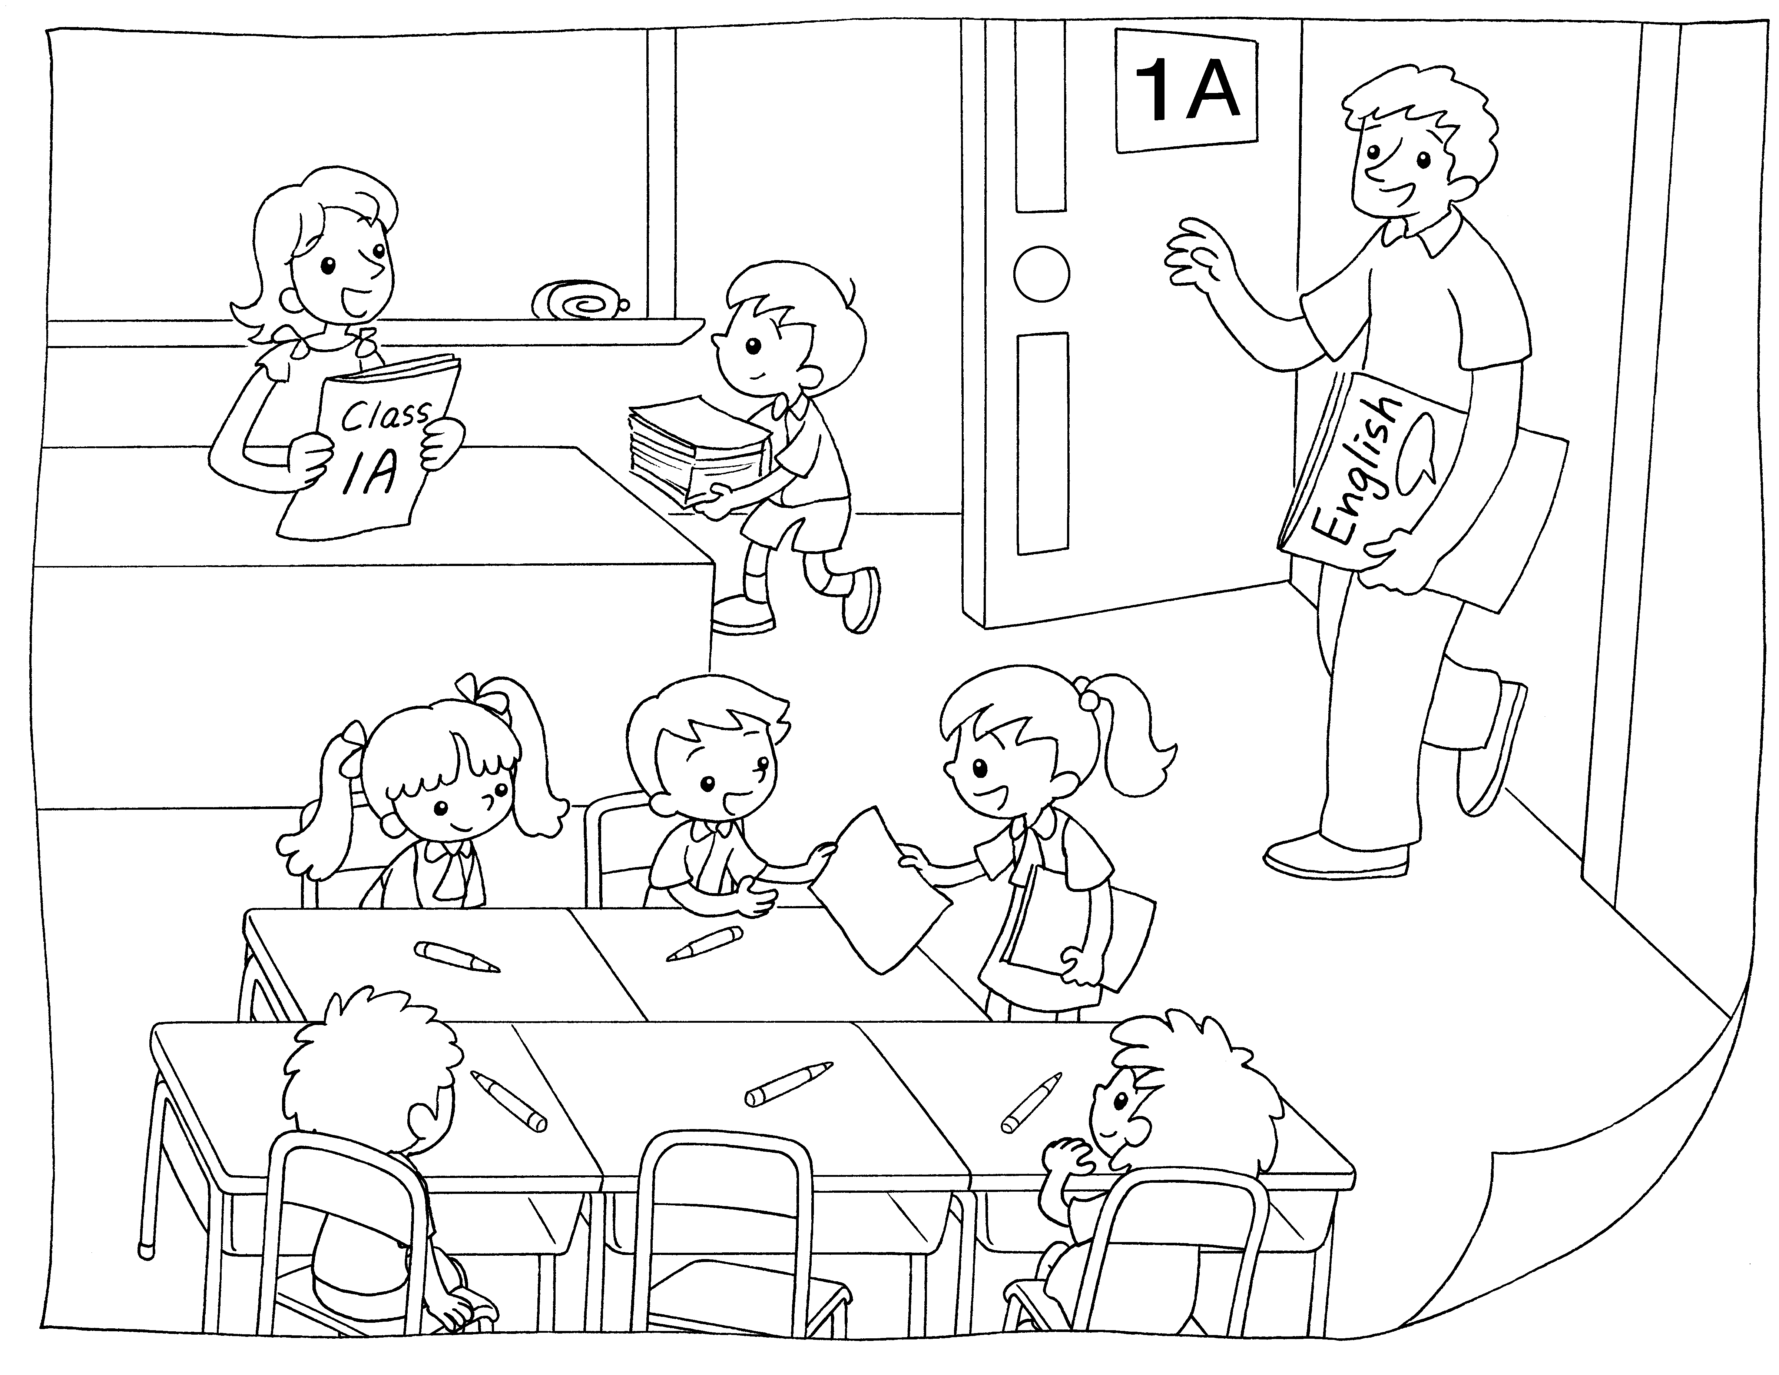
1

2

3

1
This is my English teacher.
This is my class teacher.

2
This is my English teacher.
This is my class teacher.

3
This is my teacher.
This is my classmate.

me



Book 1A Chapter 2 Graded Worksheets
Worksheet 1⬇
1 This is my English teacher.
 This is my class teacher.
2  This is my English teacher.

This is my class teacher.
3 This is my teacher.
 This is my classmate.

