Choose and write.
English teacher
classmate
class teacher

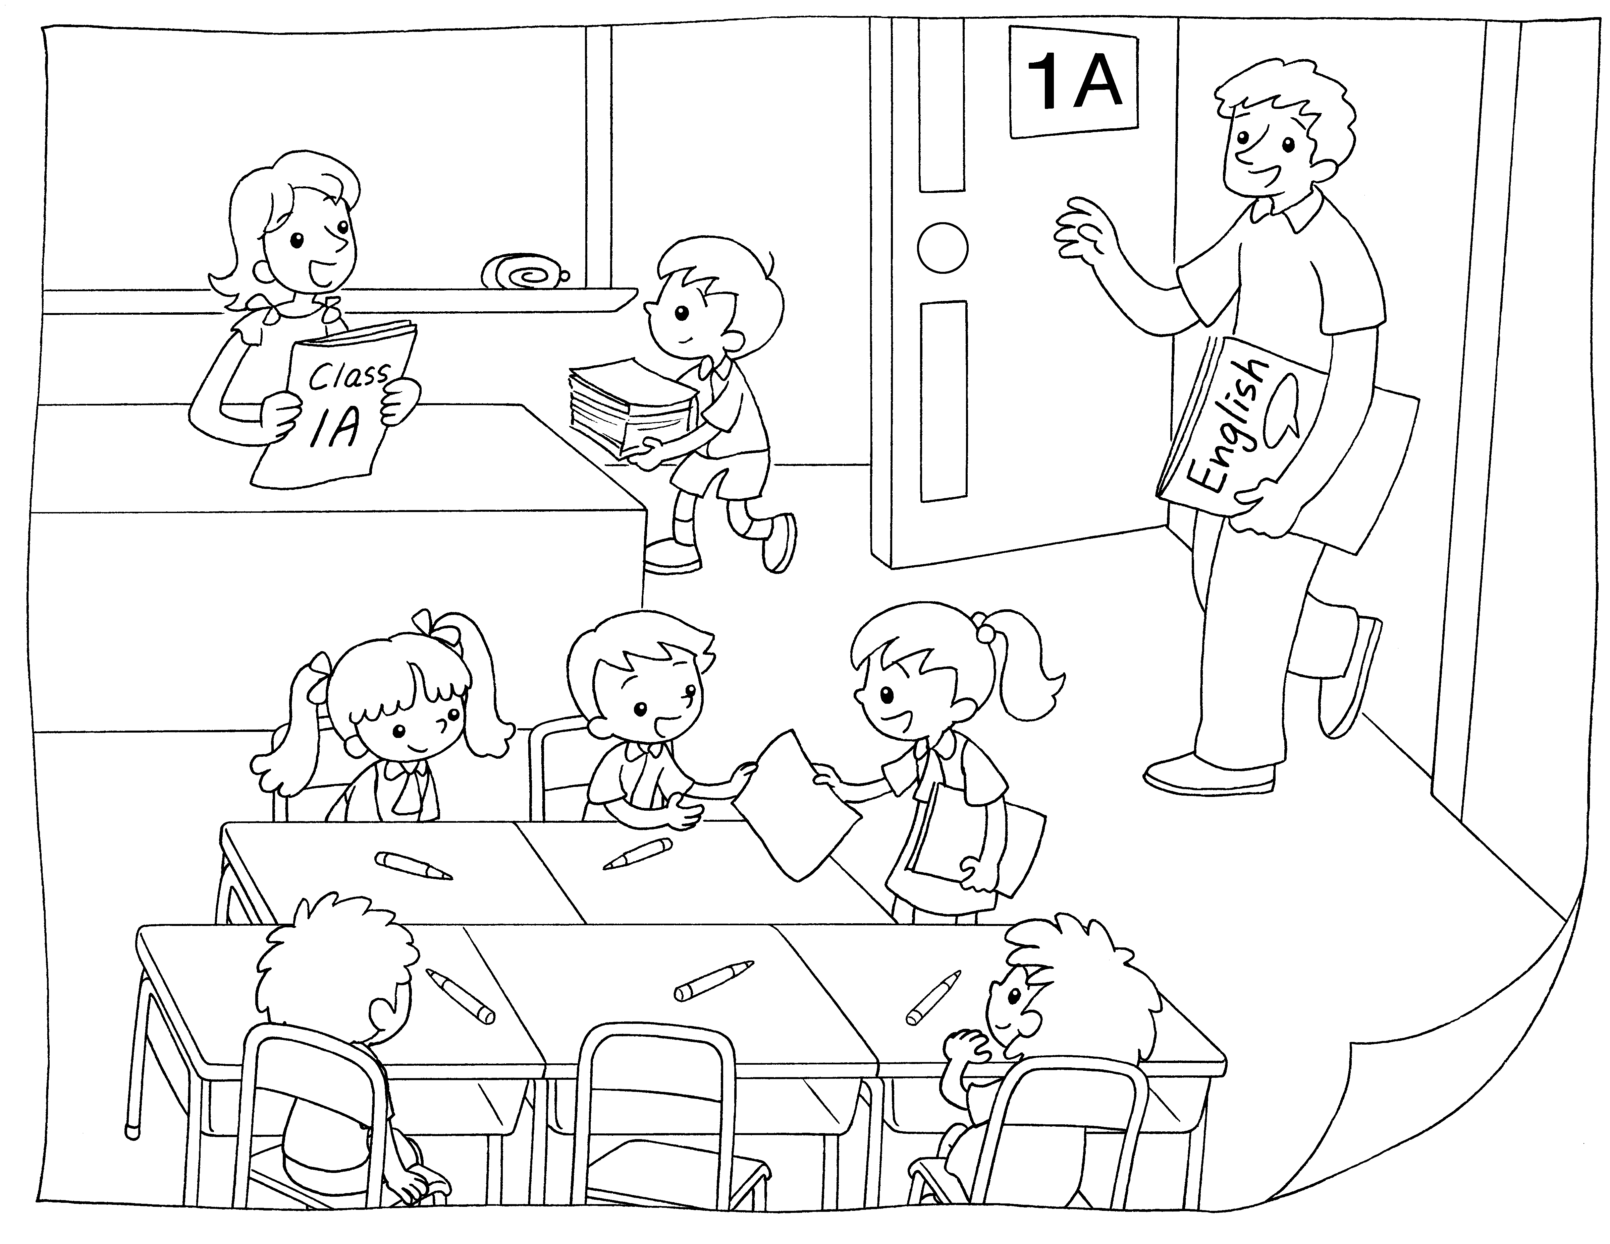
1

2

3

1
This is my .
2
This is my .
3
This is my .
me

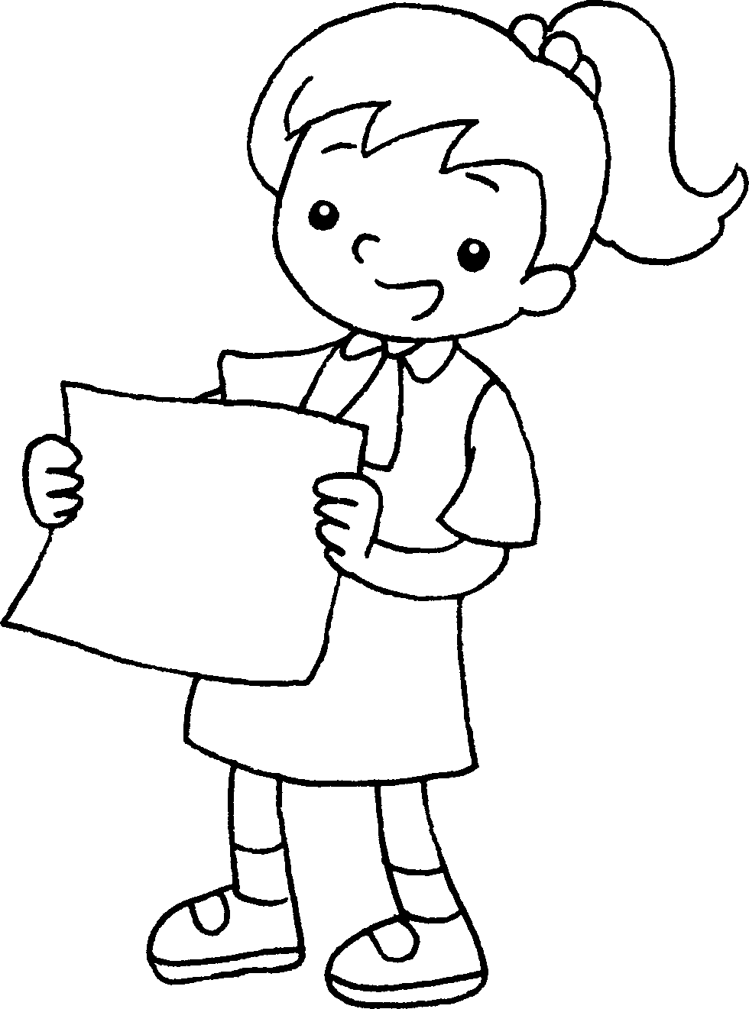


Book 1A Chapter 2 Graded Worksheets
Worksheet 1⬇⬇
- class teacher
- English teacher
- classmate

