What is the girl saying? Fill in the missing letters.

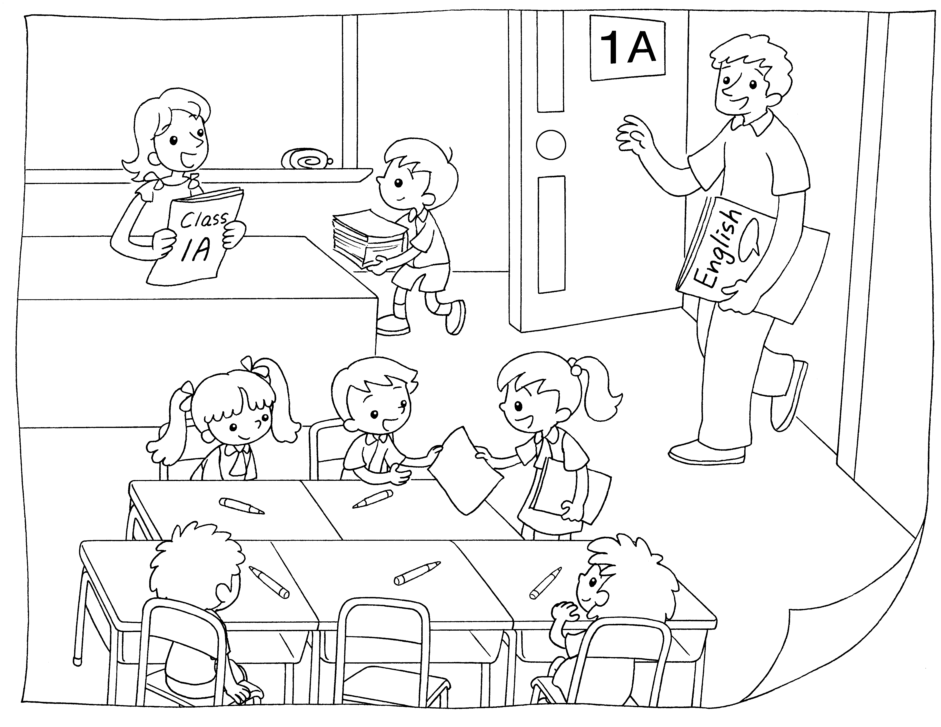
1

2

3

1
This is my c __ __ __ __ t __ __ __ __ __ __ .
2
This is my E __ __ __ __ __ __ t __ __ __ __ __ __ .
3
This is my c __ __ __ __ __ __ __ __ .
me

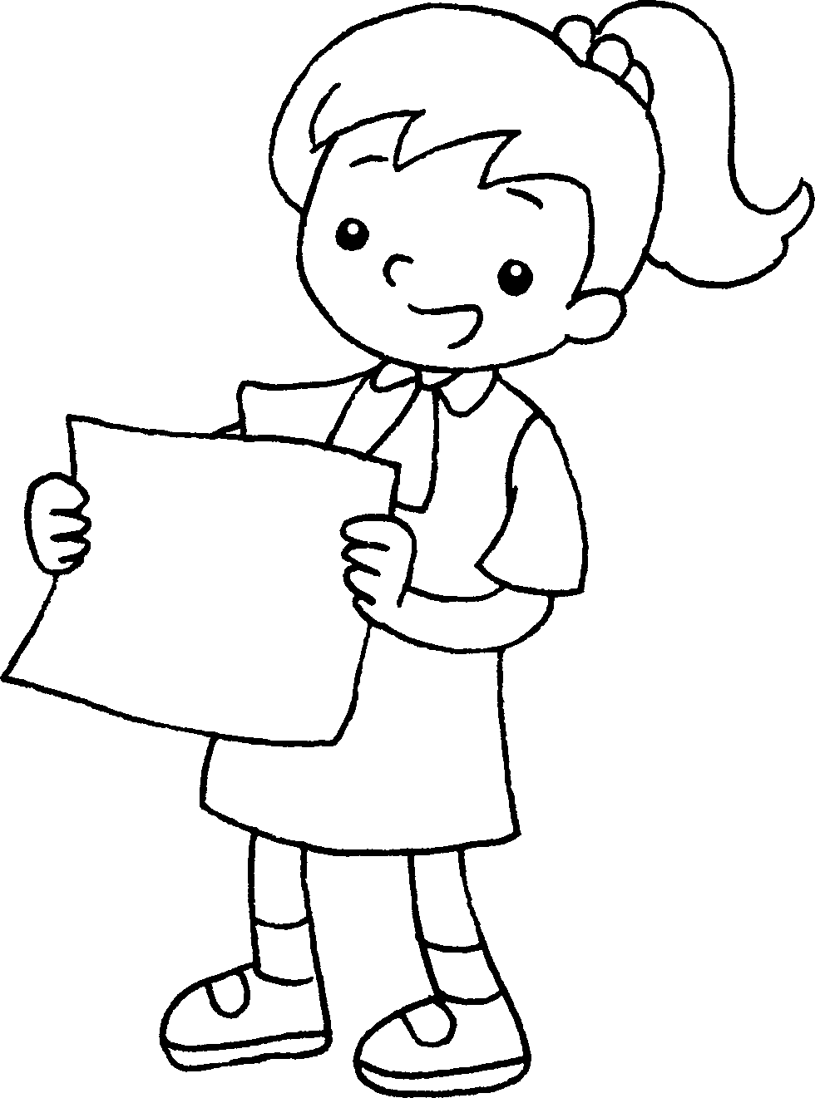



Book 1A Chapter 2 Graded Worksheets
Worksheet 1⬇⬇⬇
- c l a s s t e a c h e r
- E n g l i s h t e a c h e r
- c l a s s m a t e

