Choose and write.
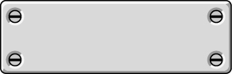
He

She

1 | 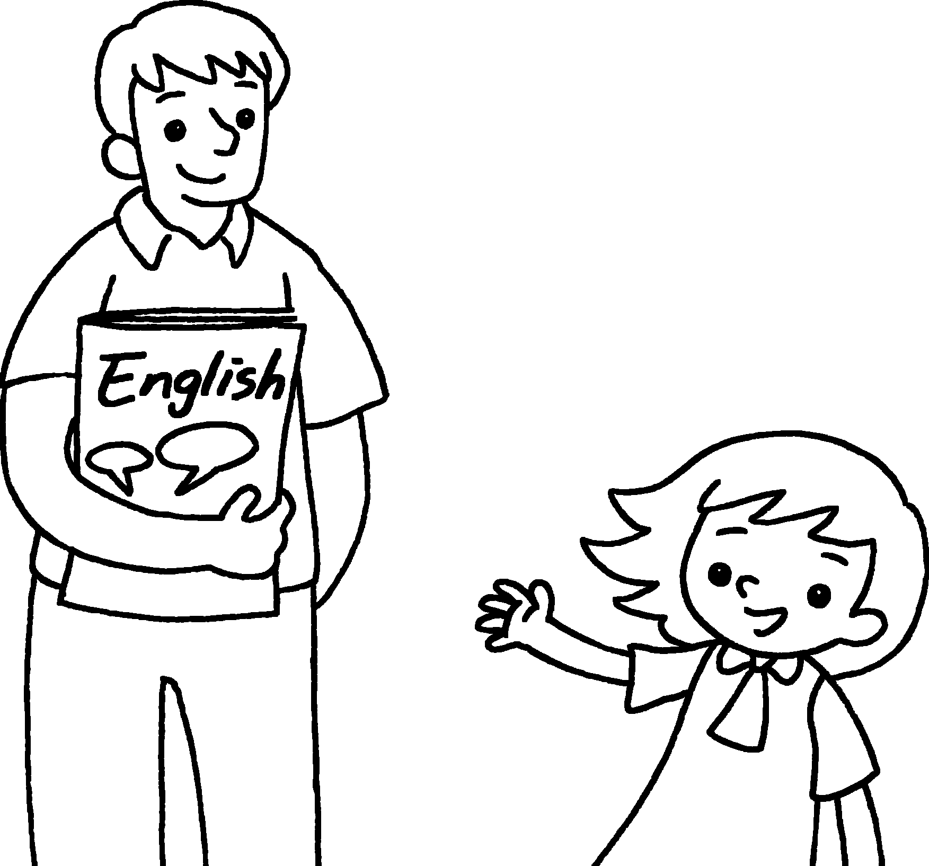  This is Mr Chow.  _______ is my English teacher.
2 |   This is Jane.  _______ is my classmate.
3 | This is Miss Ng.  _______ is my class teacher.  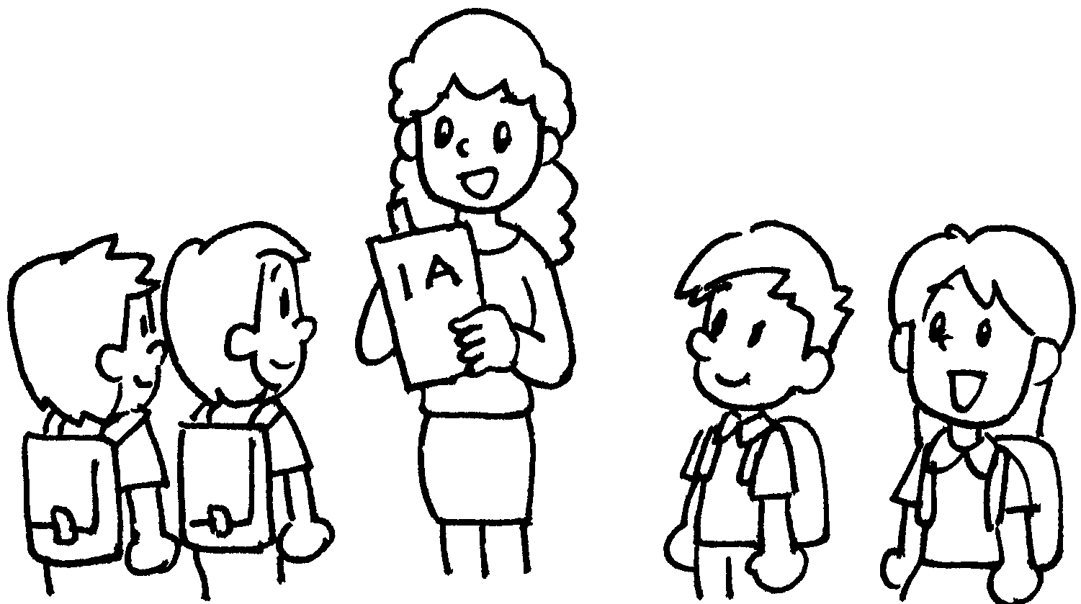
4 | 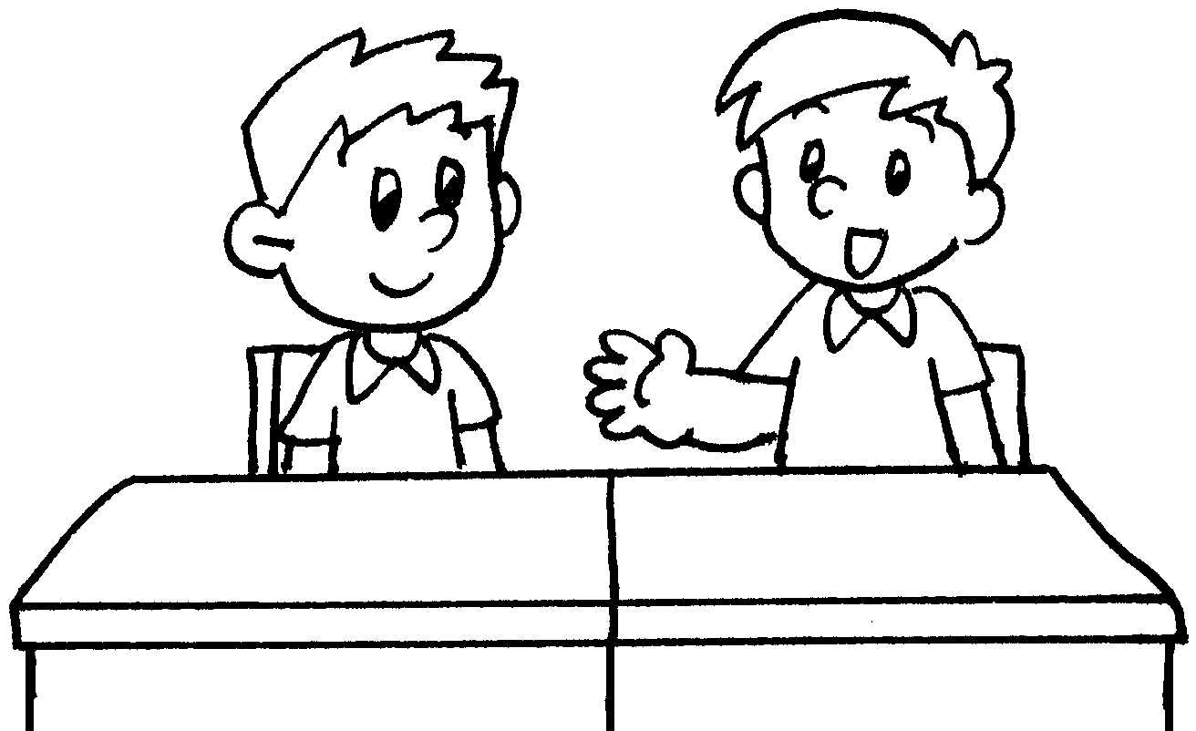 | This is Tommy.  _______ is my classmate.



Book 1A Chapter 2 Graded Worksheets

Worksheet 2⬇

He
- She
- She
- He

