Circle the correct answers.

1 | 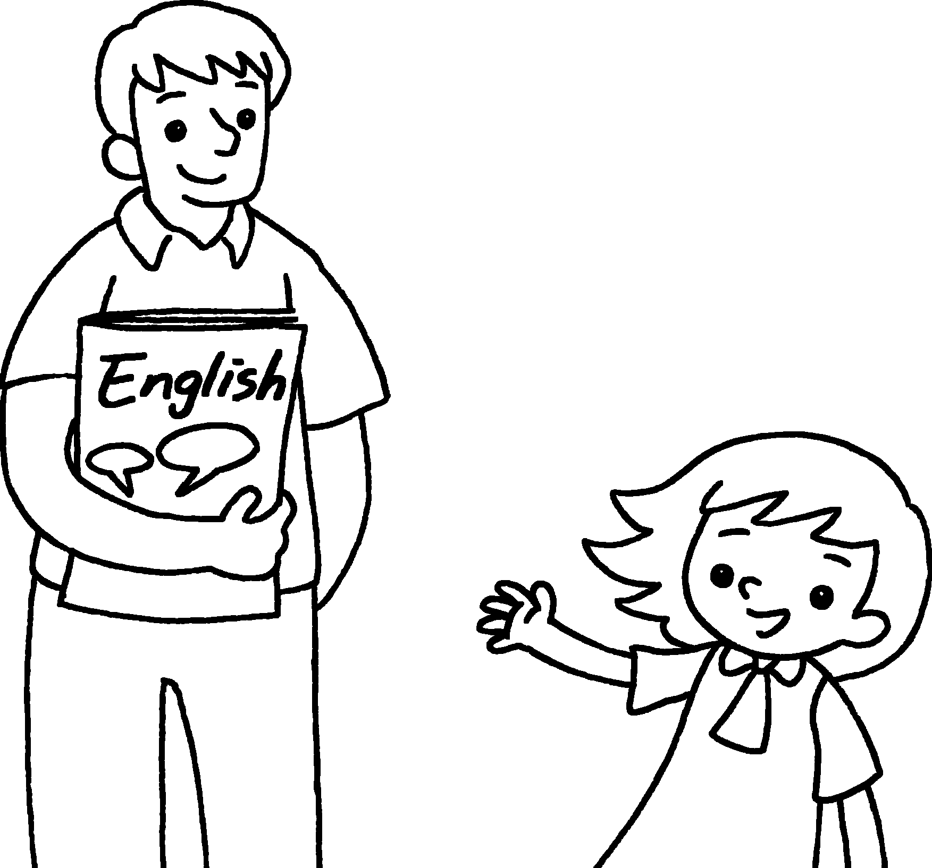  ( This is / She is ) Mr Chow.  ( He is / She is ) my English teacher.
2 |   ( He is / This is ) Jane.  ( He is / She is ) my classmate.
3 | ( This is / He is ) Miss Ng.  ( She is / He is ) my class teacher.  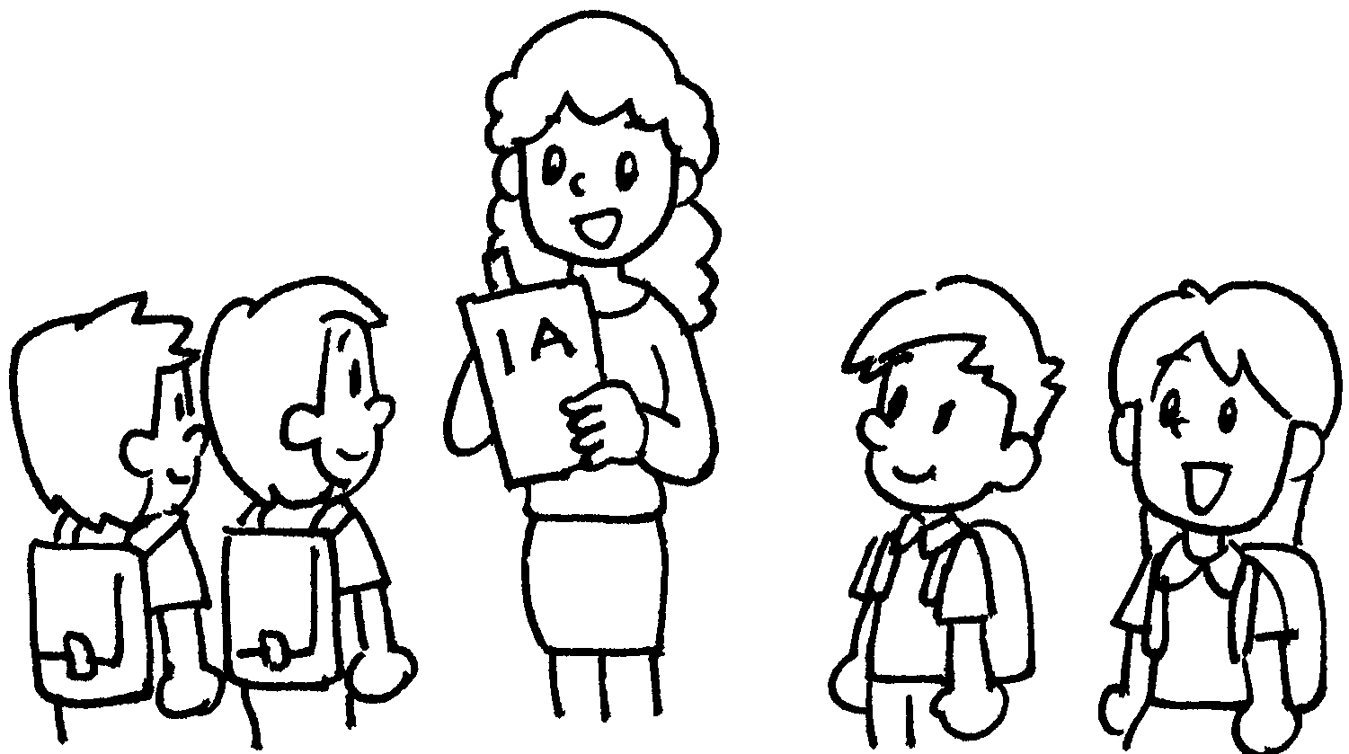
4 | 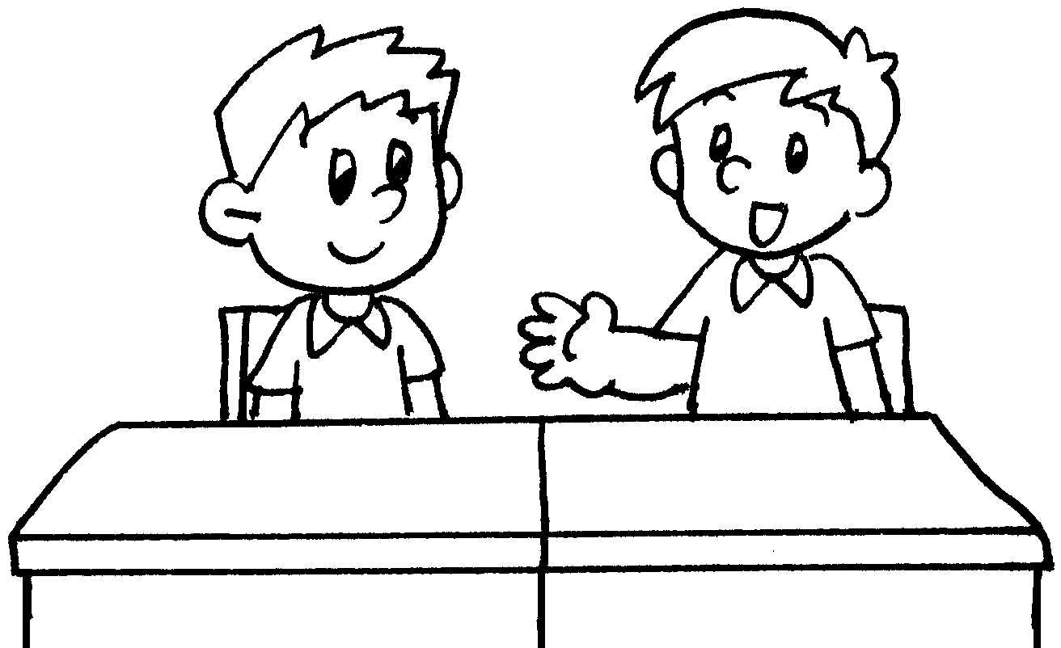 | ( She is / This is ) Tommy.  ( He is / She is ) my classmate.



Book 1A Chapter 2 Graded Worksheets

Worksheet 2⬇⬇
- ( This is / She is )
( He is / She is )
- ( He is / This is )
( He is / She is )
- ( This is / He is )
( She is / He is )
4 ( She is / This is )
( He is / She is )

