What are the children saying? Write.

1 | 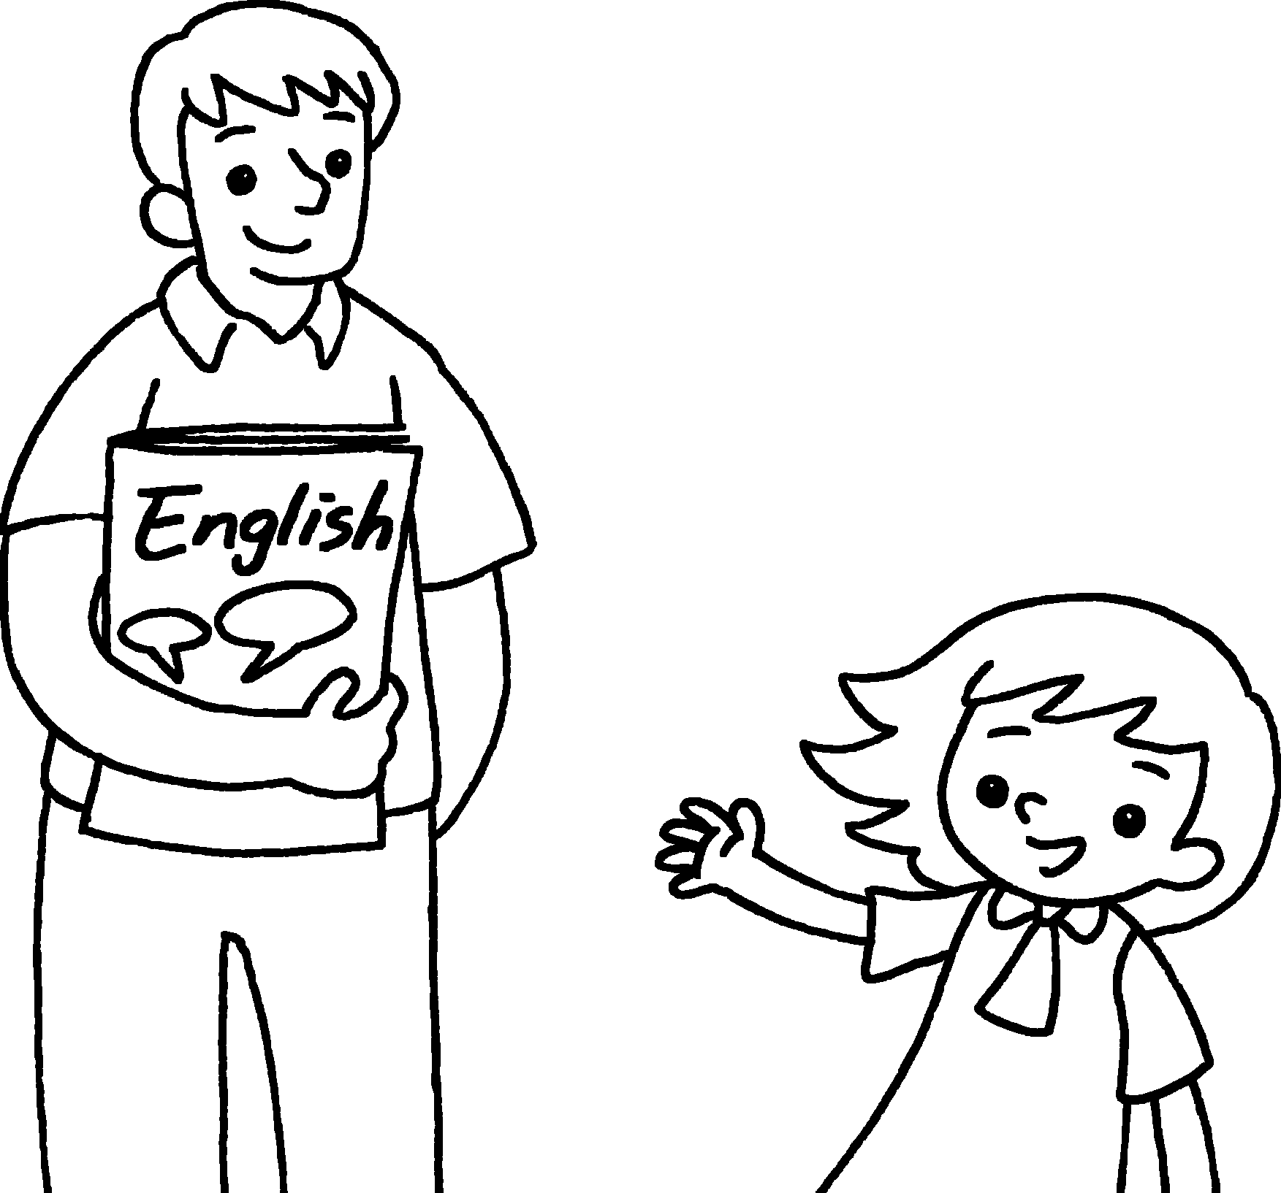  This is Mr Chow.  _____ is my English teacher.
2 | 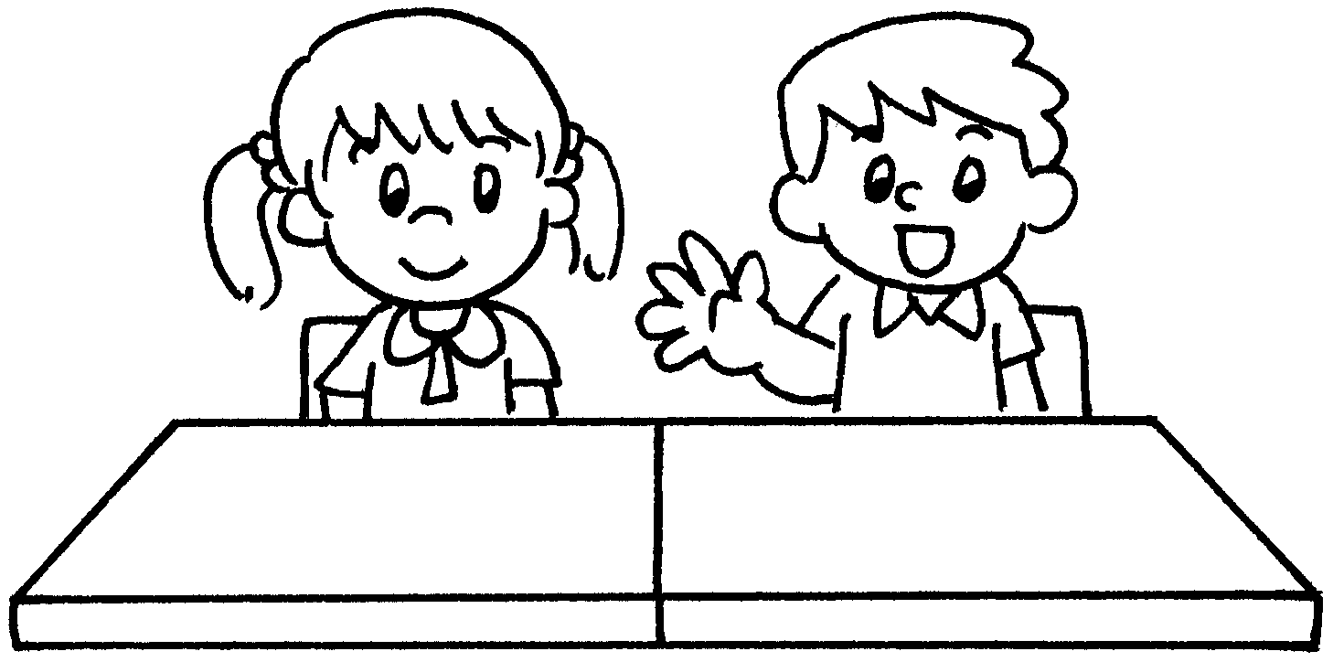  This ___ Jane.  ______ is my classmate.
3 | ______ ____ Miss Ng.  ______ ____ my class teacher.  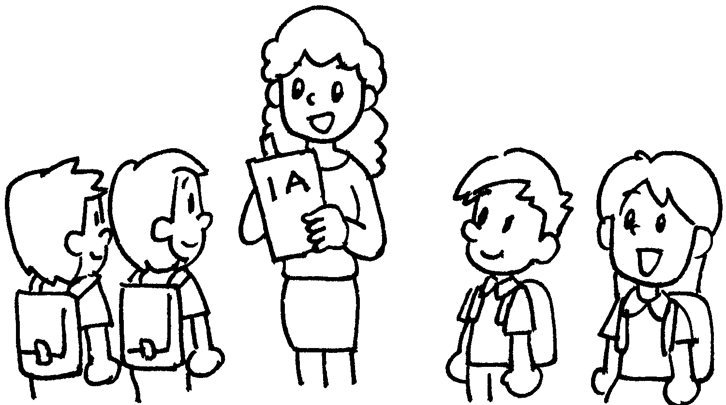
4 | 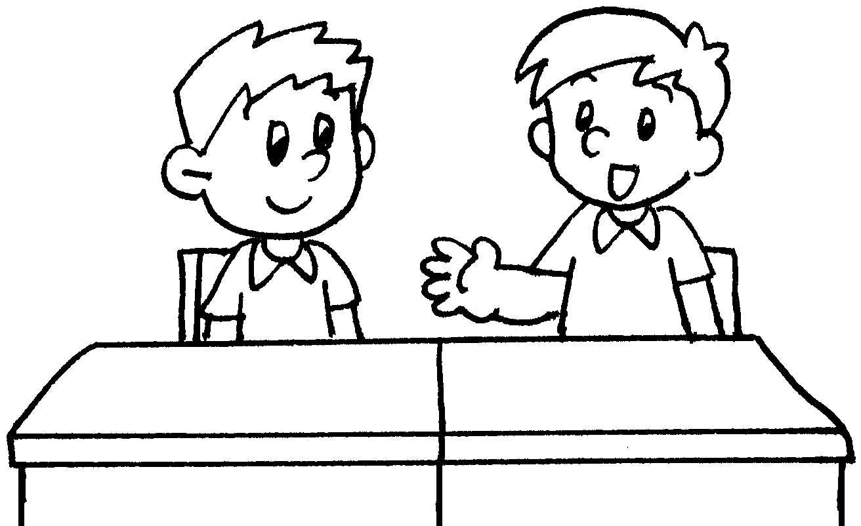 | ___________ Tommy.  ___________ my classmate.



Book 1A Chapter 2 Graded Worksheets

Worksheet 2⬇⬇⬇
- He
- is
She
- This is
She is
- This is
He is

