Circle the correct answers.

1 | 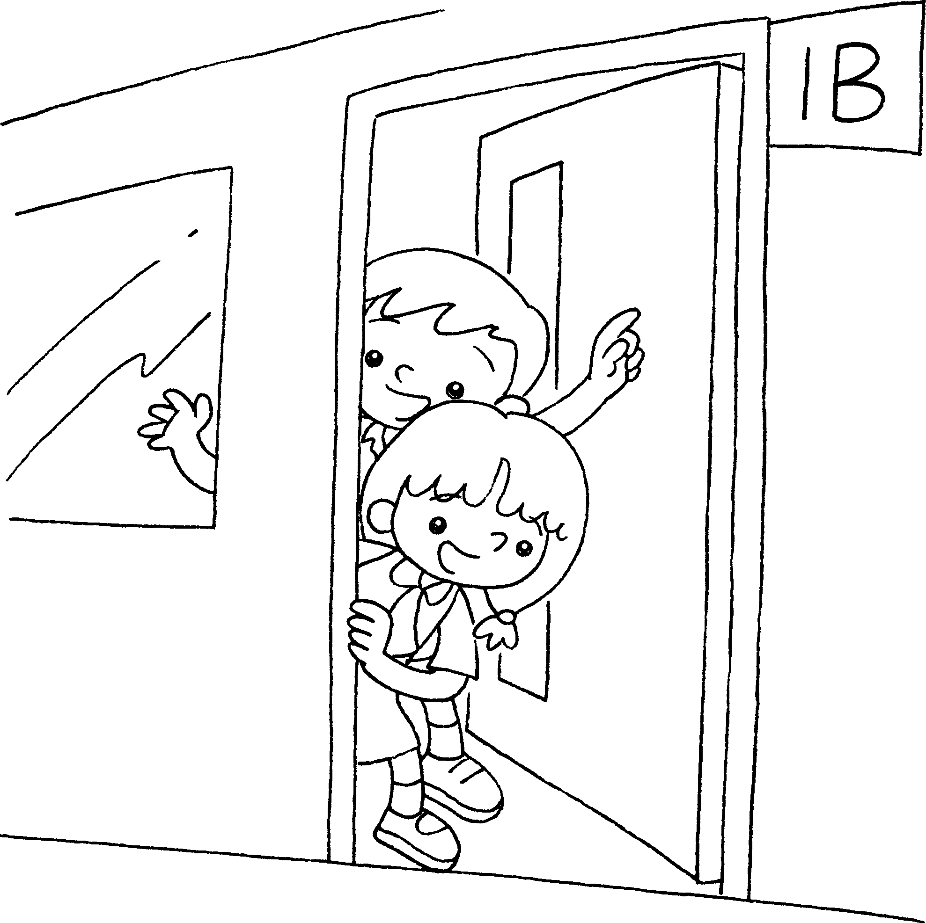  1A | 2 |  | 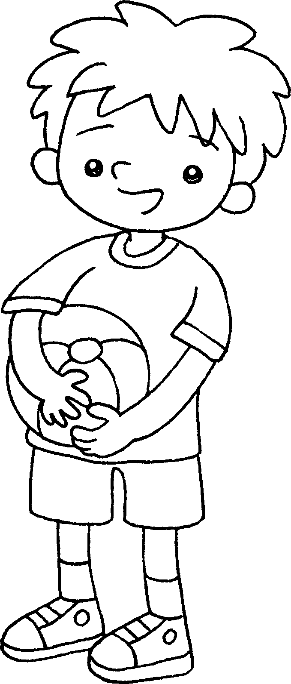
 | ( We are / I am ) in  Class 1A. |  |  | ( We are / I am ) a boy.
3 | 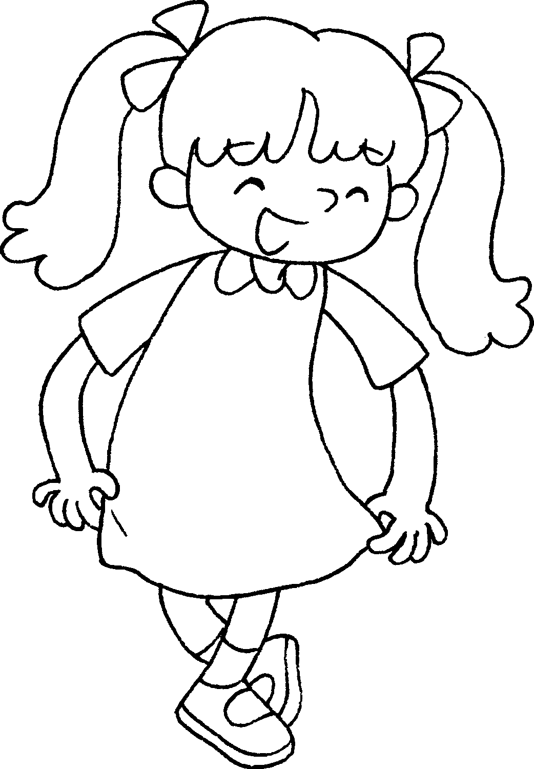 | 4 |  | 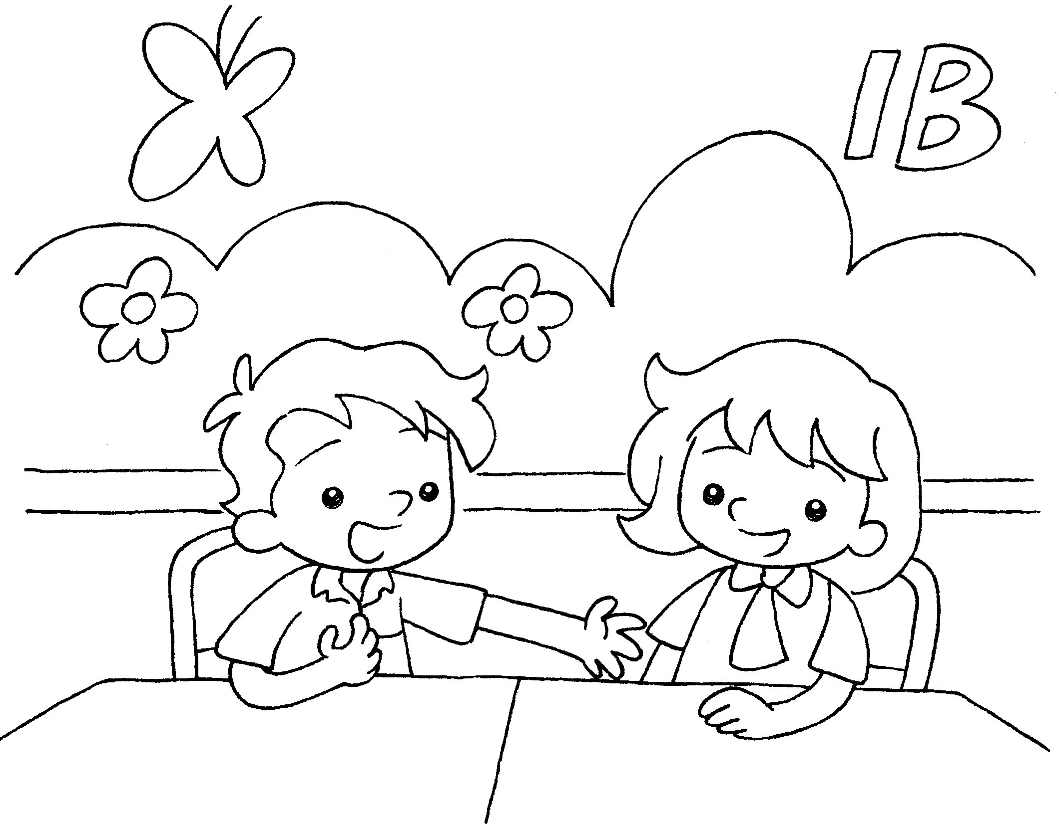
 | ( We are / I am ) a girl. |  | ( We are / I am ) in Class 1B.


Book 1A Chapter 2
Remedial Worksheets
Worksheet 3
1 ( We are / I am )
2 ( We are / I am )
3 ( We are / I am )
4 ( We are / I am )
Book 1A Chapter 2
Remedial Worksheets
Worksheet 2
1 He
2 She
3 She
4 He



Book 1A Chapter 2 Graded Worksheets

Worksheet 3⬇
- ( We are / I am )
- ( We are / I am )
- ( We are / I am )
- ( We are / I am )

