Match the pictures with the sentences.

1 | 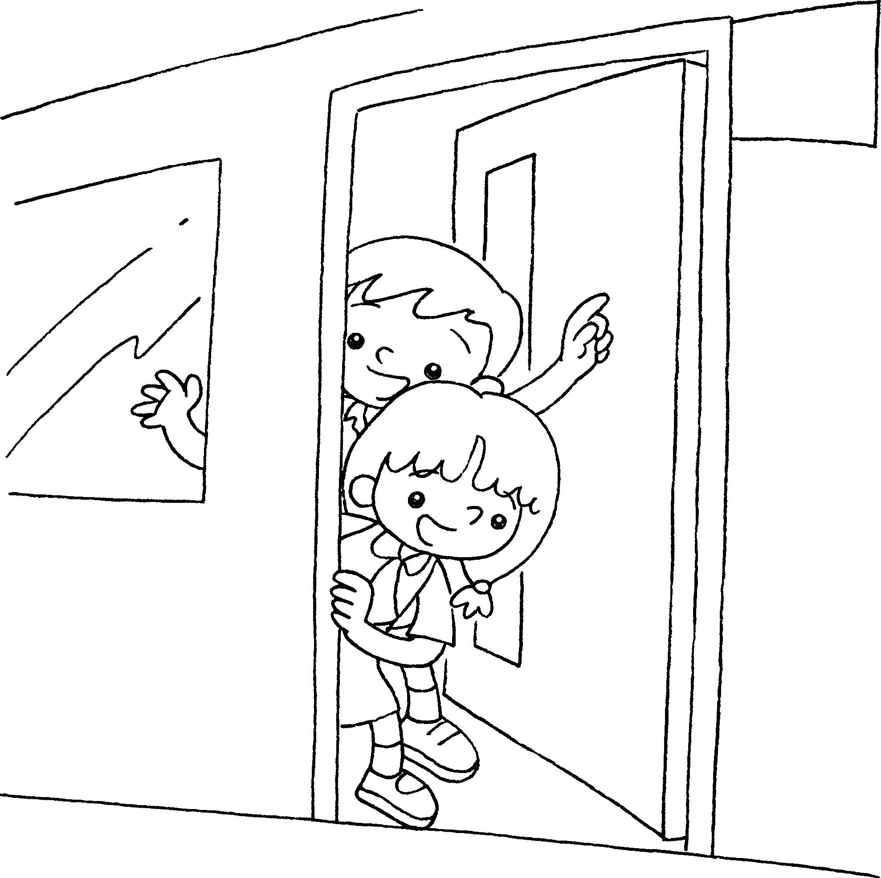  1A | ● | ● | I am a boy.
2 | 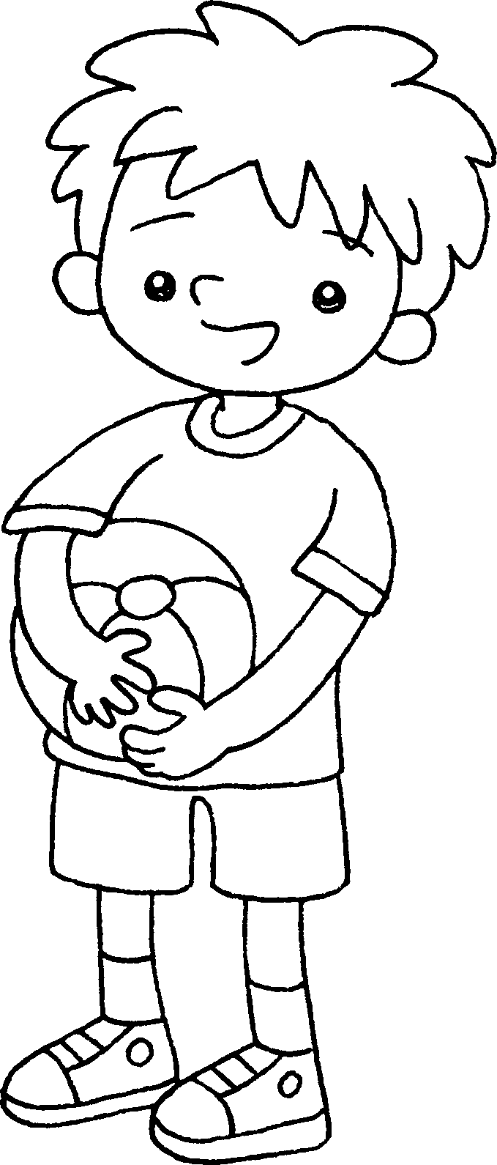 | ● | ● | We are in Class 1B.
3 | 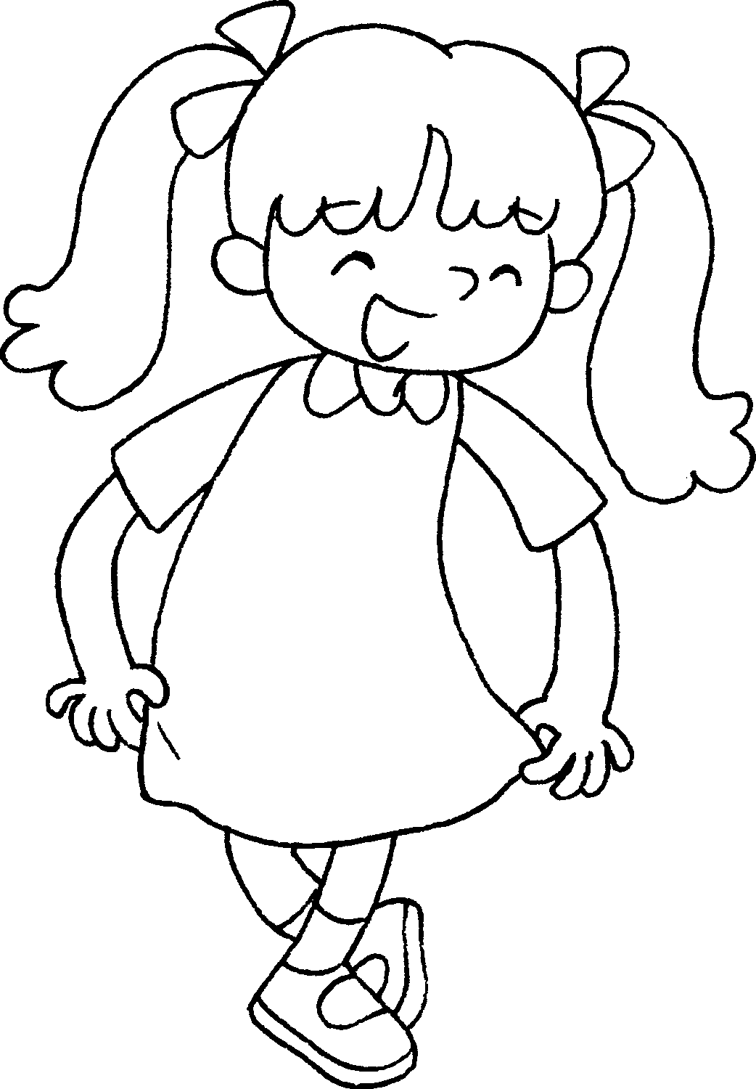 | ● | ●   | We are in Class 1C.  I am a girl.
4 | 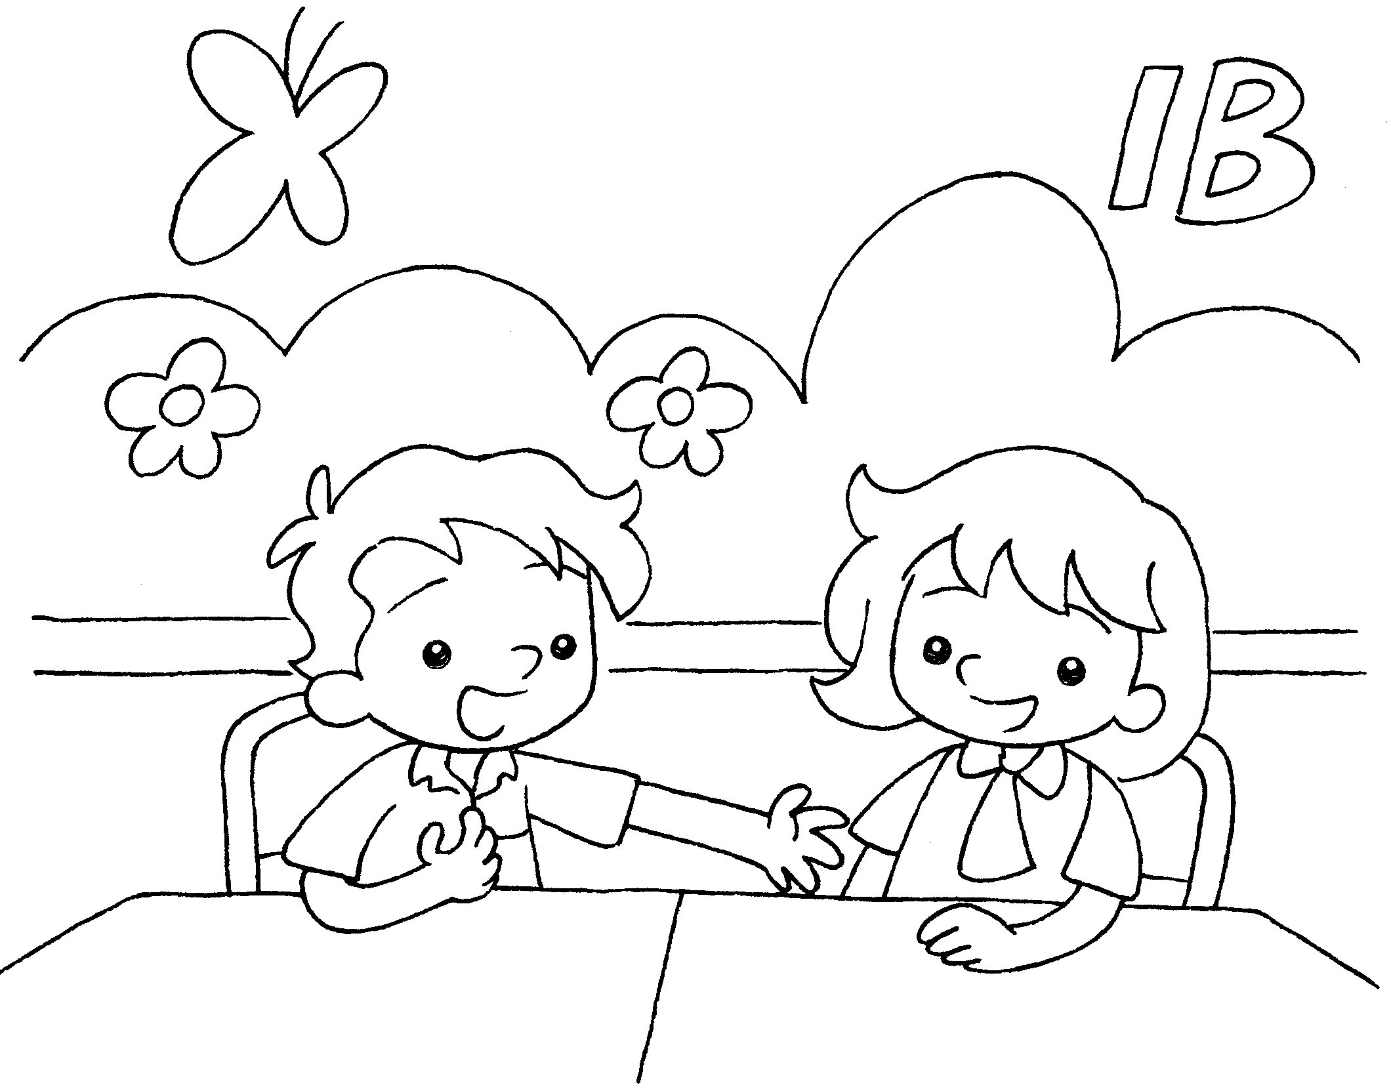 | ● | ● | We are in Class 1A.



Book 1A Chapter 2 Graded Worksheets

Worksheet 3⬇⬇
1 | ● | ● I am a boy.   We are in Class 1B.   We are in Class 1C.   I am a girl.   We are in Class 1A.
2 | ●
3 | ●
4 | ●

