Choose and write.

I We
am are

1 | 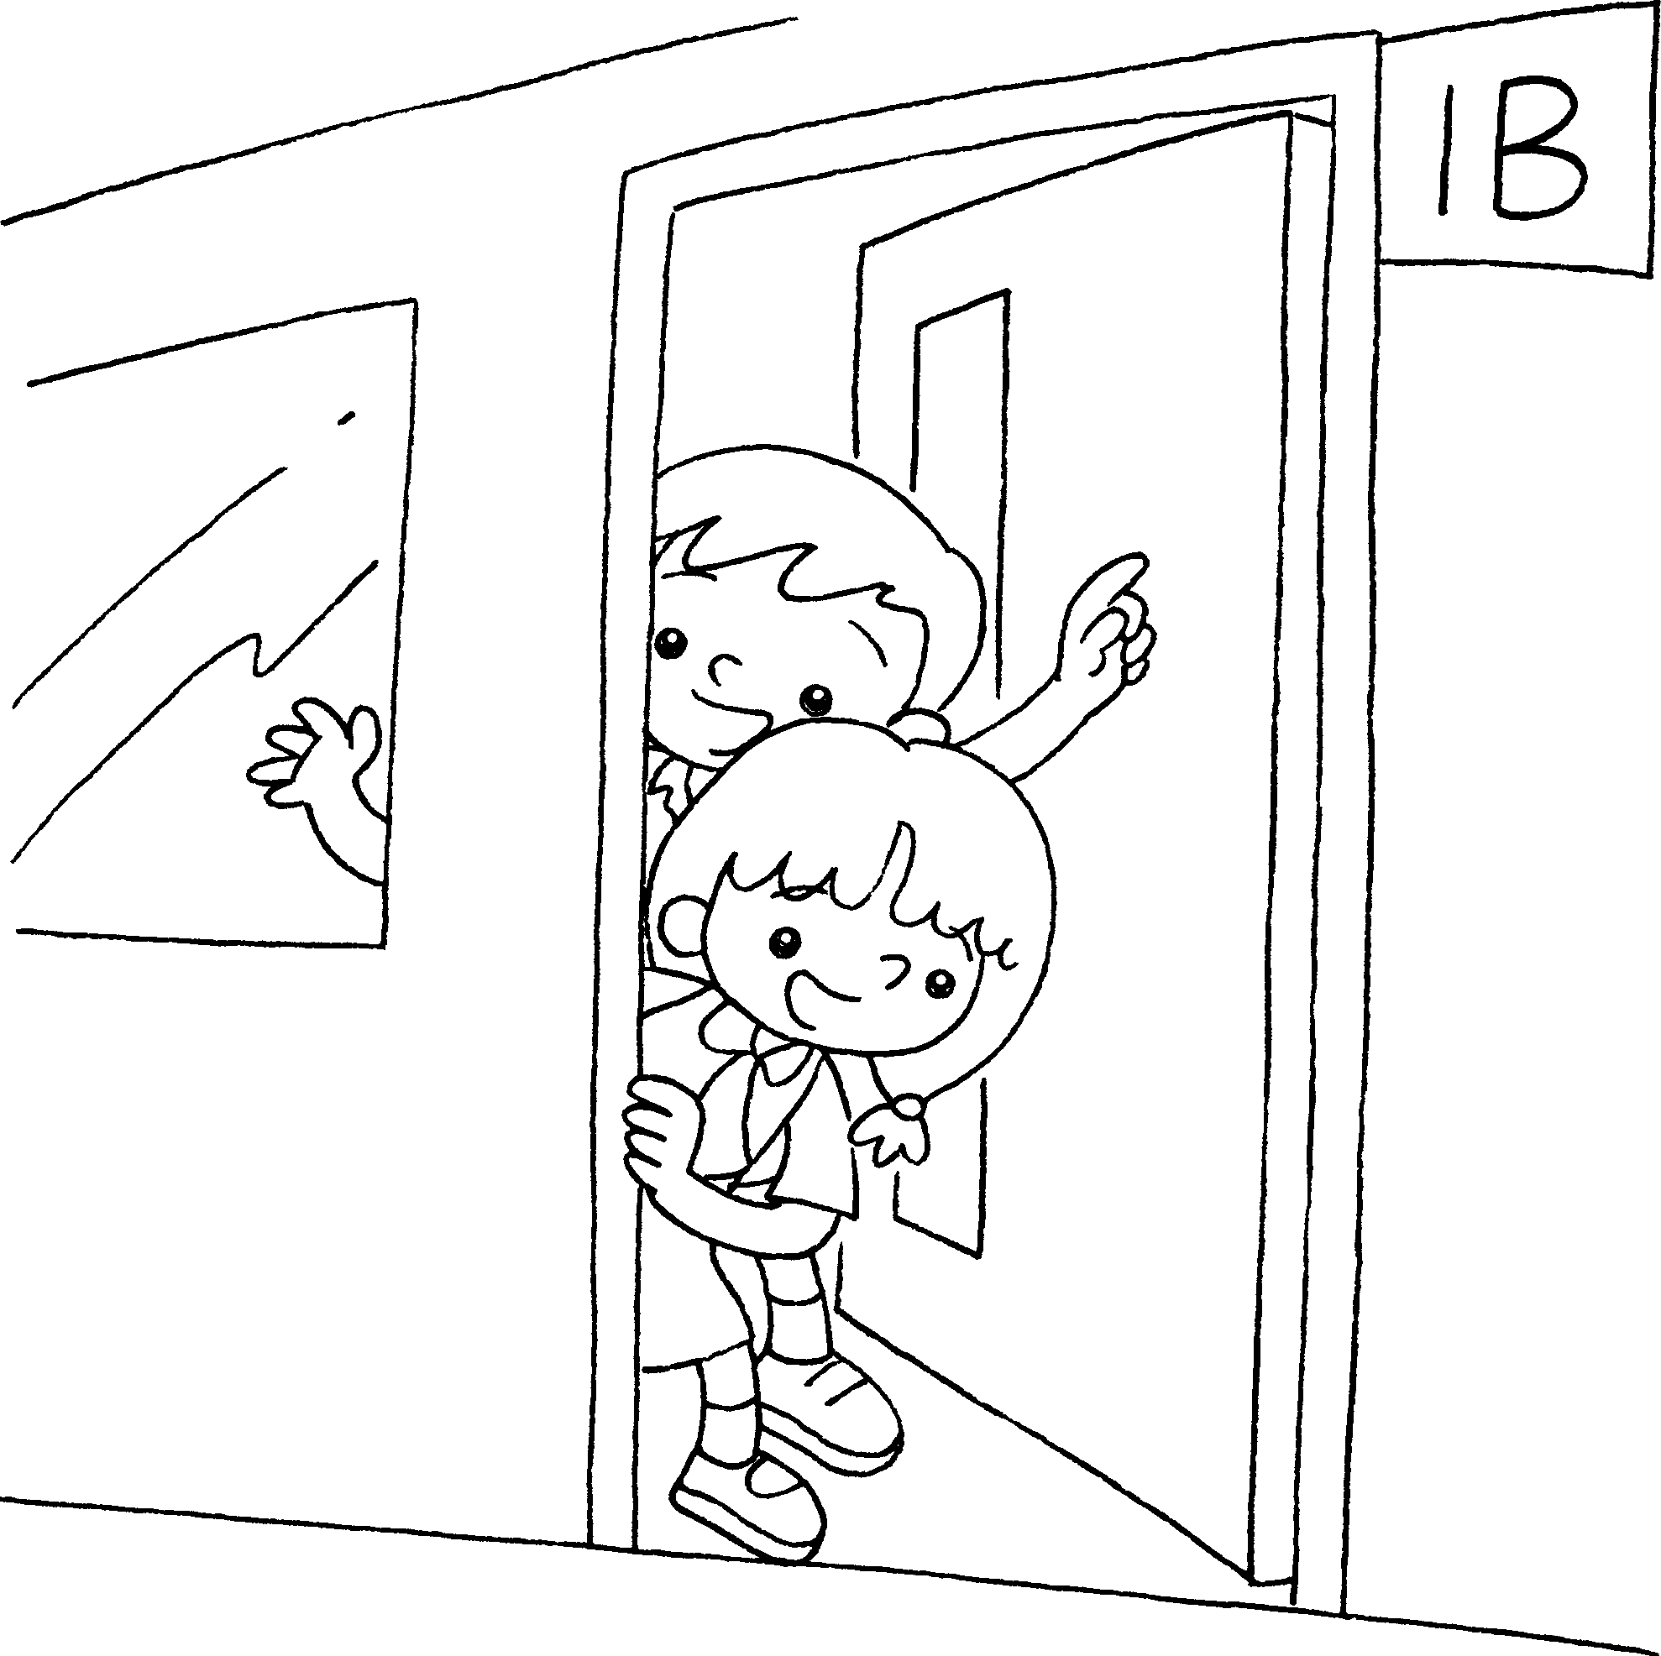  1A | 2 | 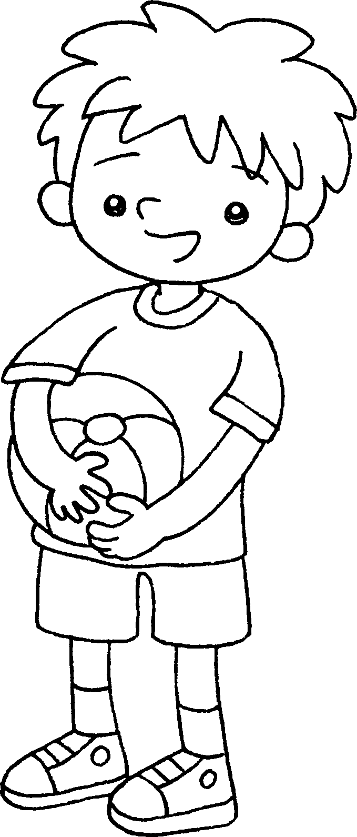
 | ______ _____ in  Class 1A. |  | _____ _____ a boy.
3 | 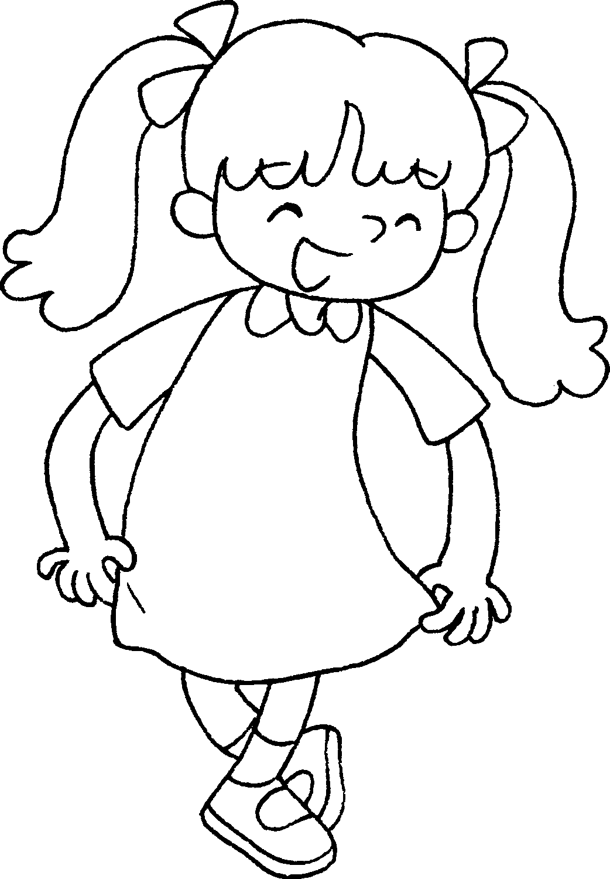  ____ ____ a girl. | 4 | 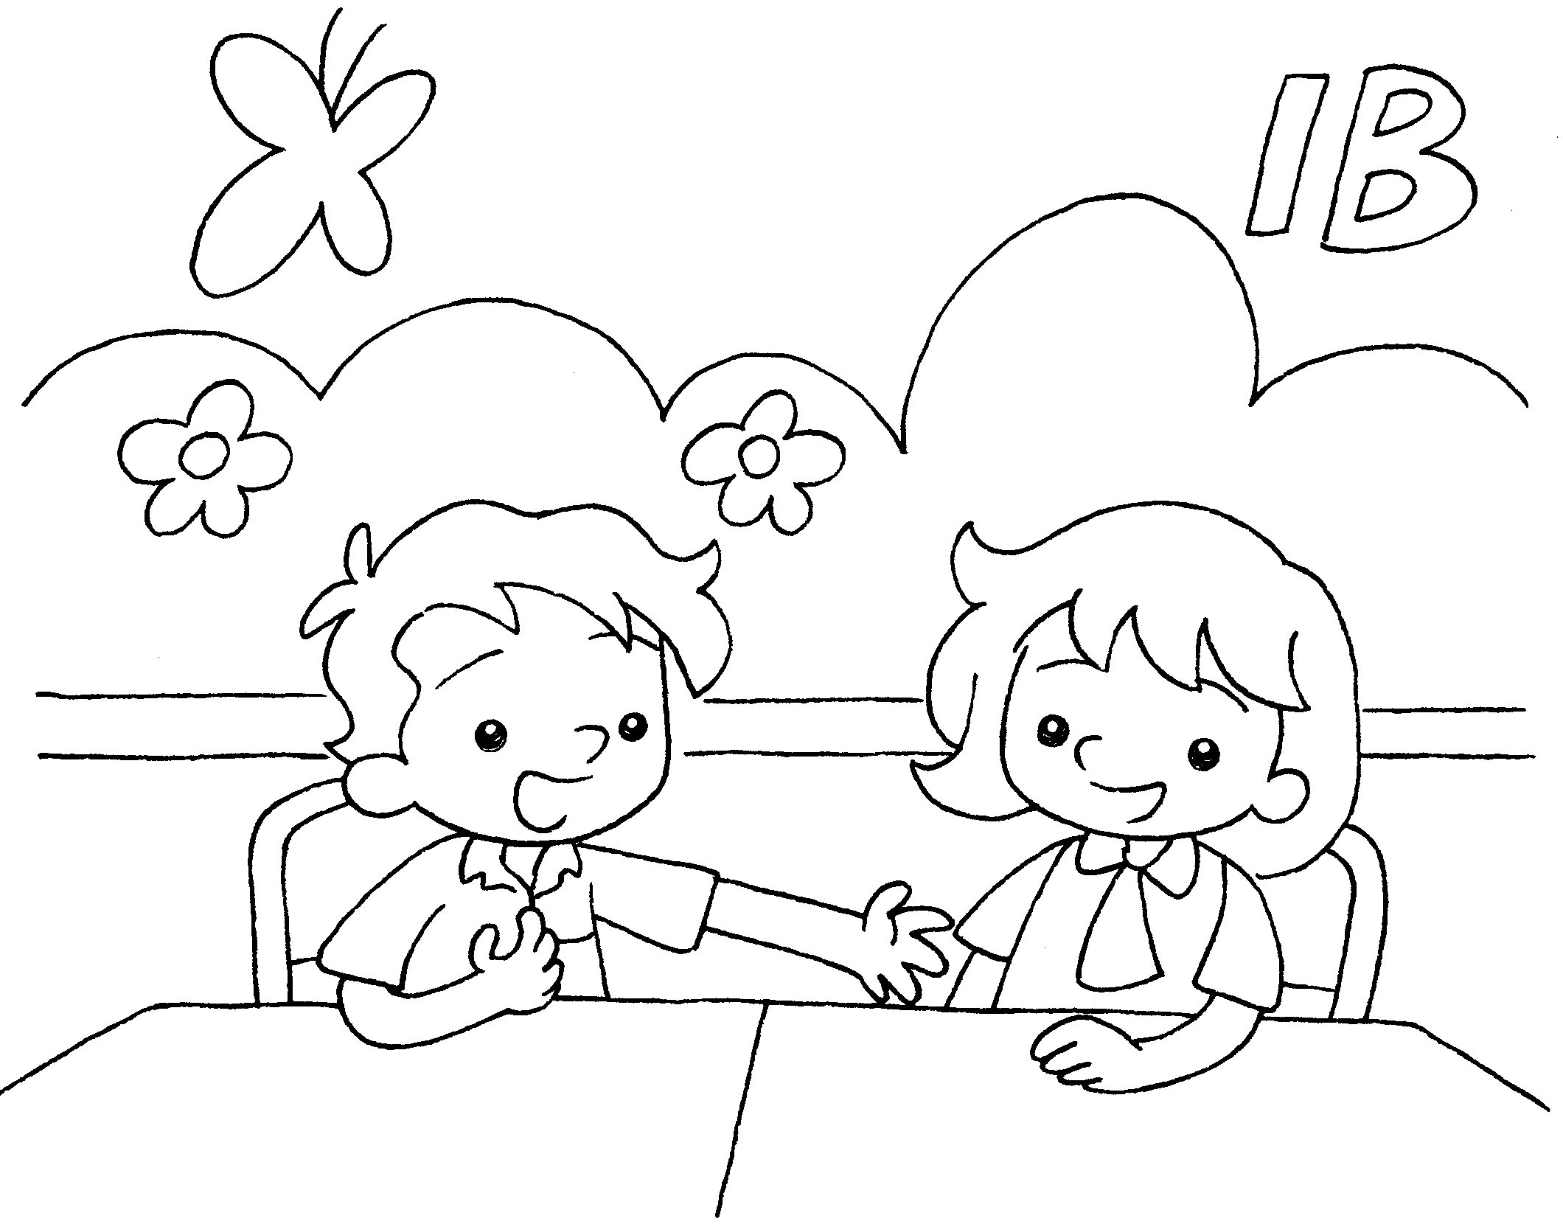
 |  |  | _____ _____ in Class1B.



Book 1A Chapter 2 Graded Worksheets

Worksheet 3⬇⬇⬇
- We are
- I am
- I am
- We are

