
1 people at school 3 English teacher 英文老師
學校裏的人
2 classmate 同學 4 class teacher 班主任
The words marked with * have different meanings in other
contexts. You can look up those meanings in a dictionary.
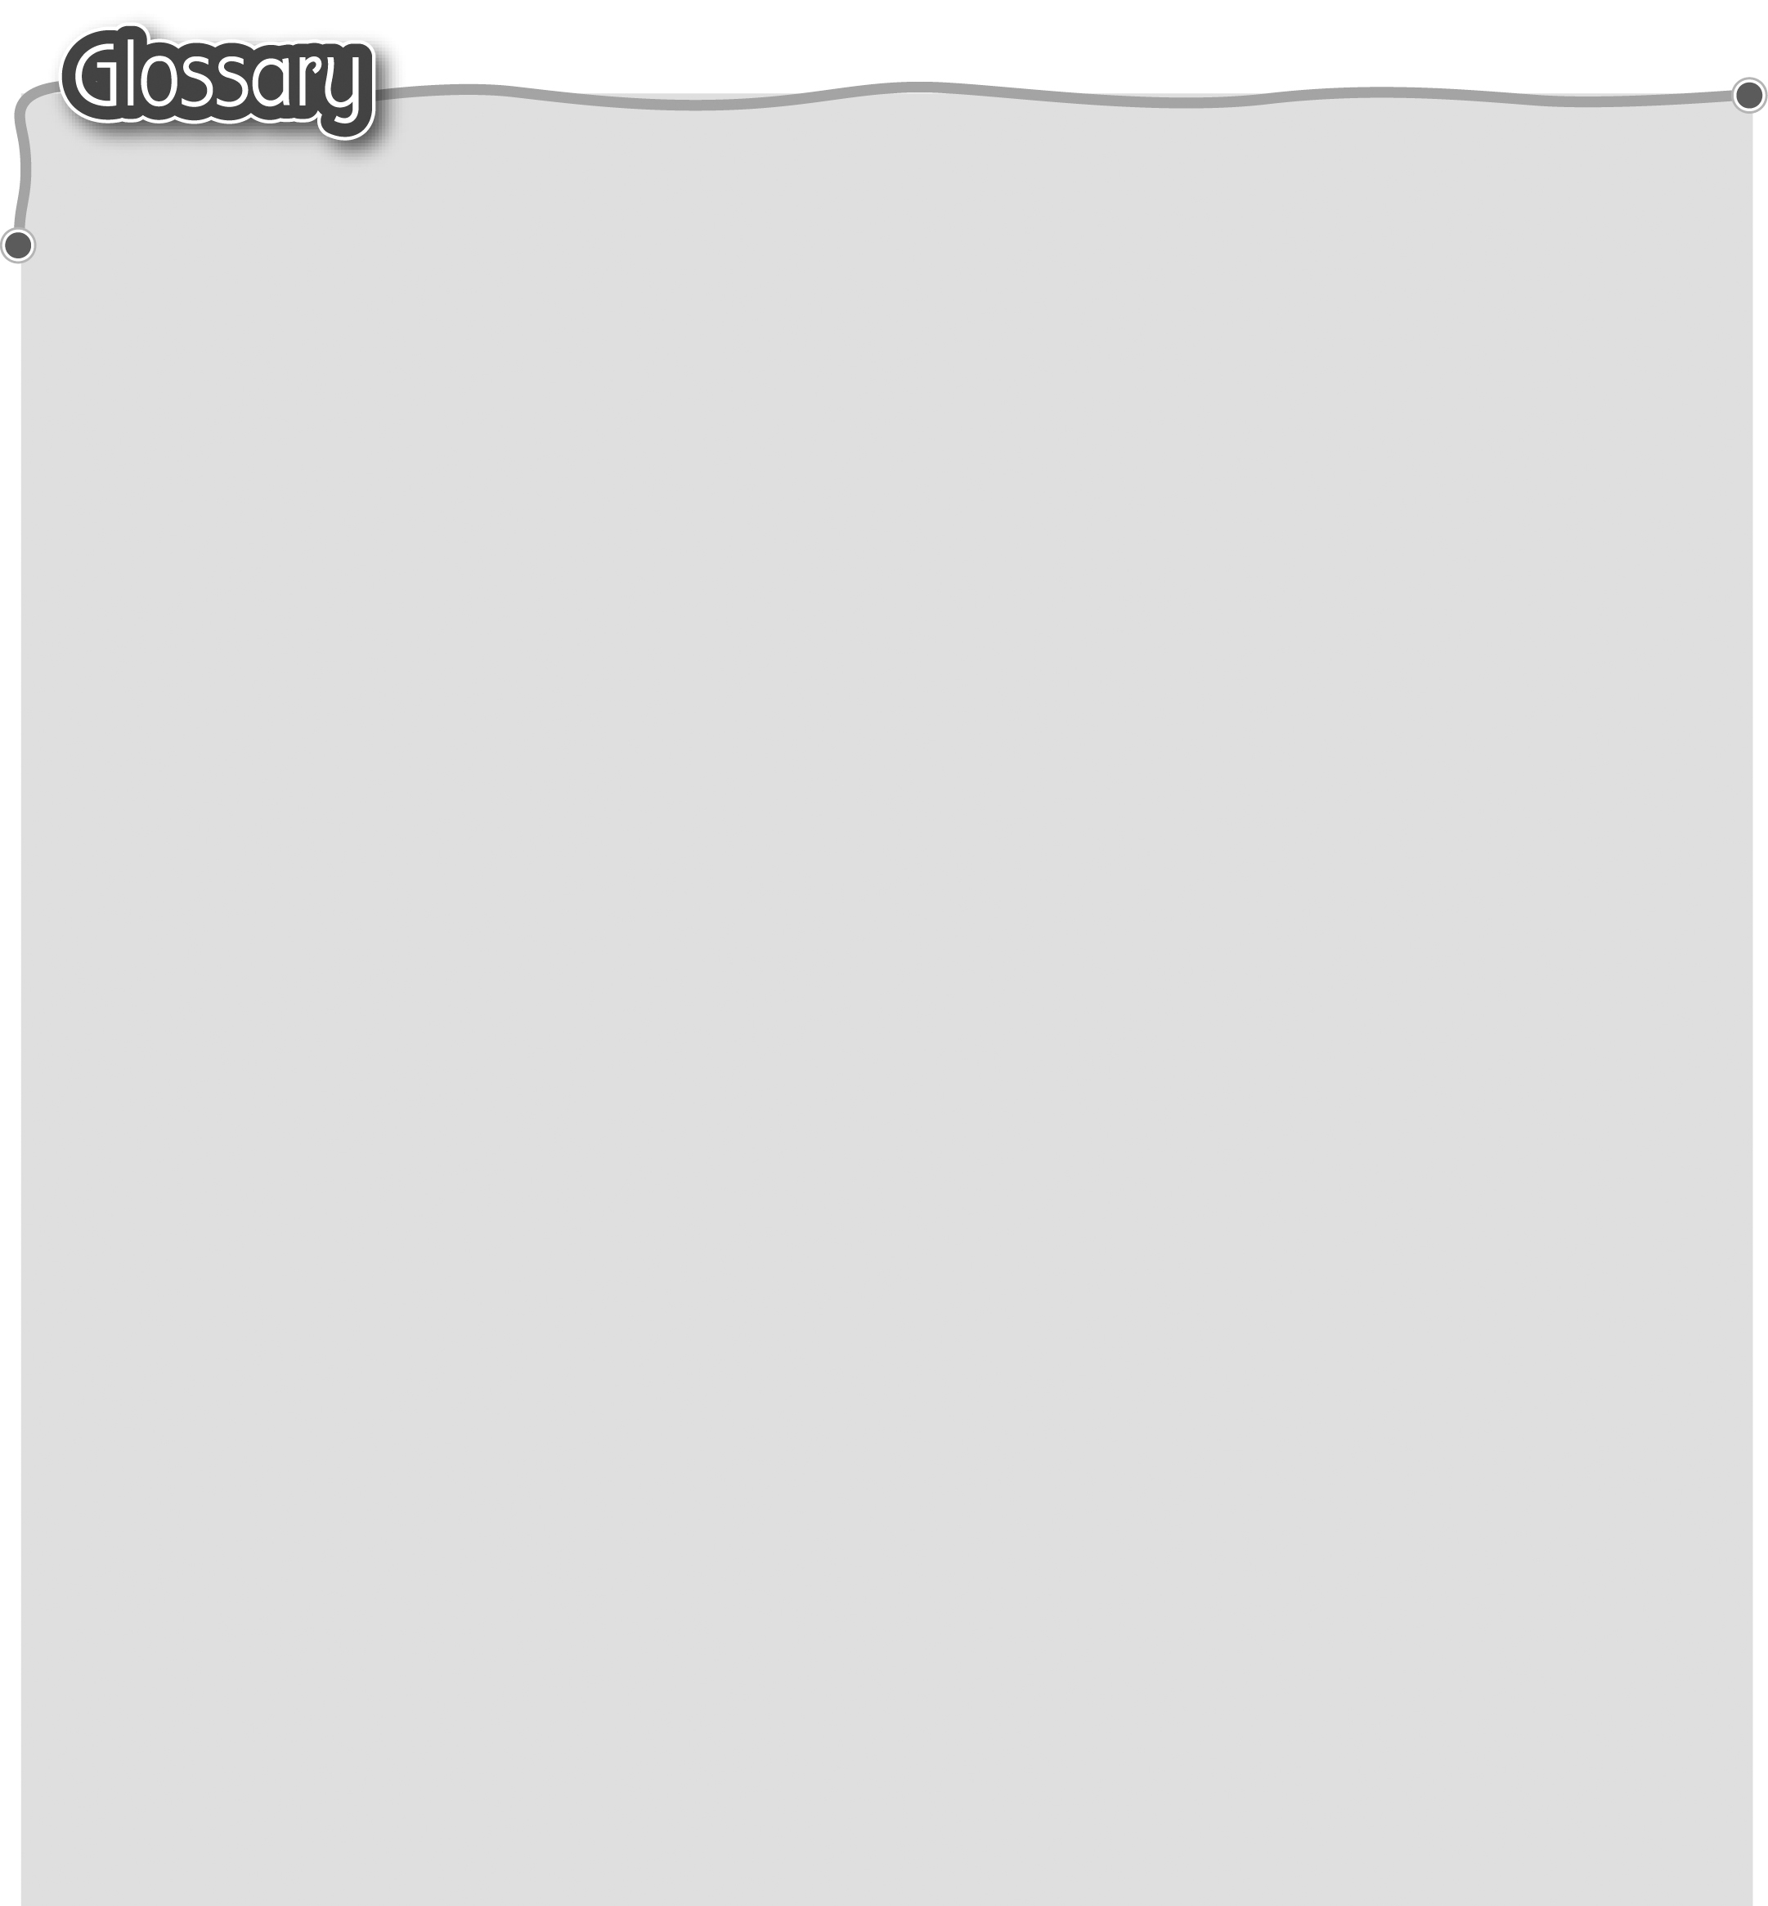
1 boy (p.18) 男孩 6 class* (p.18) 班/班別
2 this (p.18) 這 7 monitor (p.19) 班長
3 she (p.18) 她 8 nice* (p.19) 友善
4 we (p.18) 我們 9 girl (p.21) 女孩
5 are (p.18) 是


