Choose and write.
doorchairwindowdeskblackboardcomputerwhiteboard

1 | a |  |  |  | 2 | a
3 | 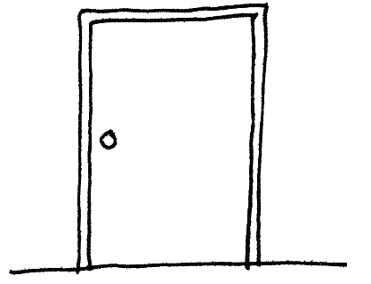  a |  |  |  | 4 | 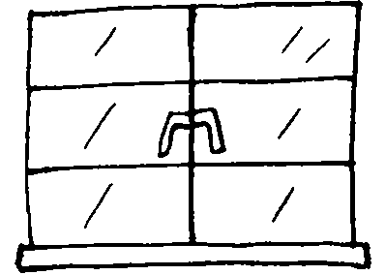  a
5 | 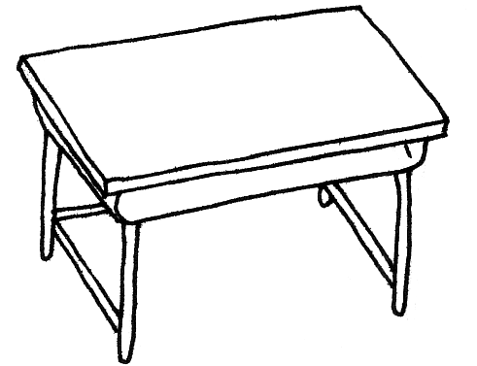  a |  |  |  | 6 | 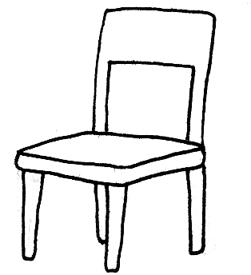  a
 |  | 7 | 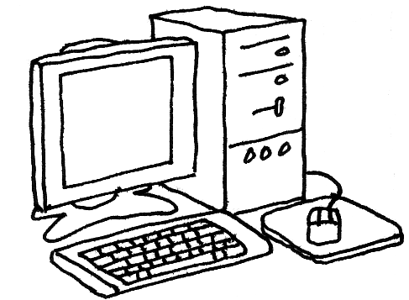  a


Book 1A Chapter 3 Graded Worksheets

Worksheet 1⬇

whiteboard

blackboard
3 door
4 window
5 desk
6 chair
7 computer

