Fill in the missing letters.

1 | a wh __ __ __ __ __ __ __ __ | 2 | a bl __ __ __ __ __ __ __ __

3 | 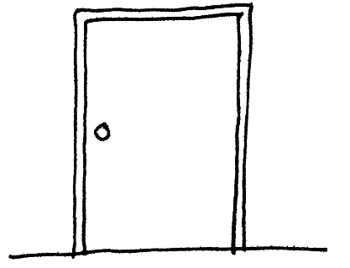  a d __ ___ __ | 4 | 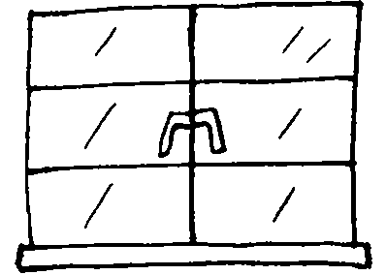  a w __ __ __ __ __

5 | 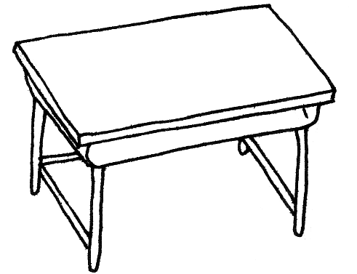  a d __ __ __ | 6 | 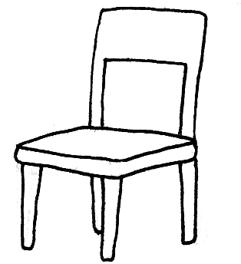  a c __ __ __ __

 | 7 | 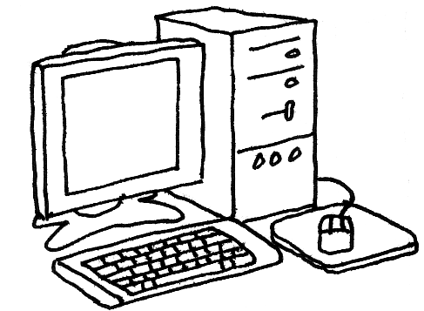  a c __ __ __ __ __ __ __


Book 1A Chapter 3 Graded Worksheets

Worksheet 1⬇⬇
1 wh i t e b o a r d
2 bl a c k b o a r d
3 d o o r
4 w i n d o w
5 d e s k
6 c h a i r
7 c o m p u t e r

