What are they? Write.

1 | a w |  |  |  | 2 | a b
3 | 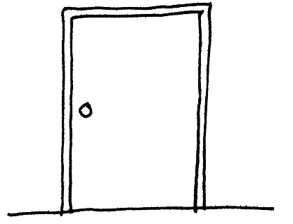  a |  |  |  | 4 | 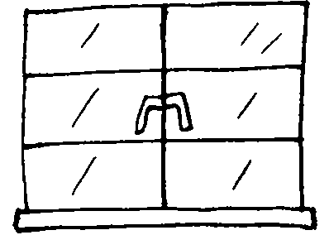  a
5 | 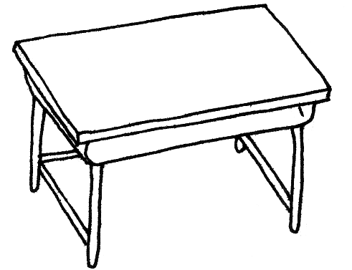  ___ |  |  |  | 6 | 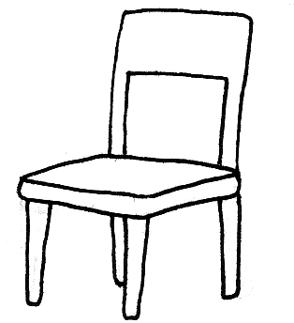  __
 |  | 7 |   __



Book 1A Chapter 3 Graded Worksheets

Worksheet 1⬇⬇⬇

1 whiteboard

2 blackboard
3 door
4 window
5 a desk
6 a chair
7 a computer

