Tick ( ✓ ) the correct pictures.

1 | Open the window, please.
 |   A. B. C. | 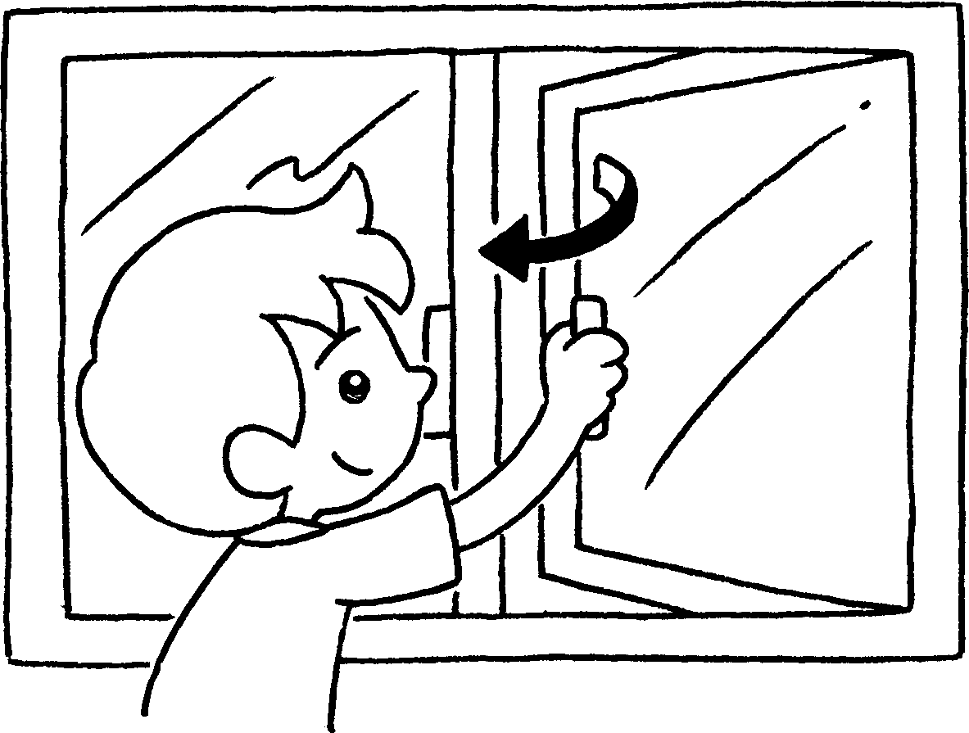 |  | 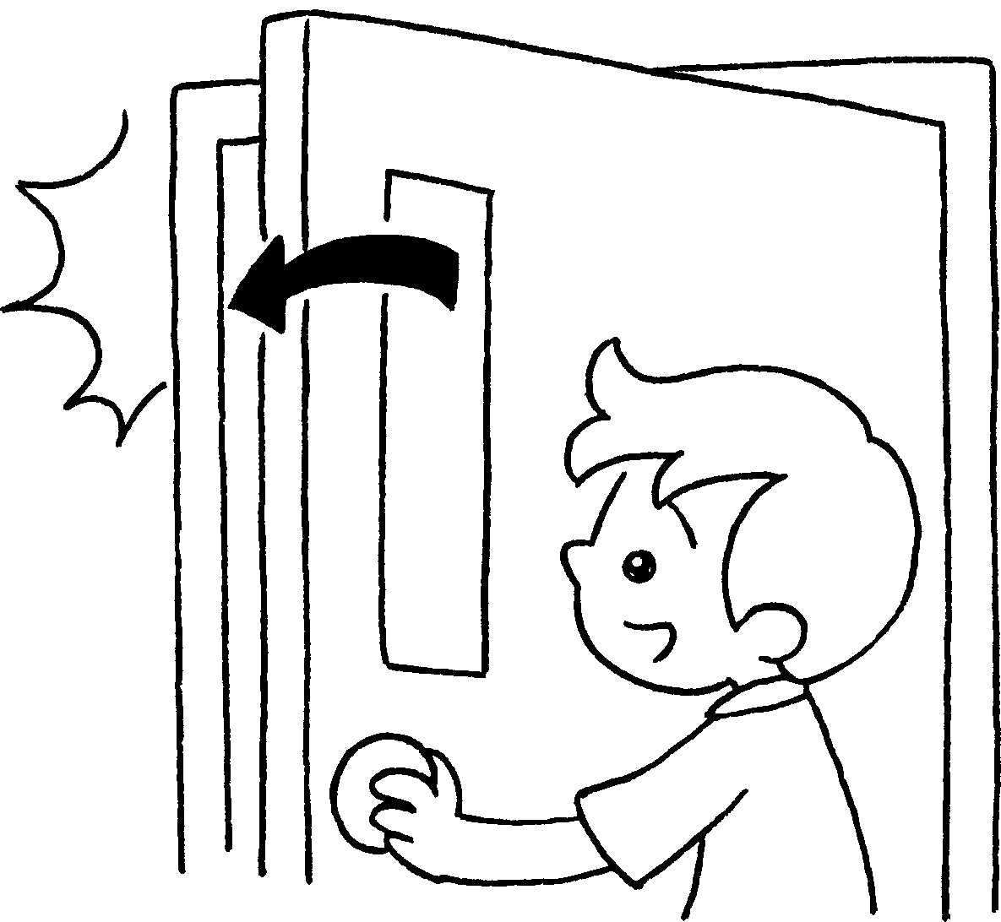 |  |  | 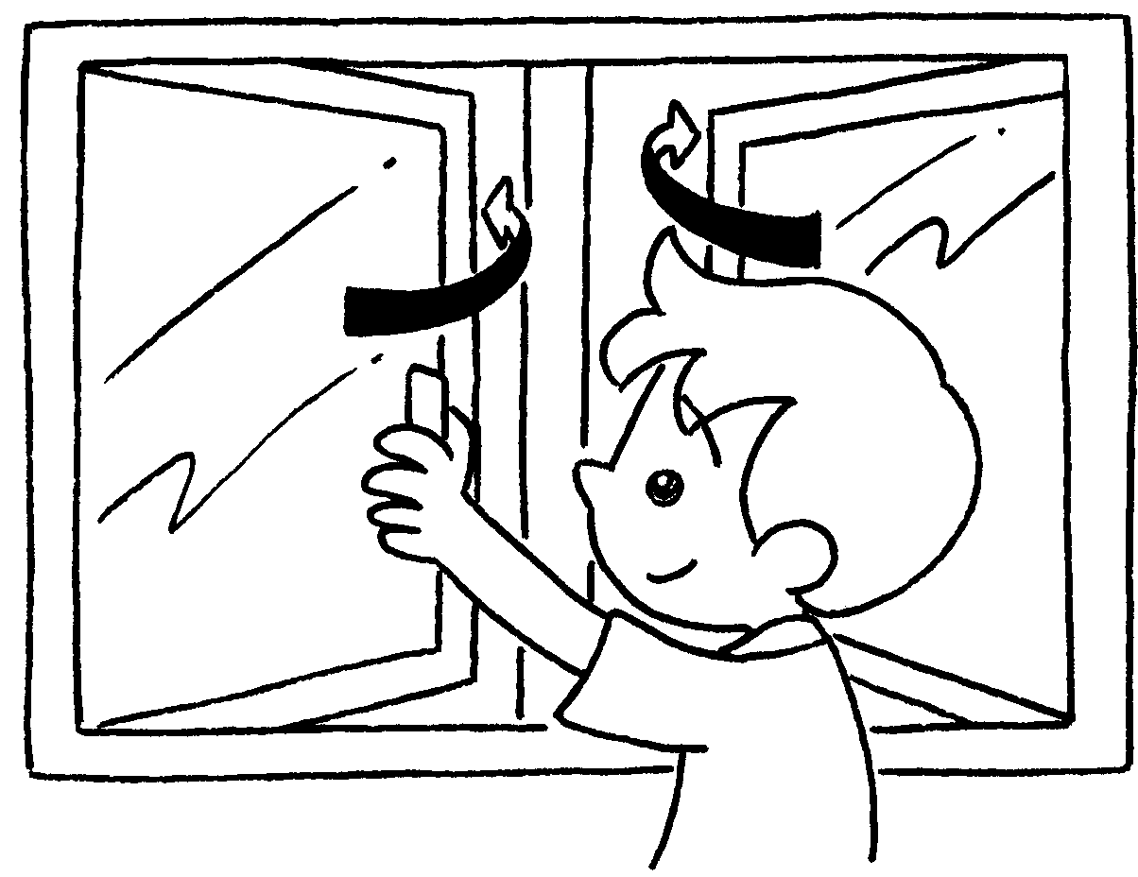
2 | Close your books, please.
 | A. B. C. | 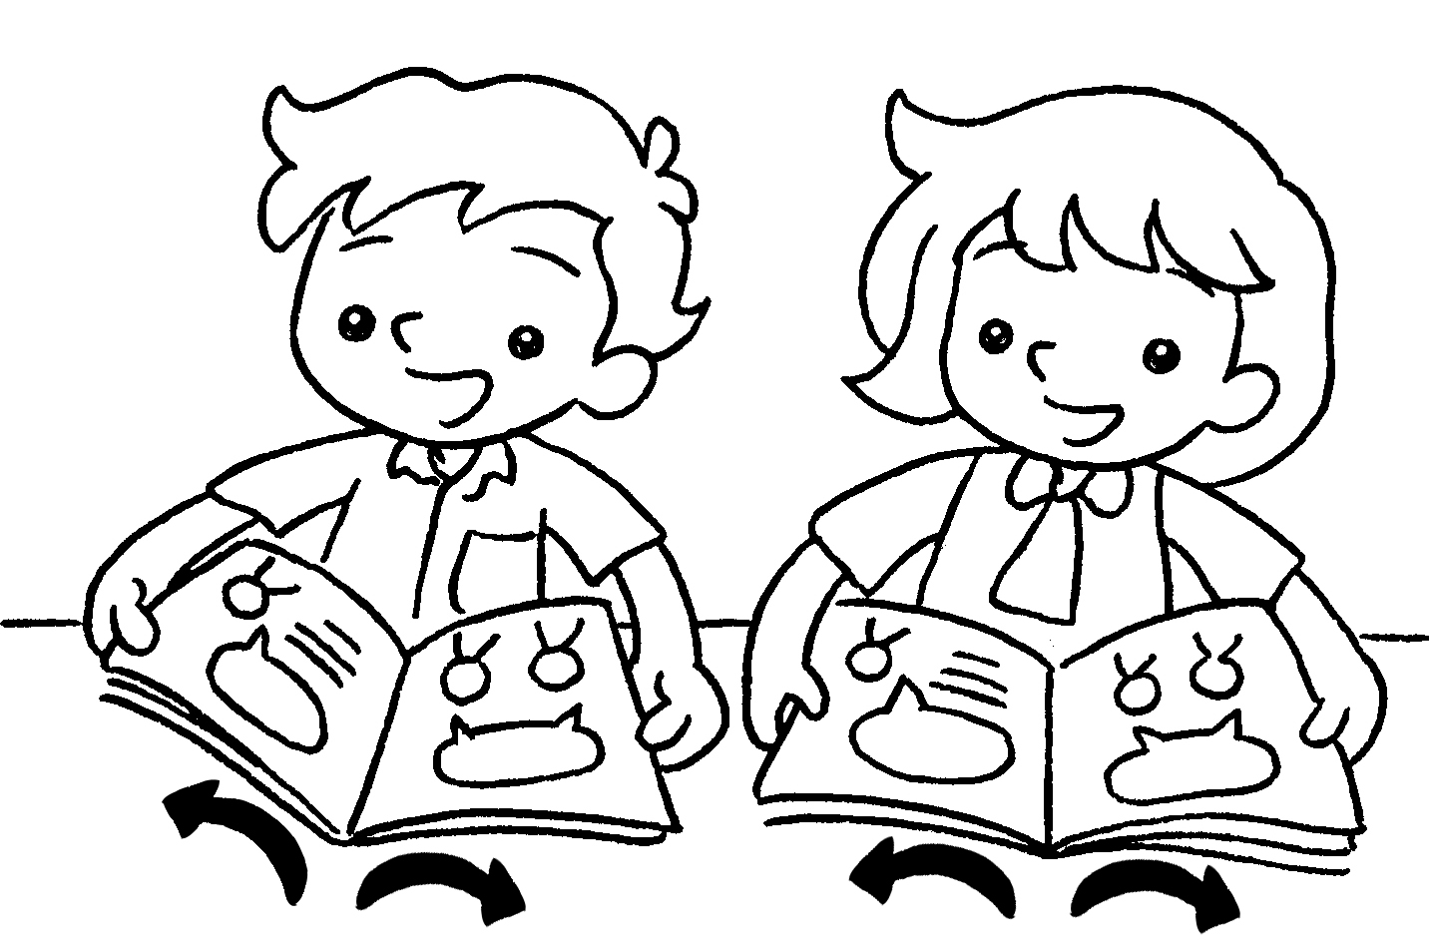 |  | 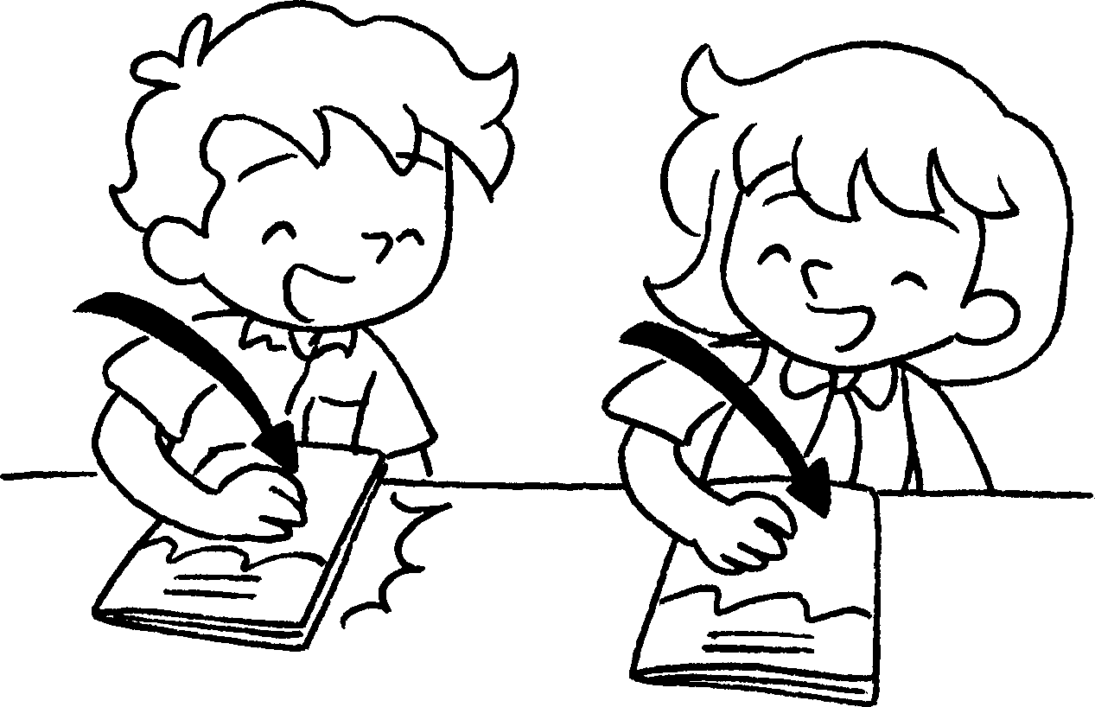 |  |  | 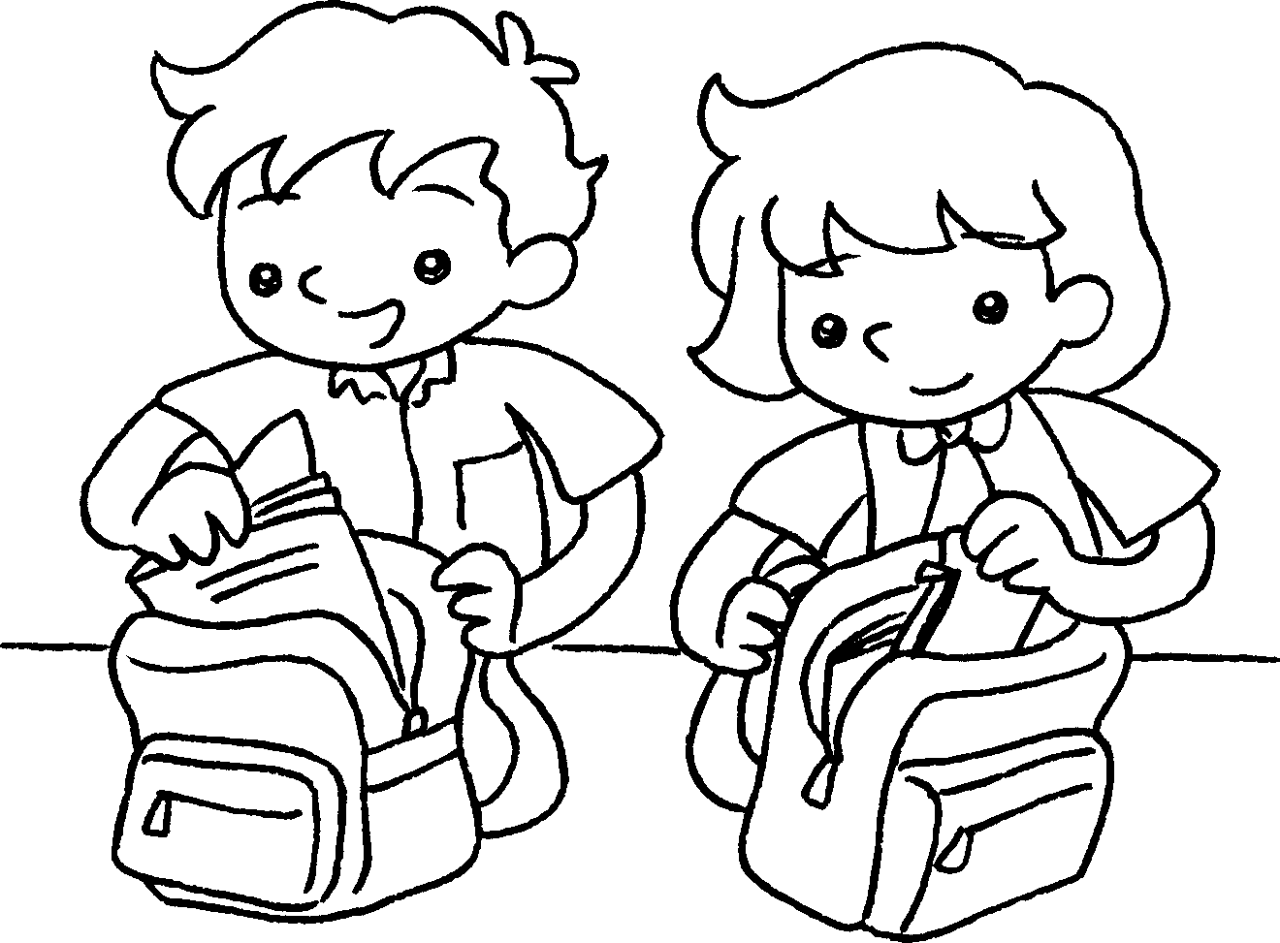
3 | Stand up, please.
 | A. B. C. | 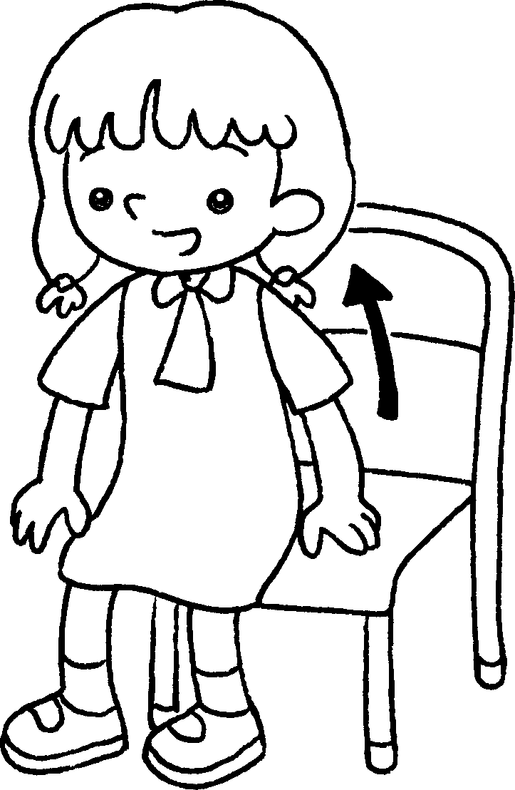 |  | 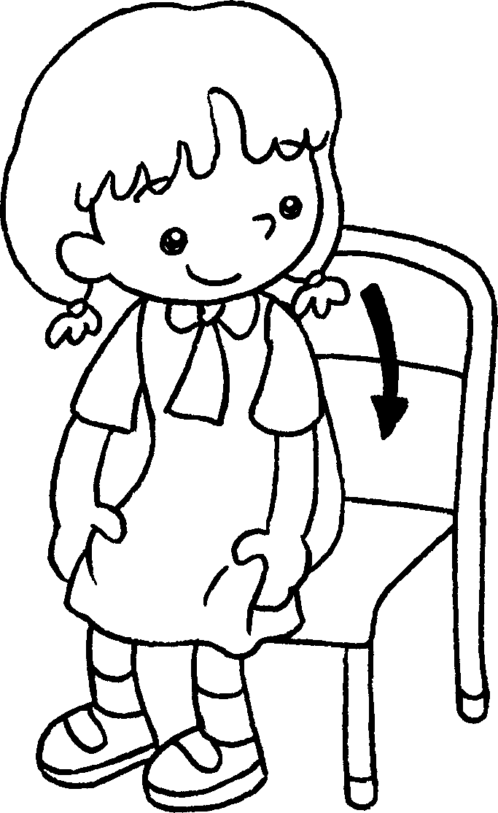 |  |  | 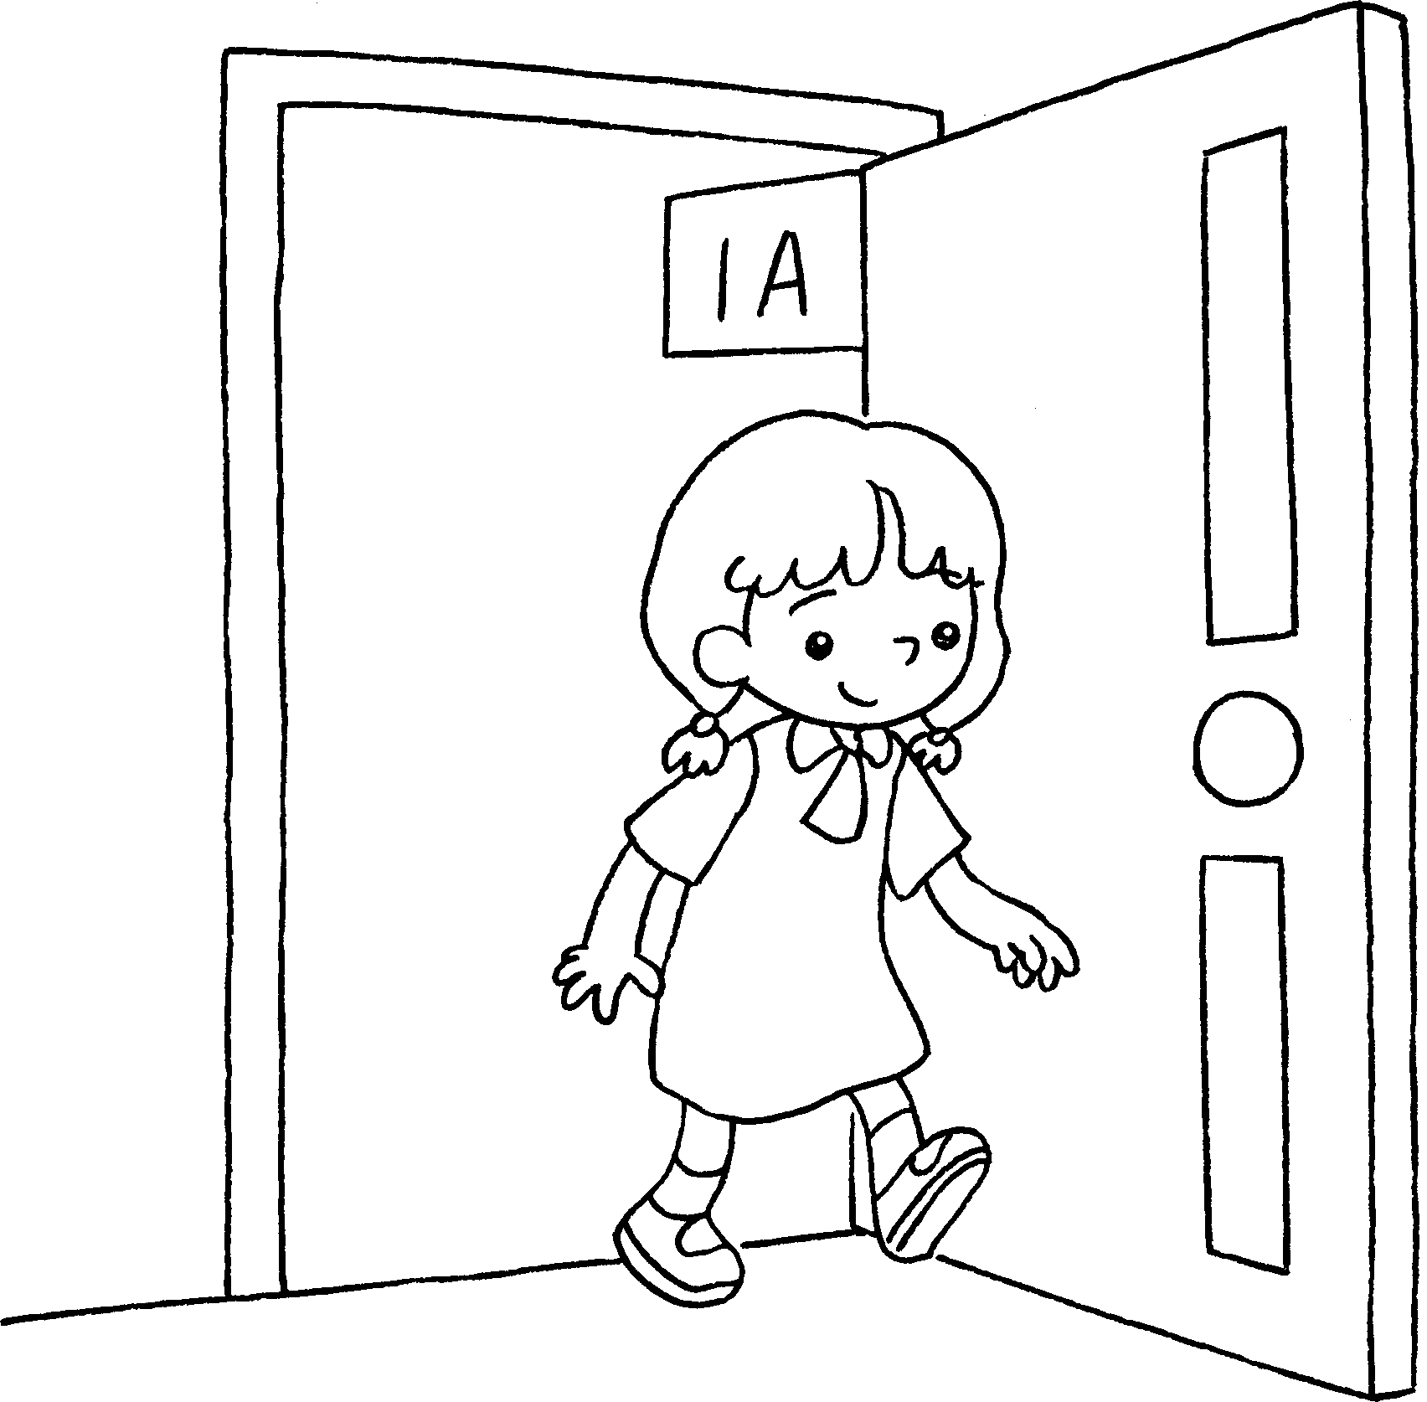
4 | Sit down, please.
 | A. B. C. | 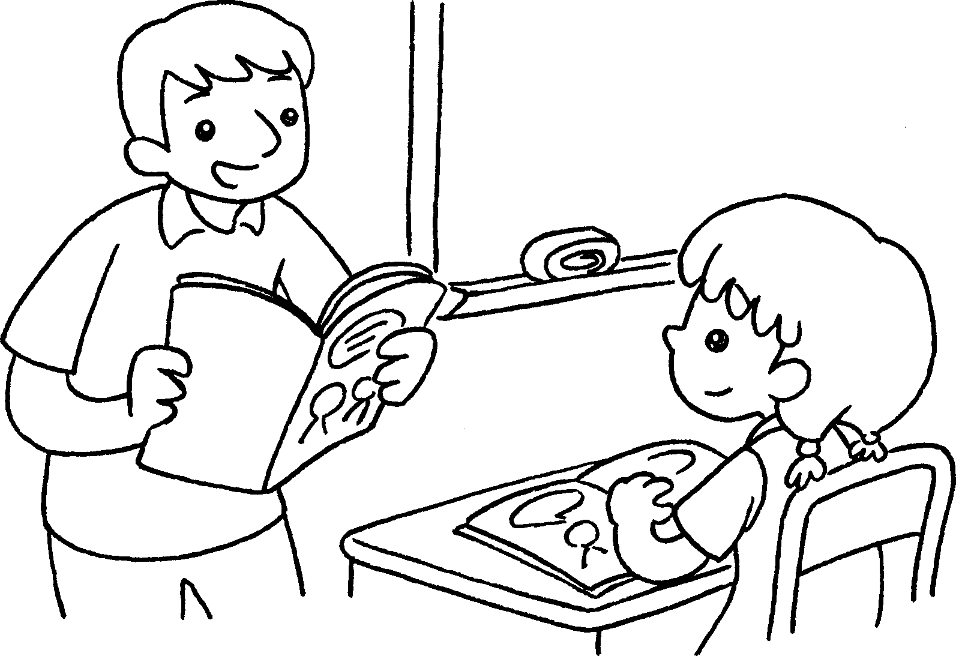


Book 1A Chapter 3 Graded Worksheets

Worksheet 2⬇
- C.
- B.
- A.
- C.

