Rearrange the words.
1 | please / , / Sit down / . /  Sit down, please. | 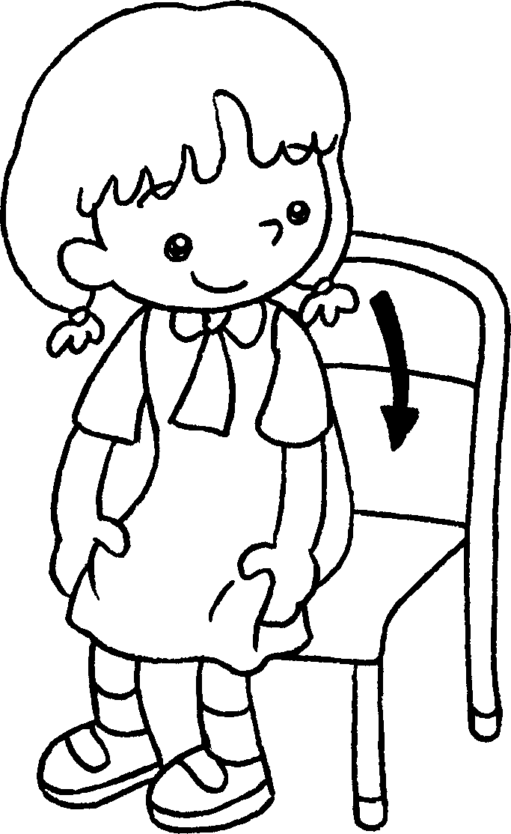
2 | the window / , / please / . / Open | 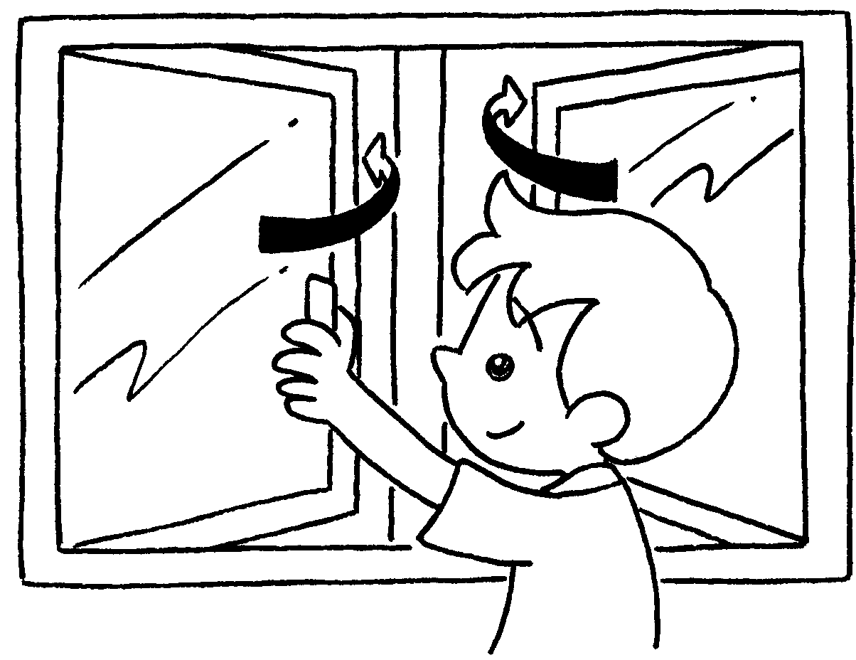
3 | Close / . / please / , / your books  ______________________________________ | 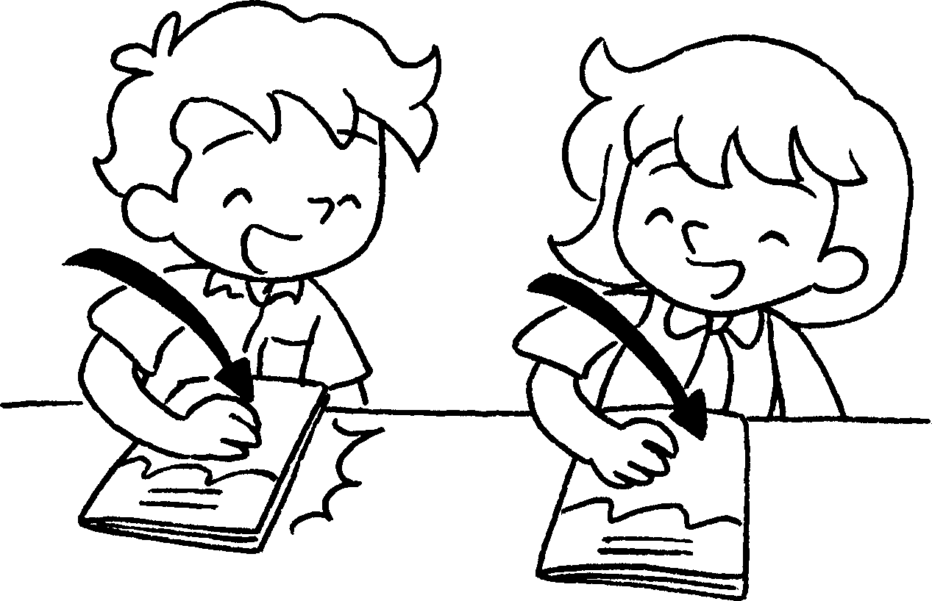
4 | please / . / , / Stand up  ______________________________________ | 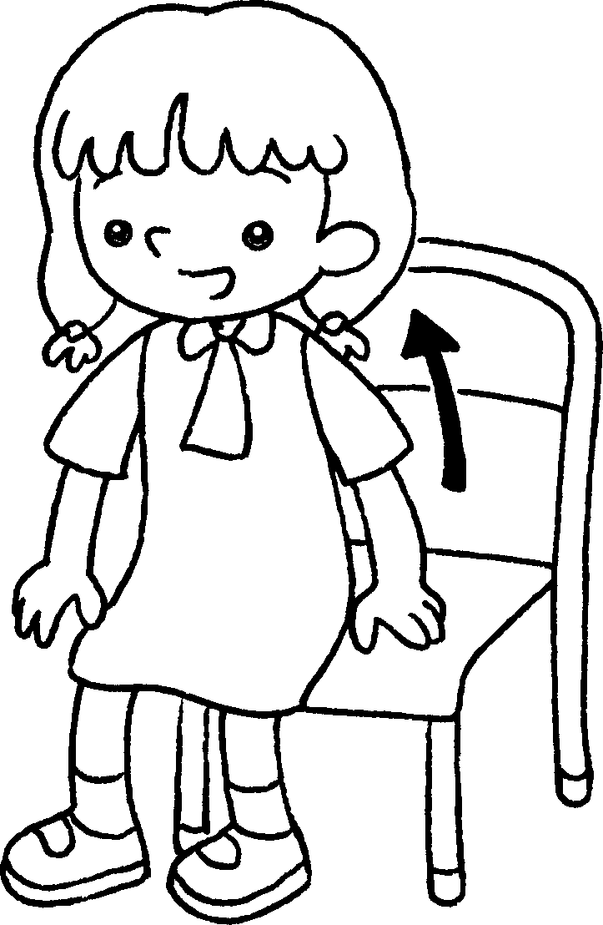
5 | the door / , / please / . / Close  ______________________________________ | 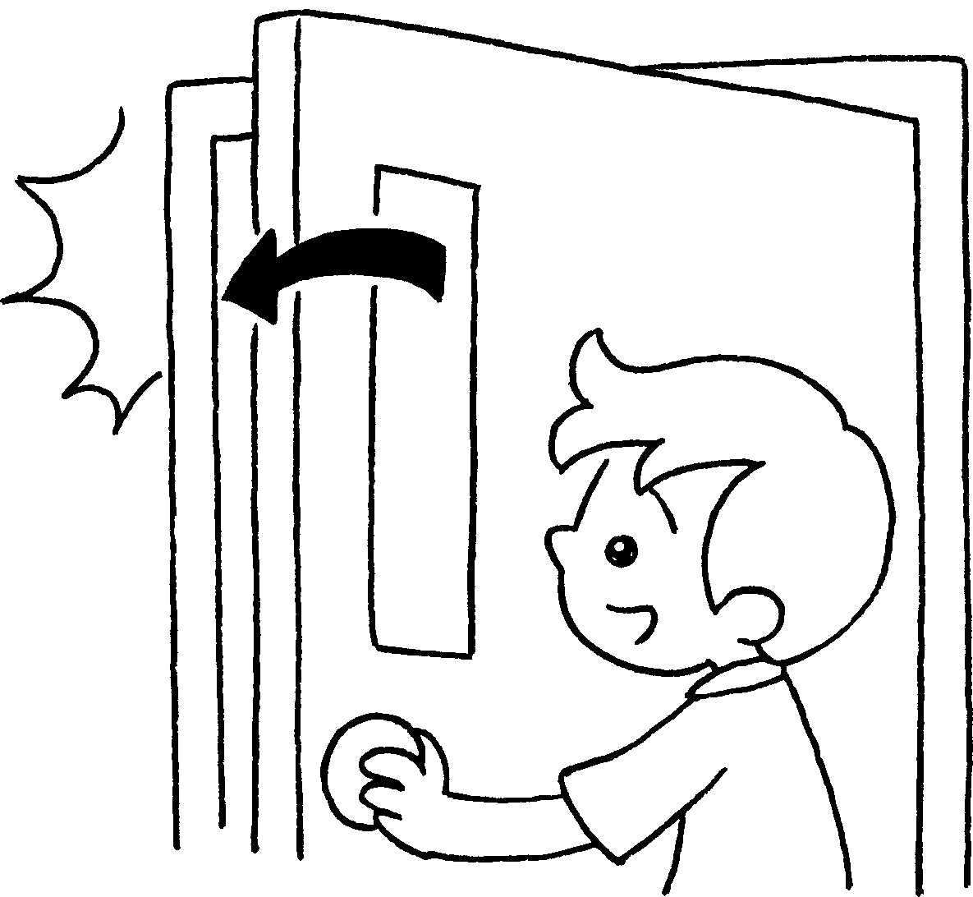


Book 1A Chapter 3 Graded Worksheets

Worksheet 2⬇⬇
- Open the window, please.
- Close your books, please.
- Stand up, please.
- Close the door, please.

