What is the teacher saying? Write.

Sit down Stand up Open Close

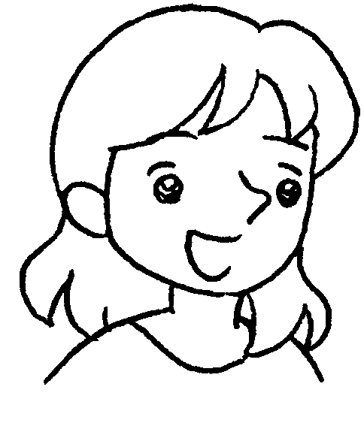

1 | _______________ , please. | 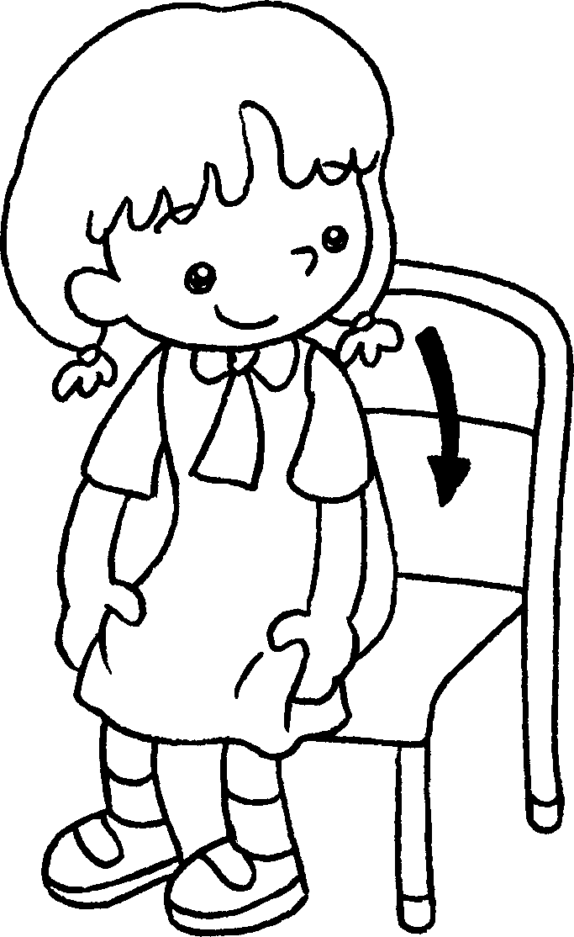
2 | the window, please. | 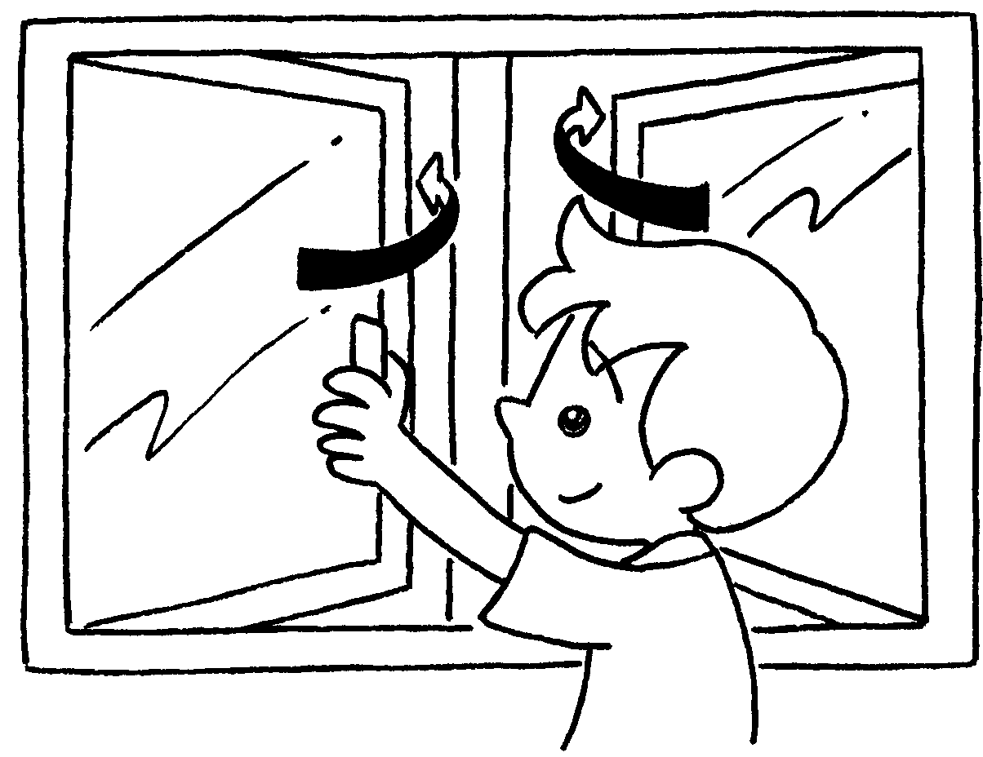
3 | _______________ your _________ , please. | 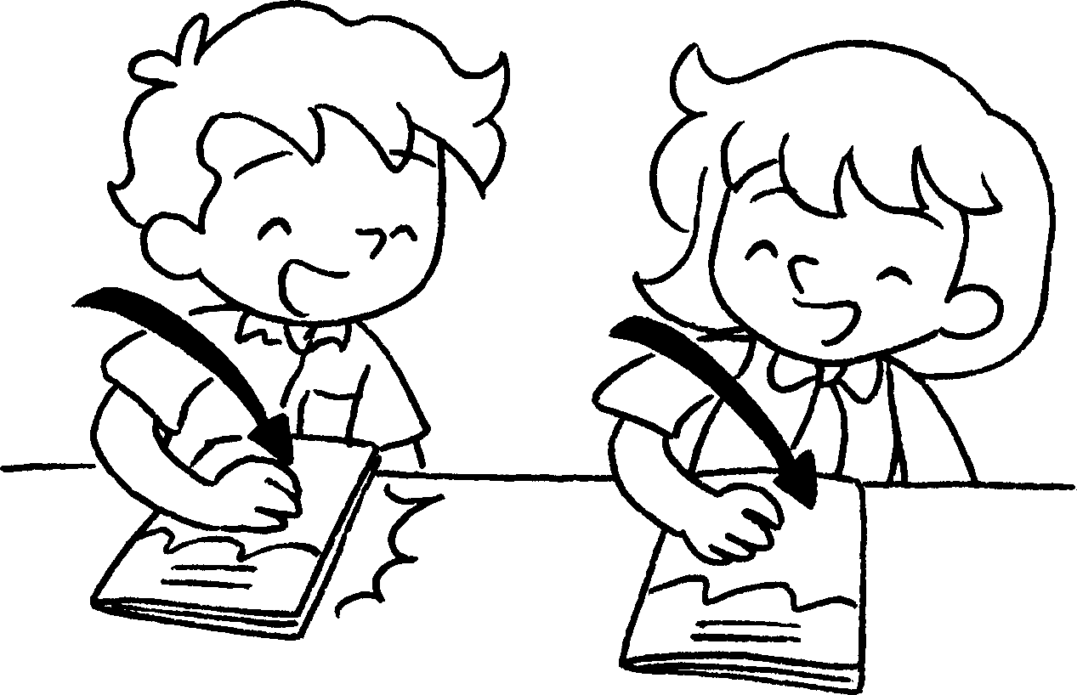
4 | ______________________________________ | 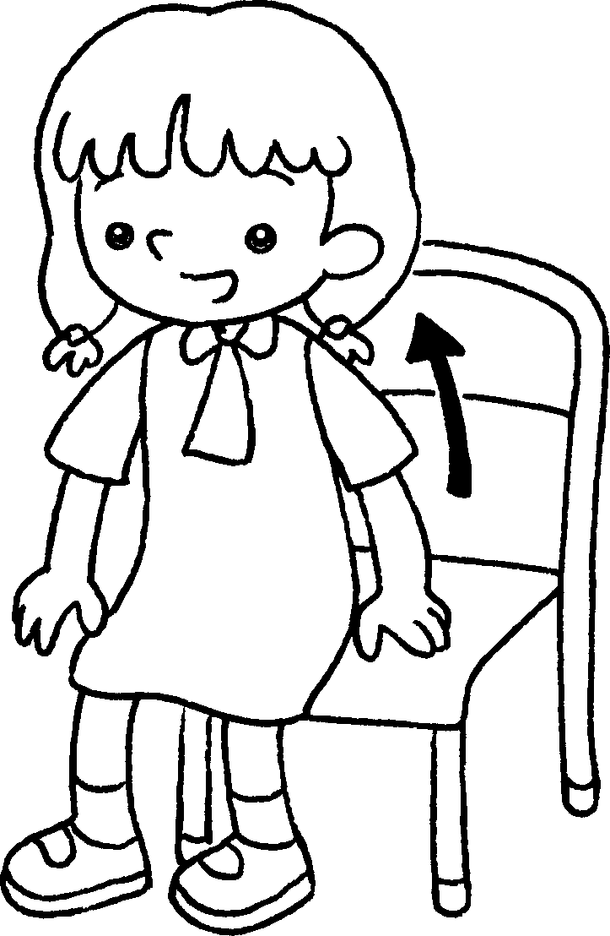
5 | ______________________________________ | 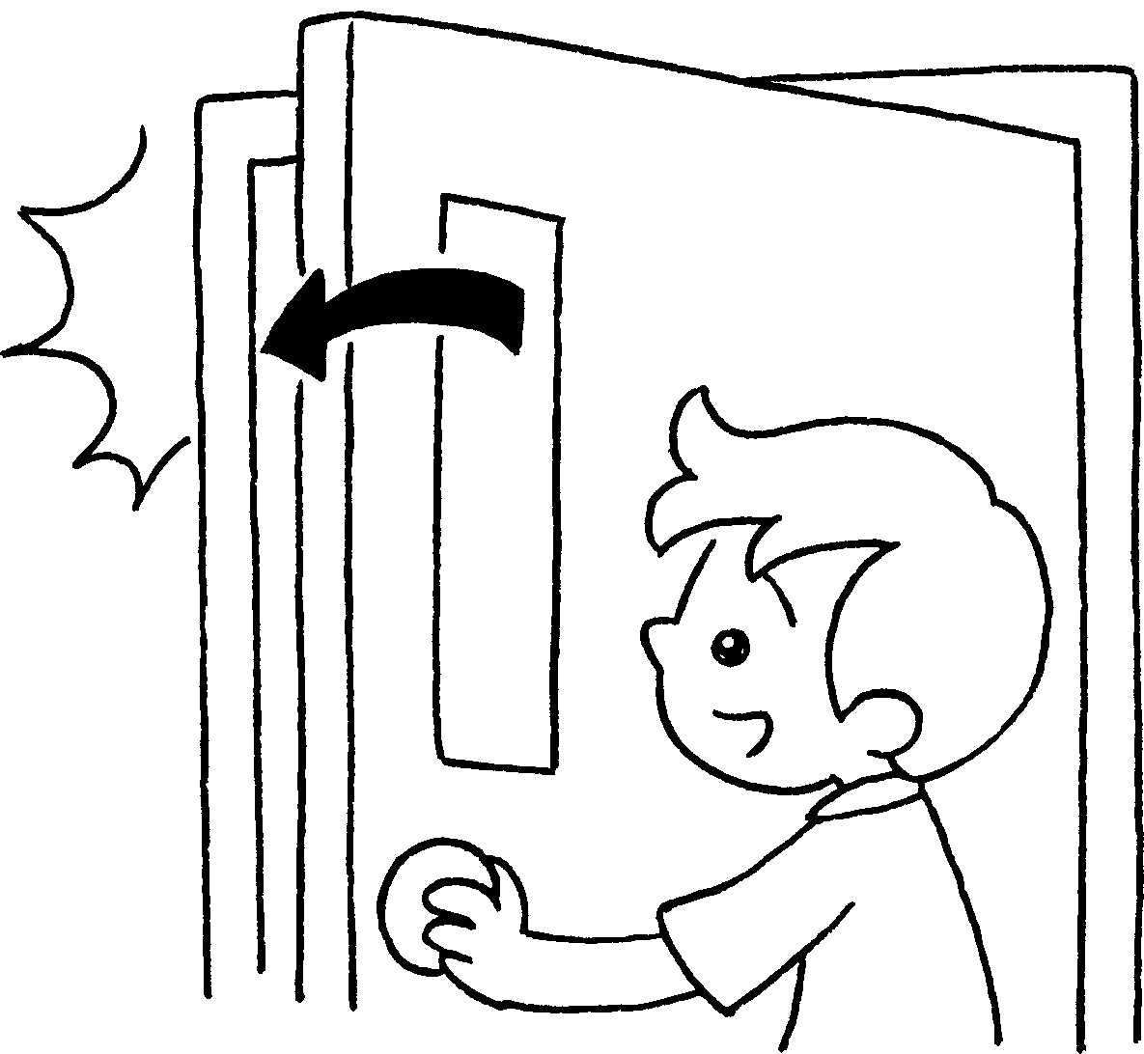


Book 1A Chapter 3 Graded Worksheets

Worksheet 2⬇⬇⬇
- Sit down
- Open
- Close books
- Stand up, please.
- Close the door, please.

