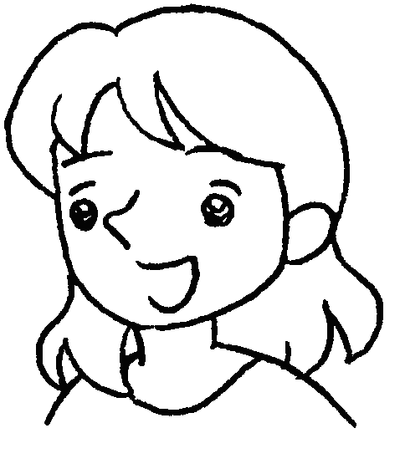
What is the teacher saying? Tick ( ✓ ) the correct boxes.

1 | 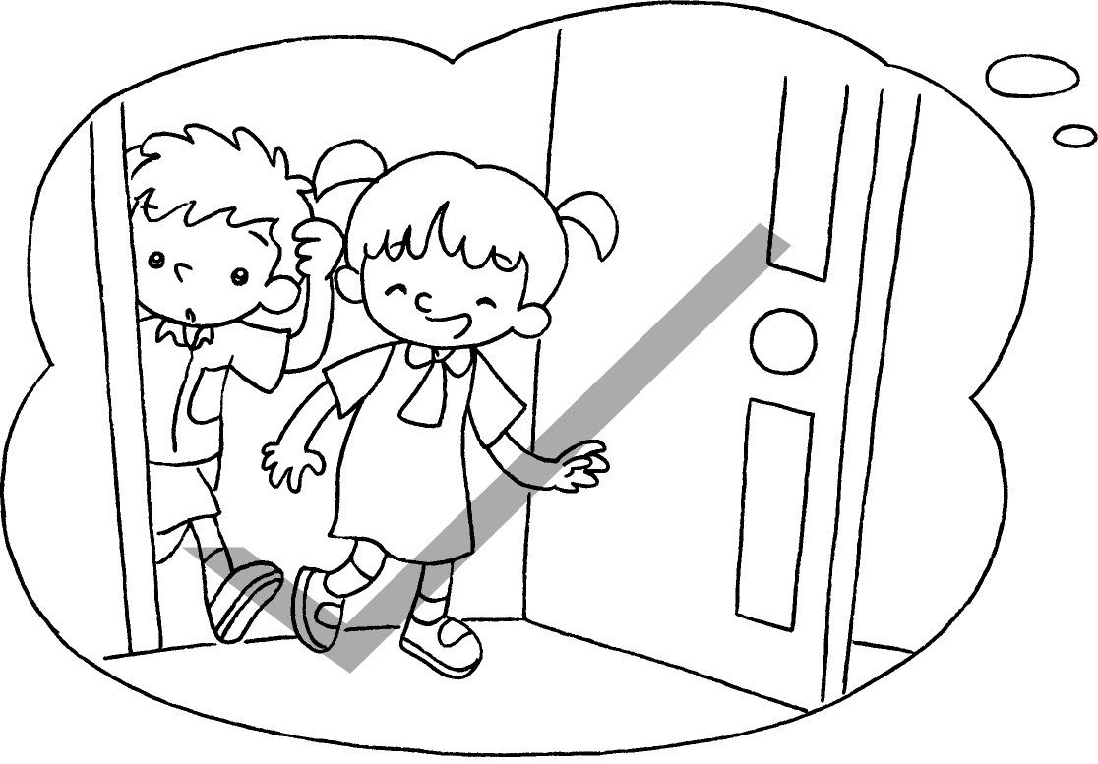 |  Come in, please.  Don’t come in.
2 | 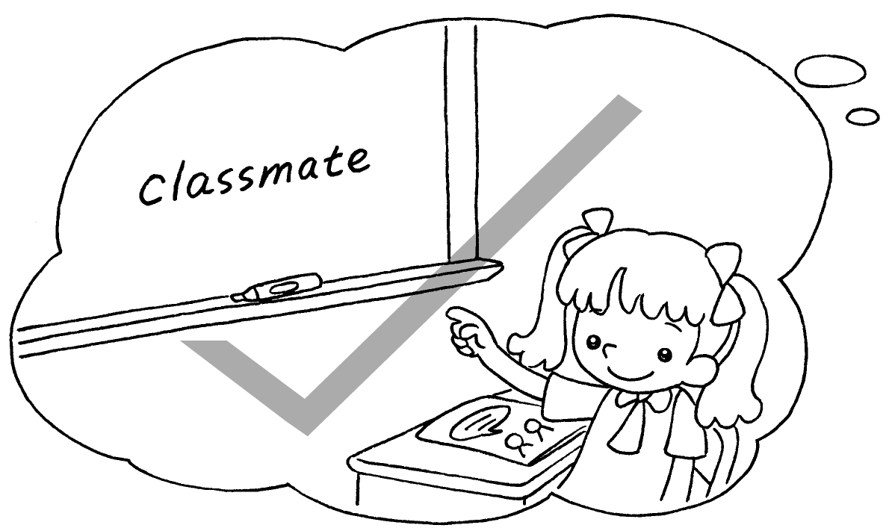 | Don’t point to the whiteboard.  Point to the whiteboard, please.
3 | 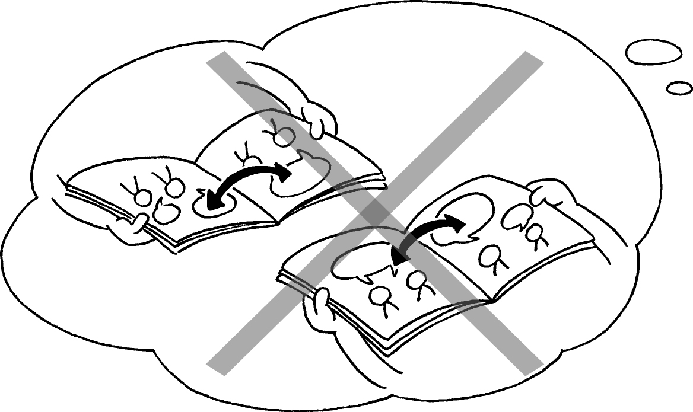 | Open your books, please.  Don’t open the door.  Don’t open your books.
4 | 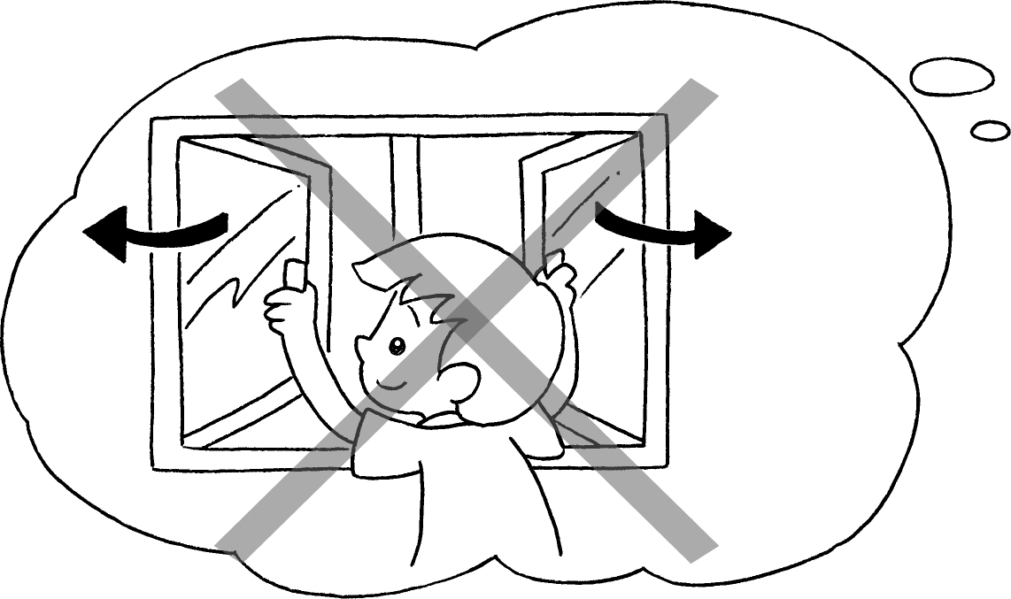 | Don’t close the window.  Close the window, please.  Don’t close the door.
5 | 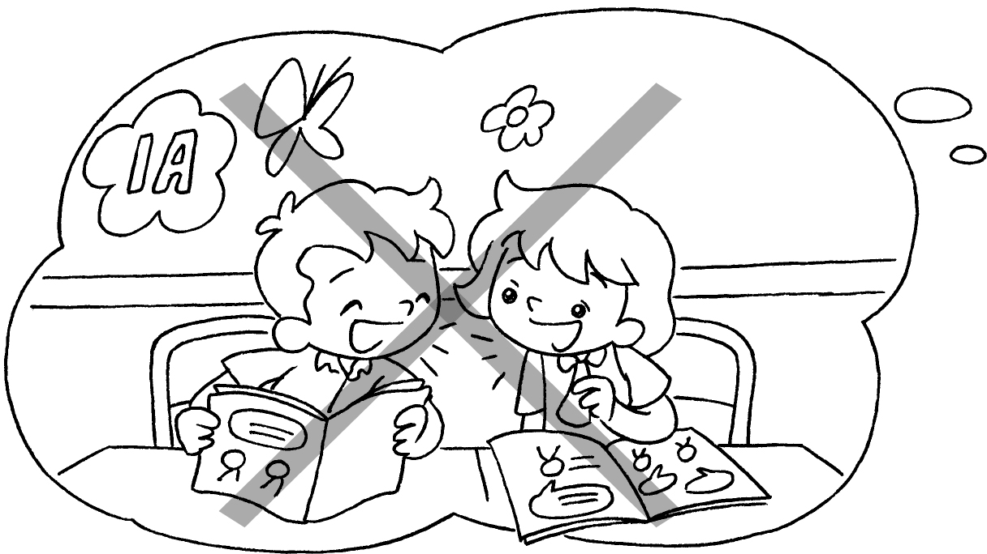 | Sit down, please.  Don’t open your books.  Don’t talk in class.


Book 1A Chapter 3 Graded Worksheets

Worksheet 3⬇⬇
1  Come in, please.
Don’t come in.
- Don’t point to the whiteboard.
 Point to the whiteboard, please.
- Open your books, please.
Don’t open the door.
  - Don’t open your books.
4  Don’t close the window.
Close the window, please.
Don’t close the door.
5 Sit down, please.
Don’t open your books.
  - Don’t talk in class.

