What is the teacher saying? Choose and write.

Don’t
come in point to
open close talk
please

1 | 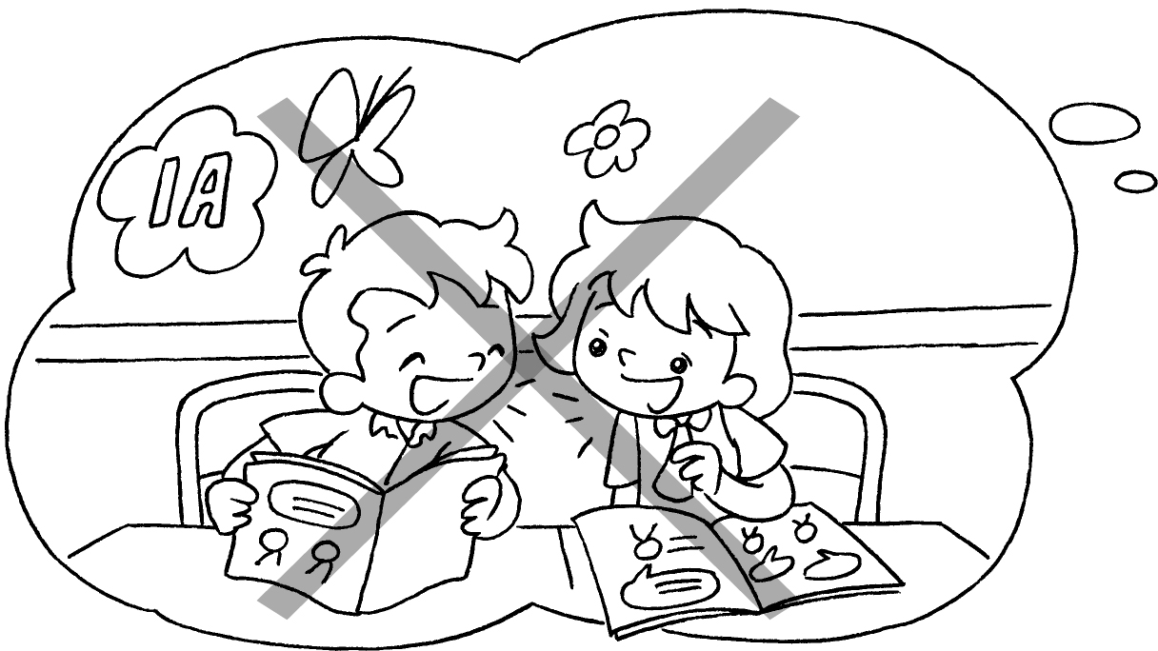 | Don’t __________ in class.
2 | 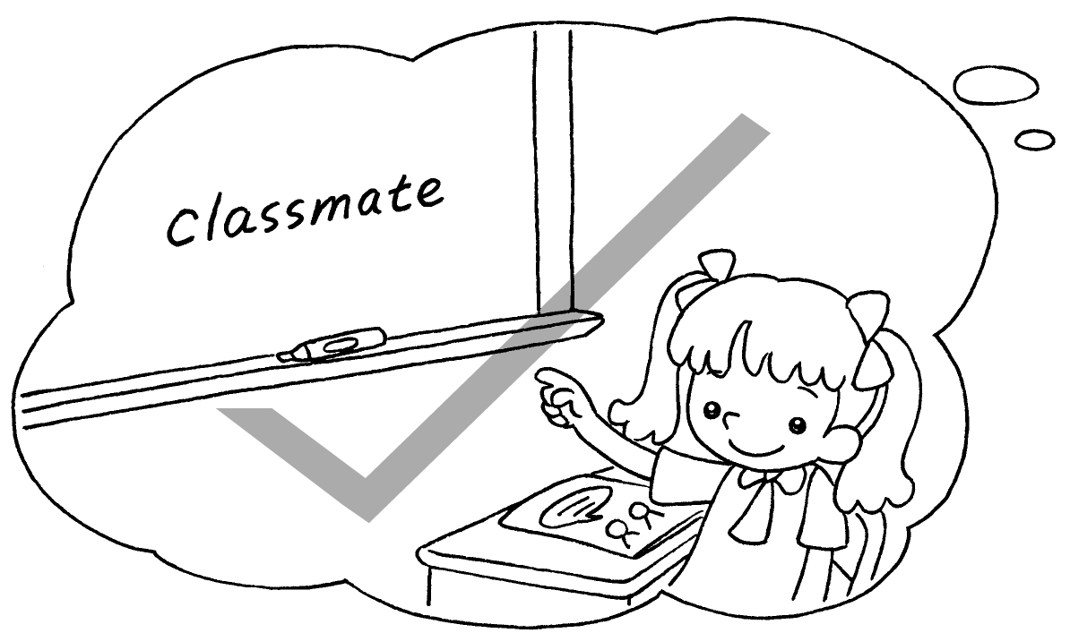 | ____________ the whiteboard, please.
3 | 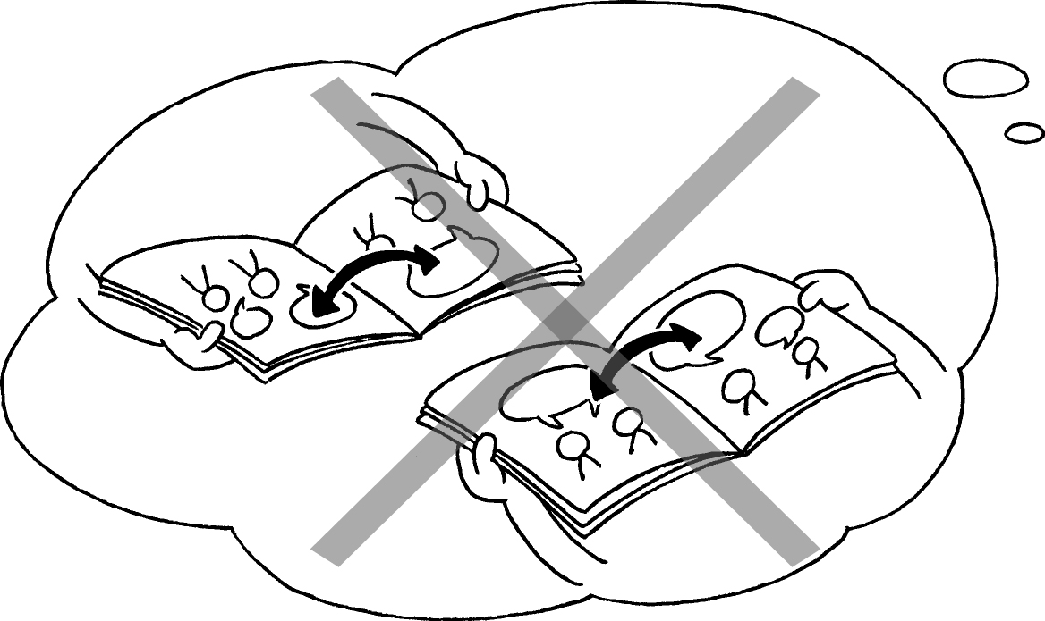 | _____________________ your books.
4 | 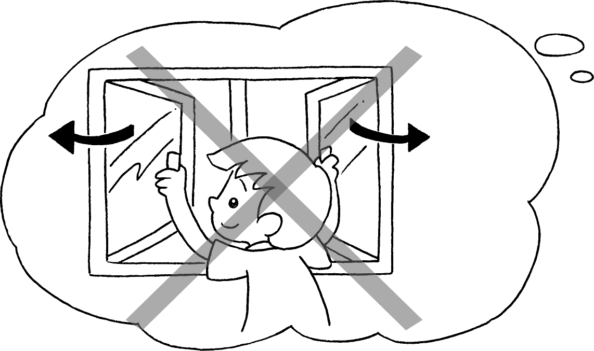 | ________________________________
5 | 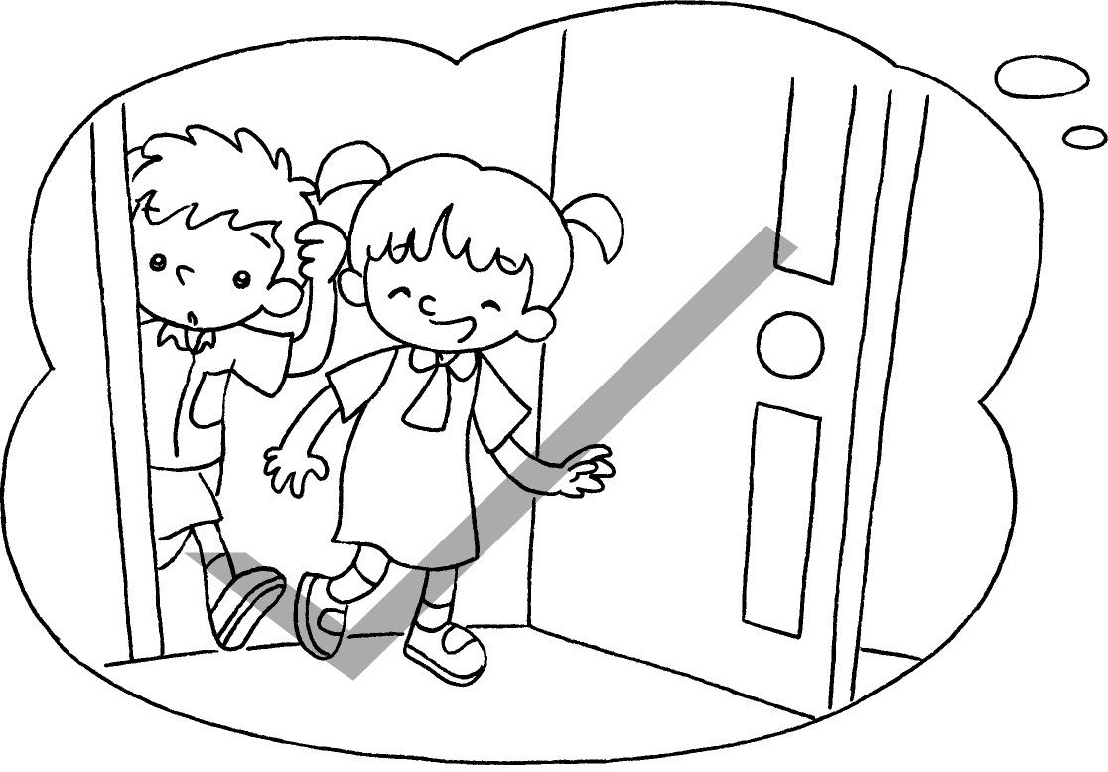 | ________________________________


Book 1A Chapter 3 Graded Worksheets

Worksheet 3⬇⬇⬇
- talk
2 Point to
3 Don’t open
4 Don’t close the window.
5 Come in, please.

