Choose and write.
bookeraserpenpencilpencil caserulerschool bag

1 | 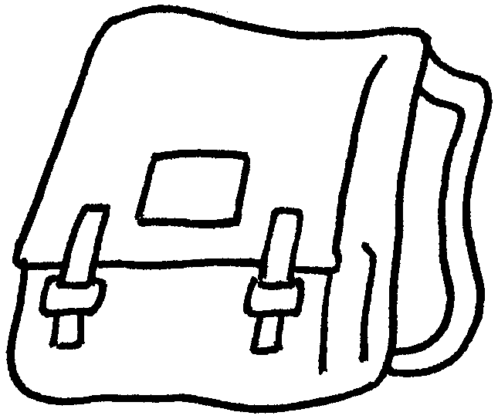  a |  |  |  | 2 | 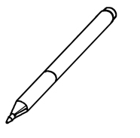  a
3 | 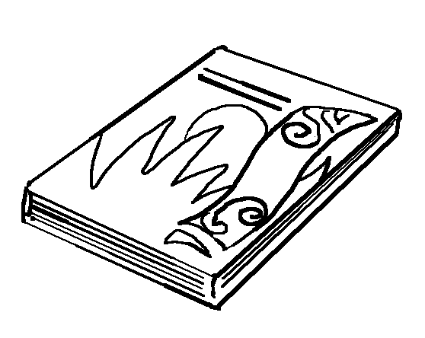  a |  |  |  | 4 | 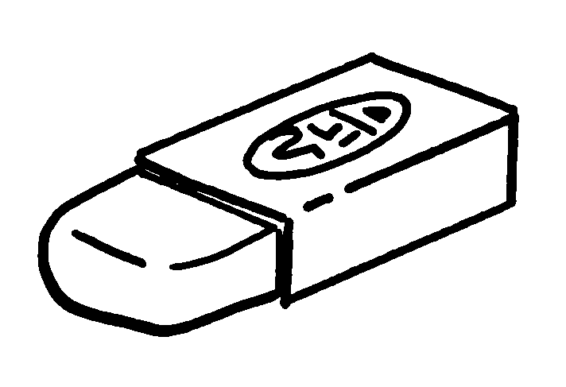  an
5 | 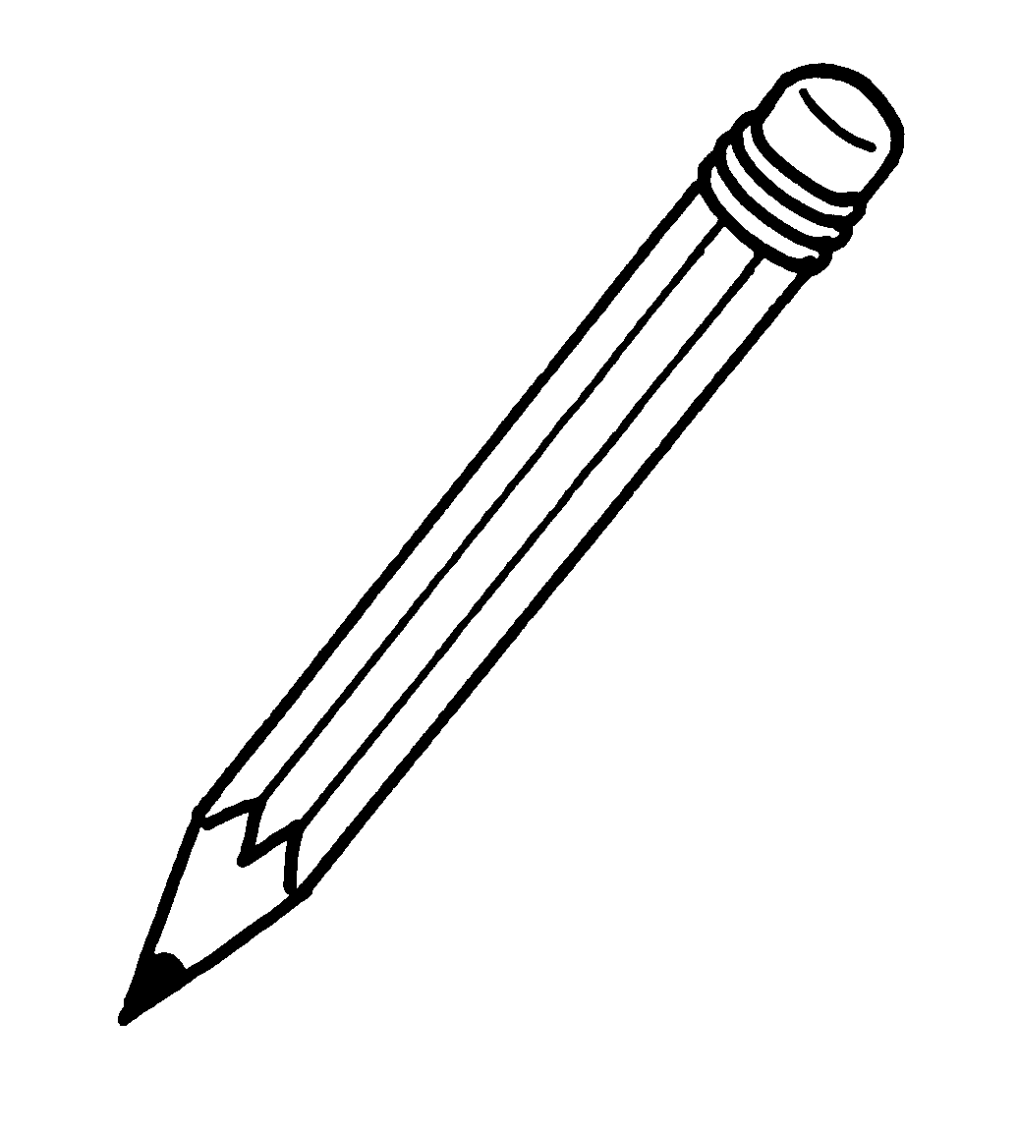  a |  |  |  | 6 | 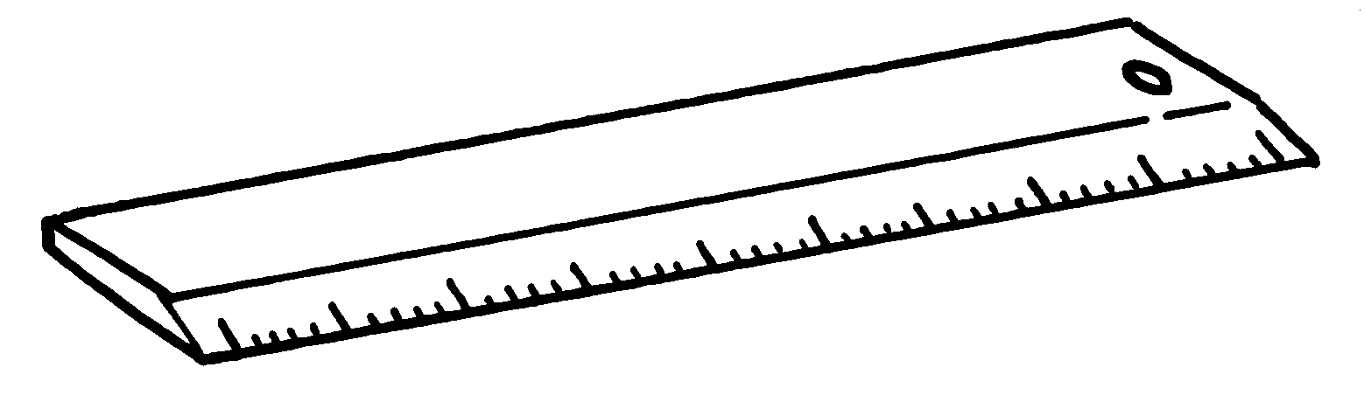  a
 |  | 7 | 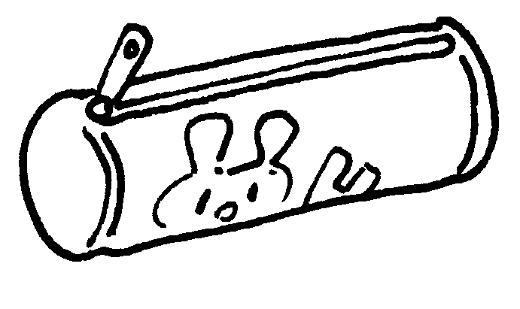  a


Book 1A Chapter 4 Graded Worksheets
Worksheet 1⬇
- school bag
- pen
- book
- eraser
- pencil
- ruler
- pencil case

