Fill in the missing letters.

1 | 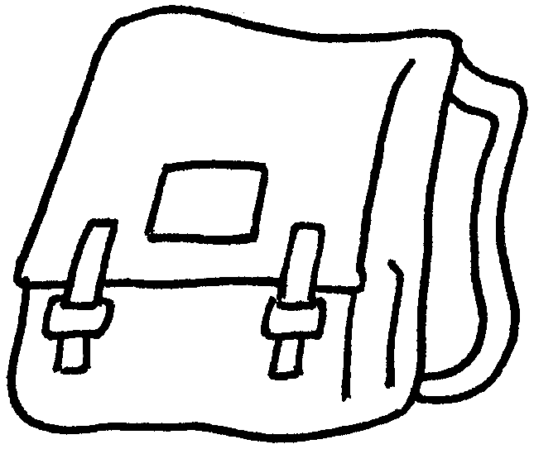  a s __ __ __ __ __ b __ __ |  |  |  |  |  | 2 |  |  | 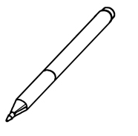  a p __ __
3 | 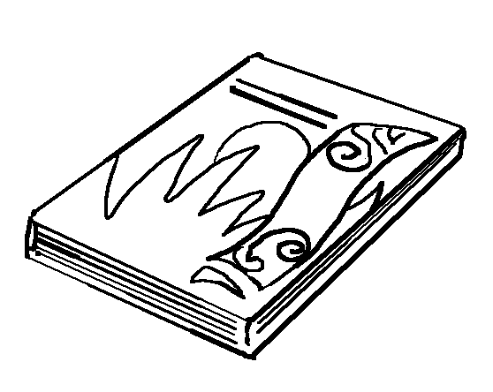  a b __ __ __ |  |  |  |  |  |  | 4 |  |  | 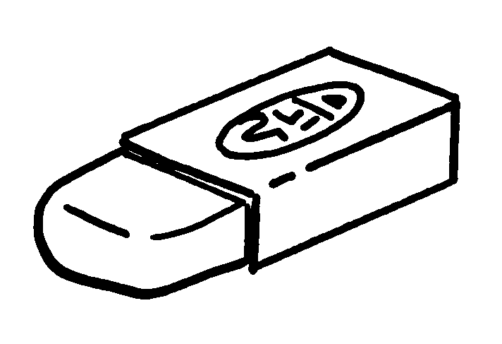  an e __ __ __ __ __
5 |   a p __ __ __ __ __ |  |  |  |  | 6 |  |  | 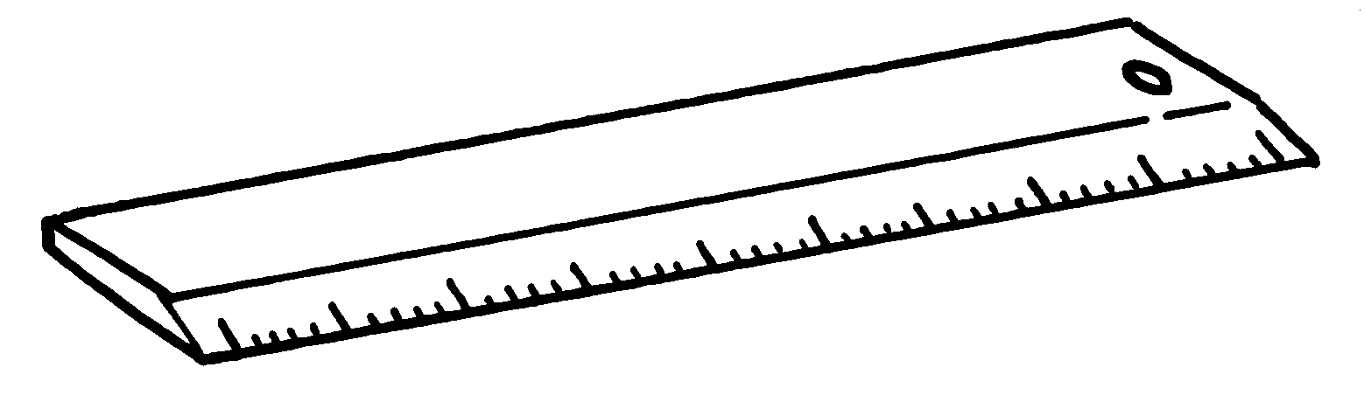  a r __ __ __ __
 |  | 7 | 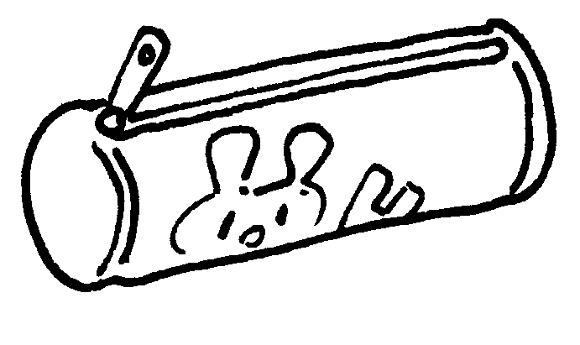  a p __ __ __ __ __ c __ __ __



Book 1A Chapter 4 Graded Worksheets
Worksheet 1B⬇⬇
- s c h o o l b a g
- p e n
- b o o k
- e r a s e r
- p e n c i l
- r u l e r
- p e n c i l c a s e

