What are they? Write.

1 | 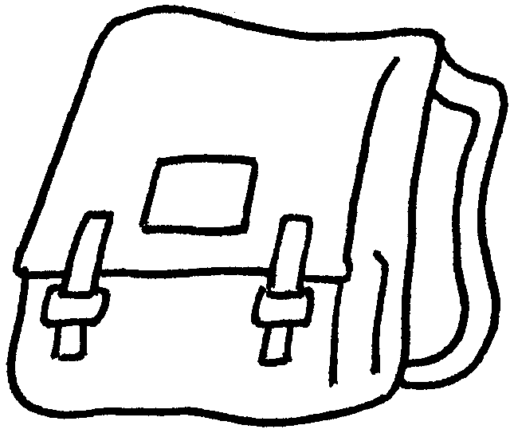  a s b |  |  |  | 2 | 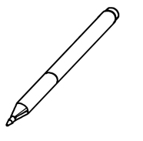  a p
3 | 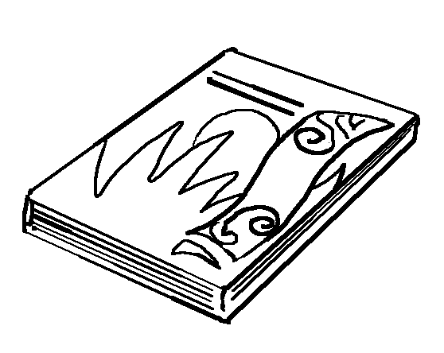  a b |  |  |  | 4 | 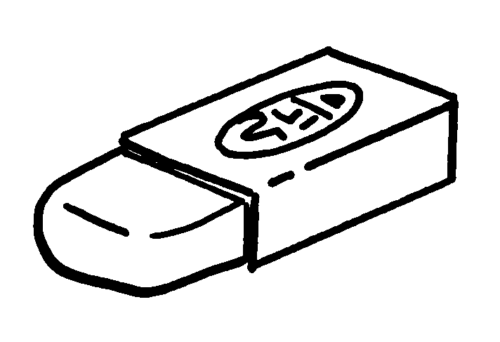  ____ _______________
5 | 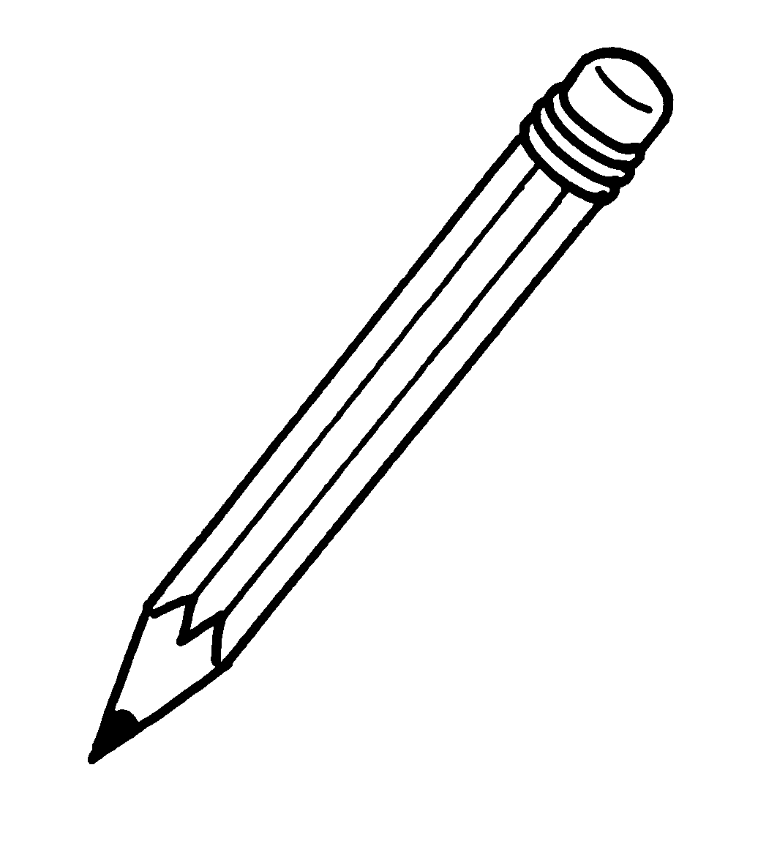  ____ ___________________ |  |  |  | 6 | 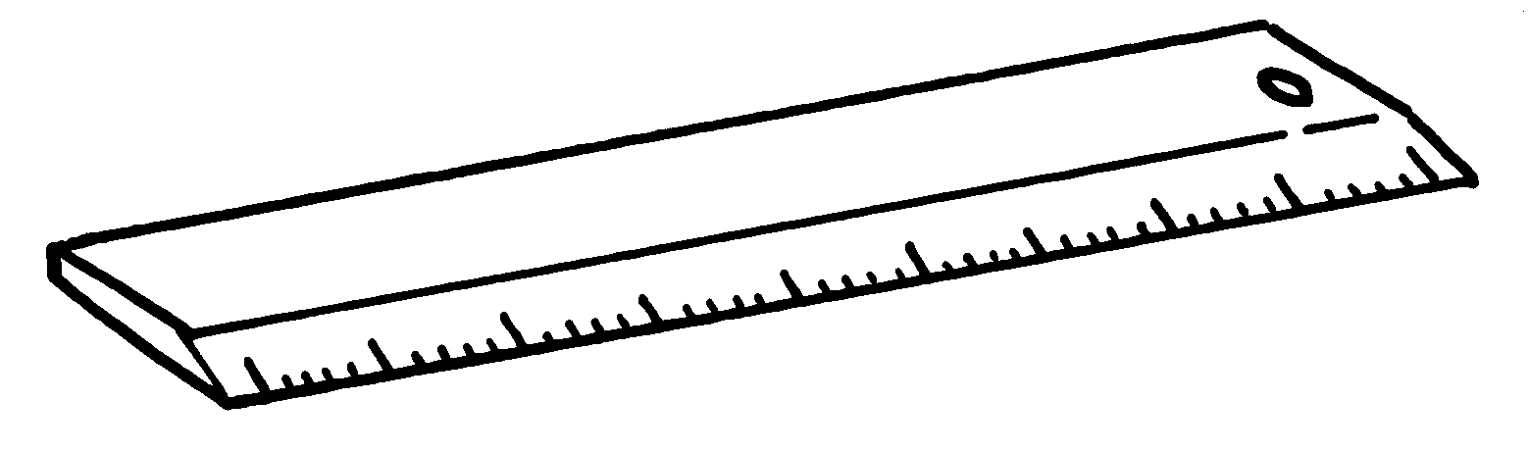  ____ _______________
 |  | 7 | 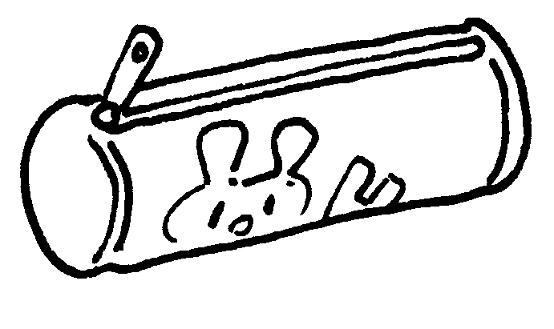  ____ ________________ __________



Book 1A Chapter 4 Graded Worksheets
Worksheet 1⬇⬇⬇
- school bag
- pen
- book
- an eraser
- a pencil
- a ruler
- a pencil case

