Choose and write.

has have
1 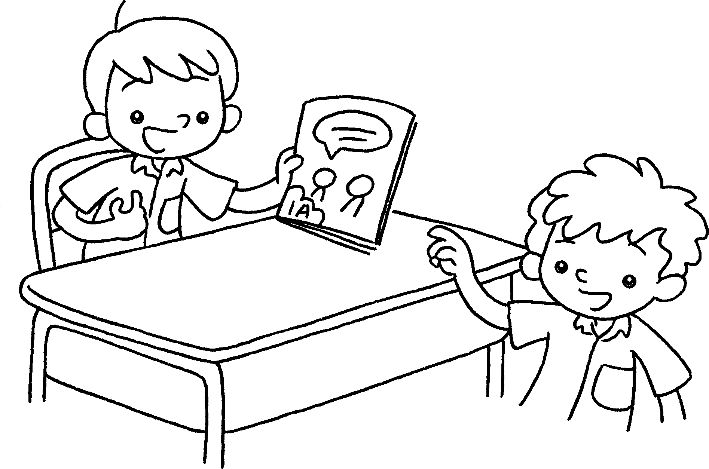 | This is Sam.  He one book.
2 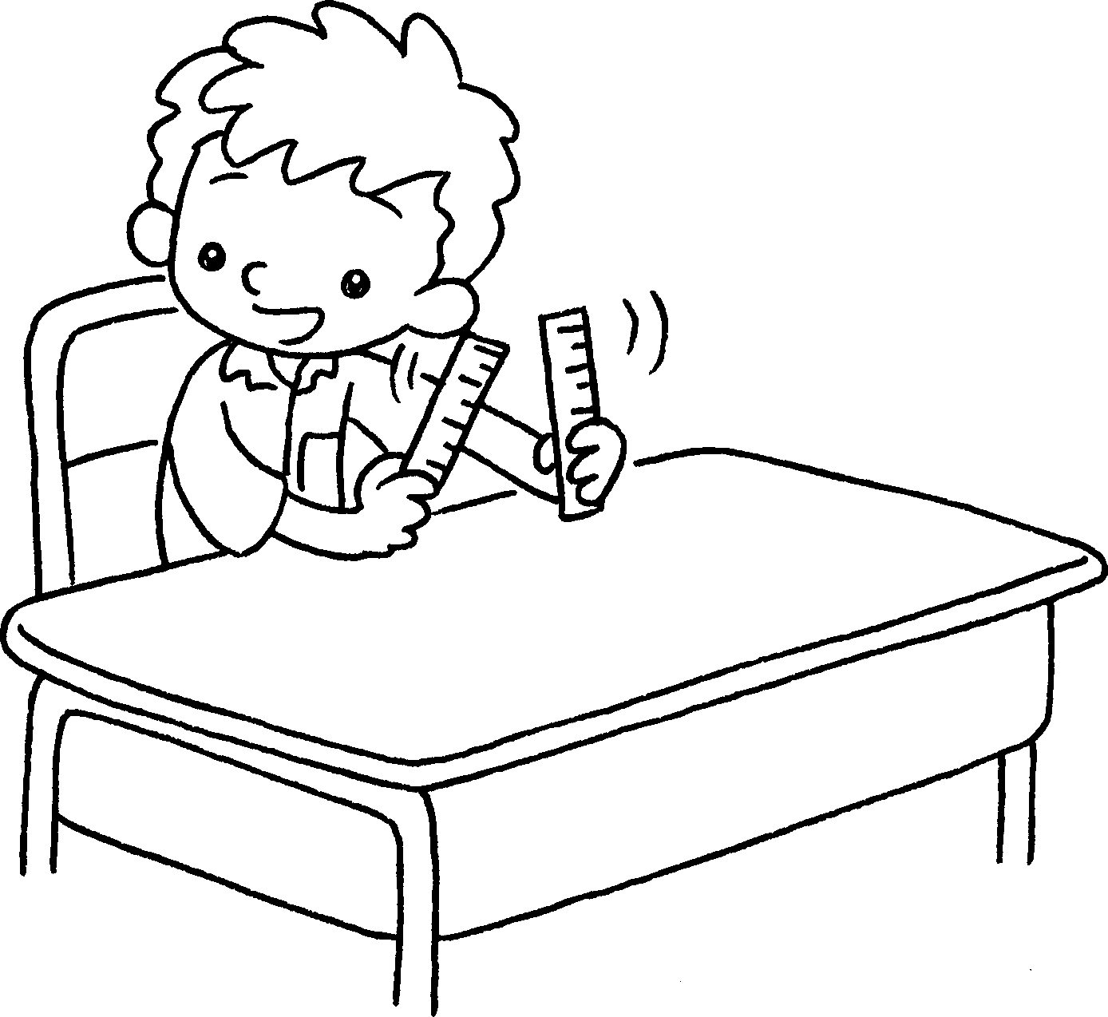  …  …  … | I two rulers.
3 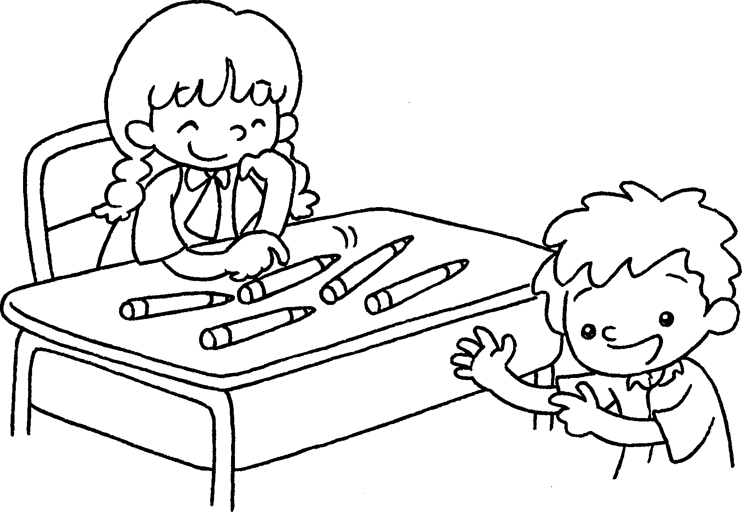 | This is Mandy.  She five pencils.
4 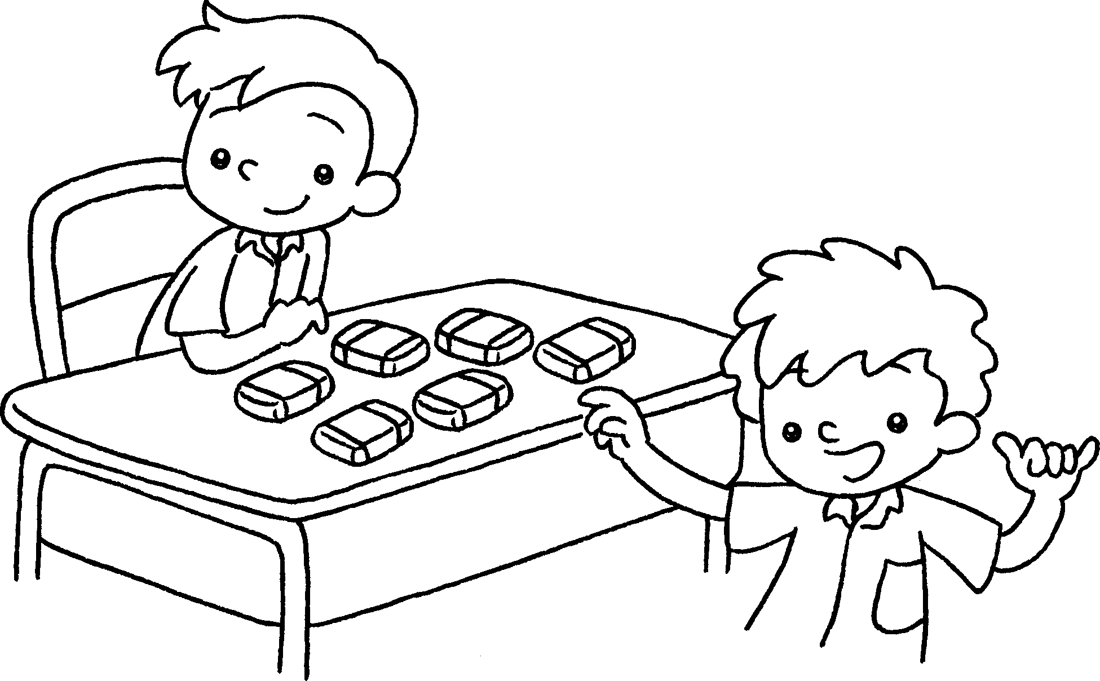  … | This is Peter.  He six erasers.



Book 1A Chapter 4 Graded Worksheets
Worksheet 3⬇
1 has
2 have
3 has
4 has

