Choose and write.

I / He / She have / has
1 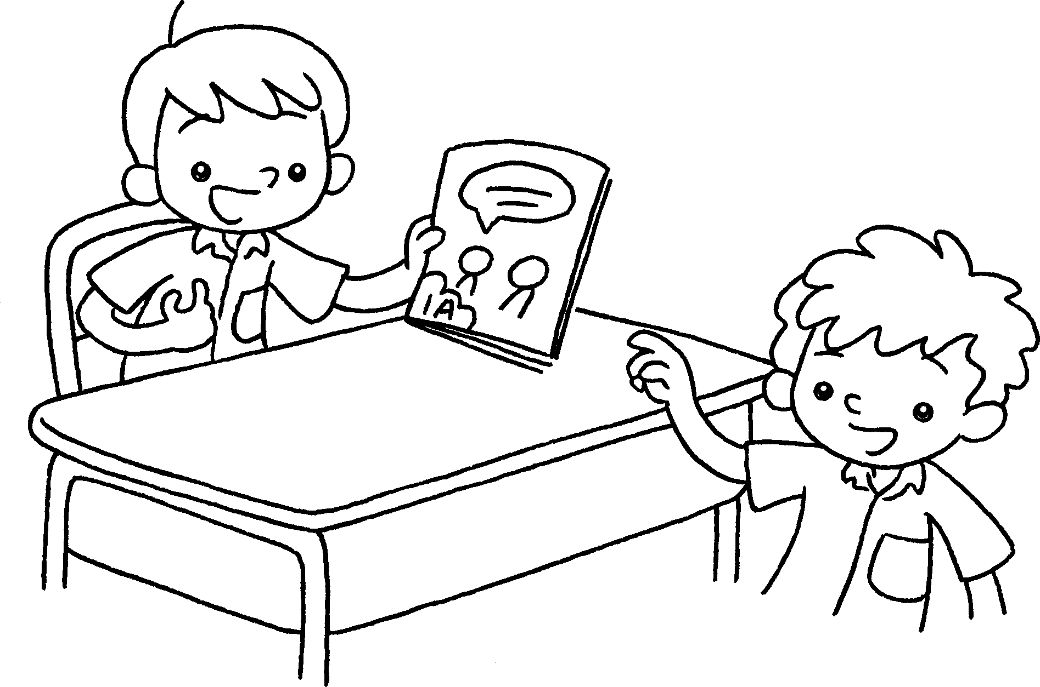 | This is Sam.  He one book.
2 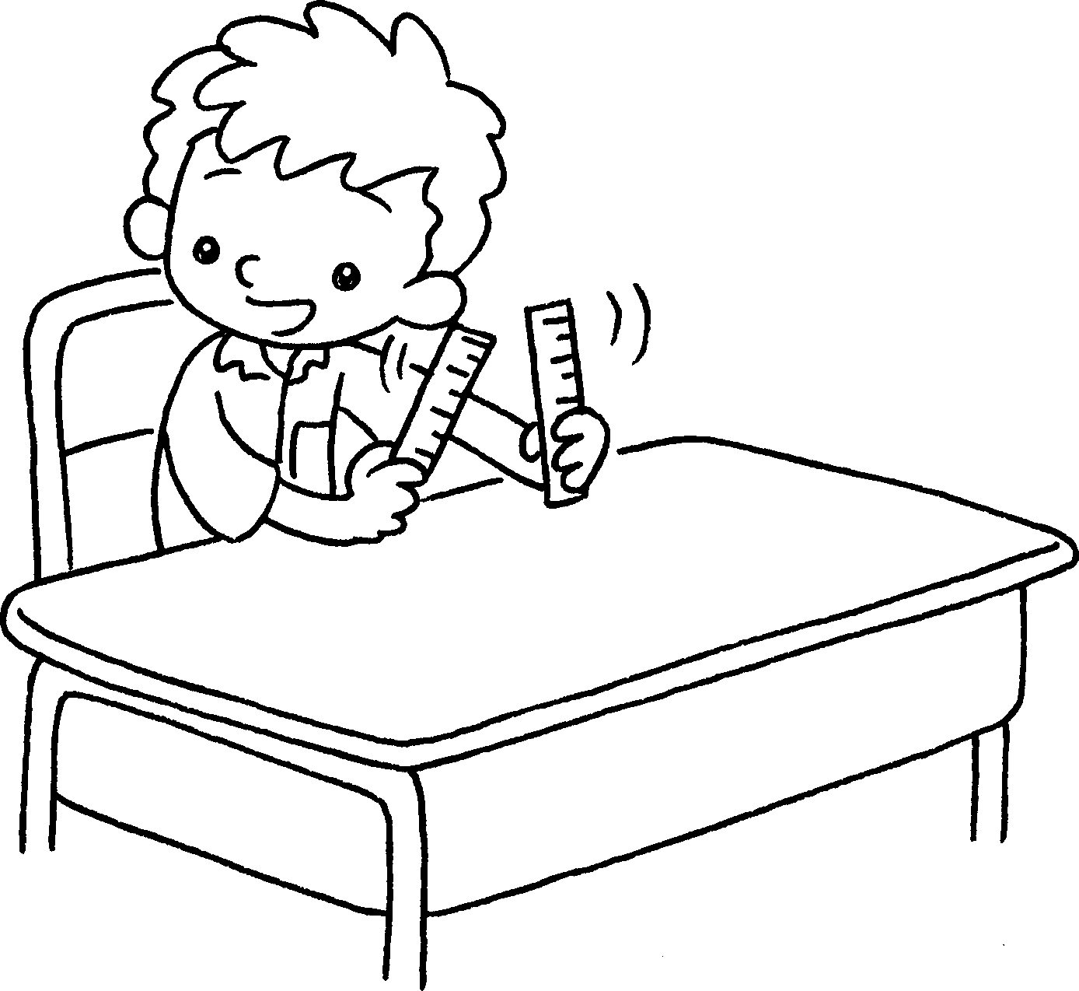  …  …  … | two rulers.
3 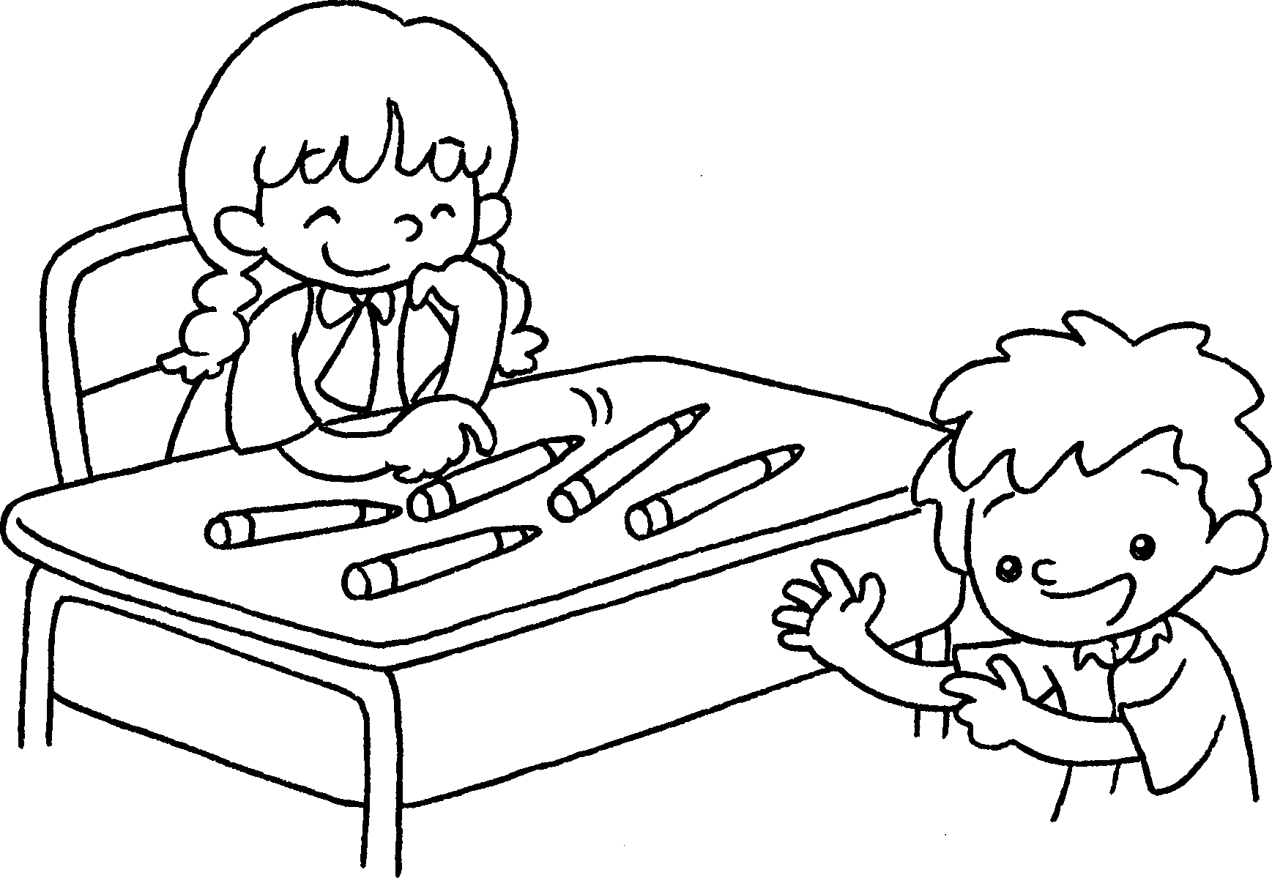 | This is Mandy.  five pencils.
4 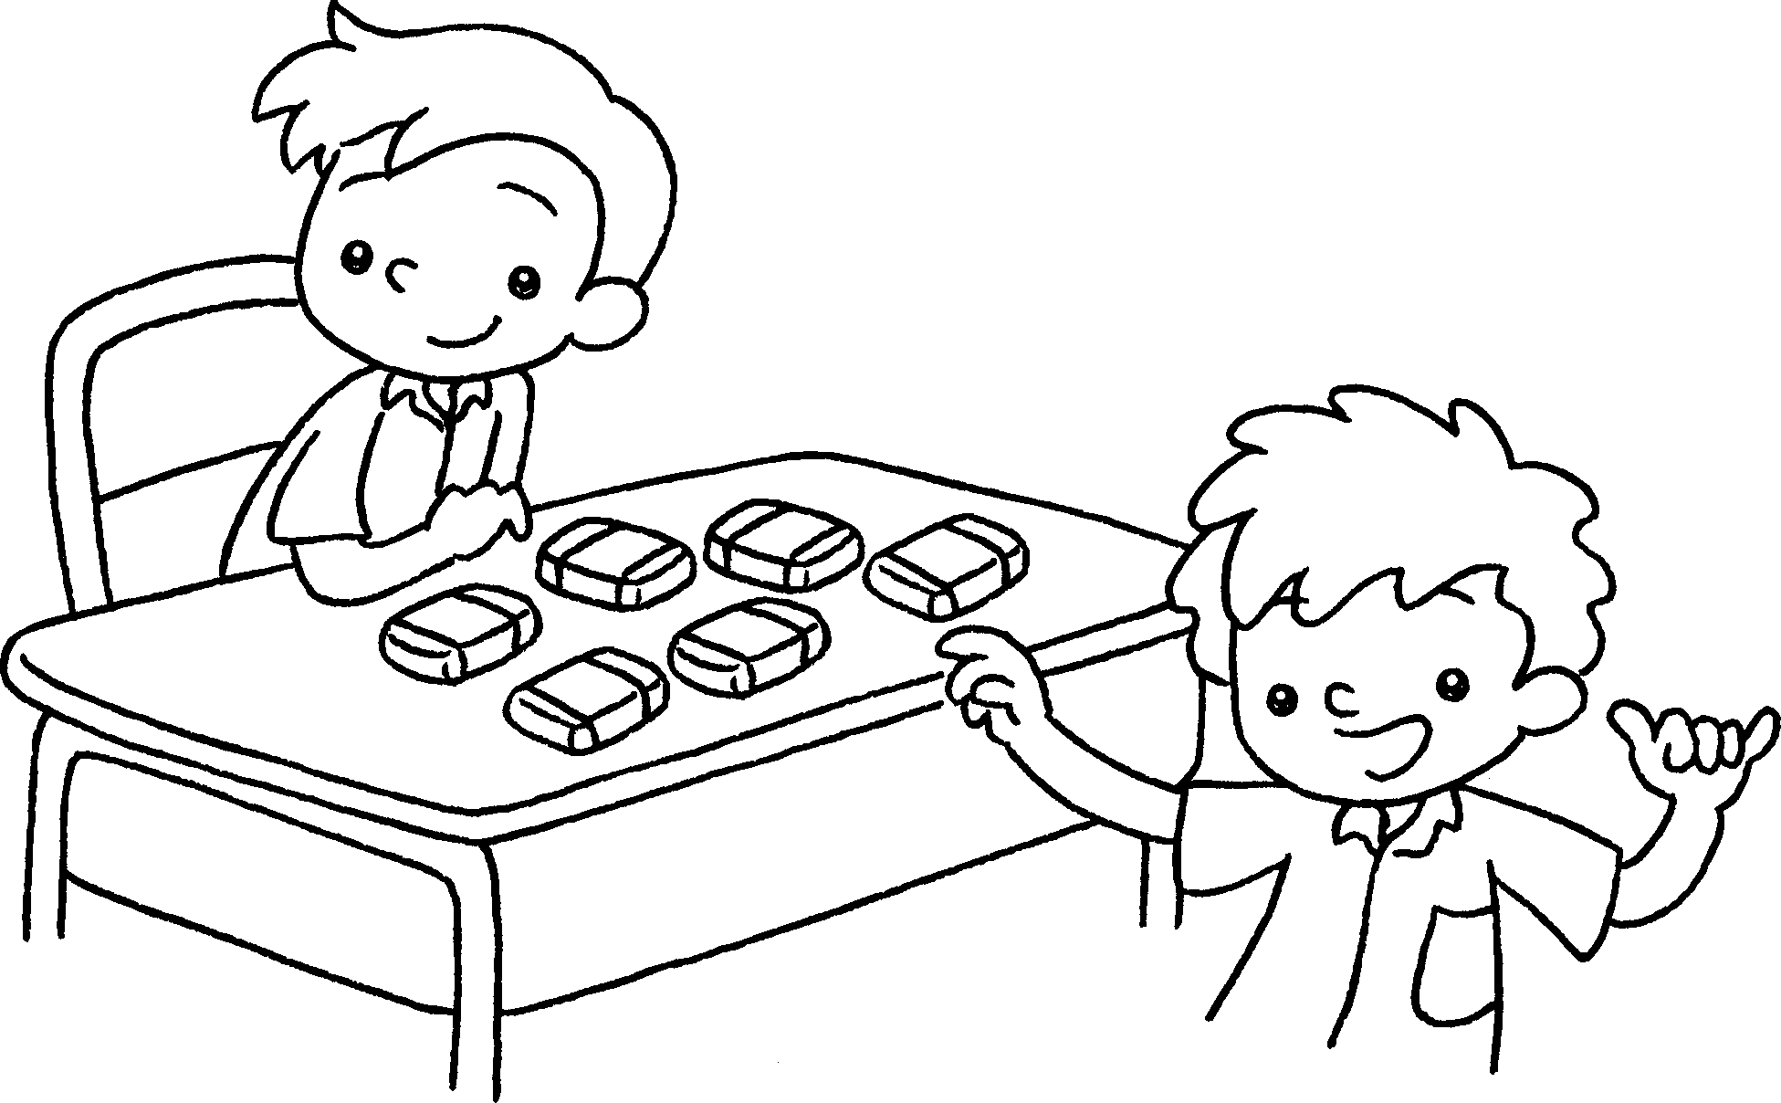  … | This is Peter.  six erasers.



Book 1A Chapter 4 Graded Worksheets
Worksheet 3⬇⬇
1 has
2 I have
3 She has
4 He has

