Choose and write.

has have
1 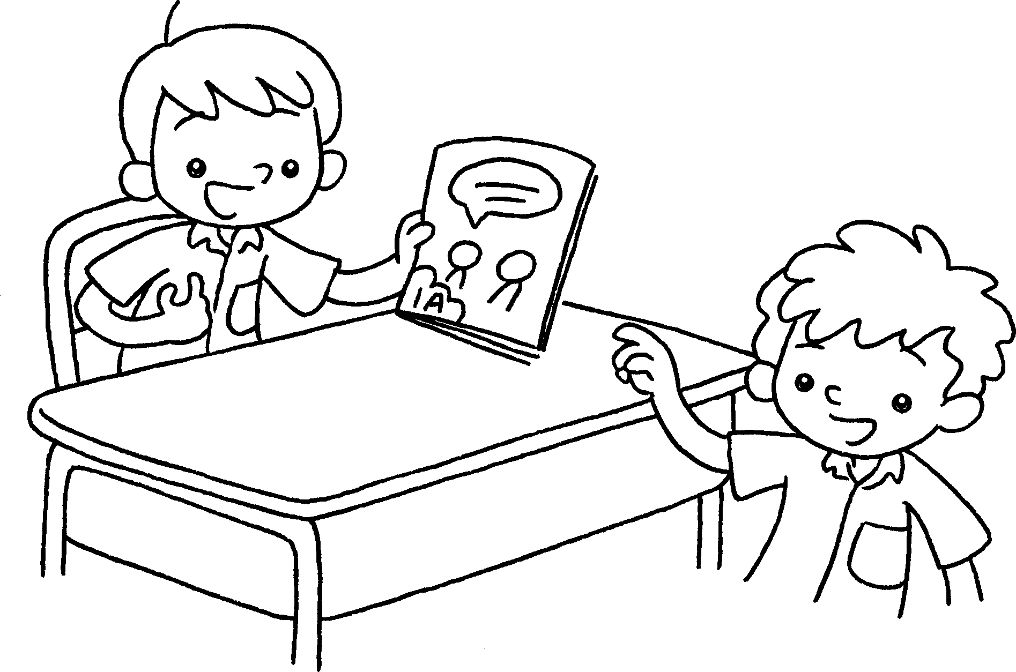 | This is Sam.  He one book.
2 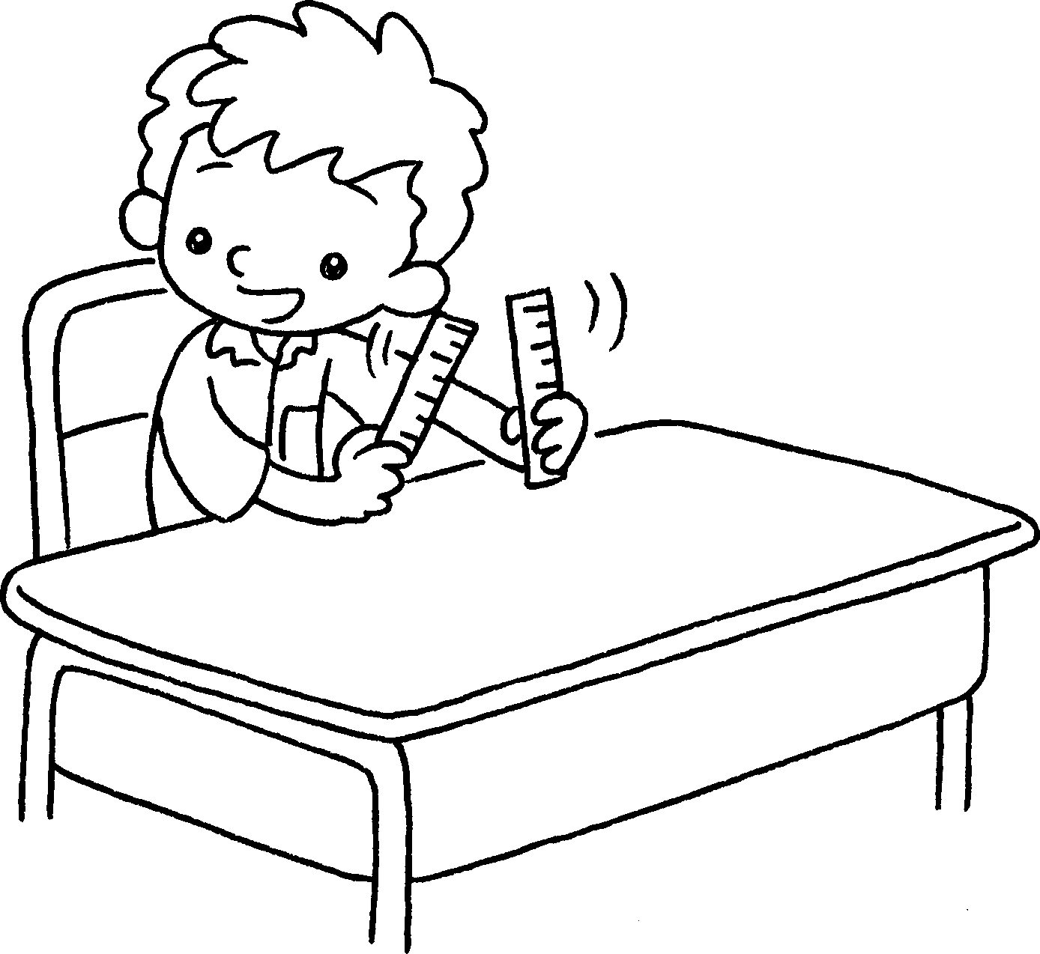  …  …  … | ______ ________ two rulers.
3 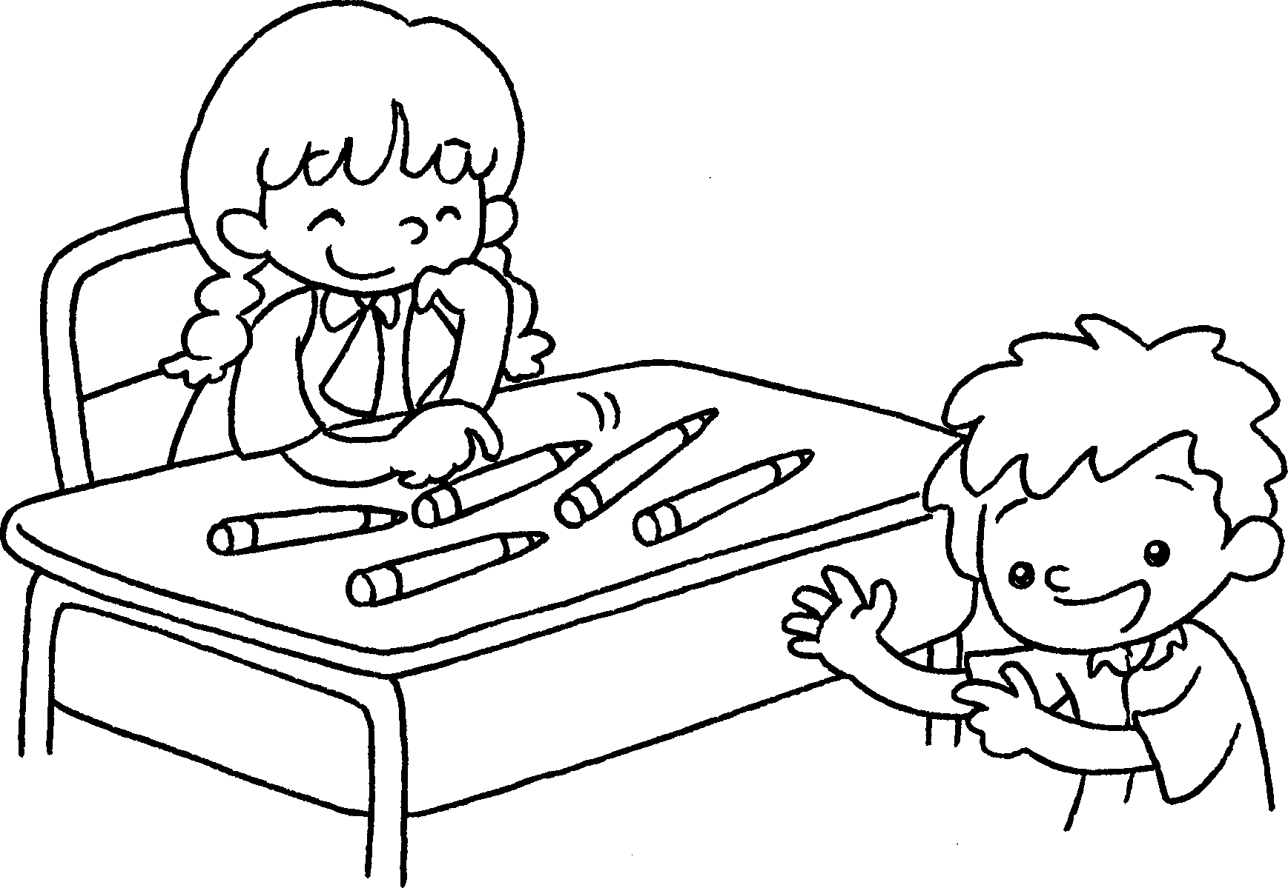 | This is Mandy.  ______ ________ _______ pencils.
4 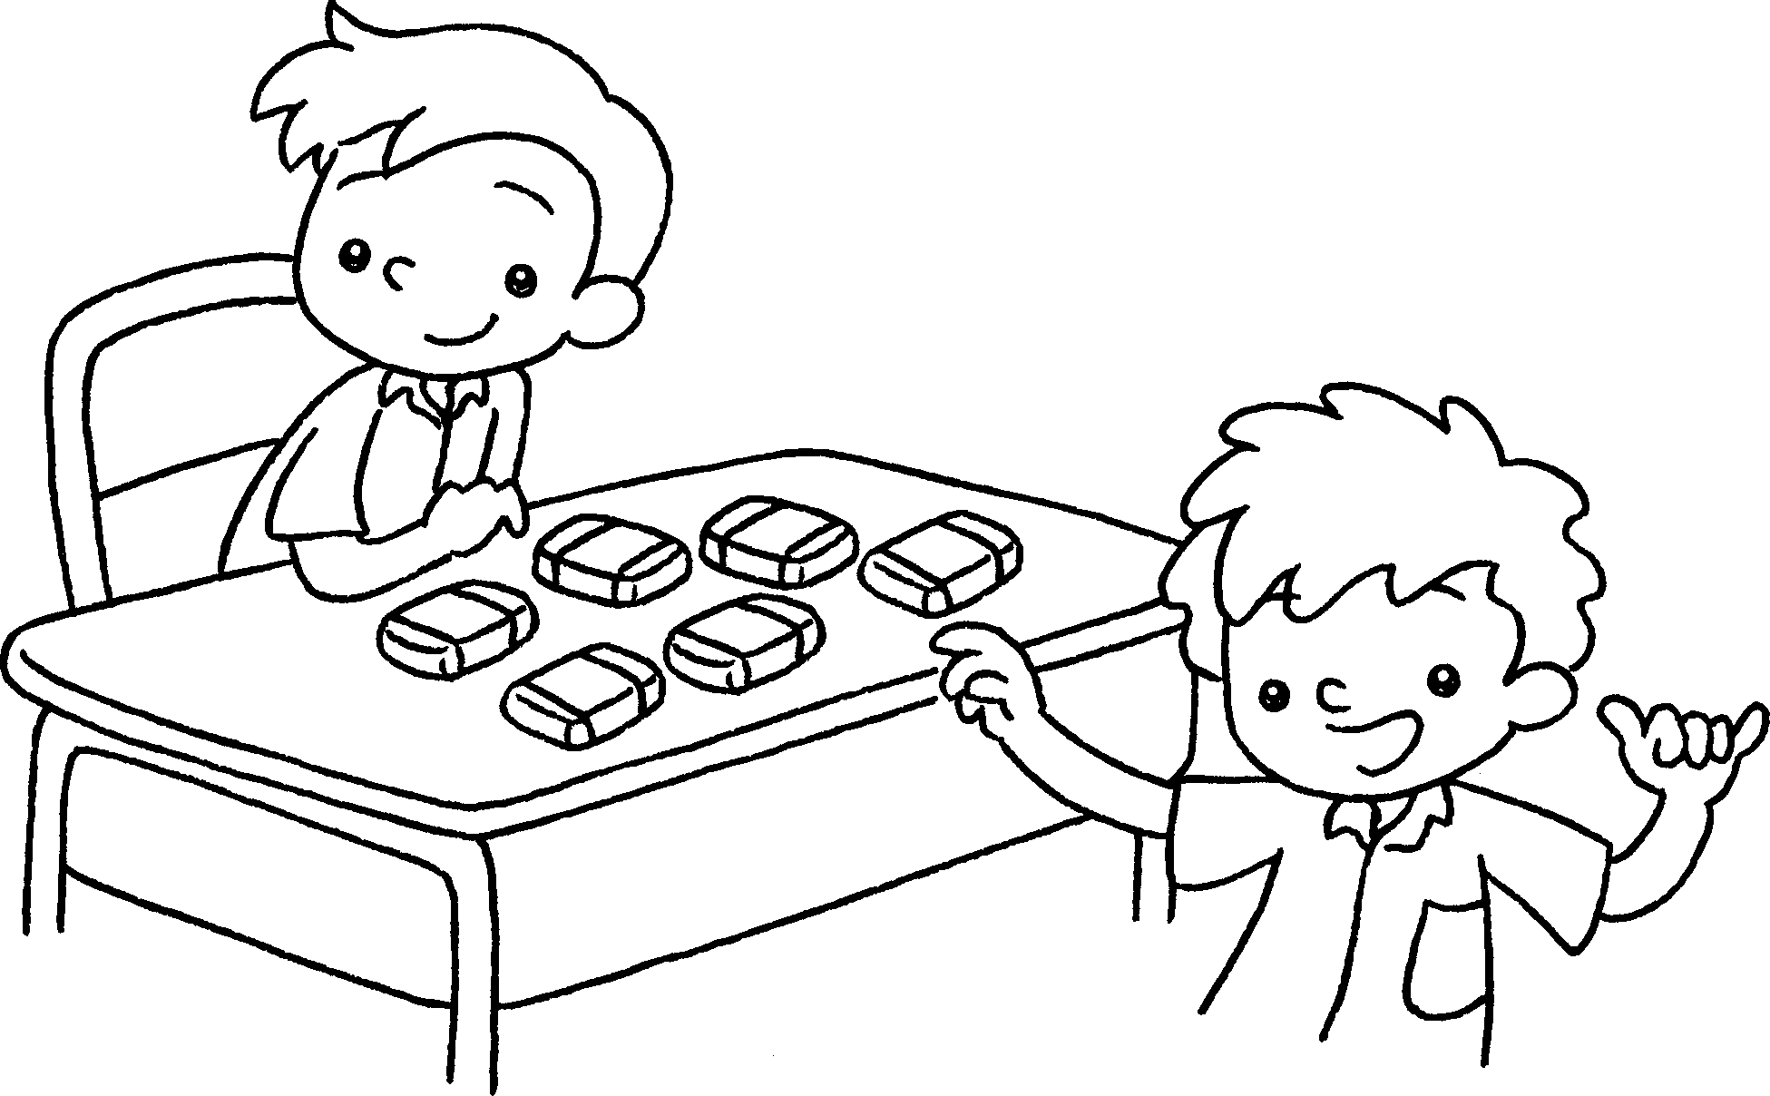  … | This is Peter.  ______ six _____________ .



Book 1A Chapter 4 Graded Worksheets
Worksheet 3⬇⬇⬇
1 has
2 I have
3 She has five
4 He has erasers

