Choose and write.
catcowdoghamsterhorsepigrabbitturtle

1 | 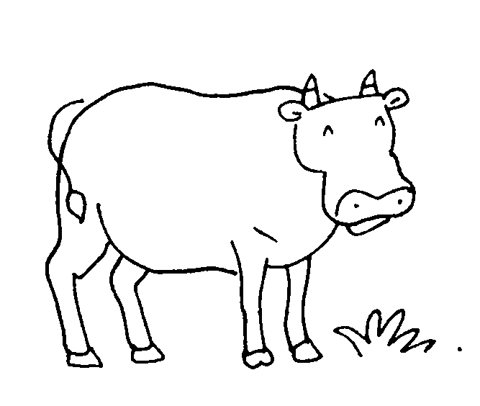  a |  | 2 | 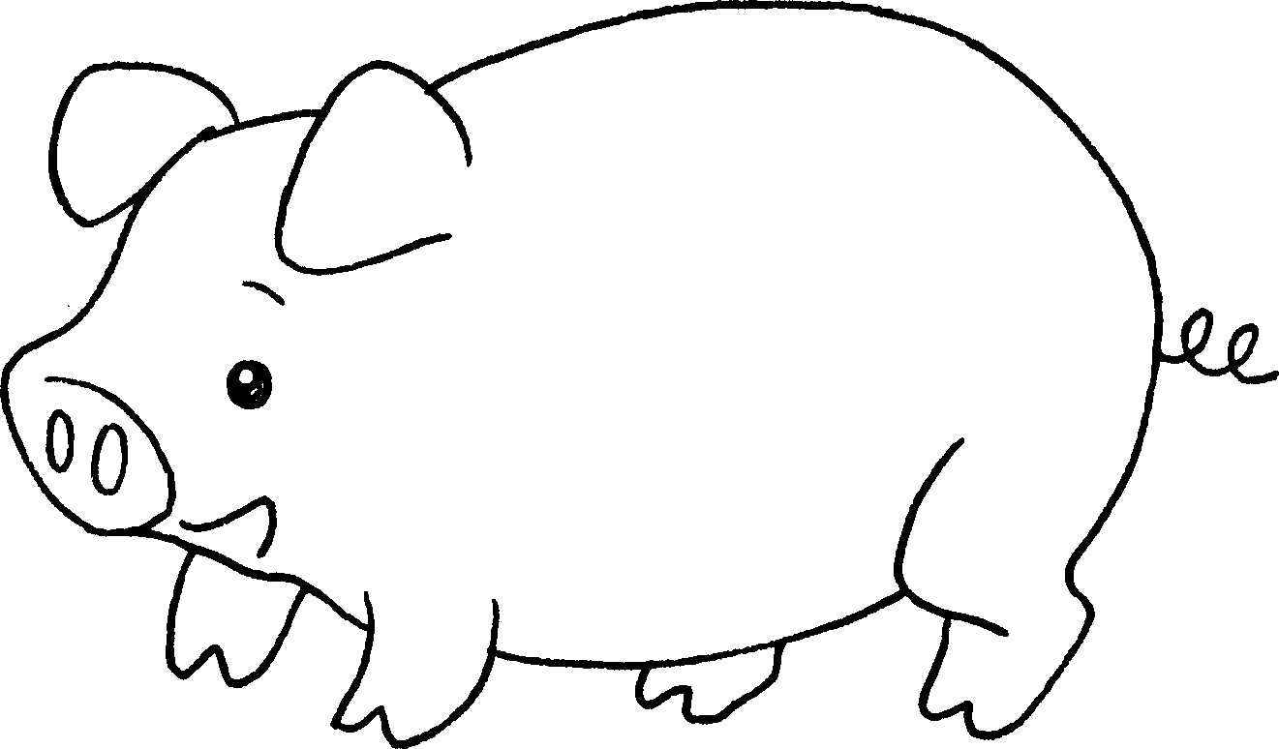  a
3 | 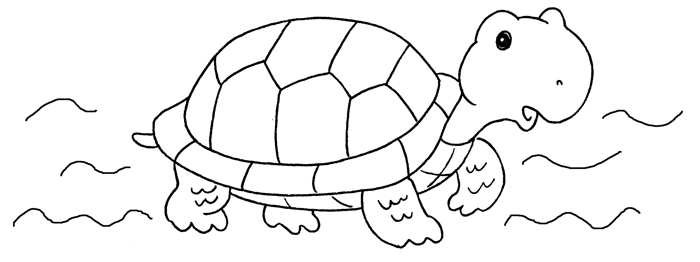  a |  | 4 | 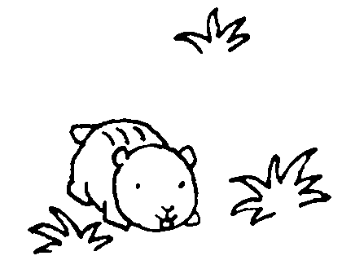  a
5 | 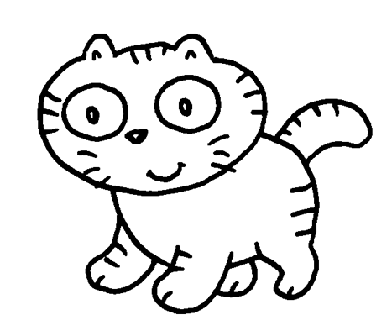  a |  | 6 | 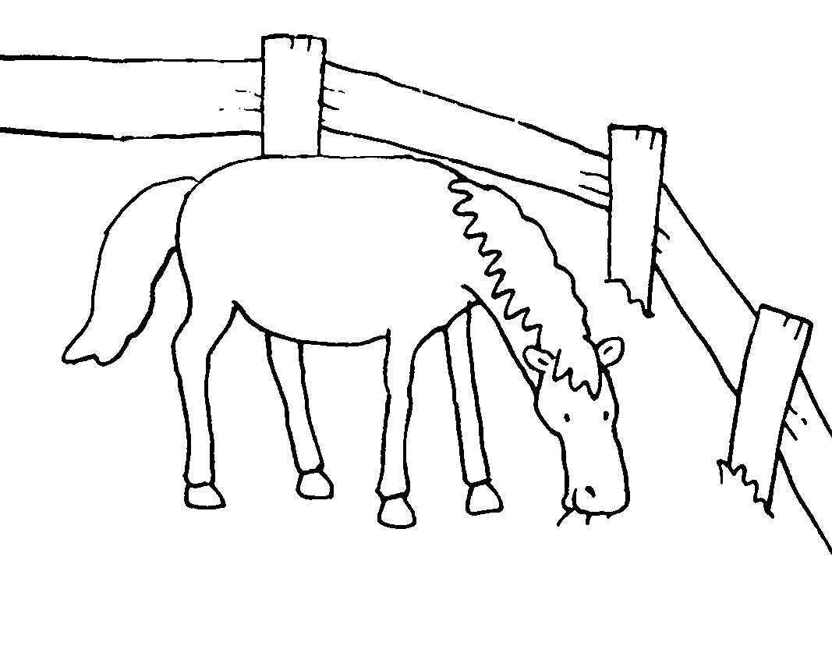  a
7 | 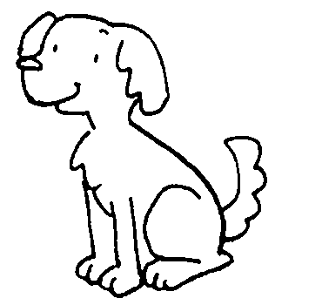  a |  | 8 | 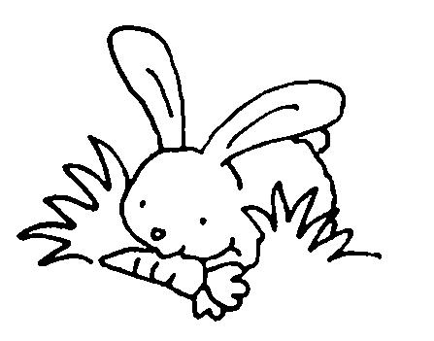  a


Book 1A Chapter 5 Graded Worksheets
Worksheet 1⬇
1 cow 2 pig
3 turtle 4 hamster
5 cat 6 horse
7 dog 8 rabbit

