Fill in the missing letters.

1 | 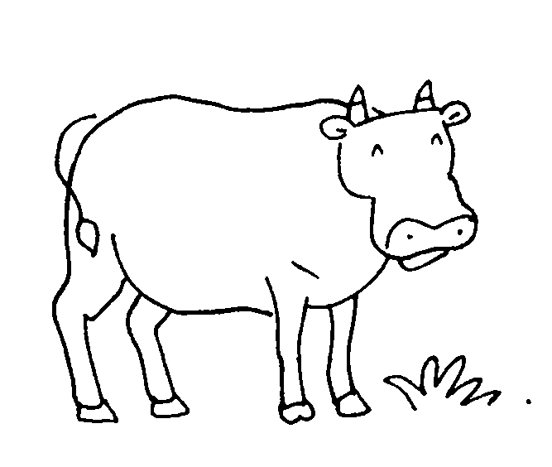  a c __ __ |  | 2 | 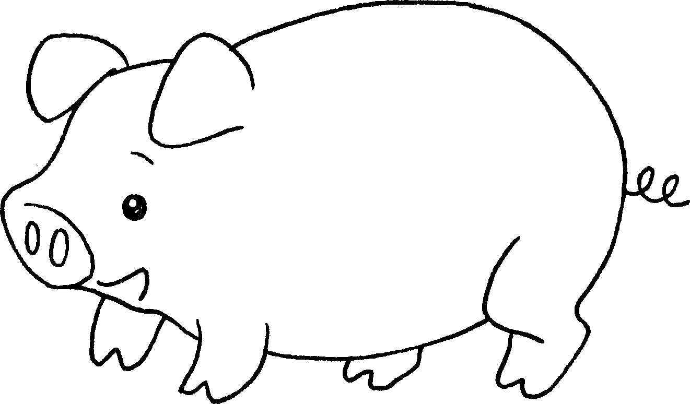  a p __ __
3 | 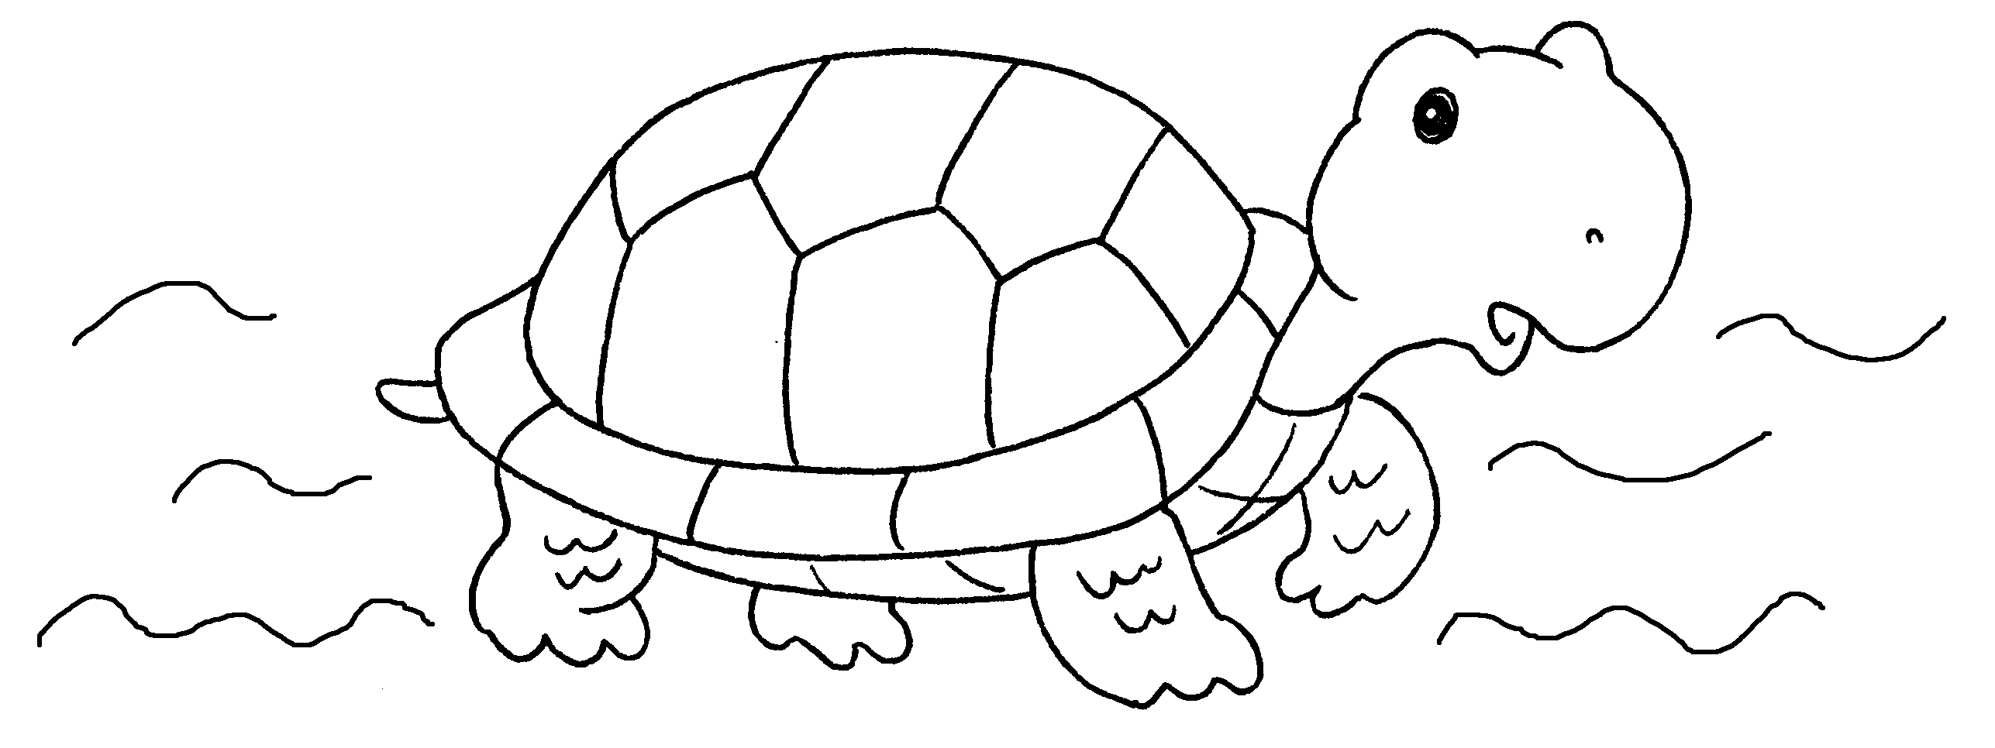  a t __ __ __ __ __ |  | 4 | 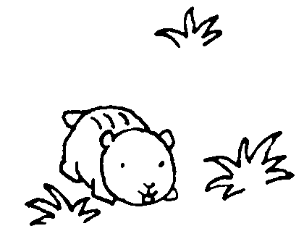  a h __ __ __ __ __ __
5 | 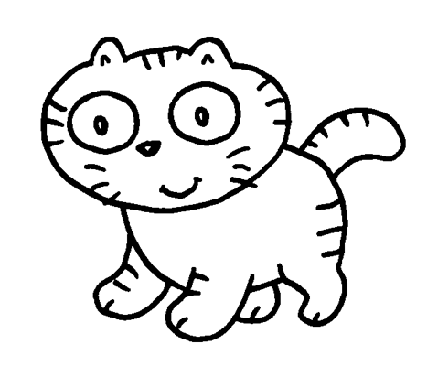  a c __ __ |  | 6 | 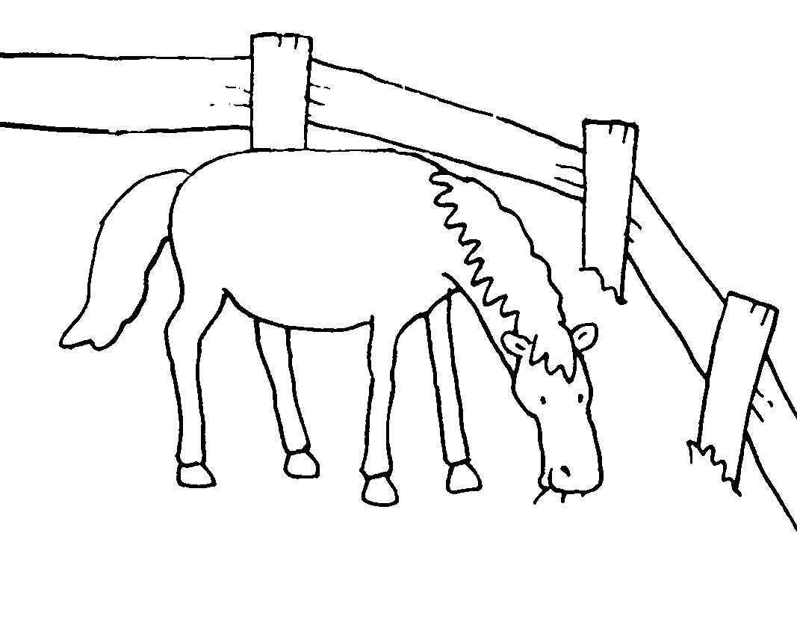  a h __ __ __ __
7 | 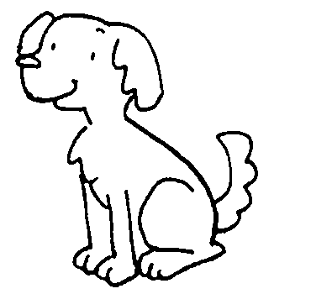  a d __ __ |  | 8 | 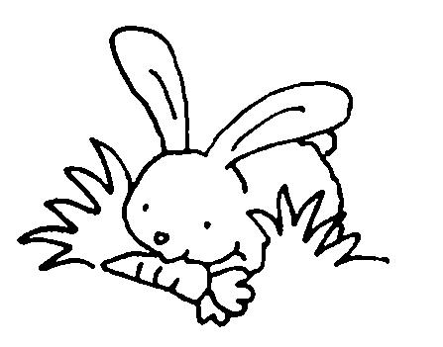  a r __ __ __ __ __


Book 1A Chapter 5 Graded Worksheets
Worksheet 1⬇⬇
1 c o w 2 p i g
3 t u r t l e 4 h a m s t e r
5 c a t 6 h o r s e
7 d o g 8 r a b b i t

