What are they? Write.

1 | 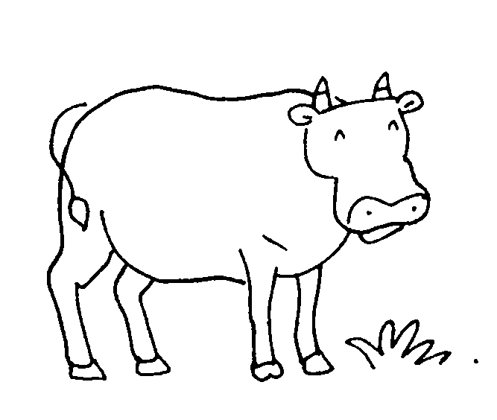  a c |  | 2 | 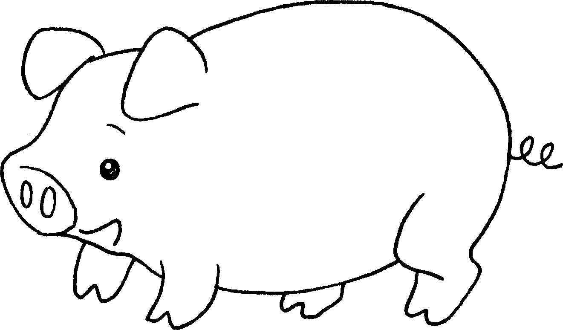  a p
3 | 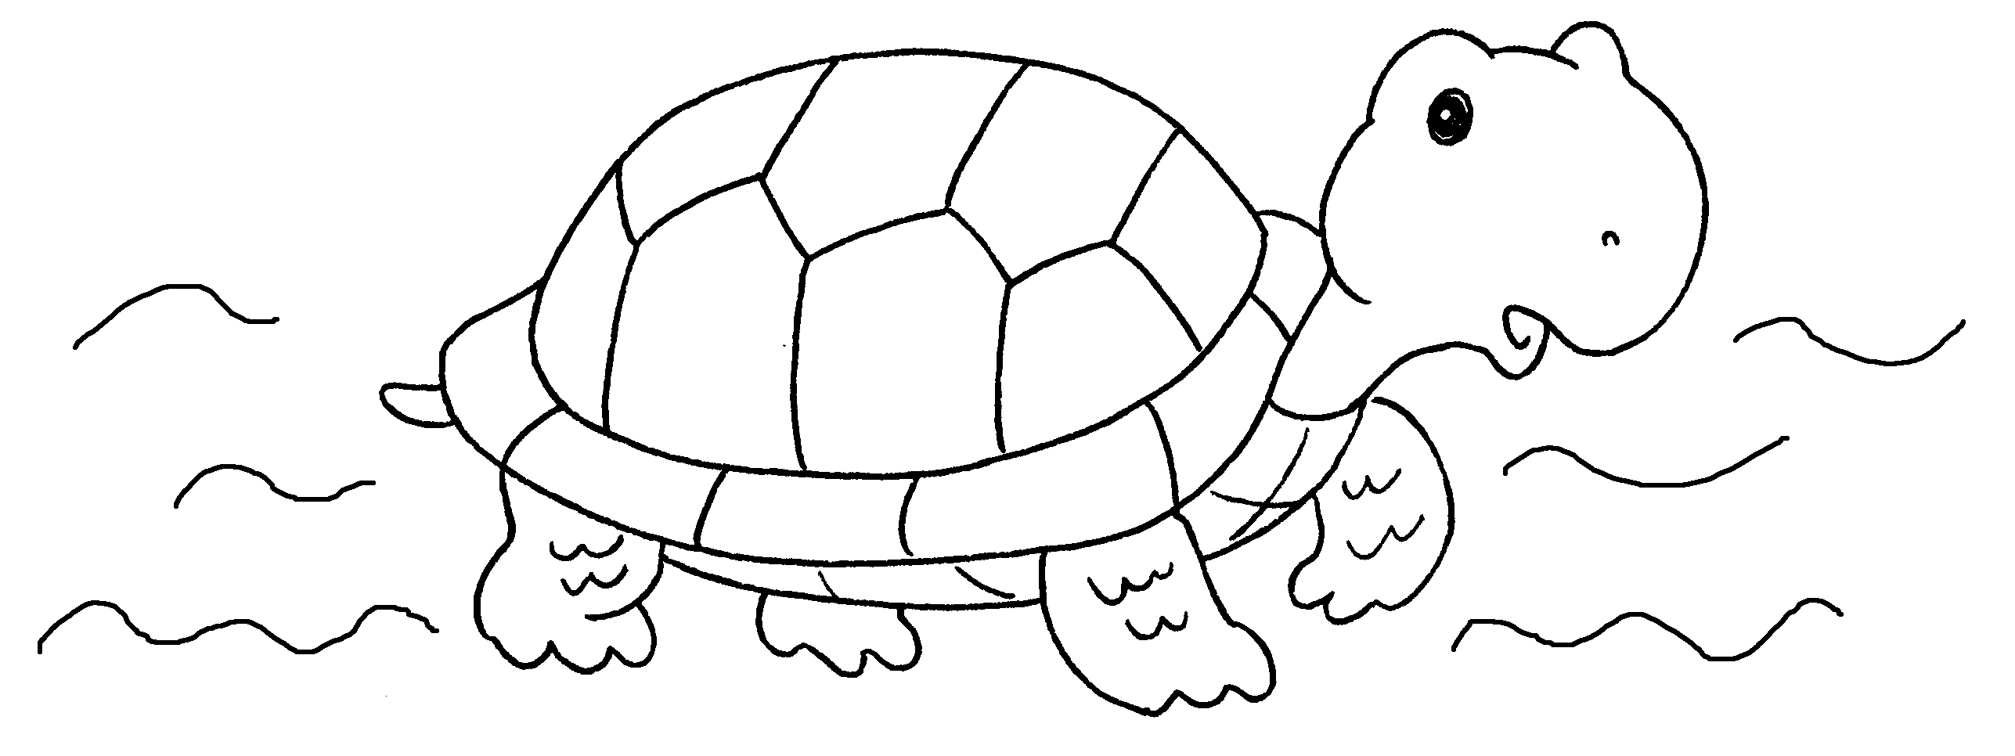  a _________________ |  | 4 | 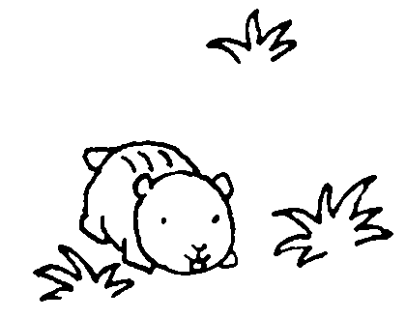  ___
5 | 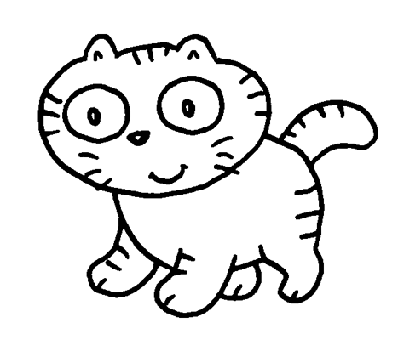  ___ |  | 6 | 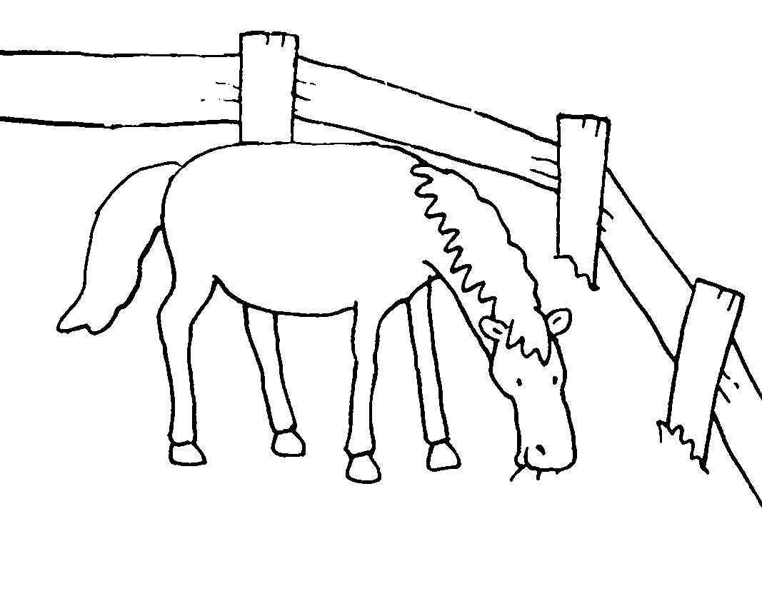  ___
7 | 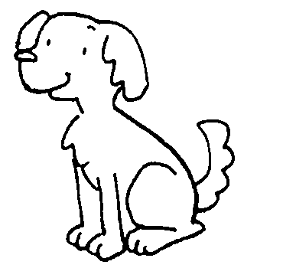  ___ |  | 8 | 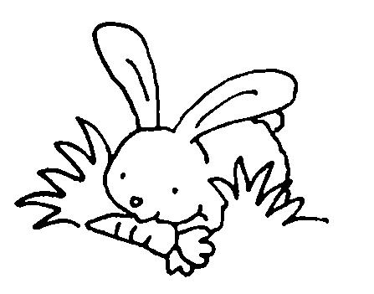


Book 1A Chapter 5 Graded Worksheets
Worksheet 1⬇⬇⬇
1 cow 2 pig
3 turtle 4 a hamster
5 a cat 6 a horse
7 a dog 8 a rabbit

