Circle the correct answers.
1  …  … | 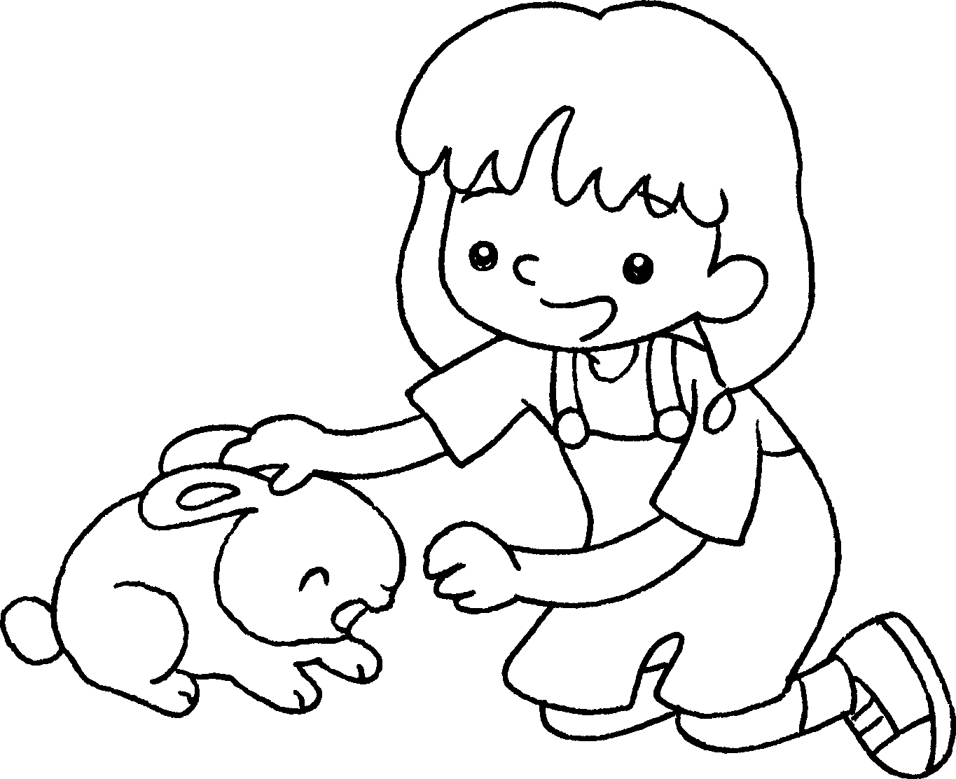 | 2 | 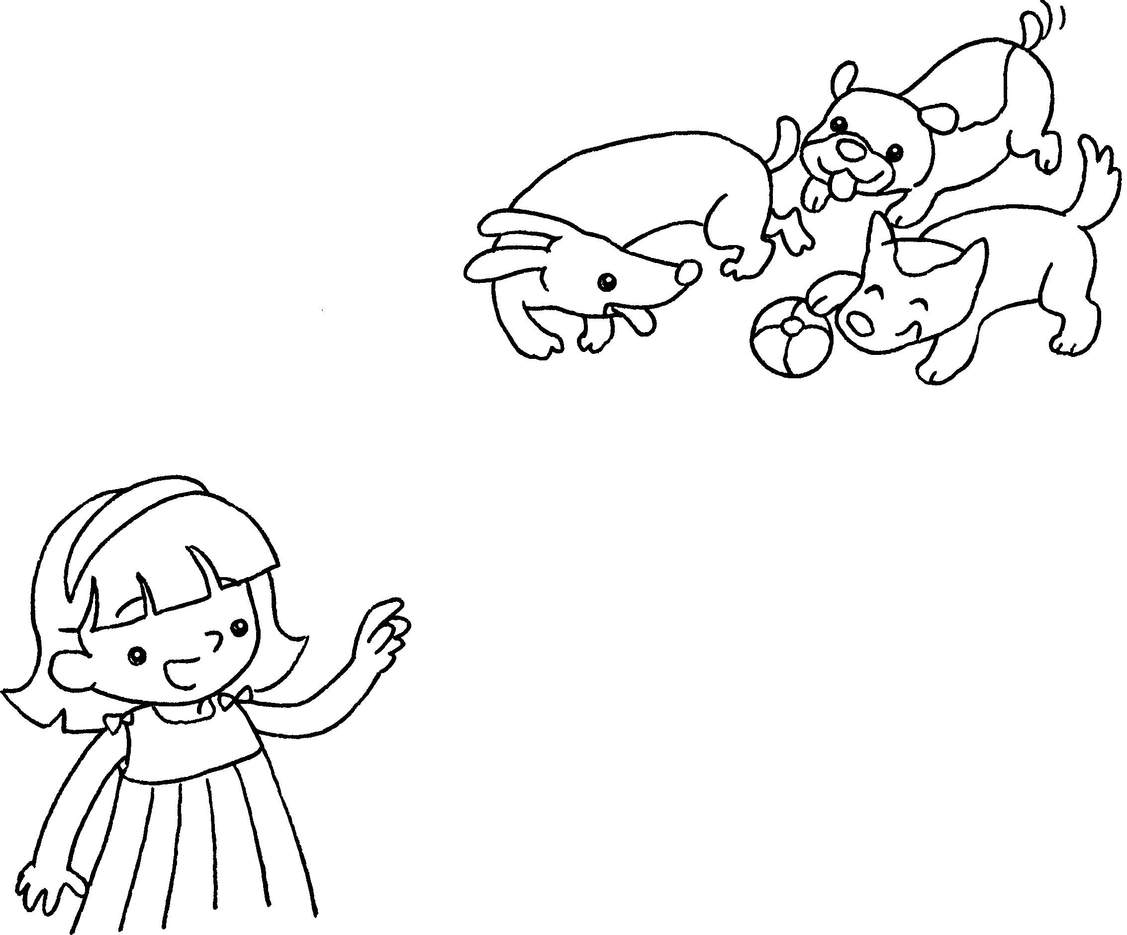
 | I like ( this / these ) rabbit. |  | I like ( these / those ) dogs.
3  …  … | 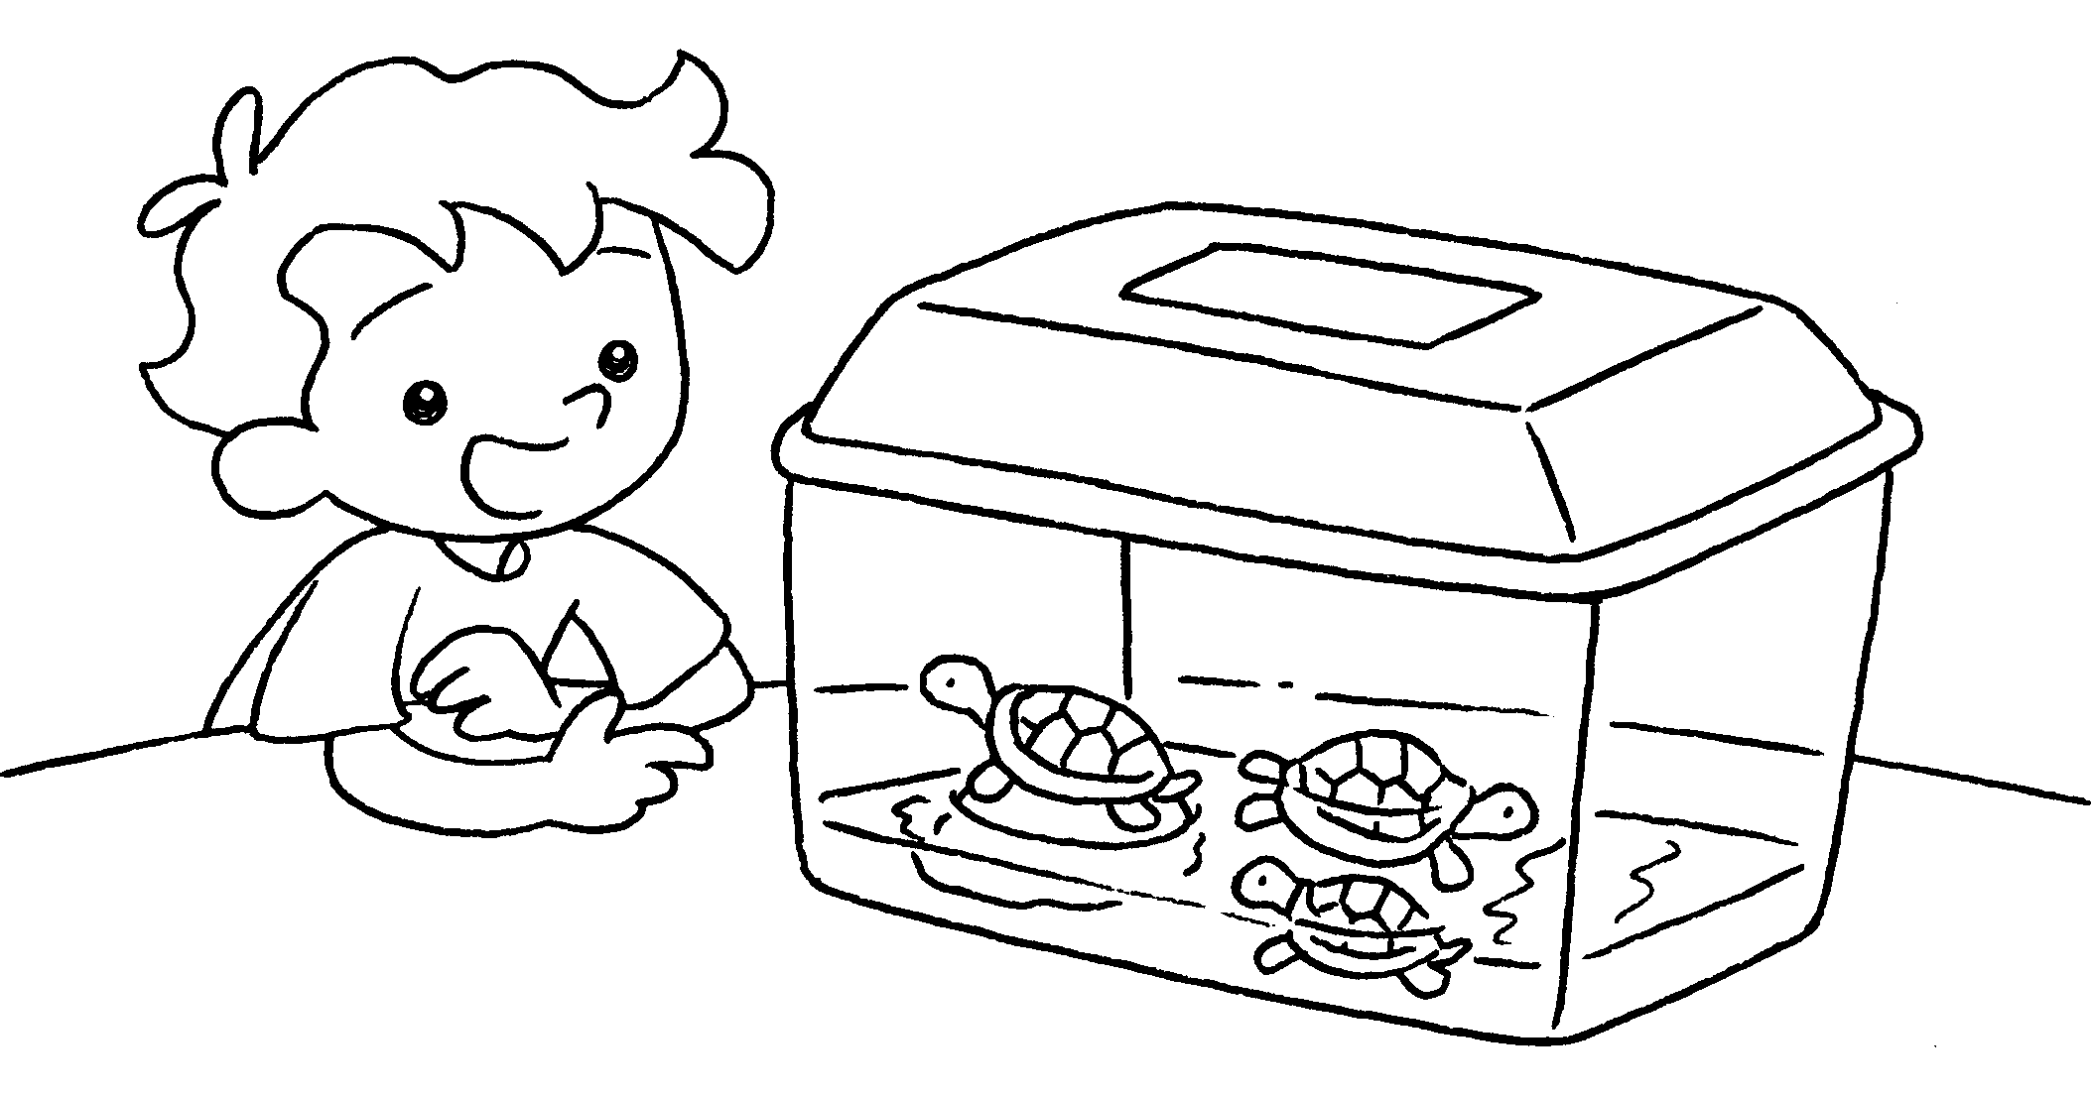 | 4 | 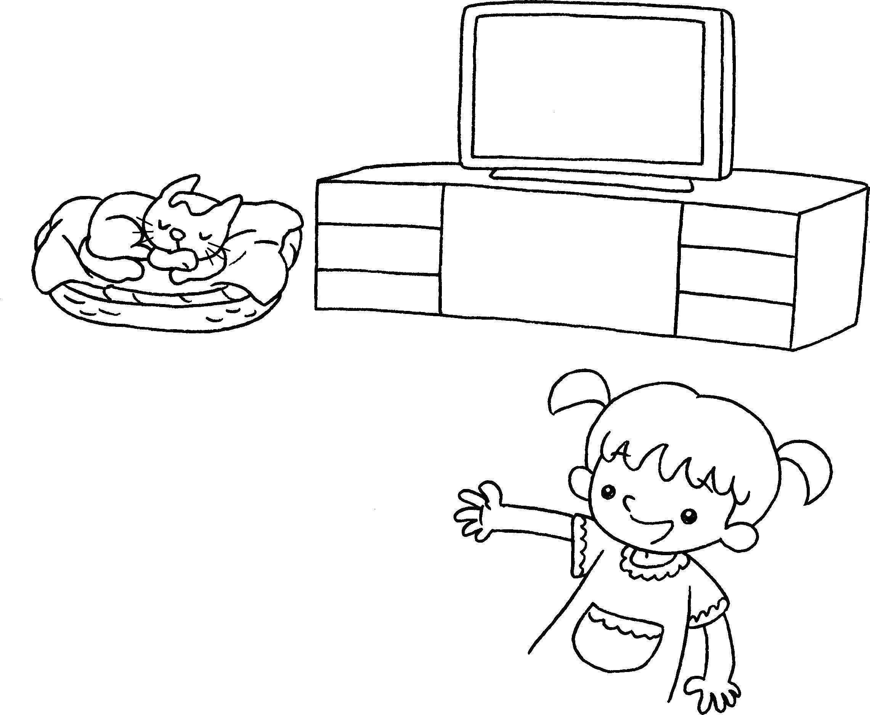
 | I like ( this / these ) turtles. |  | I like ( that / those ) cat.



Book 1A Chapter 5 Graded Worksheets
Worksheet 2⬇
- ( this / these )
- ( these / those )
- ( this / these )
- ( that / those )

