Circle the correct answers.
1  …  … | 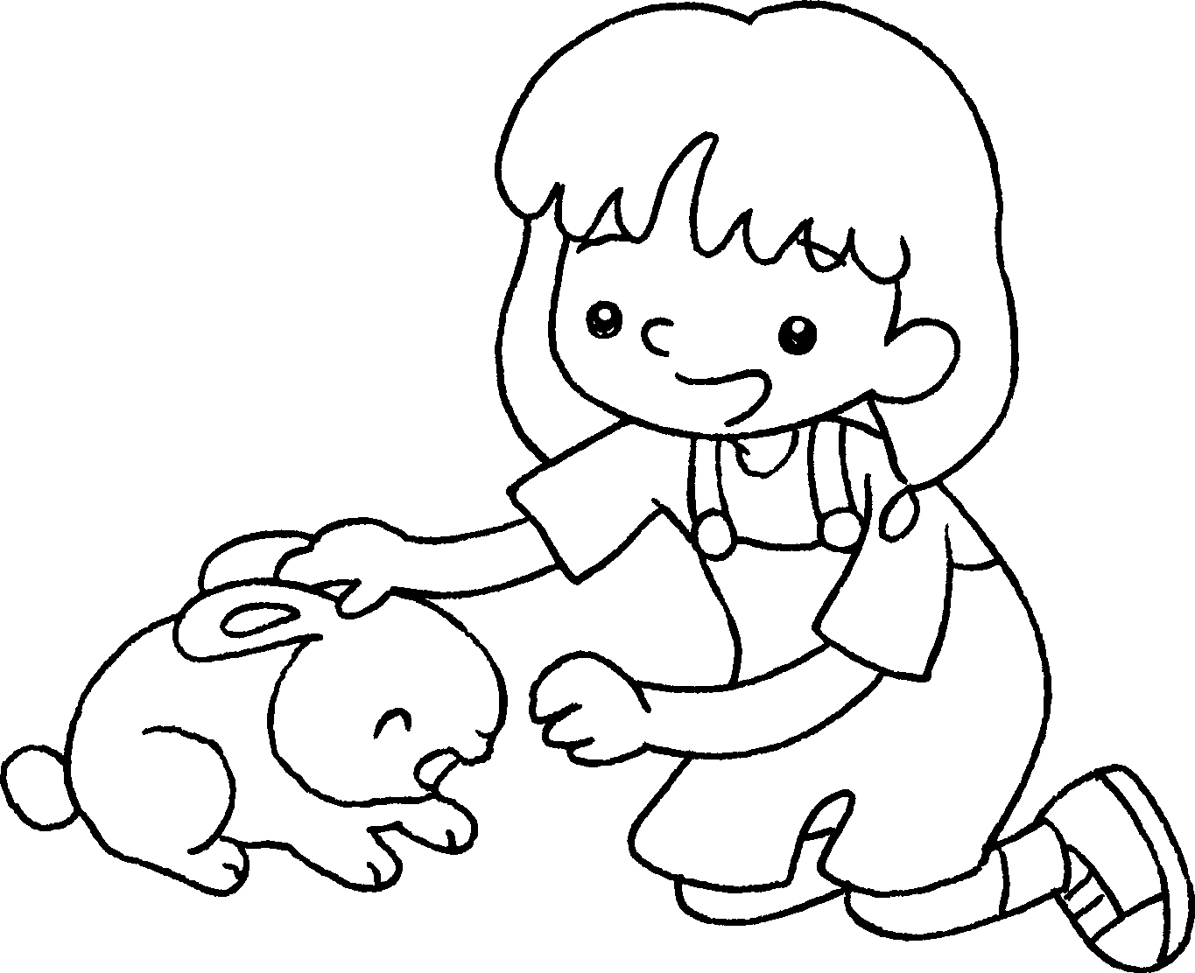 | 2 | 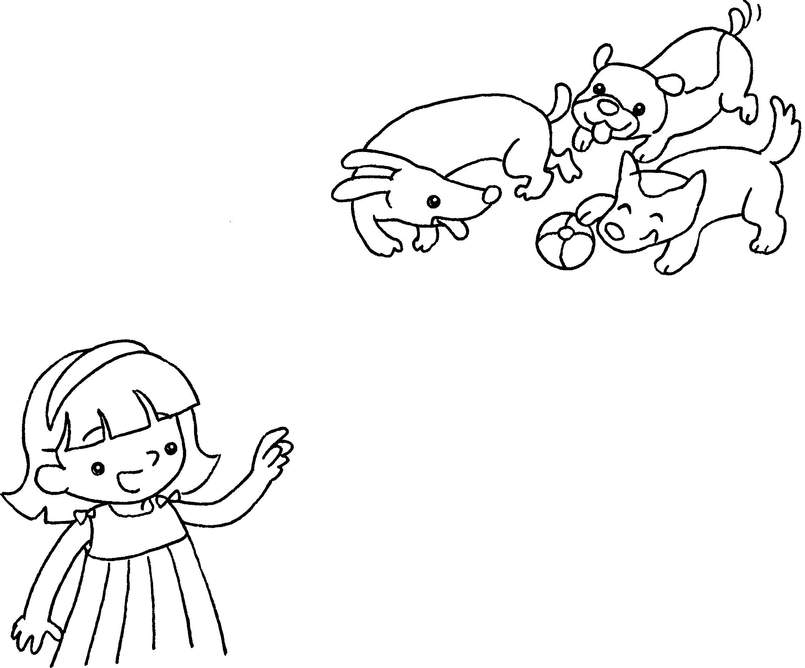
 | I like ( this / these ) ( rabbit / rabbits ). |  | I like ( these / those )  ( dog / dogs ).
3  …  … | 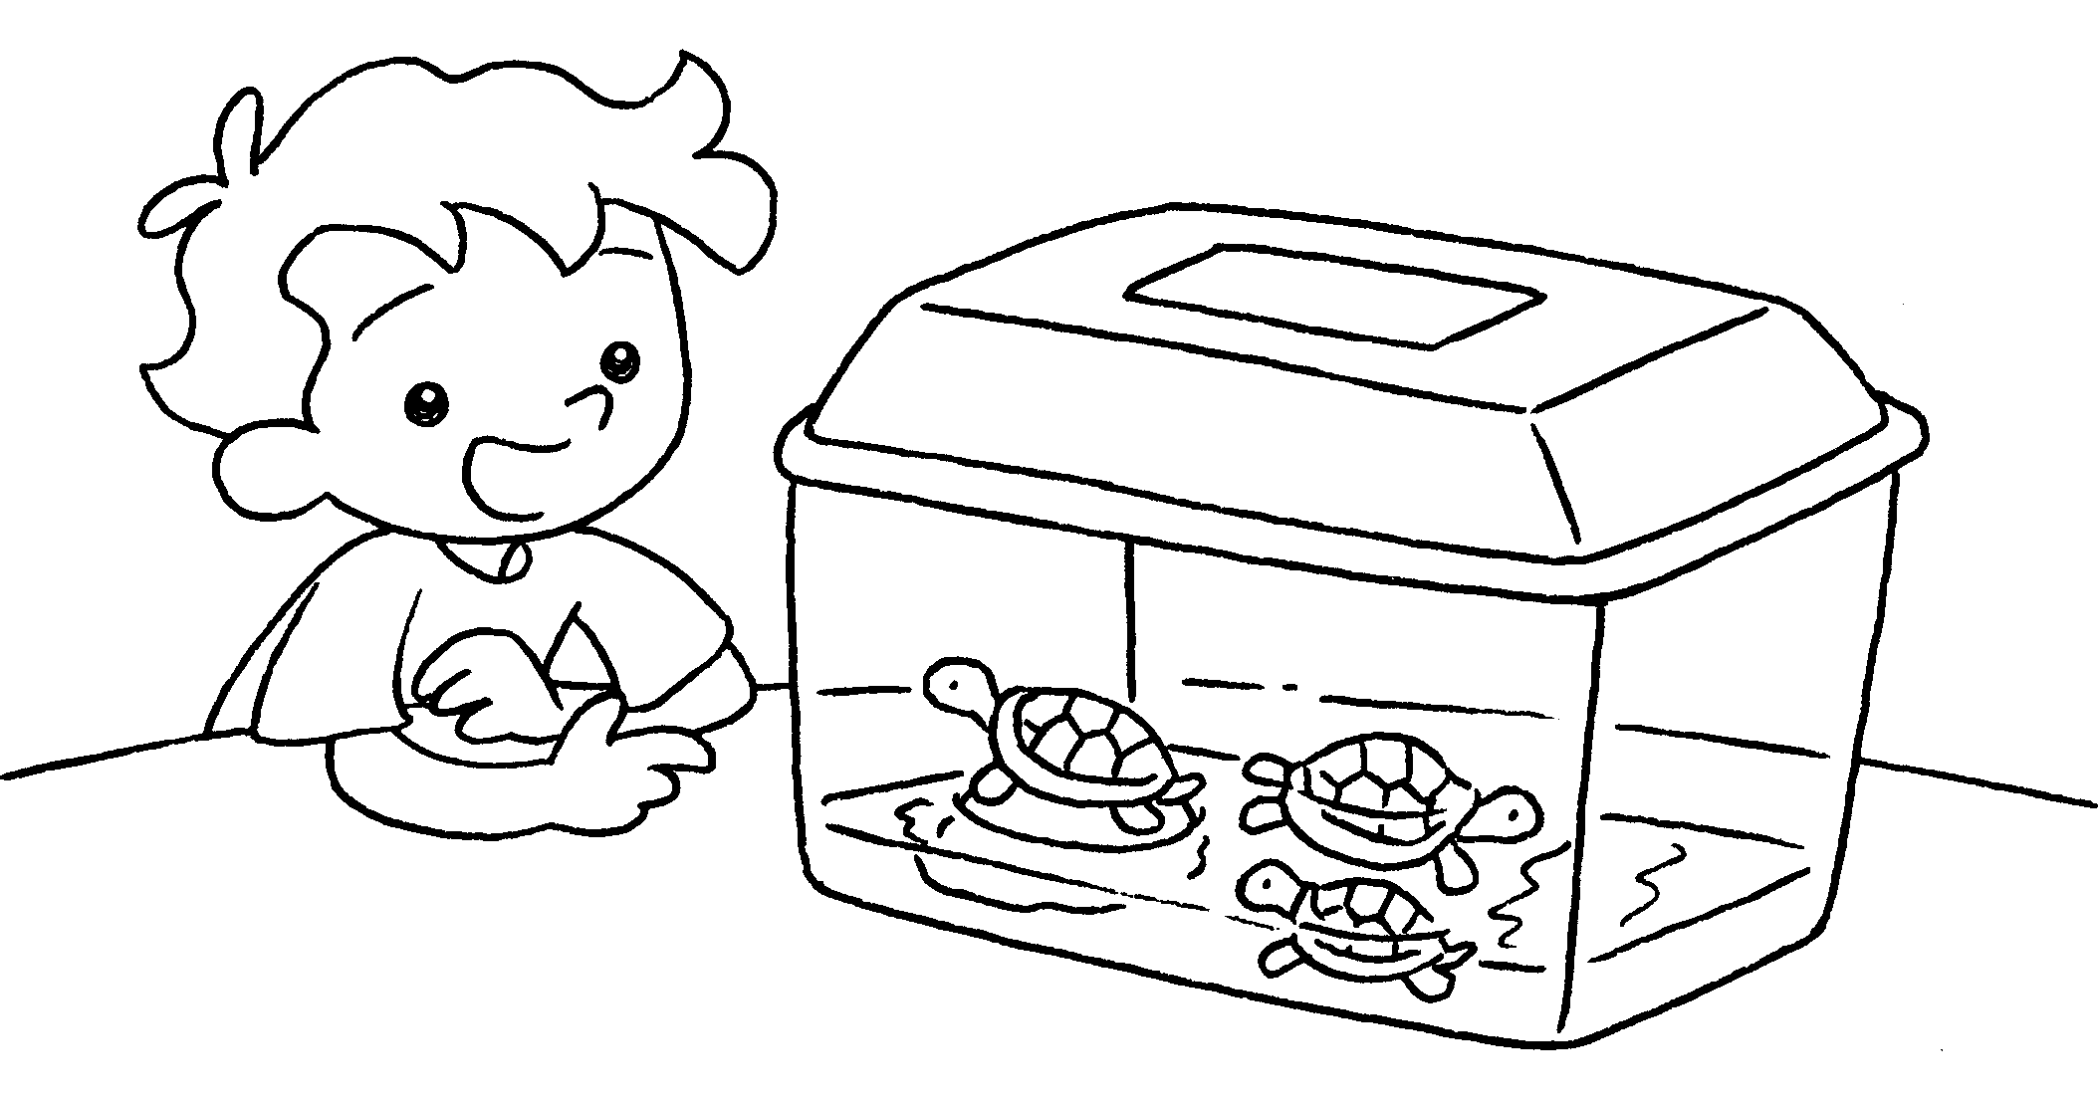 | 4 | 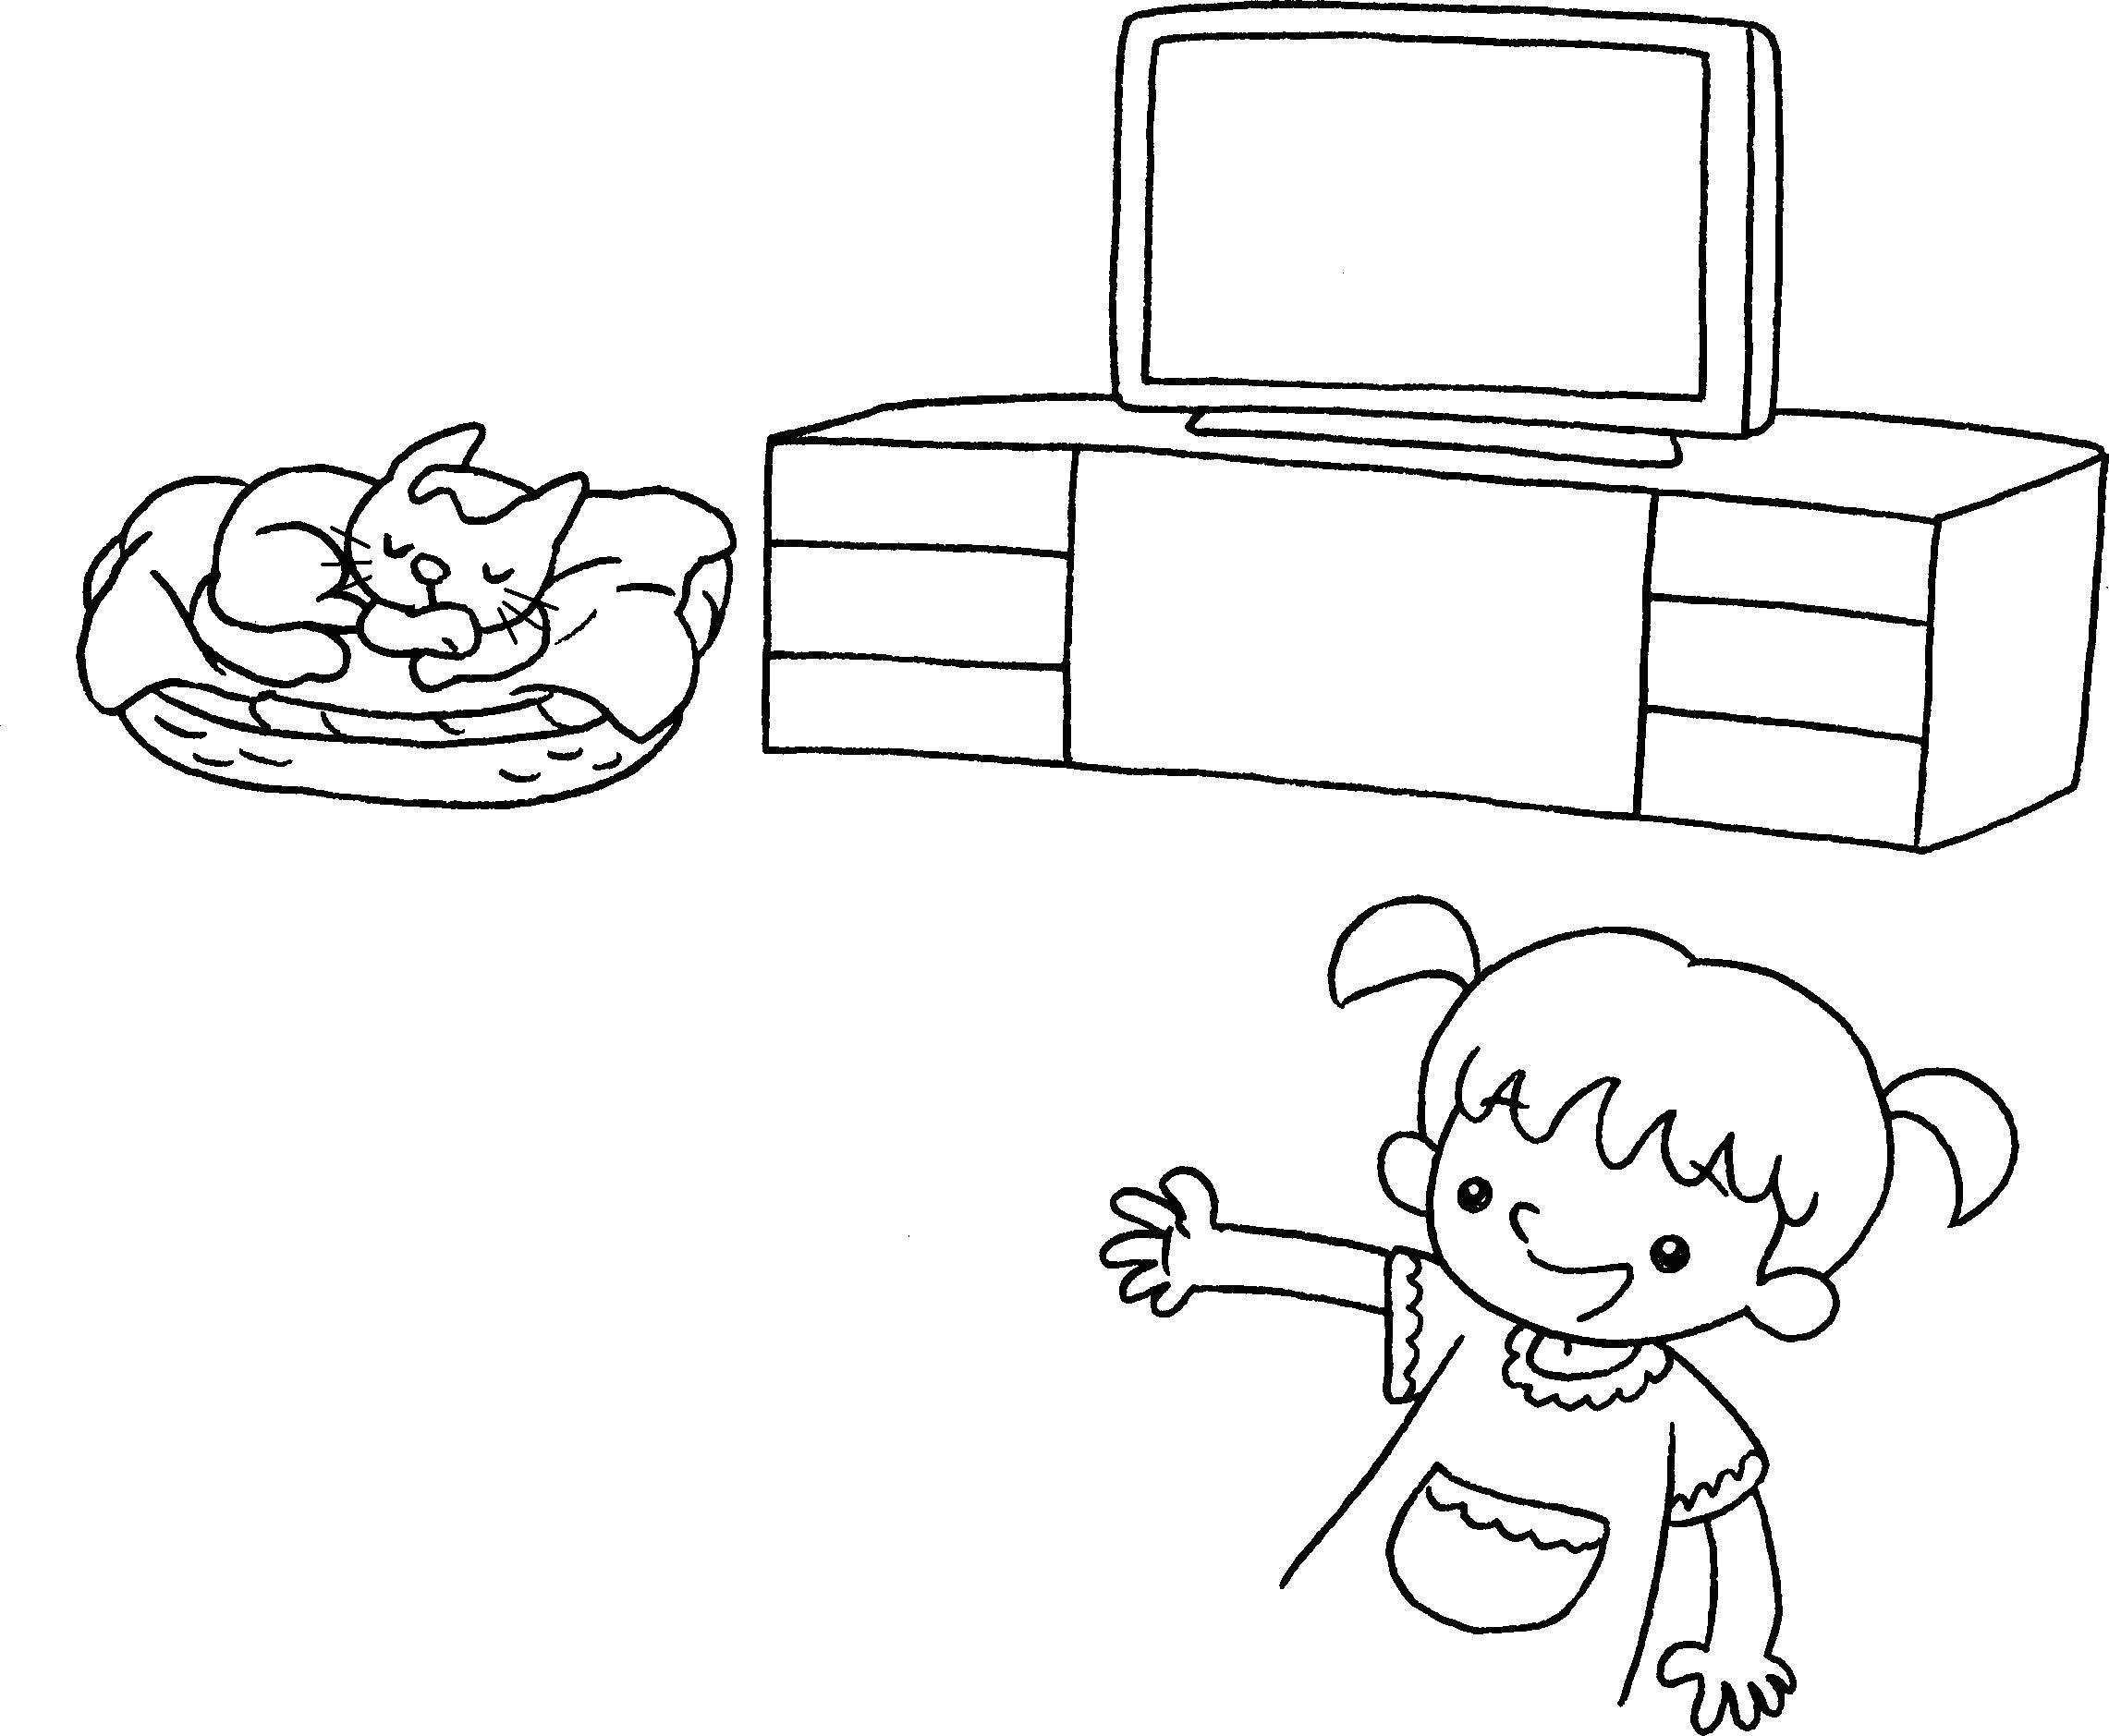
 | I like ( this / these ) ( turtle / turtles ). |  | I like ( that / those )  ( cat / cats ).



Book 1A Chapter 5 Graded Worksheets
Worksheet 2⬇⬇
1 ( this / these ) ( rabbit / rabbits )
2 ( these / those ) ( dog / dogs )
3 ( this / these ) ( turtle / turtles )
4 ( that / those ) ( cat / cats )

