What are the children saying? Write.

this that these those
1  …  … | 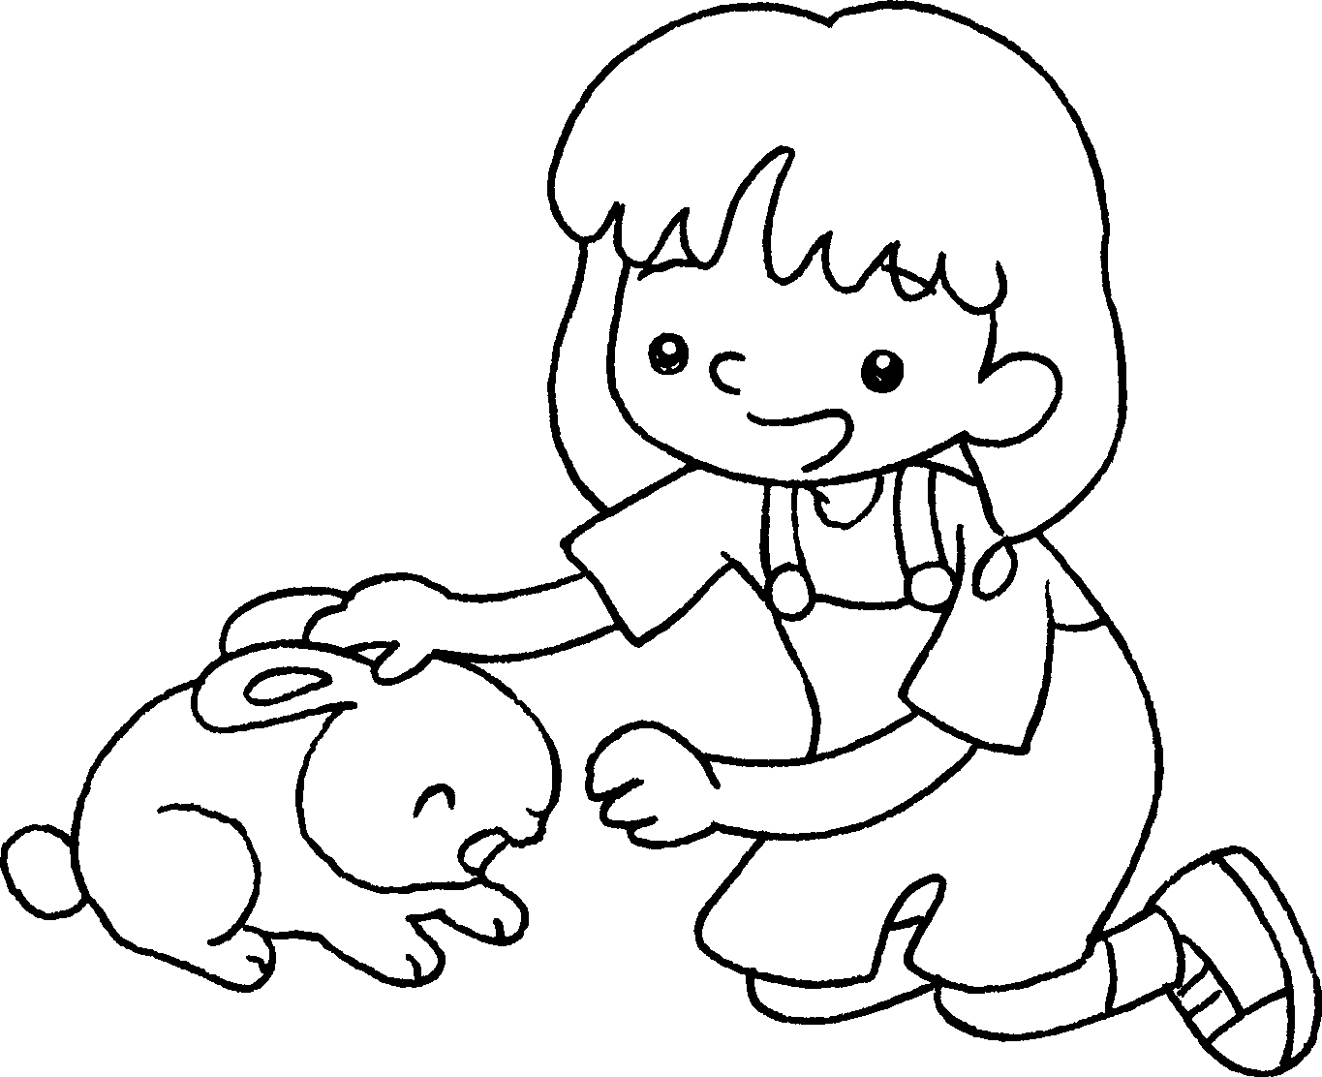 | 2 | 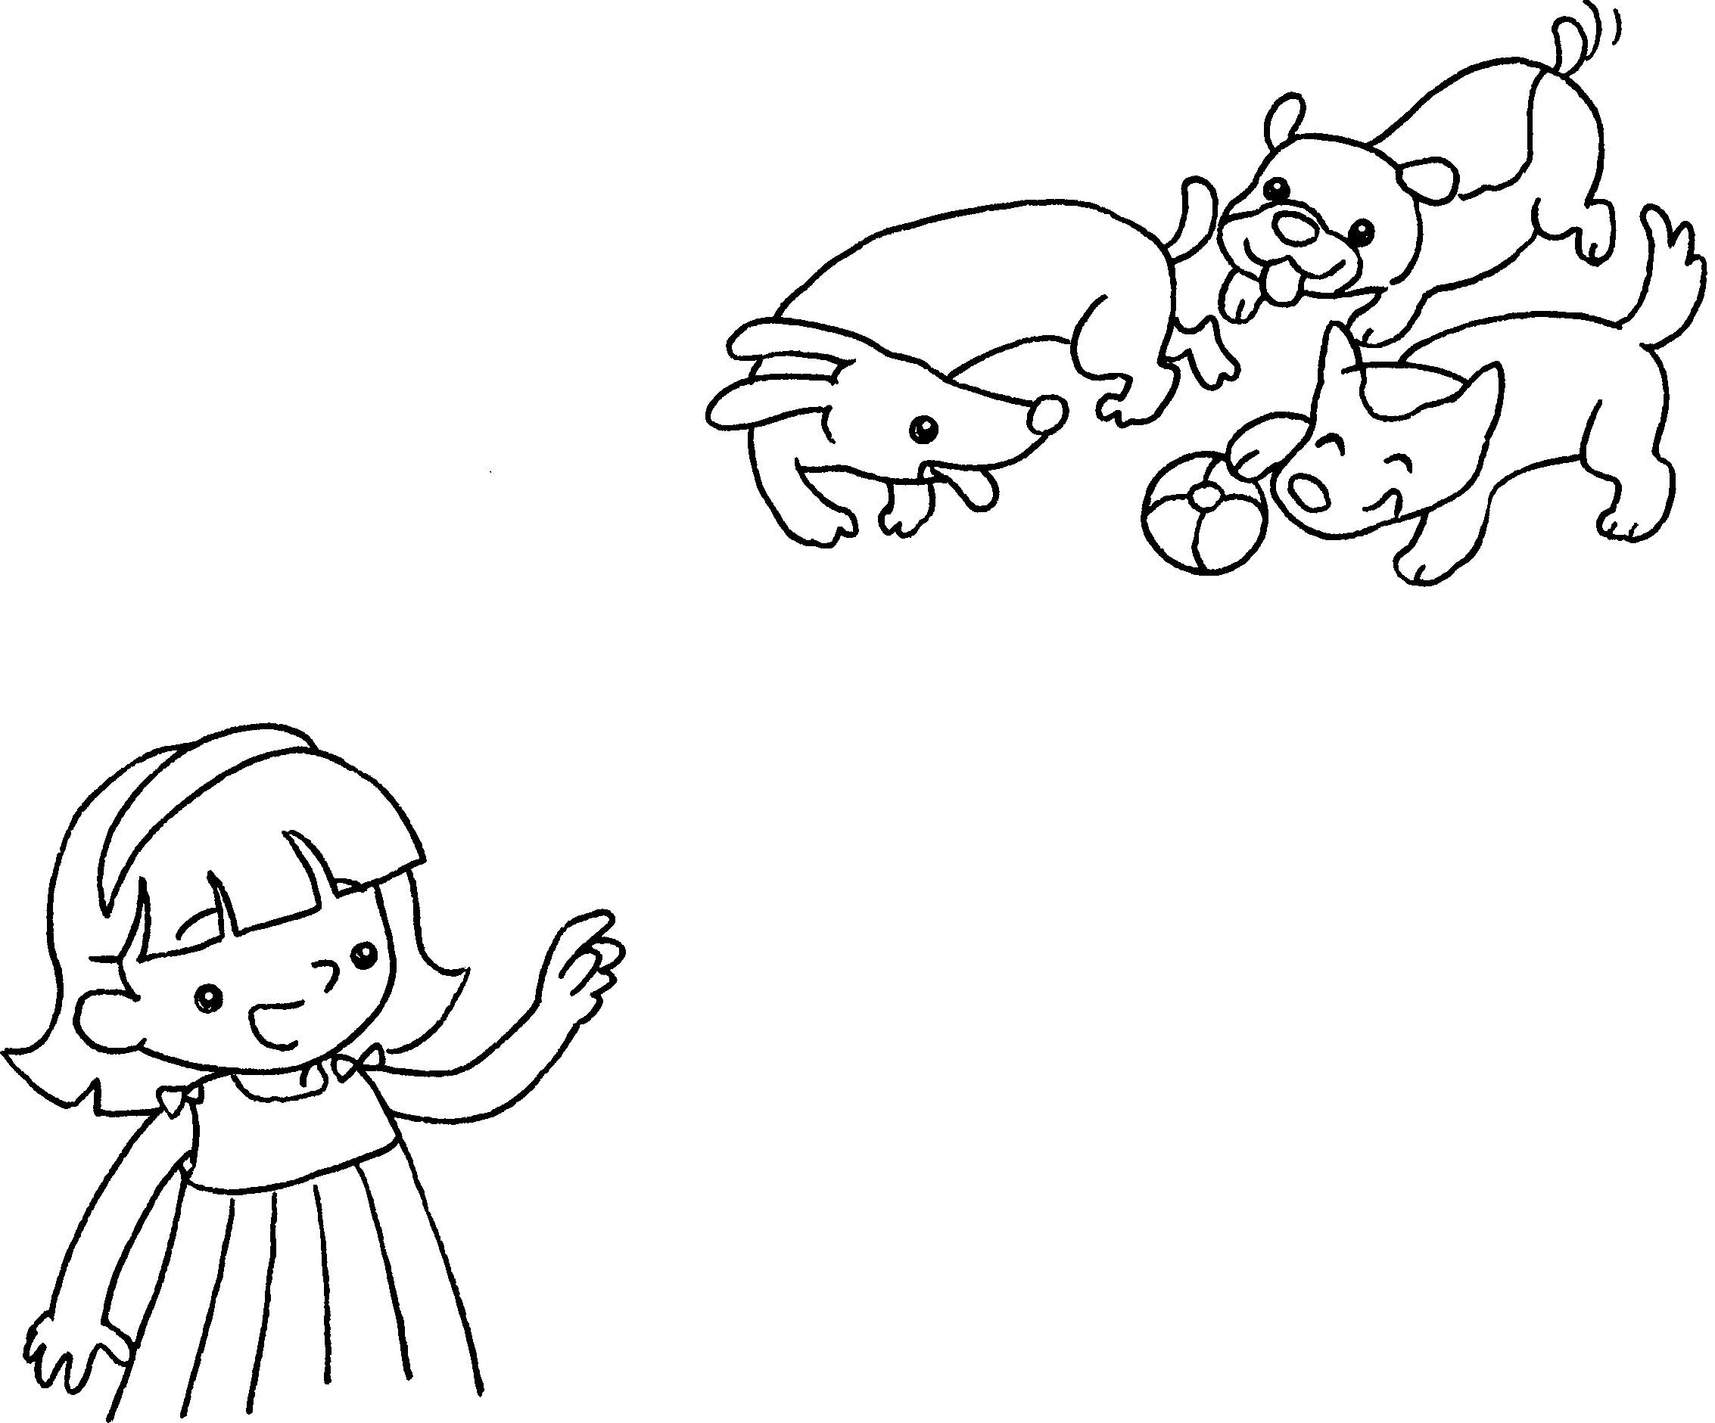
 | I like __________ rabbit. |  | I like ___________ dogs.
3  …  … | 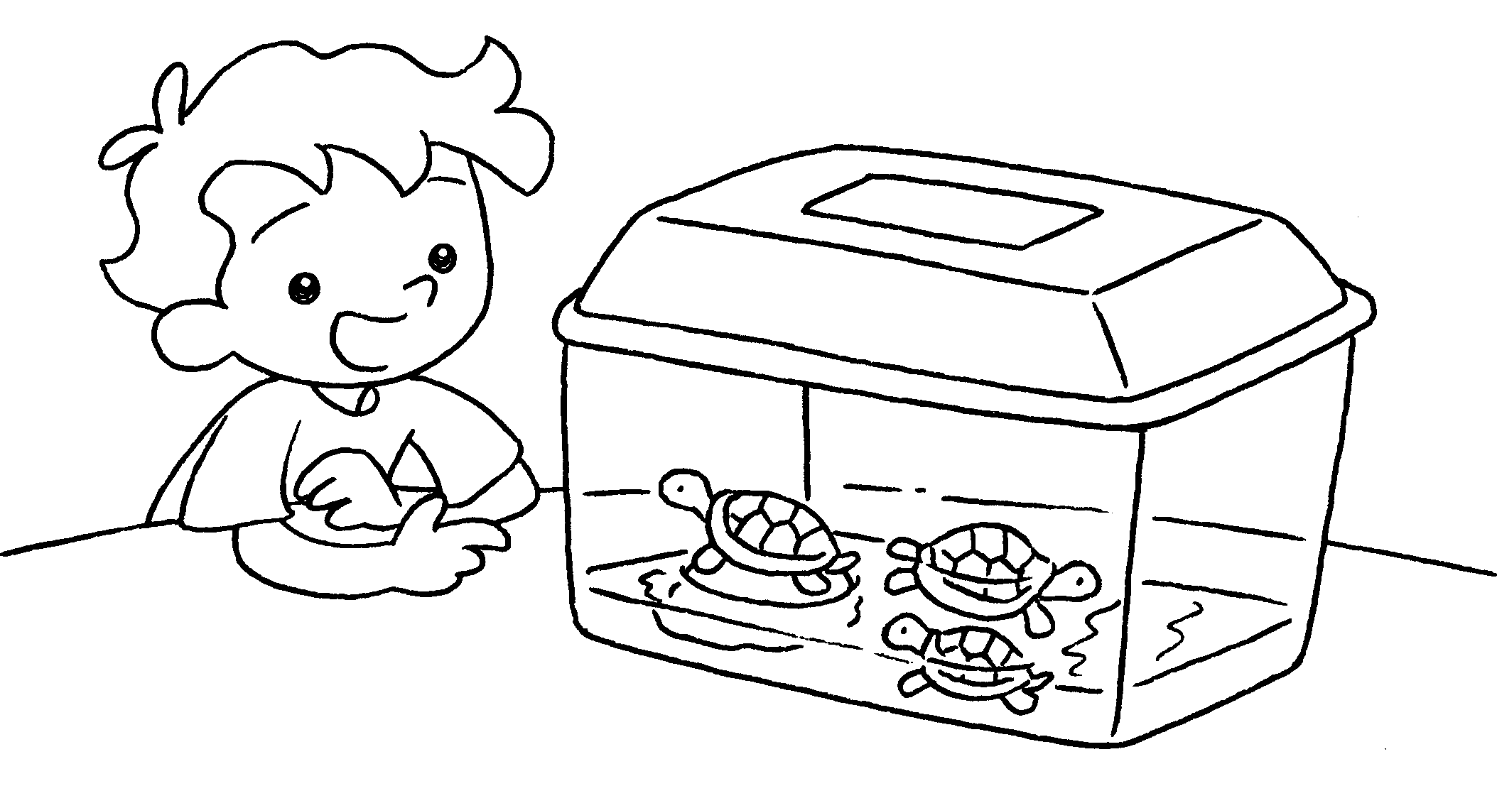 | 4 | 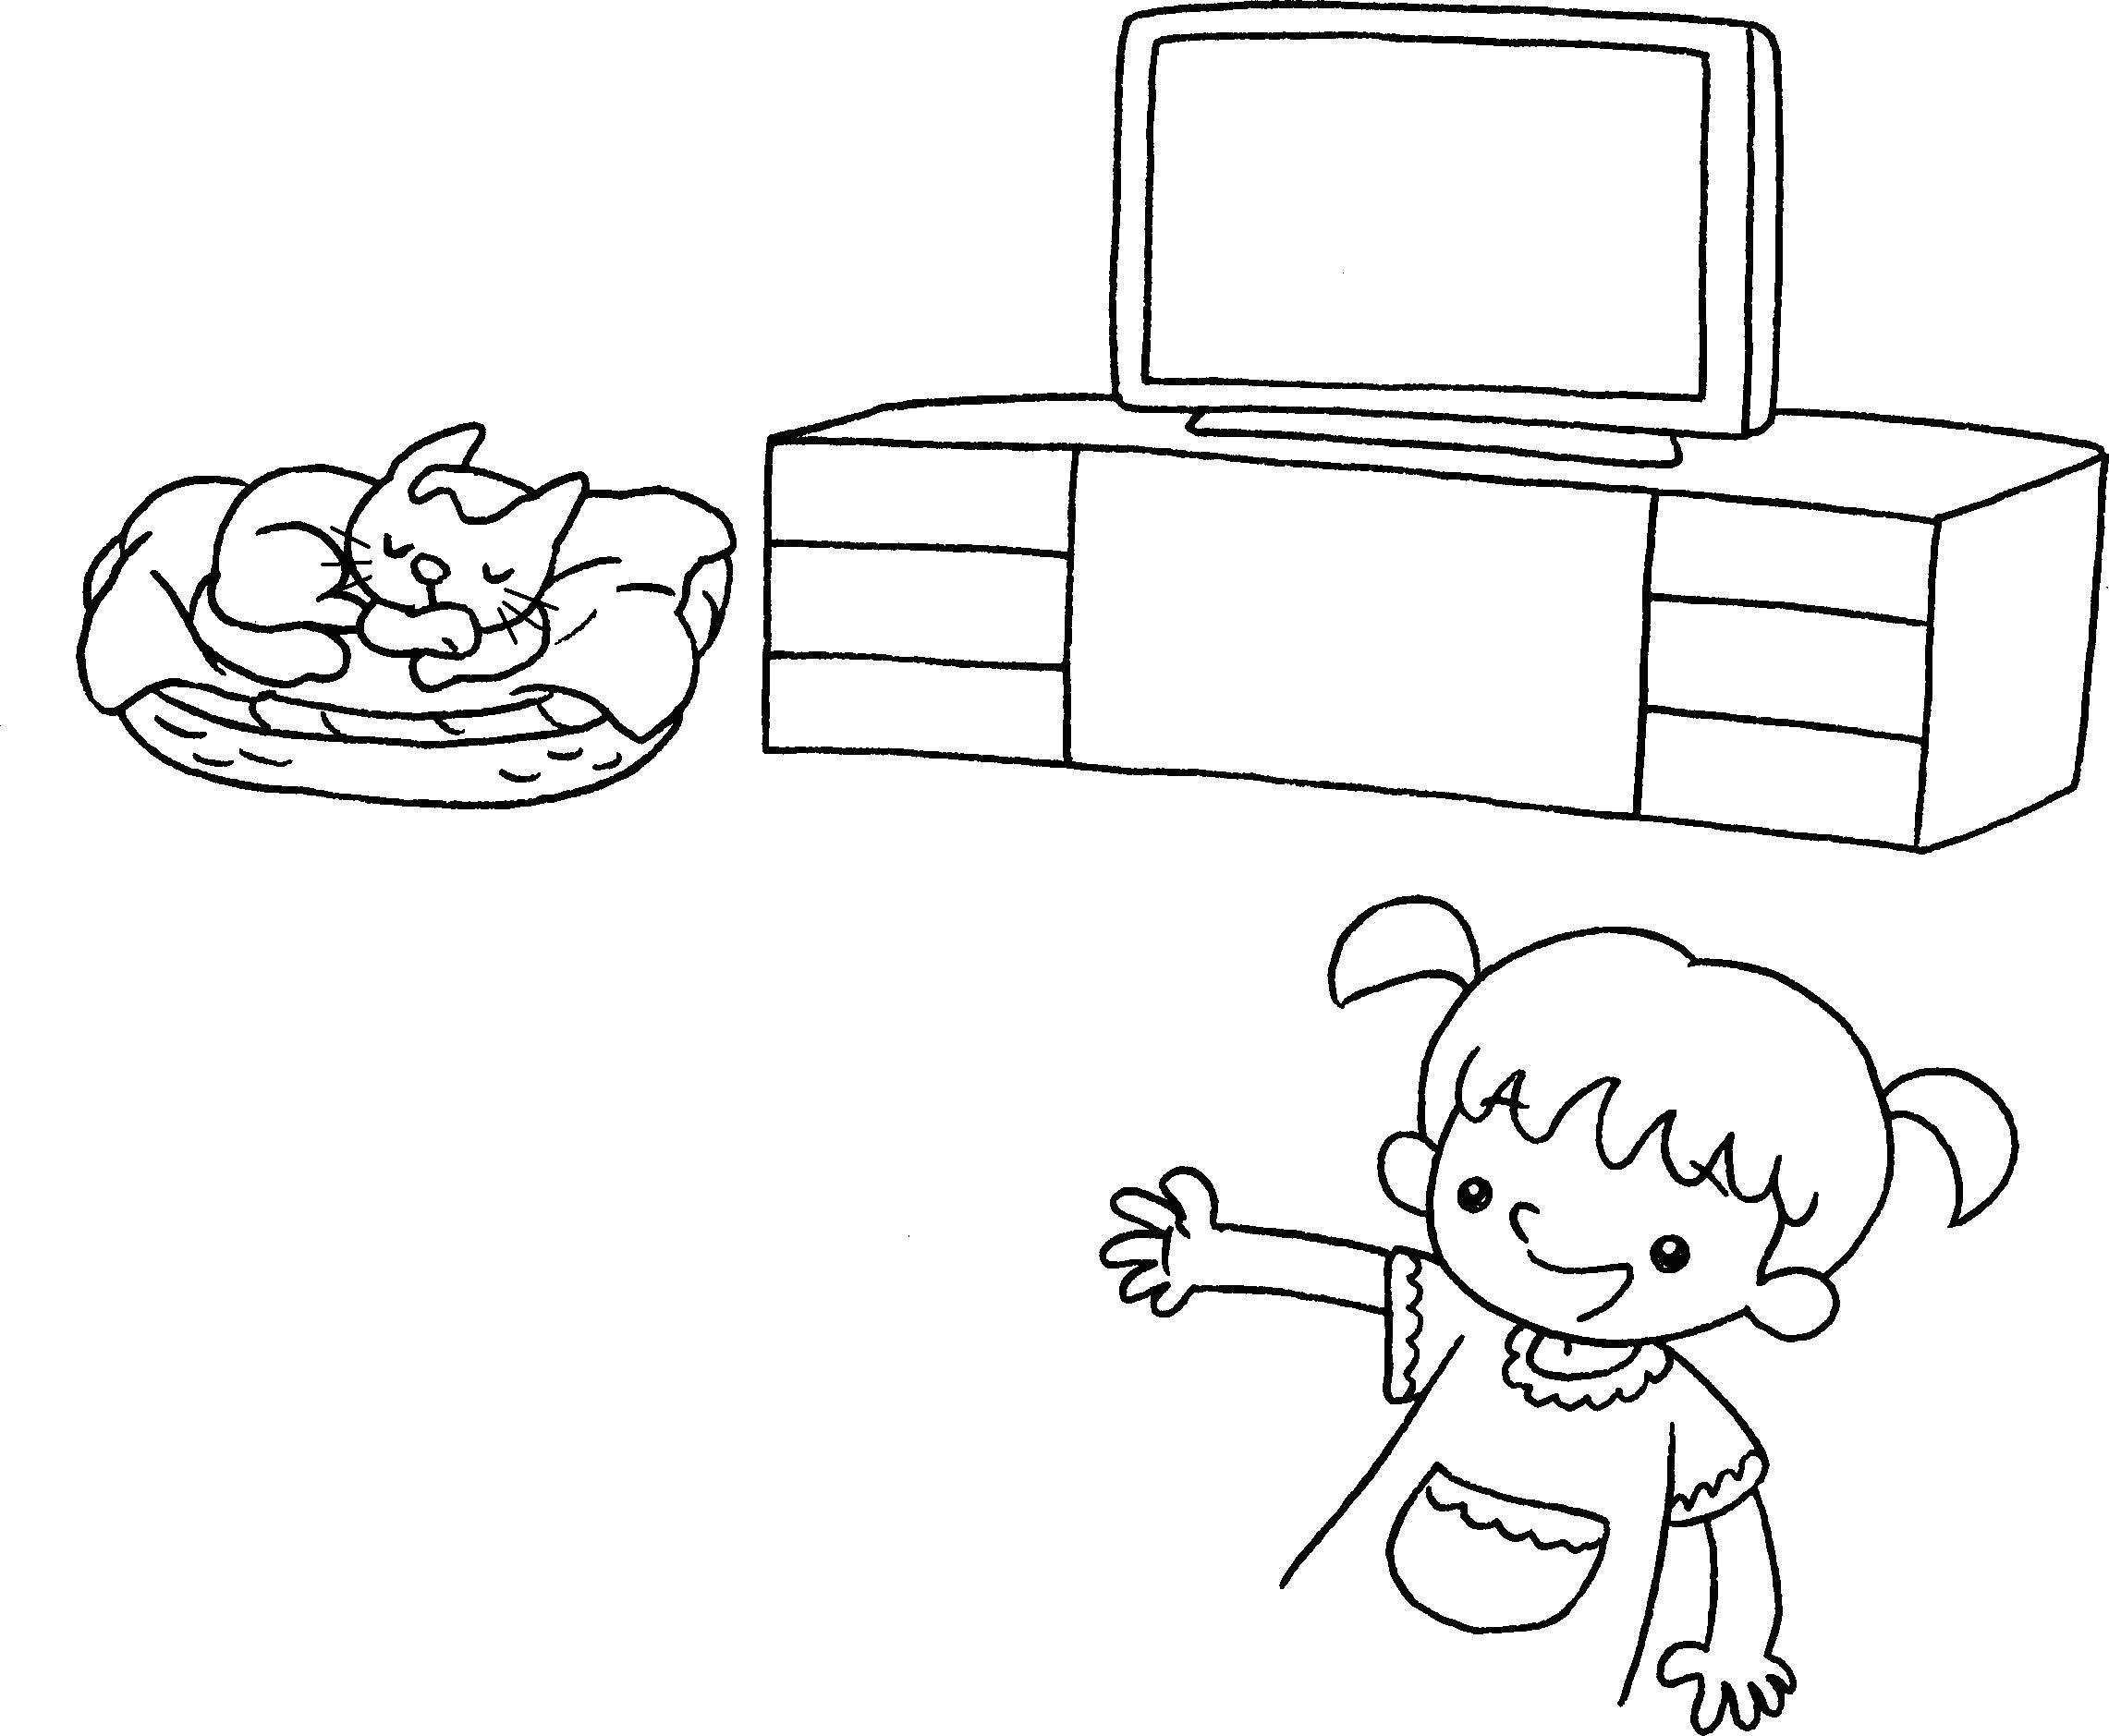
 | I like _______ ___________ . |  | I like _________ _______ .


Book 1A Chapter 5 Graded Worksheets
Worksheet 2⬇⬇⬇
1 this
2 those
3 these turtles
4 that cat

