Choose and write.

It is They are
1 | 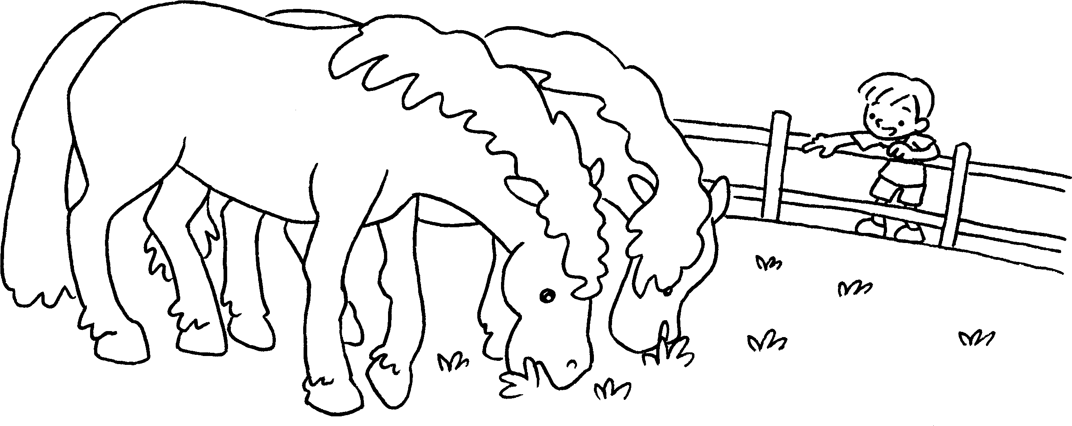 | Look at those horses.  big.
2  …  …  …  …  … | 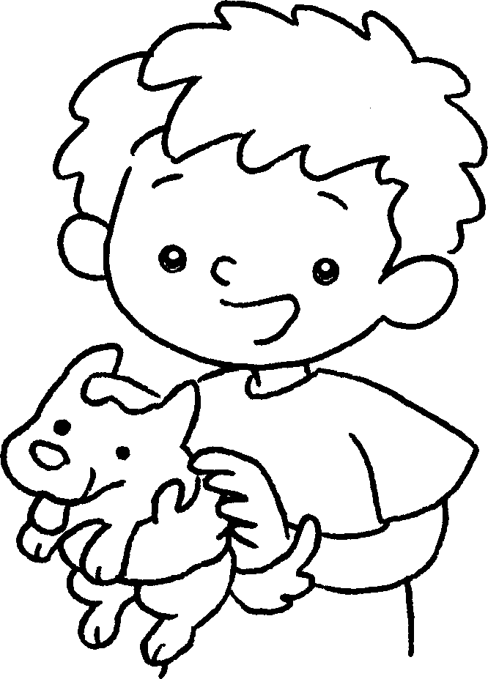 | I like this dog.  small.
3 | 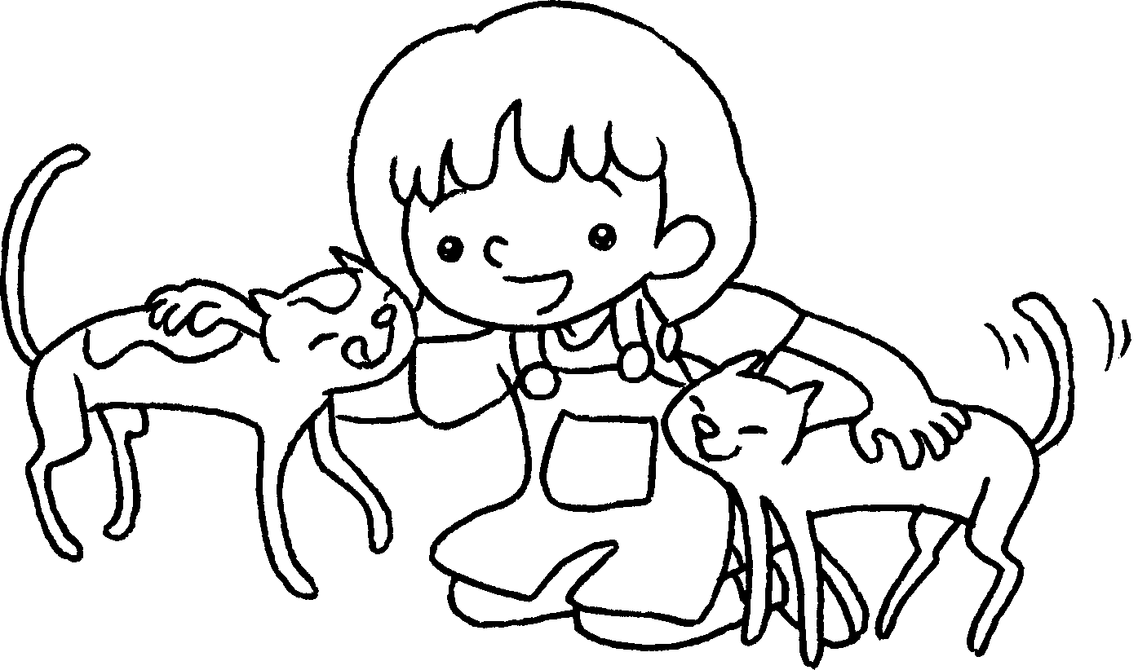 | I like these cats.  thin.
4 | 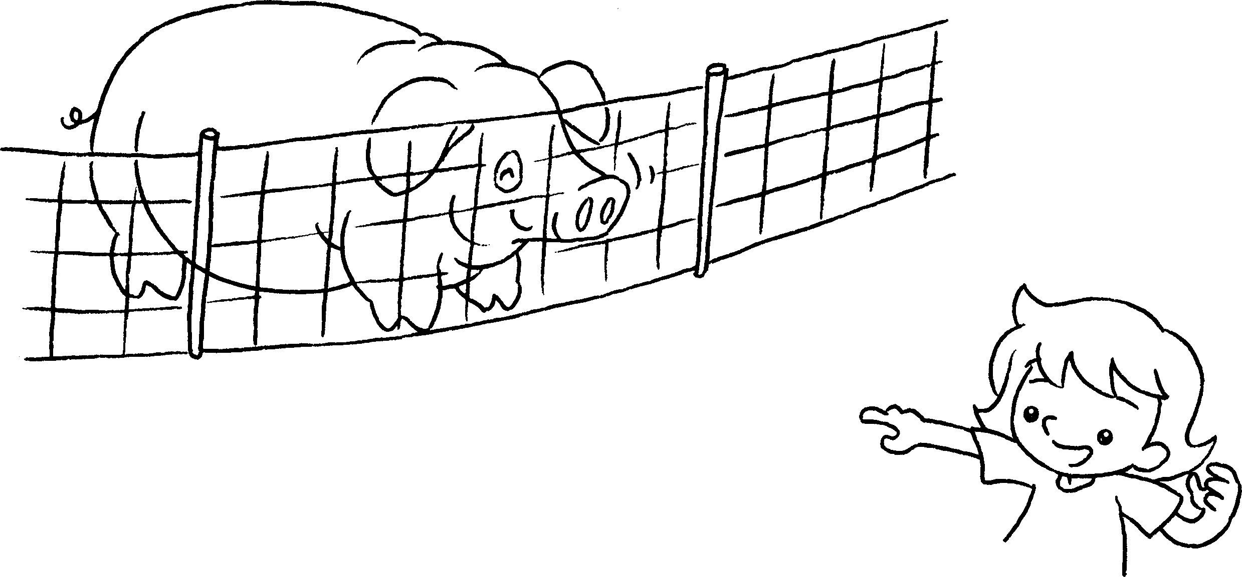 | Look at that pig.  fat.
5 | 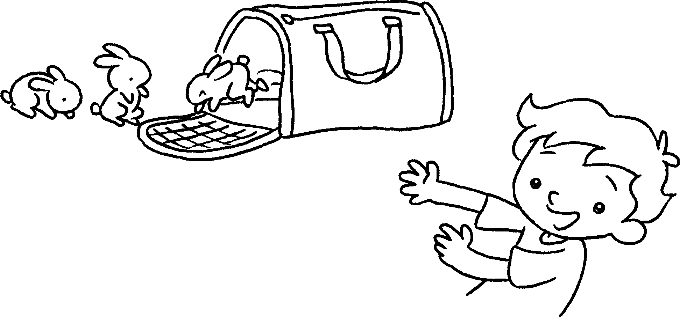 | Look at those rabbits.  small.


Book 1A Chapter 5 Graded Worksheets
Worksheet 3⬇
- They are
- It is
- They are
- It is
- They are

