Circle and write.

It / They is / are
1 | 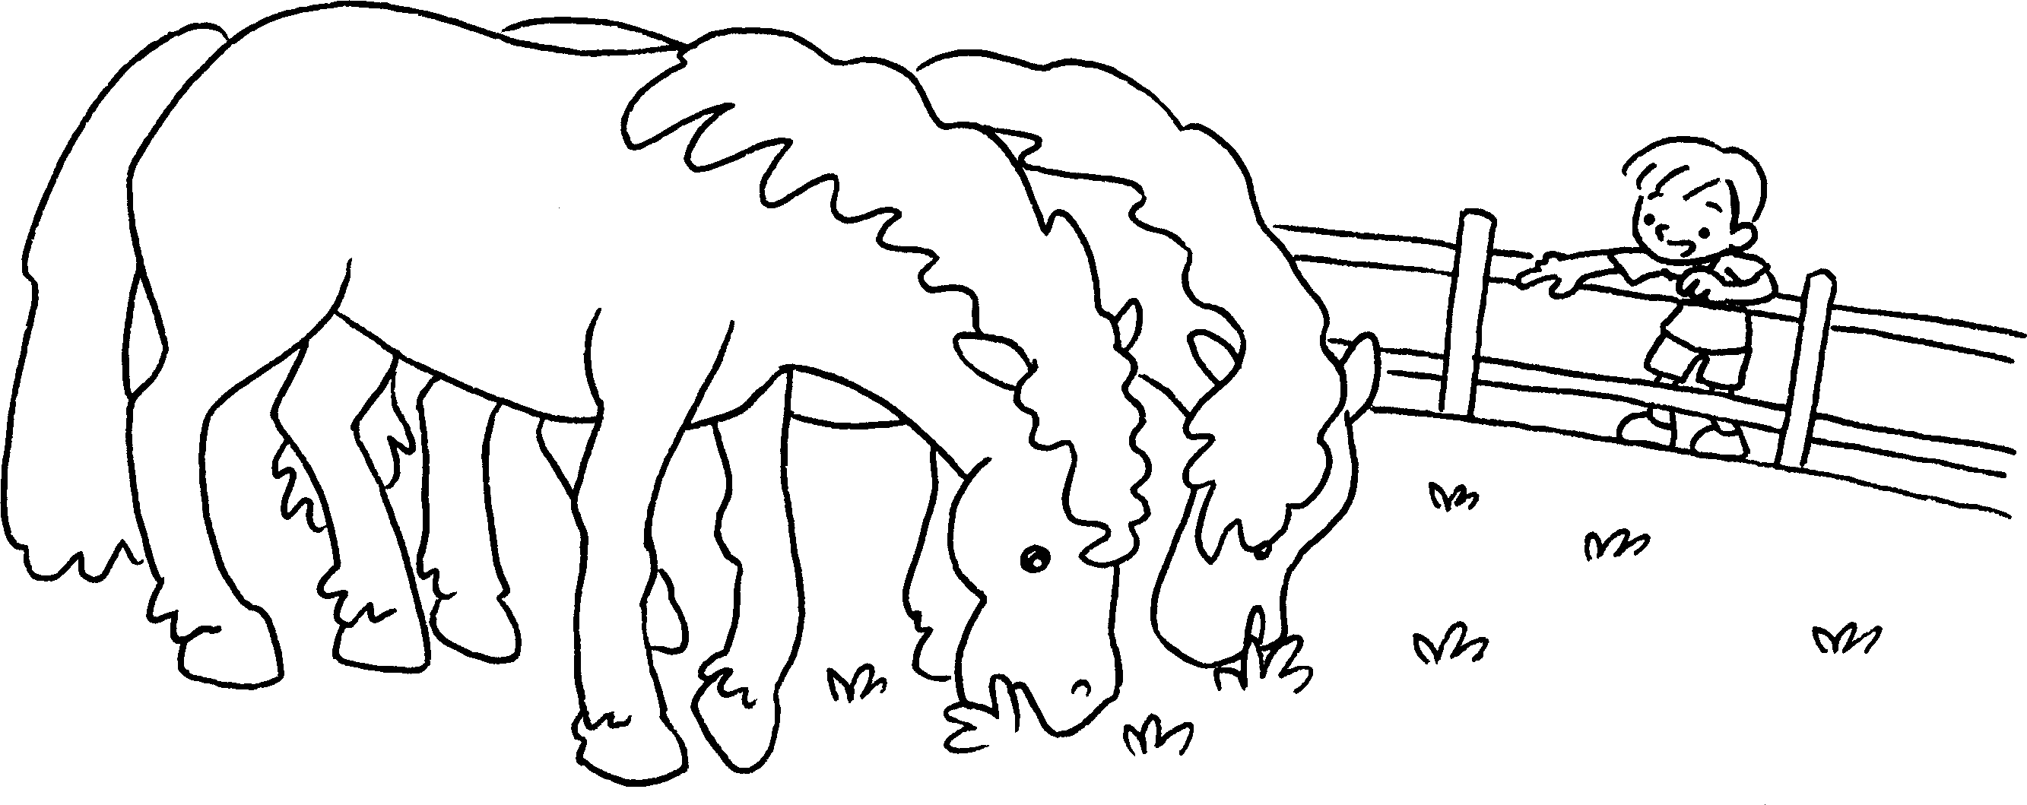 | Look at those horses.  They big.
2  …  …  …  …  … | 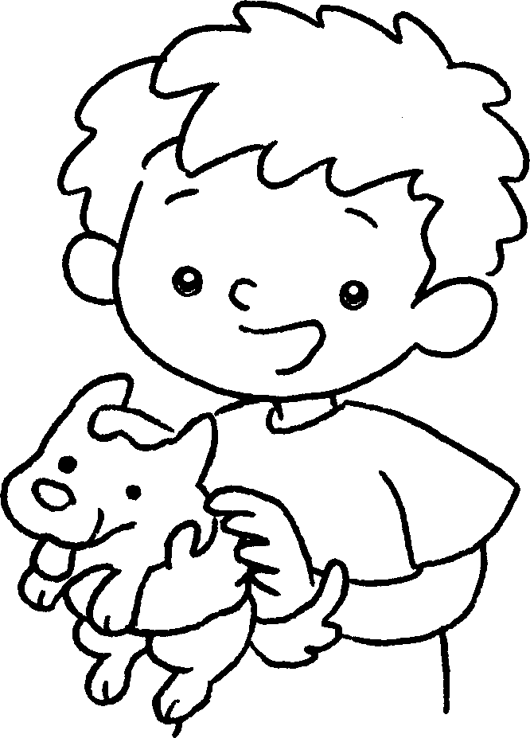 | I like this dog.  small.
3 | 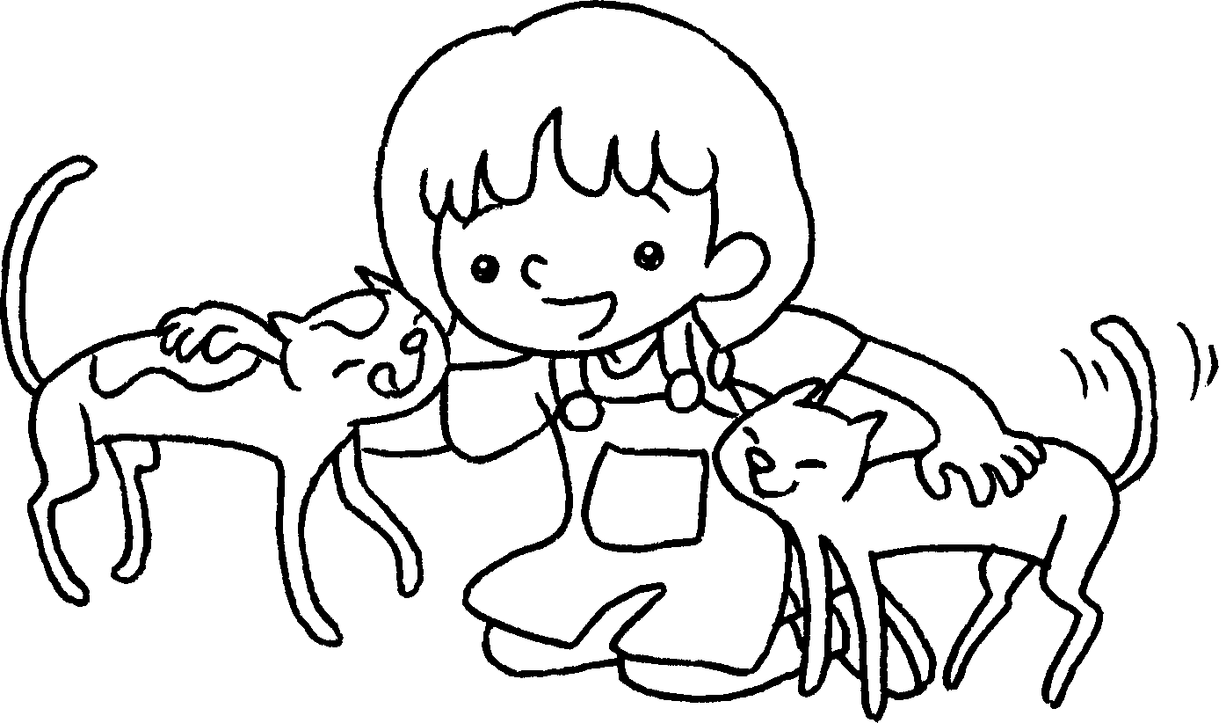 | I like ( those / these ) cats.  ____________________ thin.
4 | 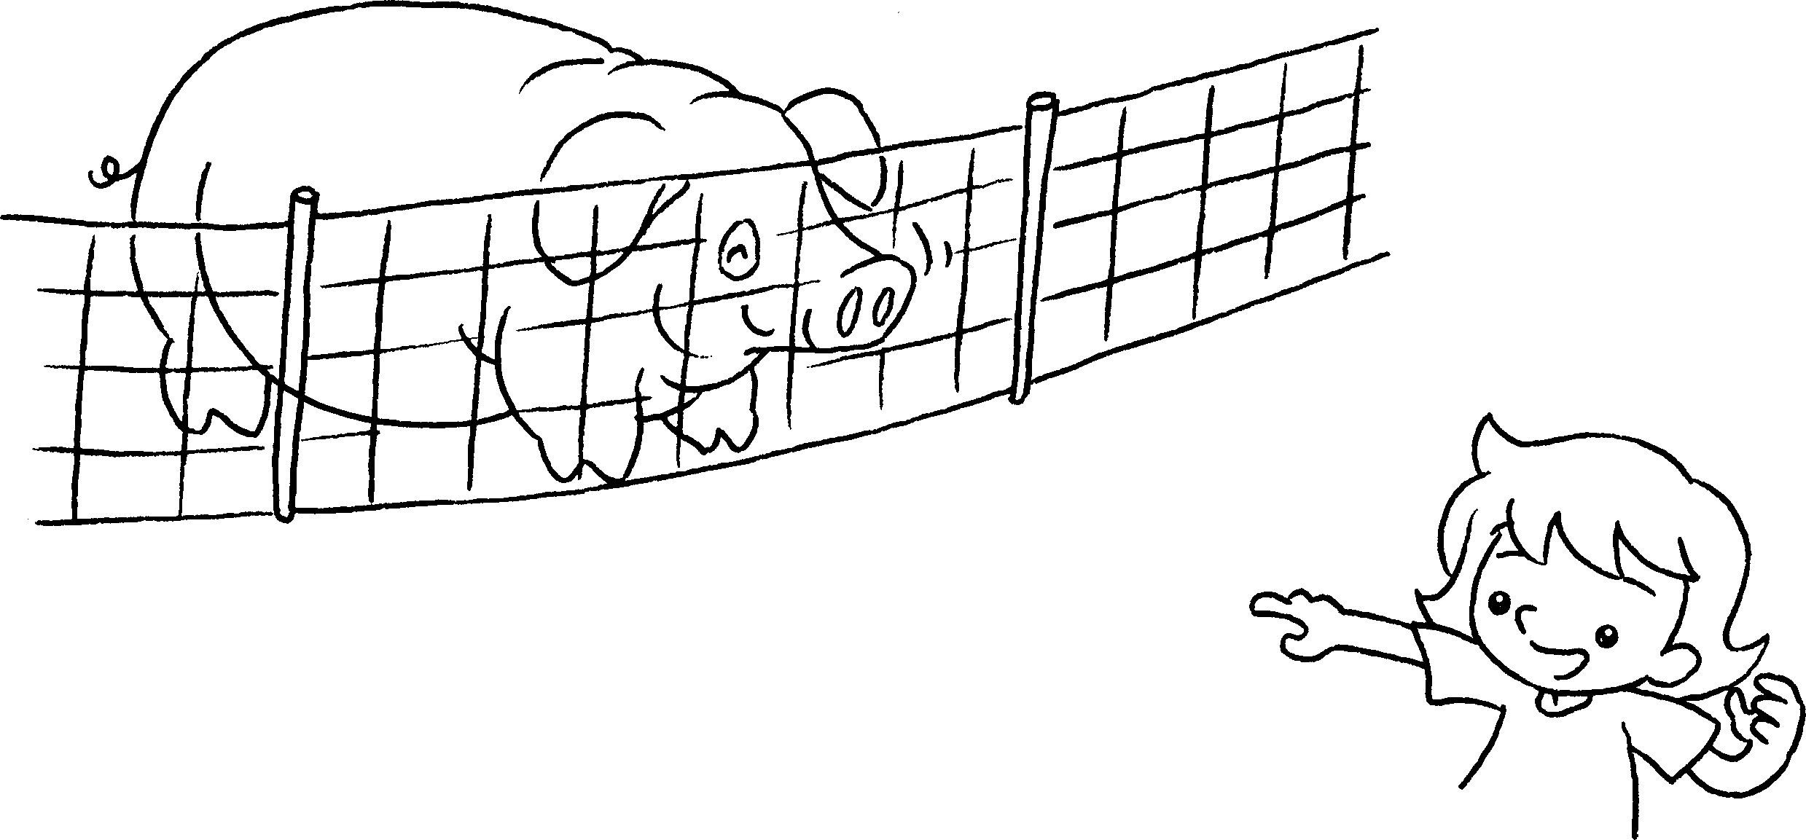 | Look at ( this / that ) pig.  fat.
5 | 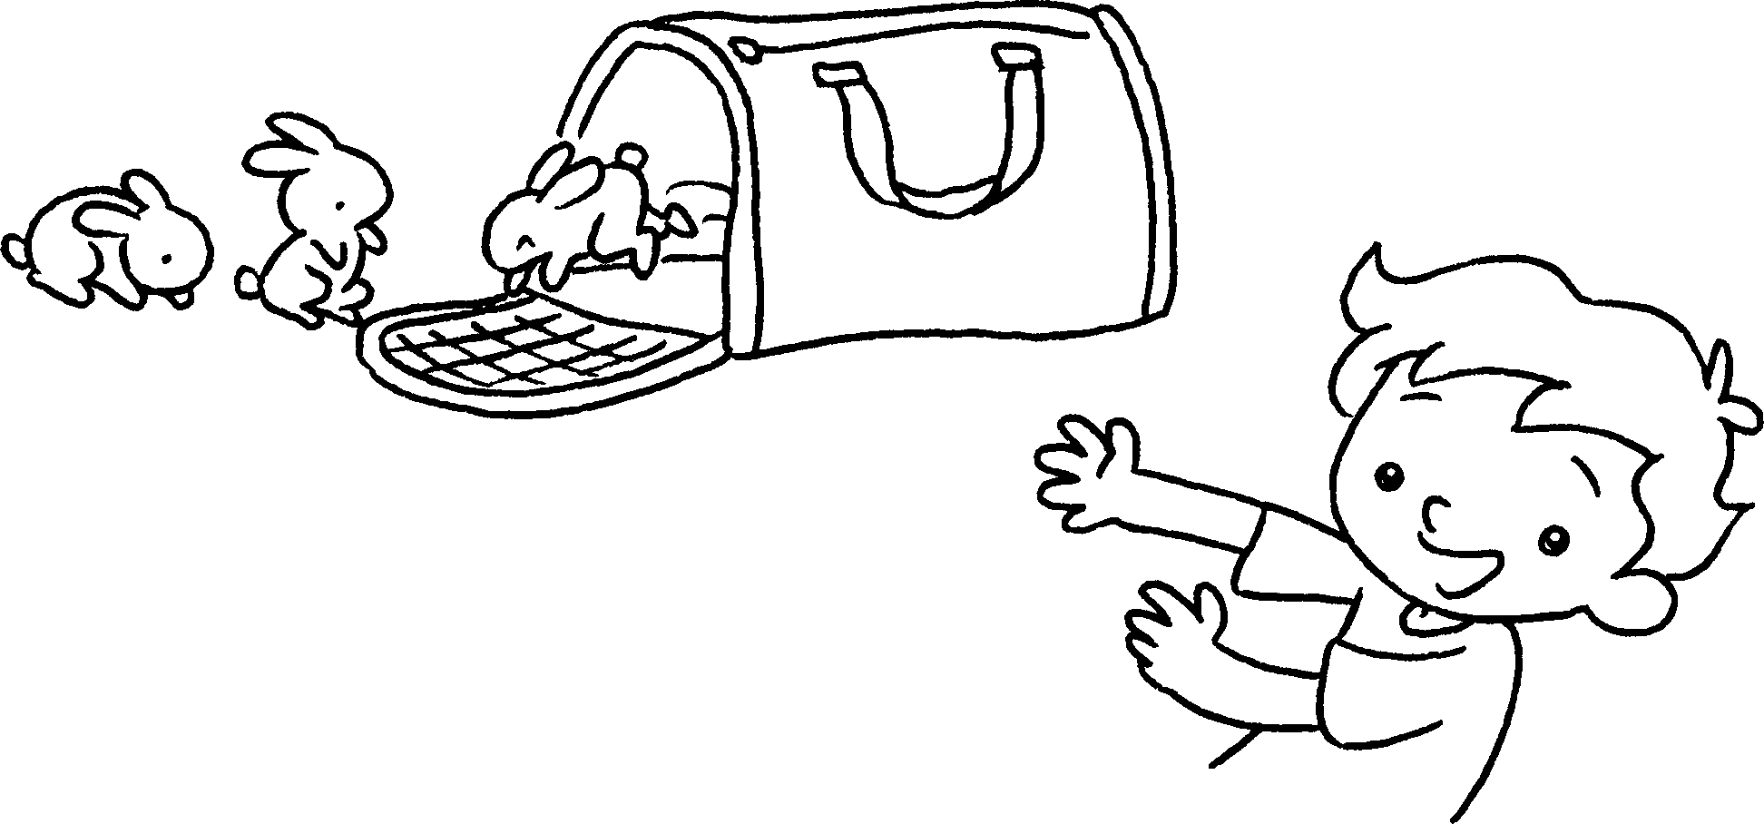 | Look at ( those / that ) rabbits.  small.


Book 1A Chapter 5 Graded Worksheets
Worksheet 3⬇⬇
- are
- It is
- ( those / these )
They are
- ( this / that )
It is
- ( those / that )
They are

