What are the children saying? Write.
this / that / these / those It / They is / are
1 | 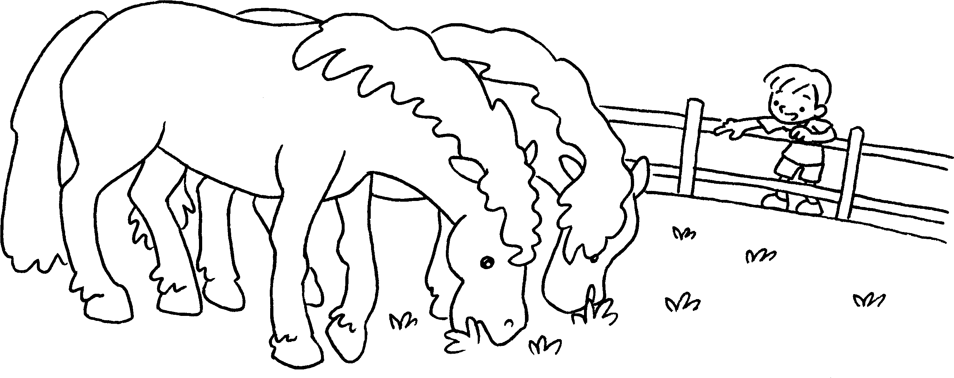 | Look at those horses.  They _________ big.
2  …  …  …  … | 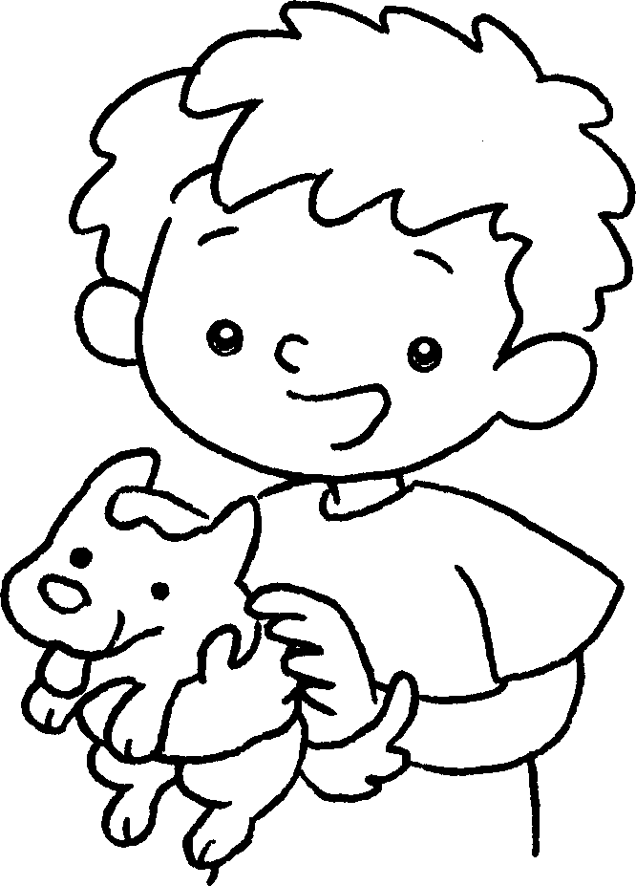  … | I like __________ dog.  __________ is small.
3 | 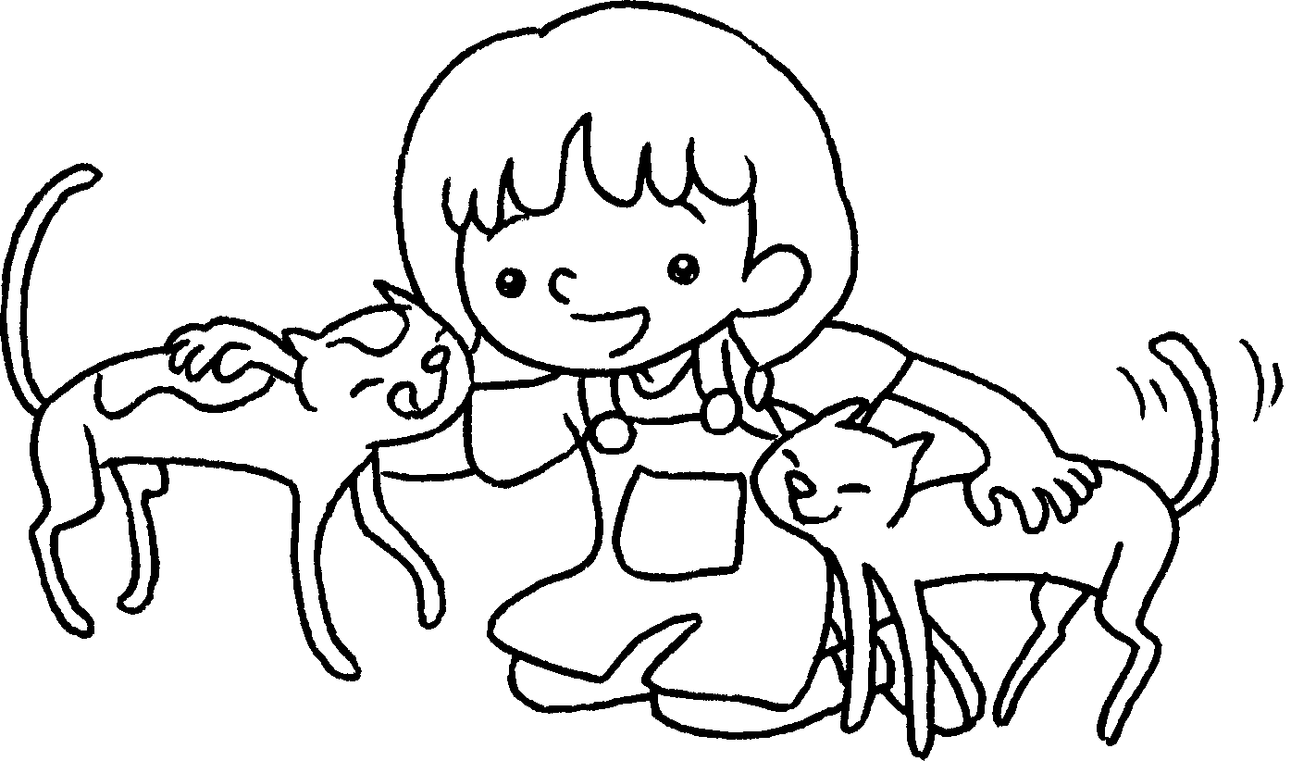 | I like __________ cats.  thin.
4 | 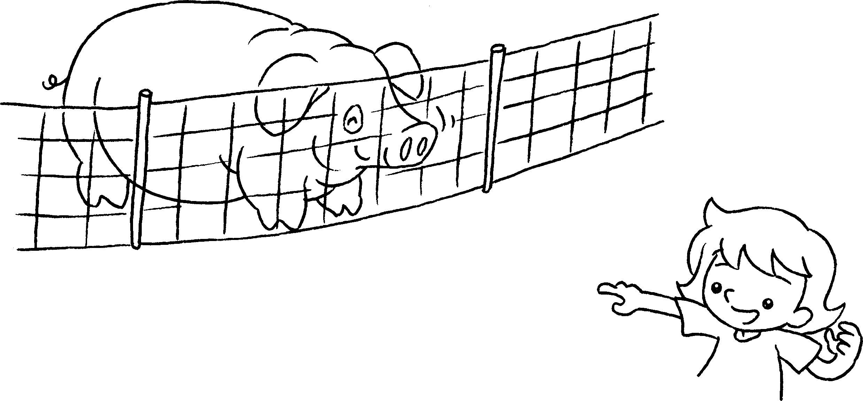 | Look at __________ pig.  fat.
5 | 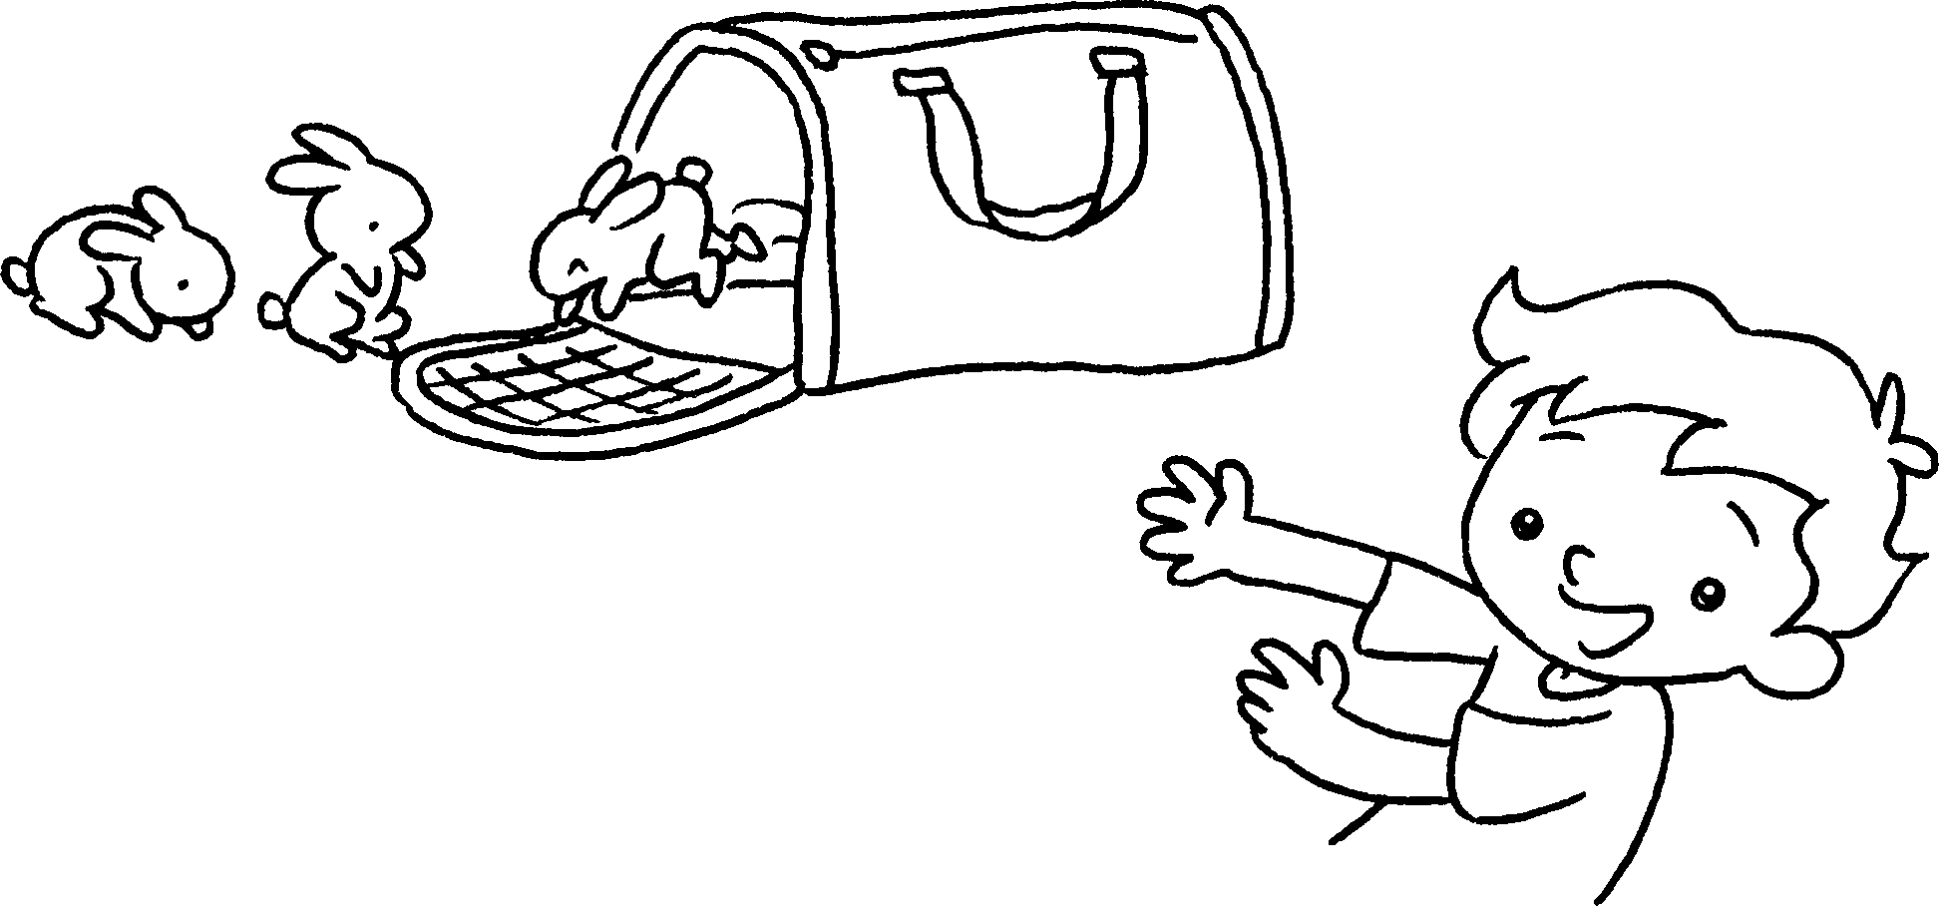 | Look at __________ rabbits.  small.


Book 1A Chapter 5 Graded Worksheets
Worksheet 3⬇⬇⬇
- are
- this
It
- these
They are
- that
It is
- those
They are

