Choose and write.

arm | ear |  | eye |  | foot |  | hair
hand |  | leg |  | mouth |  | nose

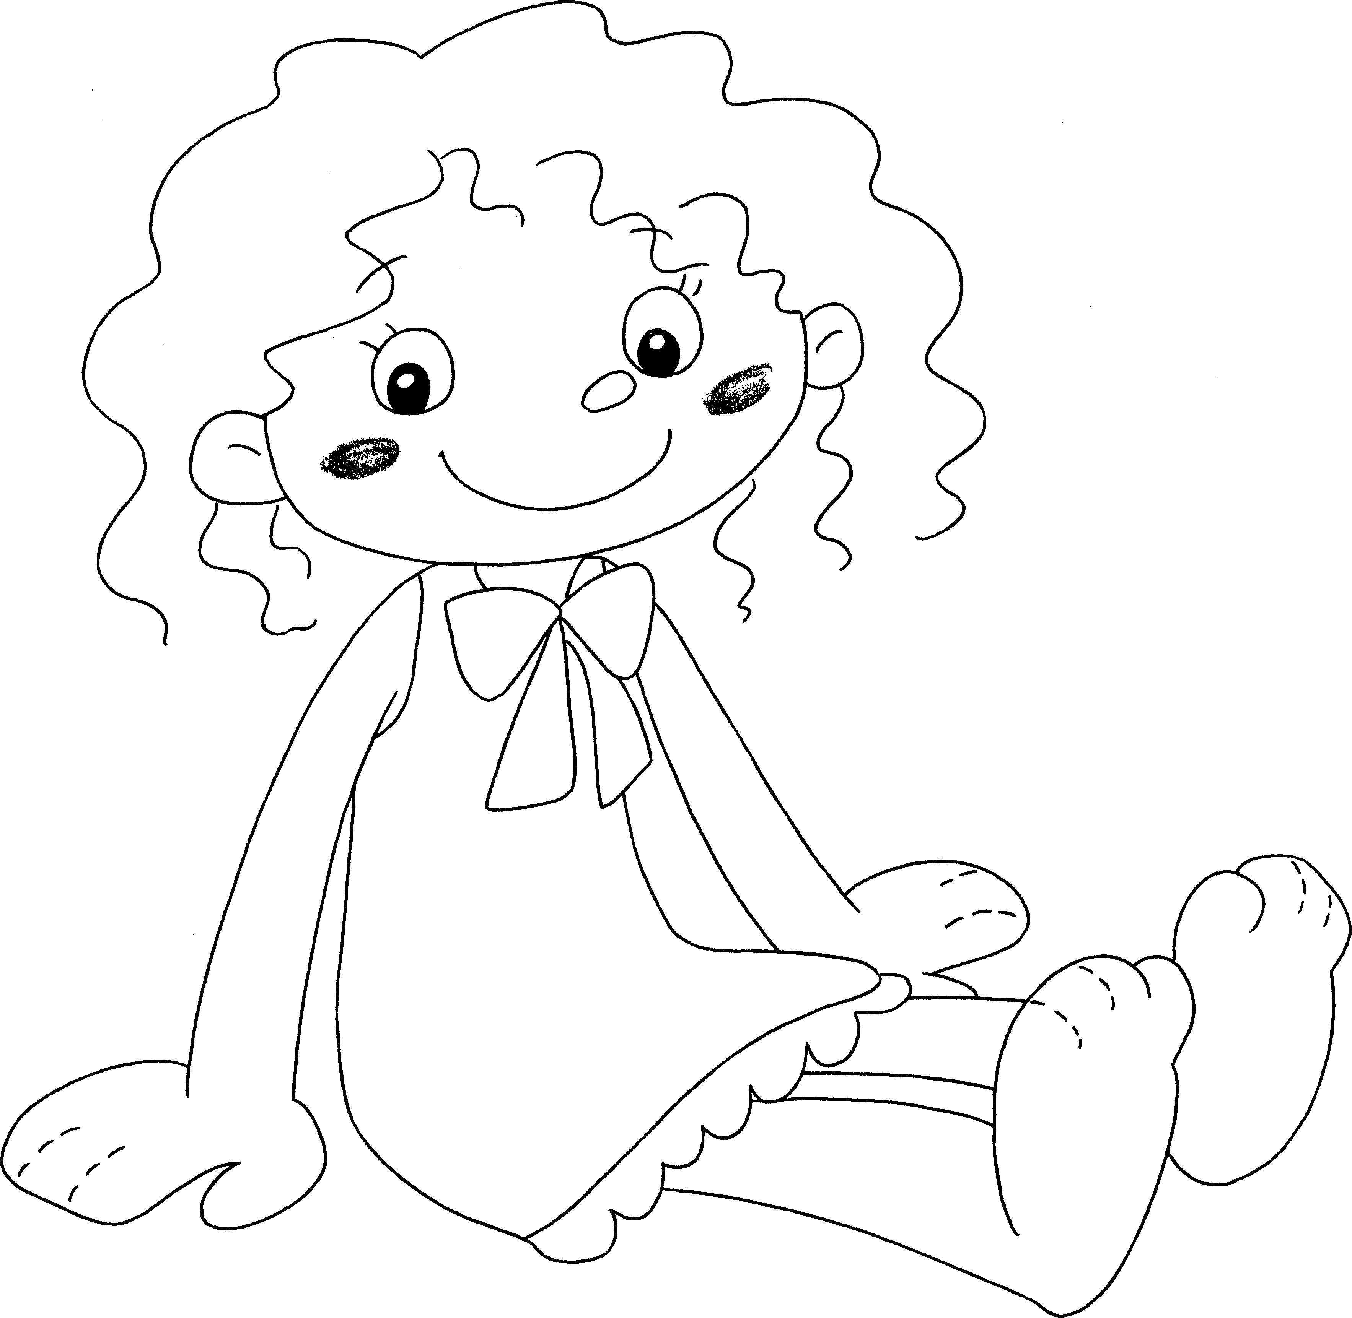
1

3

5

7

9

2

4

6

8

1 |  |  | 2 | an
3 | an |  | 4 | a
5 | a |  | 6 | a
7 | an |  | 8 | a
9 | a


Book 1A Chapter 6 Graded Worksheets
Worksheet 1⬇
- hair 2 ear
3 eye 4 mouth
5 nose 6 leg
7 arm 8 foot
9 hand

