Fill in the missing letters.

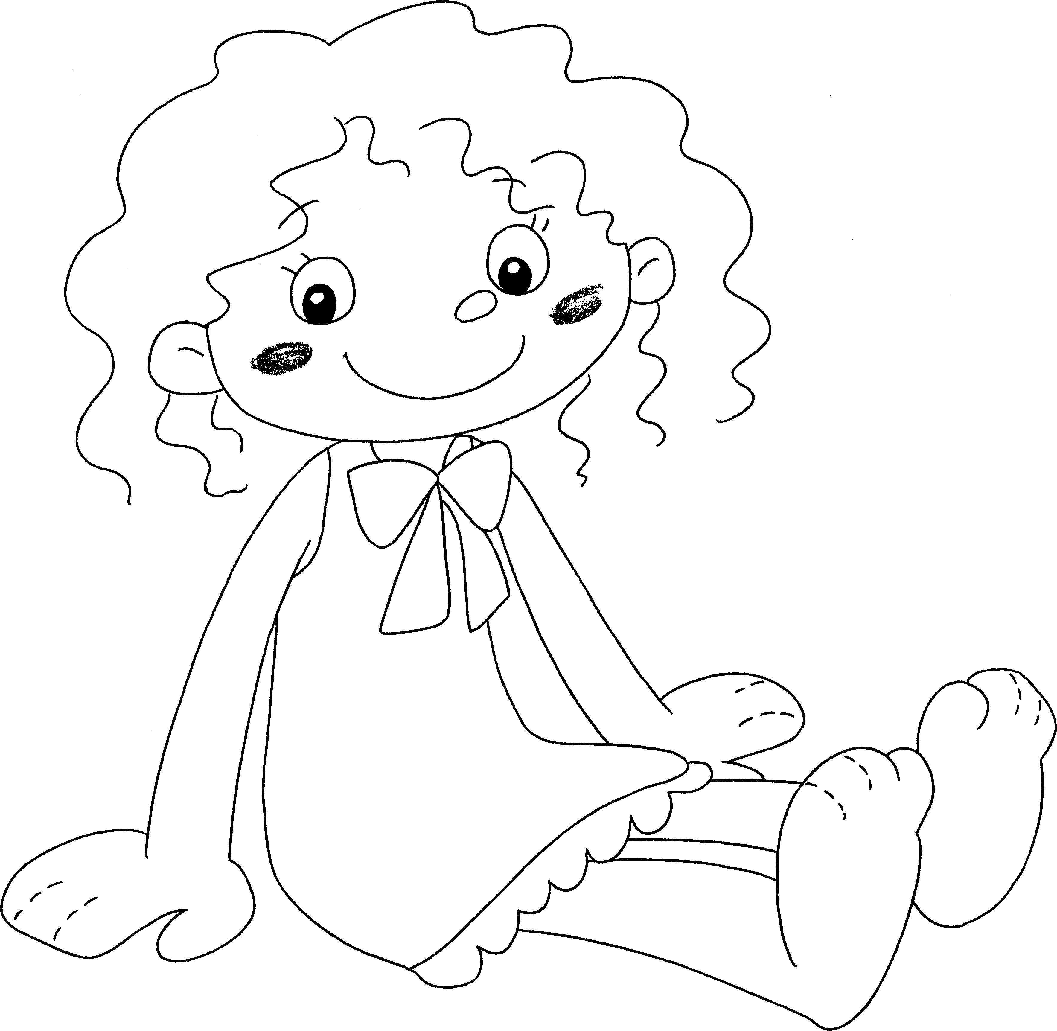
1

3

5

7

9

2

4

6

8

1 | h __ __ __ |  | 2 | an e __ __
3 | an e __ __ |  | 4 | a m __ __ __ __
5 | a n __ __ __ |  | 6 | a l __ __
7 | an a __ __ |  | 8 | a f __ __ __
9 | a h __ __ __


Book 1A Chapter 6 Graded Worksheets
Worksheet 1⬇⬇
1 h a i r 2 e a r
3 e y e 4 m o u t h
5 n o s e 6 l e g
7 a r m 8 f o o t
9 h a n d

