What are the different body parts? Write.

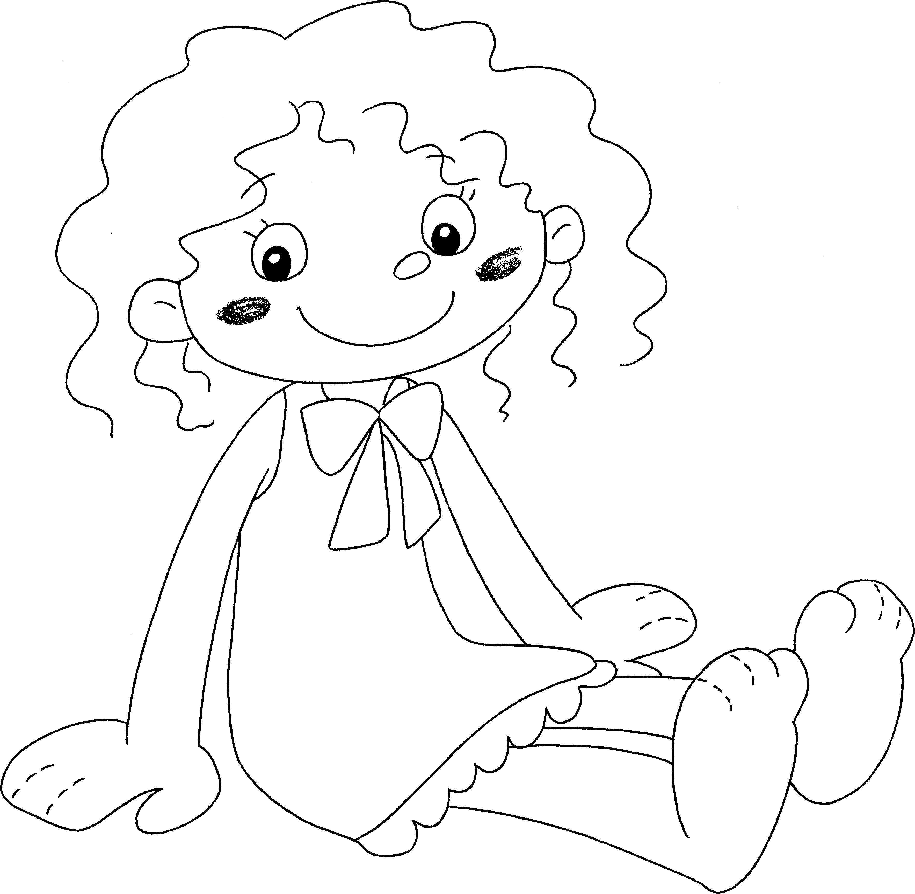
1

3

5

7

9

2

4

6

8

1 | h |  | 2 | an e
3 |  |  | 4
5 |  |  | 6
7 |  |  | 8
9


Book 1A Chapter 6 Graded Worksheets
Worksheet 1⬇⬇⬇
1 hair 2 ear
3 an eye 4 a mouth
5 a nose 6 a leg
7 an arm 8 a foot
9 a hand

