Circle the correct answers.
1 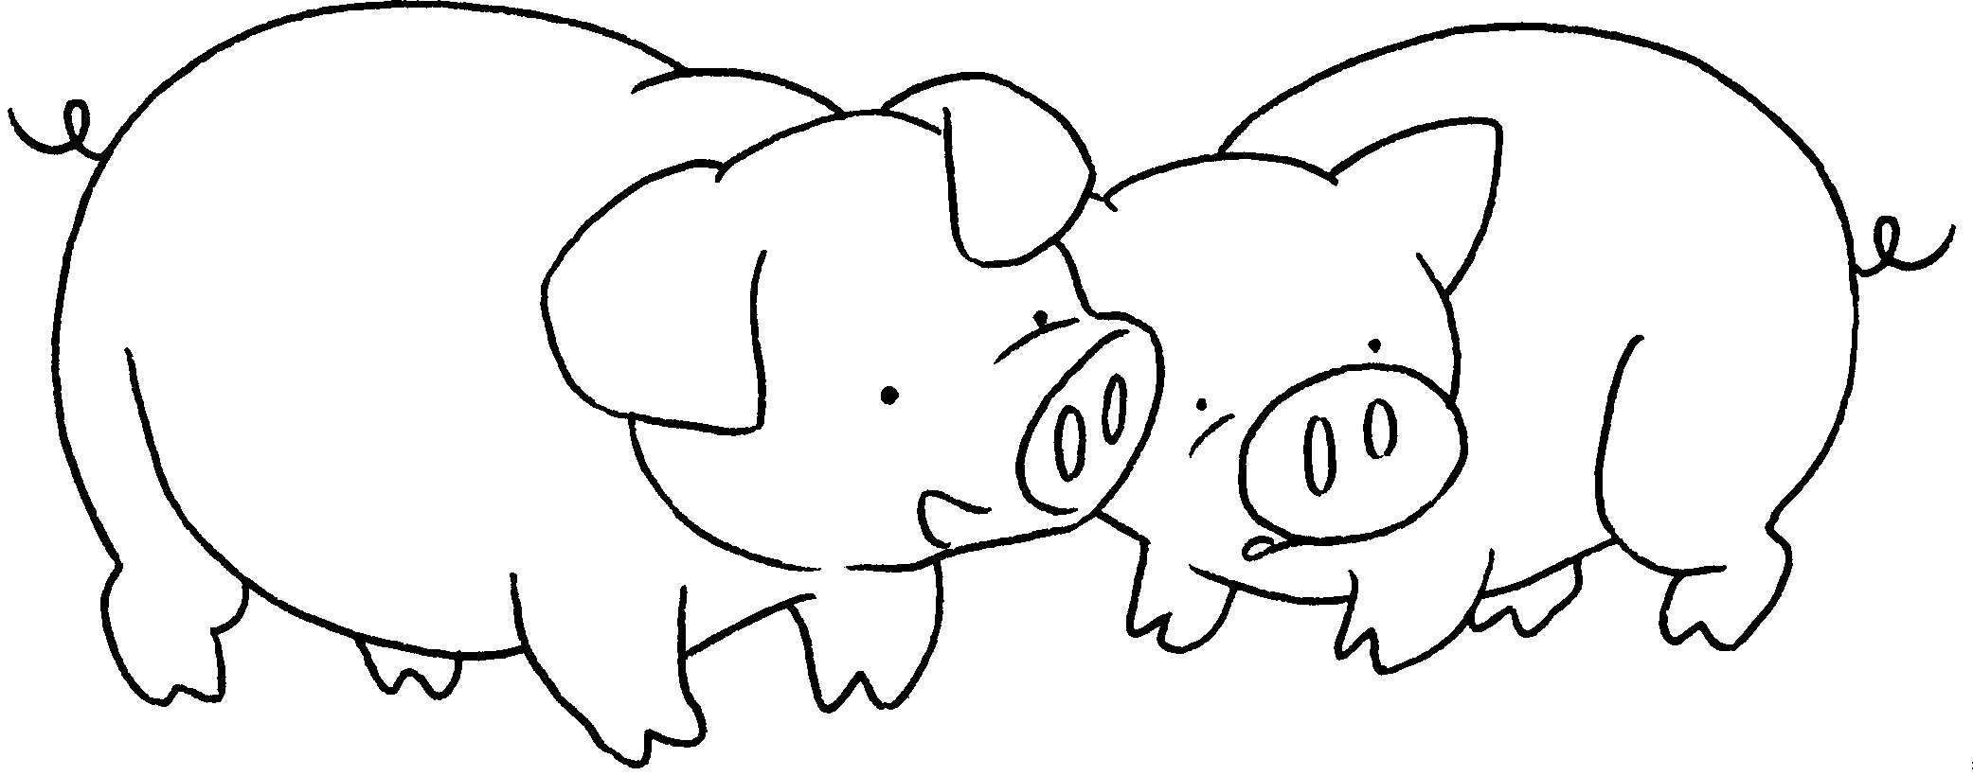 | These are my pigs.  They have ( big / small ) eyes.
2 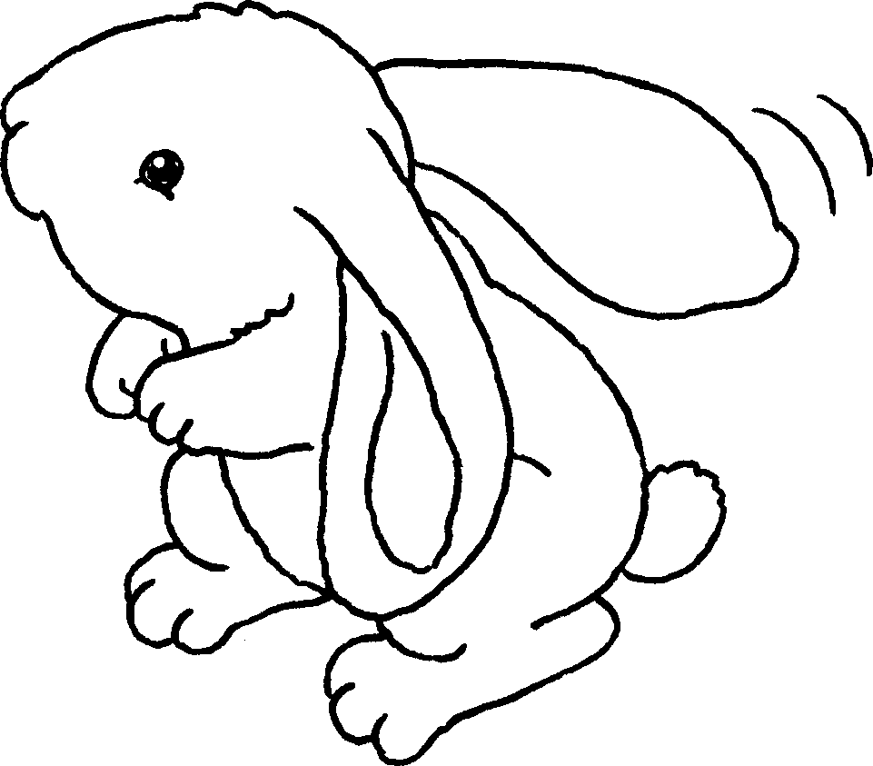 | This is my rabbit.  It has ( big / small ) ears.
3 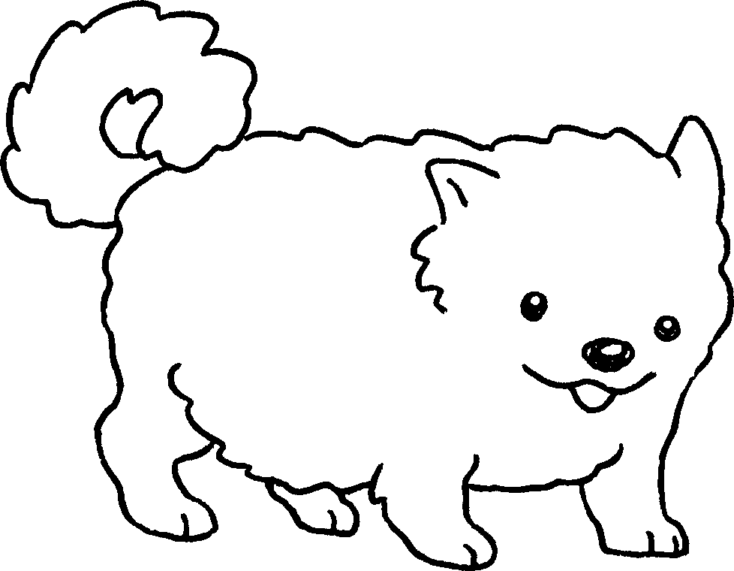 | This is my dog.  It has ( long / short ) legs.
4 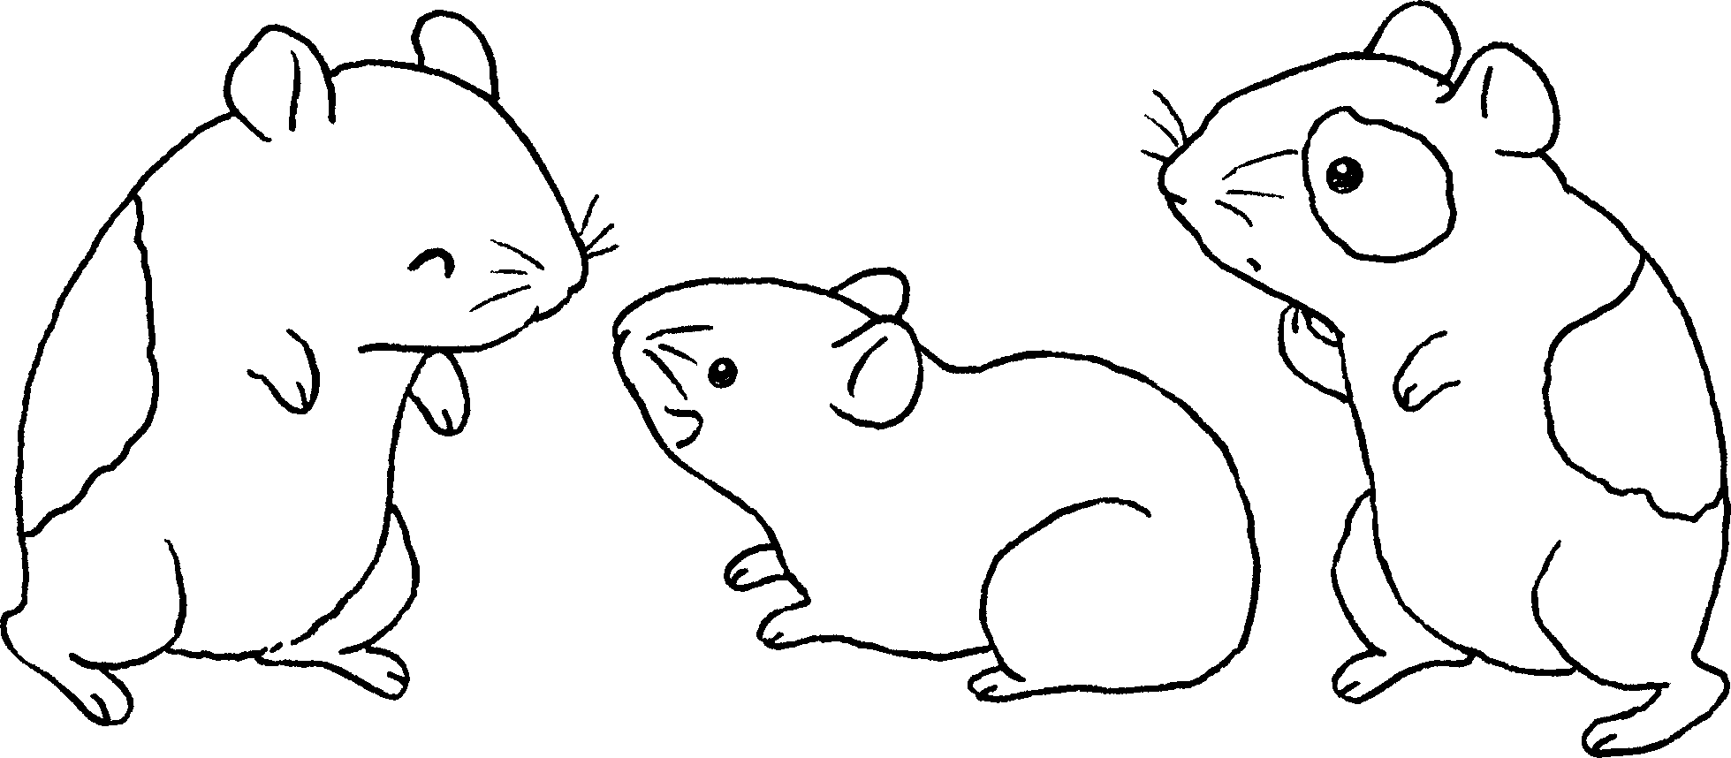 | These are my hamsters.  They have ( big / small ) feet.
5 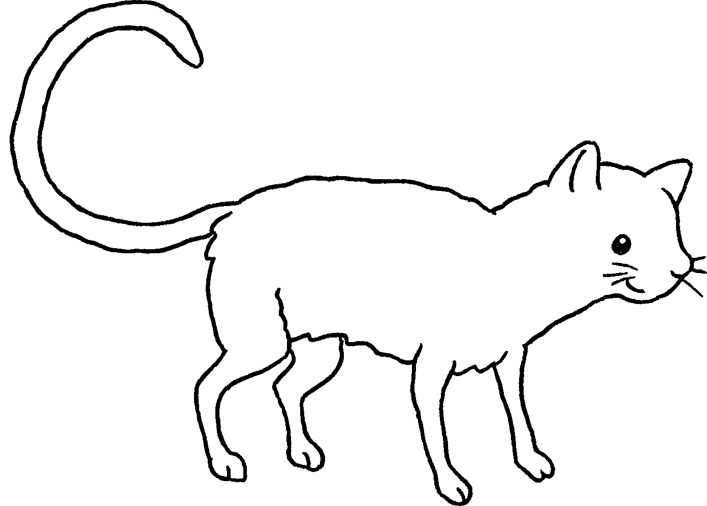 | This is my cat.  It has a ( long / short ) tail.


Book 1A Chapter 6 Graded Worksheets
Worksheet 2⬇
- ( big / small )
- ( big / small )
- ( long / short )
- ( big / small )
- ( long / short )

