Choose and write.
long short big small
1 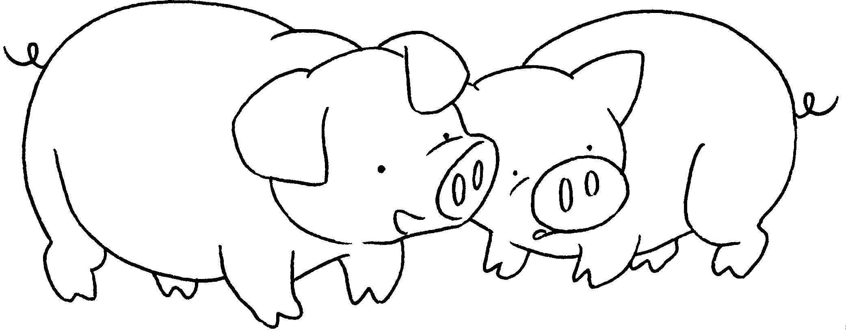 | These are my pigs.  They have __________ eyes.
2 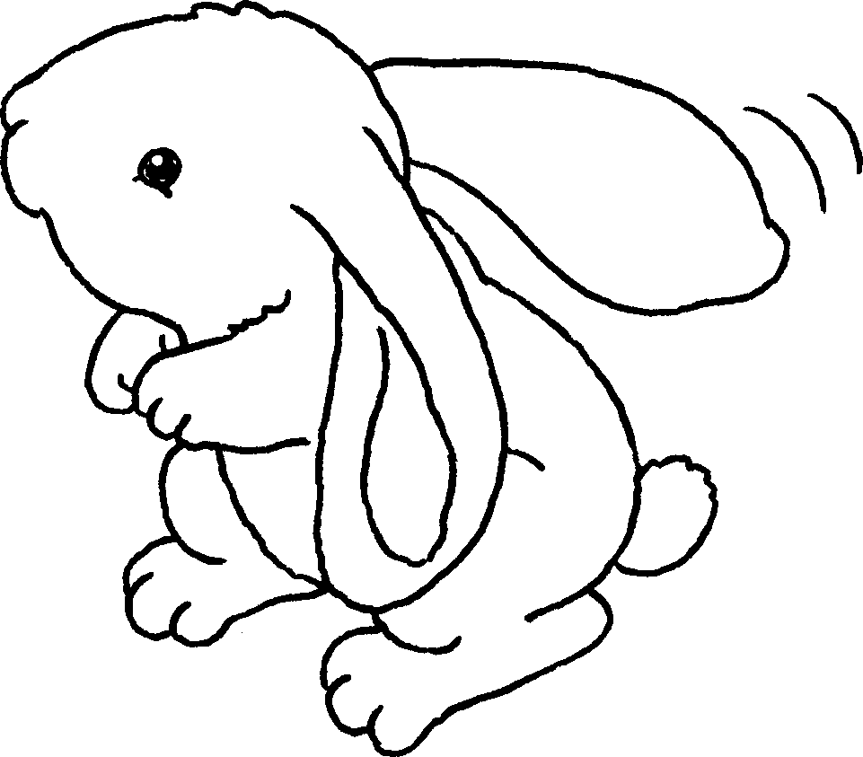 | This is my rabbit.  It has __________ ears.
3 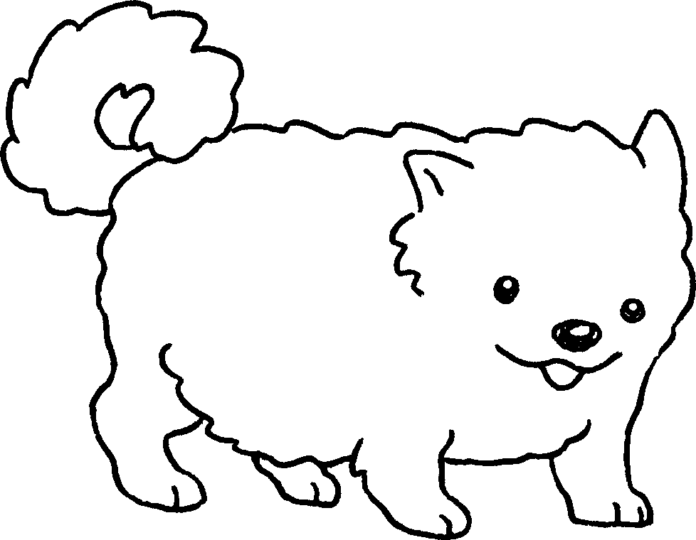 | This is my dog.  It has __________ legs.
4 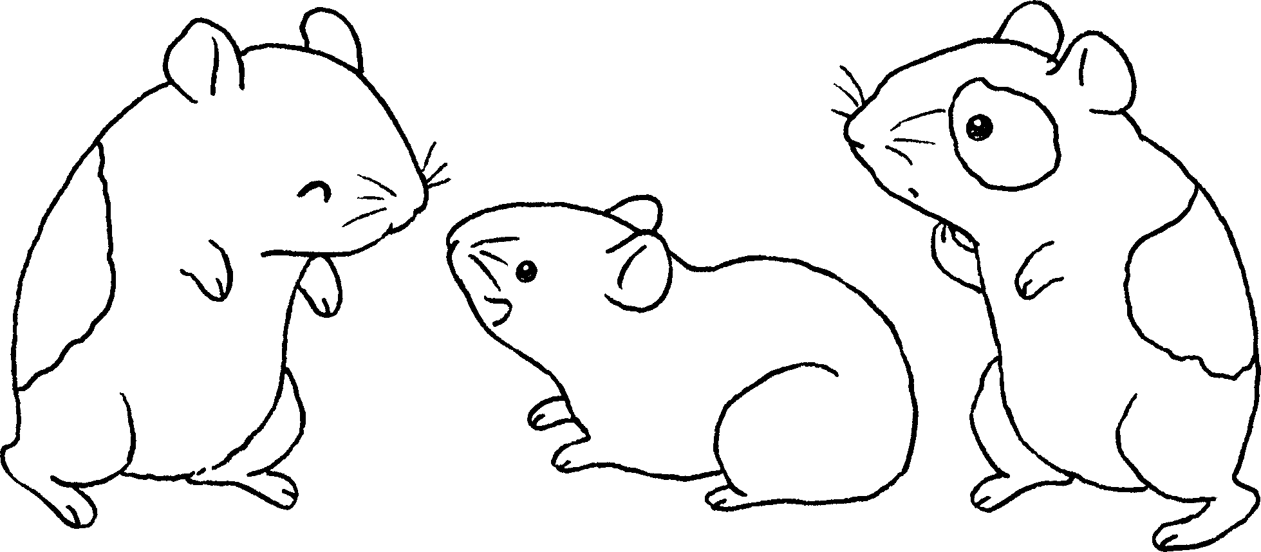 | These are my hamsters.  They have __________ feet.
5 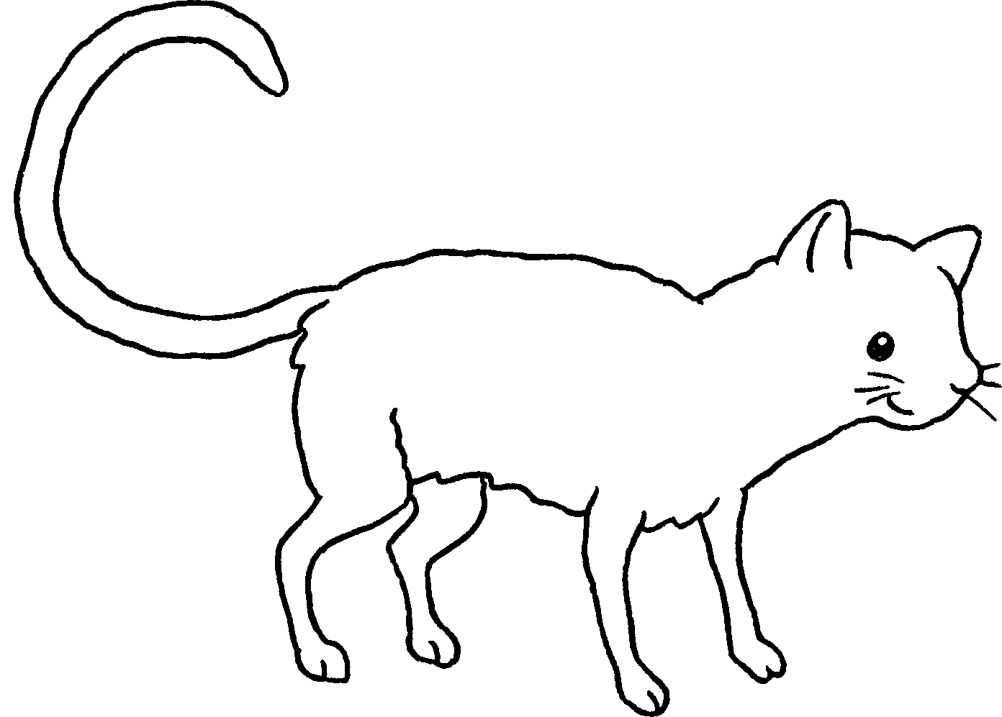 | This is my cat.  It has a __________ tail.


Book 1A Chapter 6 Graded Worksheets
Worksheet 2⬇⬇
- small
- big / long
- short
- small
- long

