Finish the sentences.

1 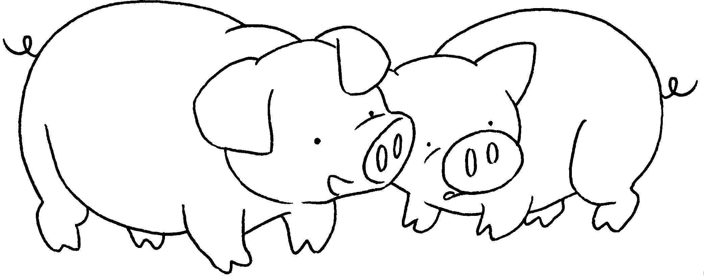 | These are my pigs.  They have small eyes.
2 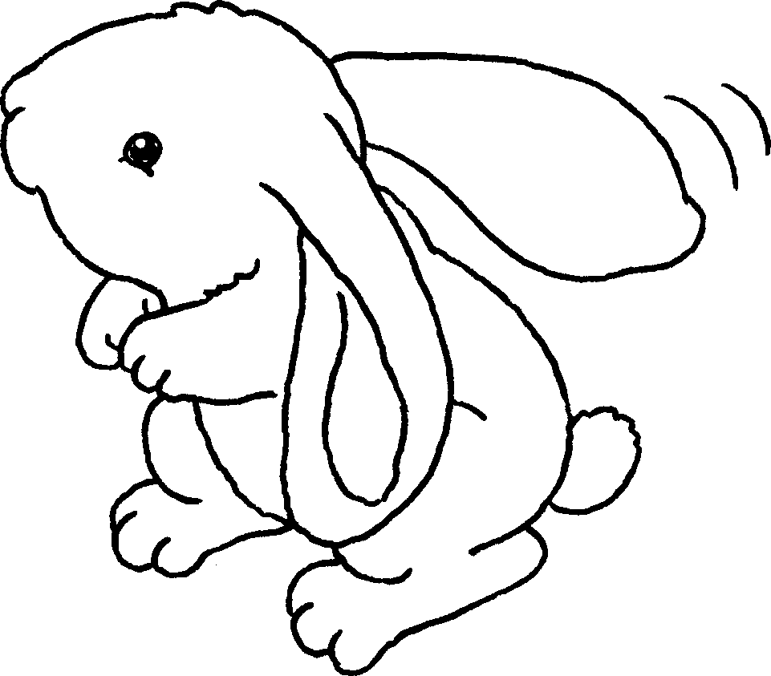 | This is my rabbit.  It has _______ ears.
3 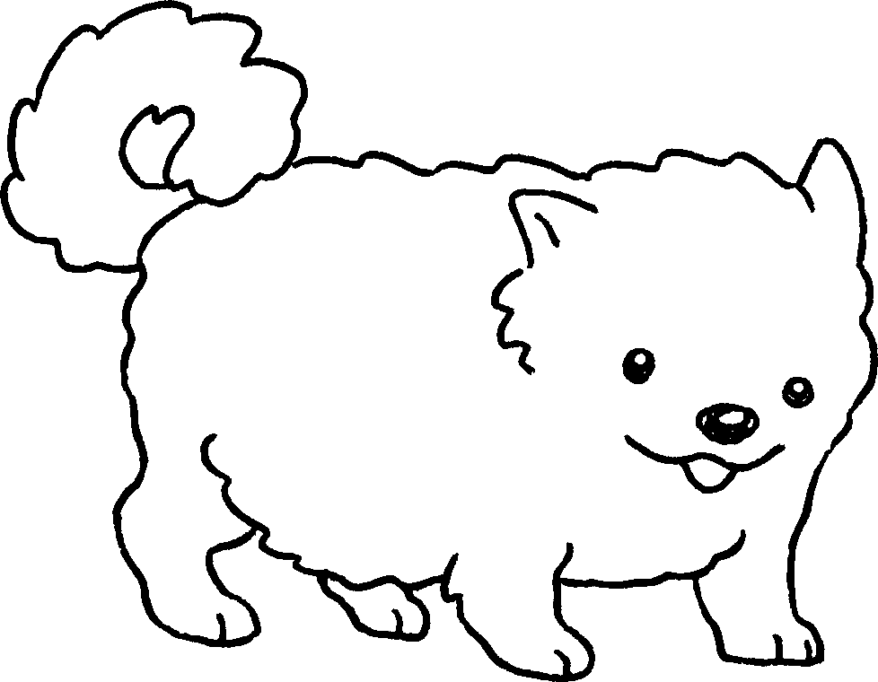 | This is my dog.  It has ________ ________ .
4 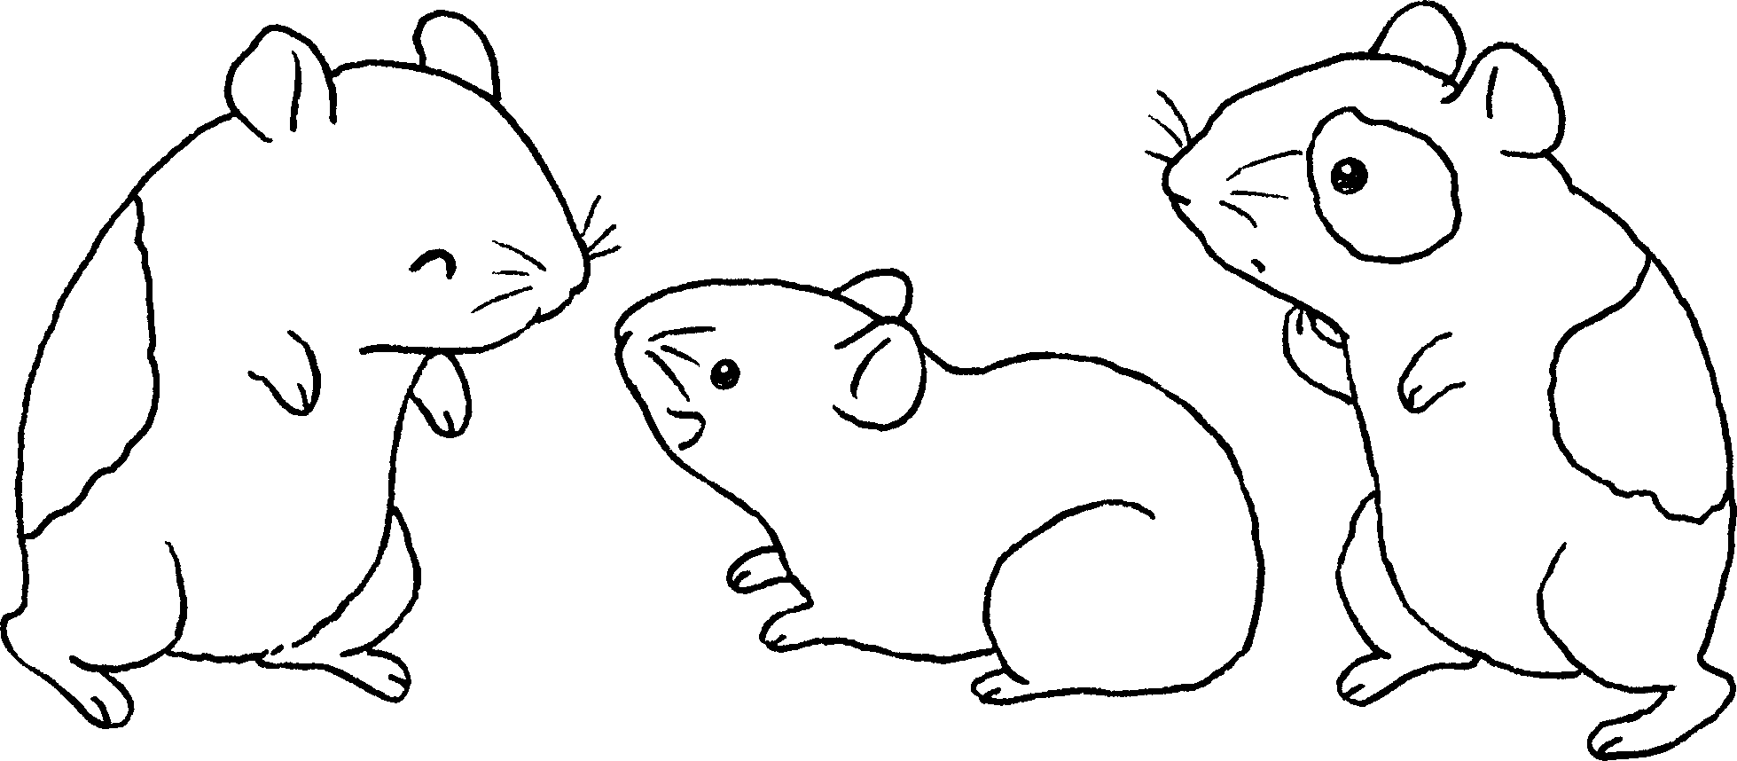 | These are my hamsters.  They have _______ ________ .
5 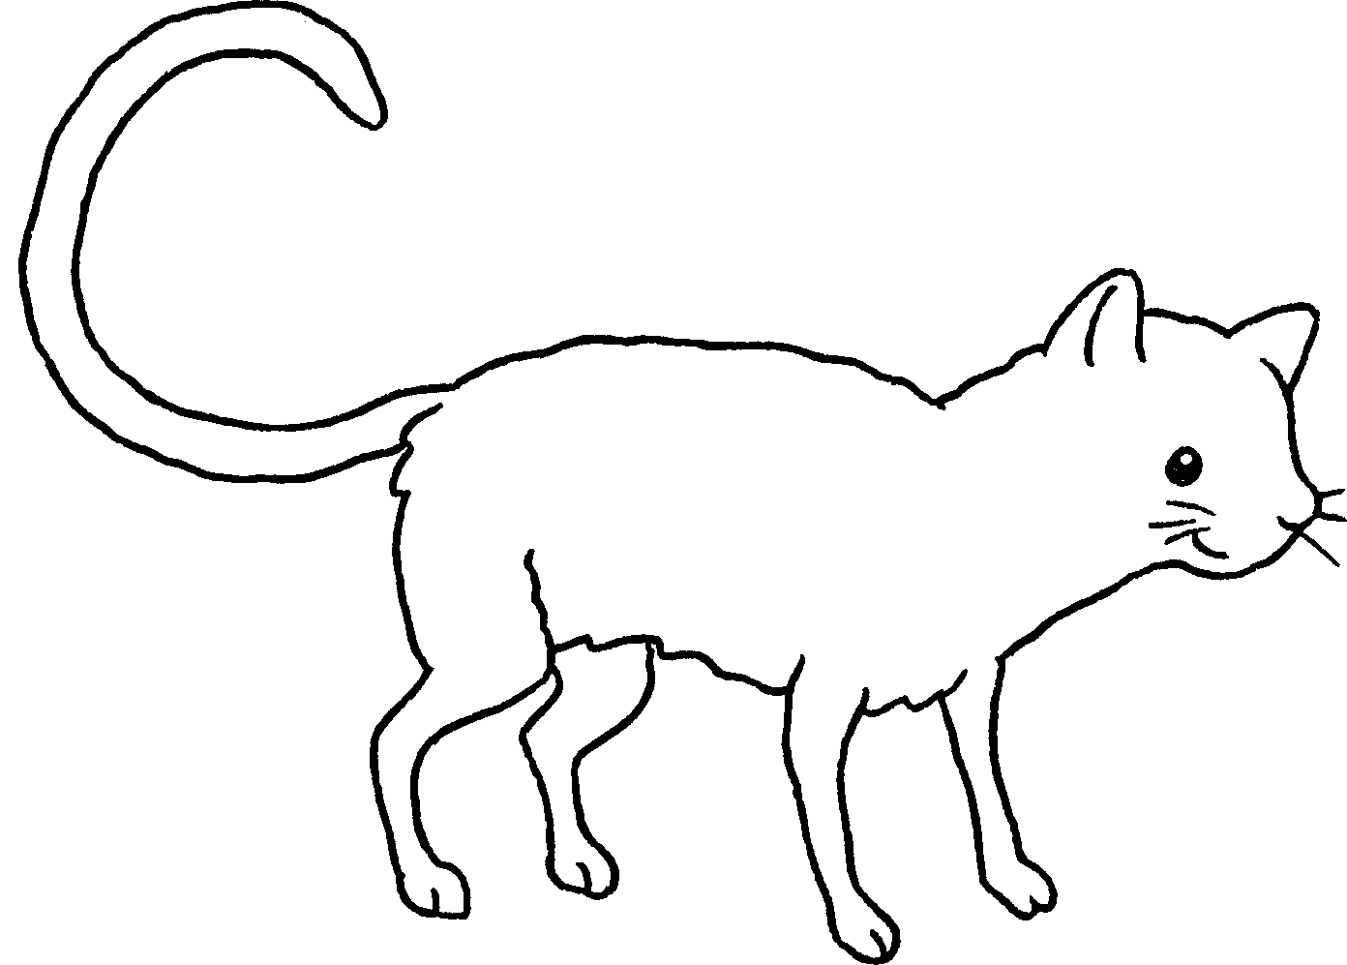 | This is my cat.  It has ____ _________ ________ .


Book 1A Chapter 6 Graded Worksheets
Worksheet 2⬇⬇⬇
- big / long
- short legs
- small feet
- a long tail

