Choose and write.

It / They has / have

1 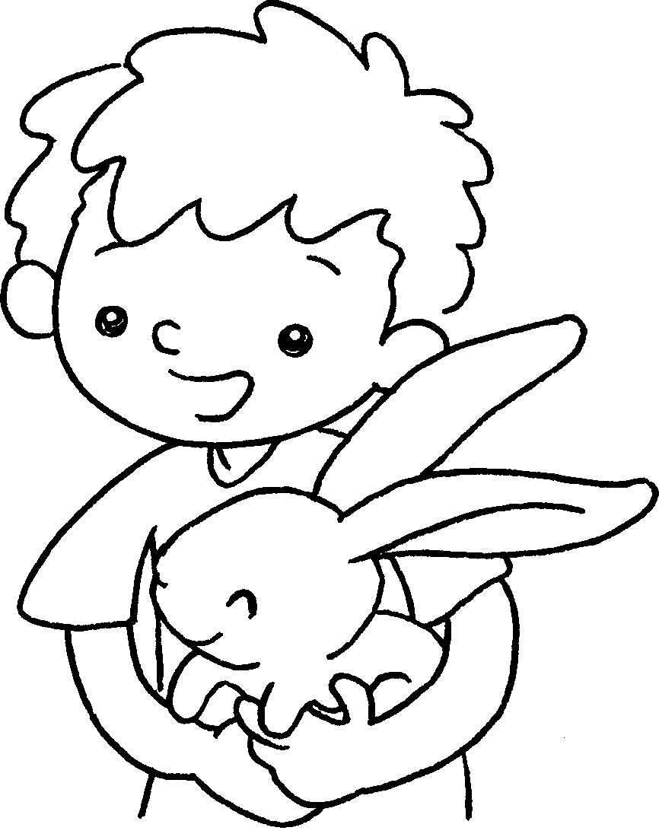  … | This is my rabbit.  big ears.
2 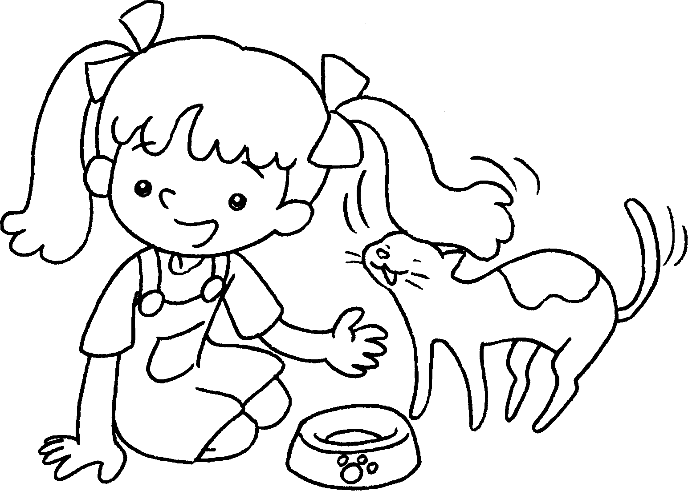  … | This is my cat.  small eyes.
3 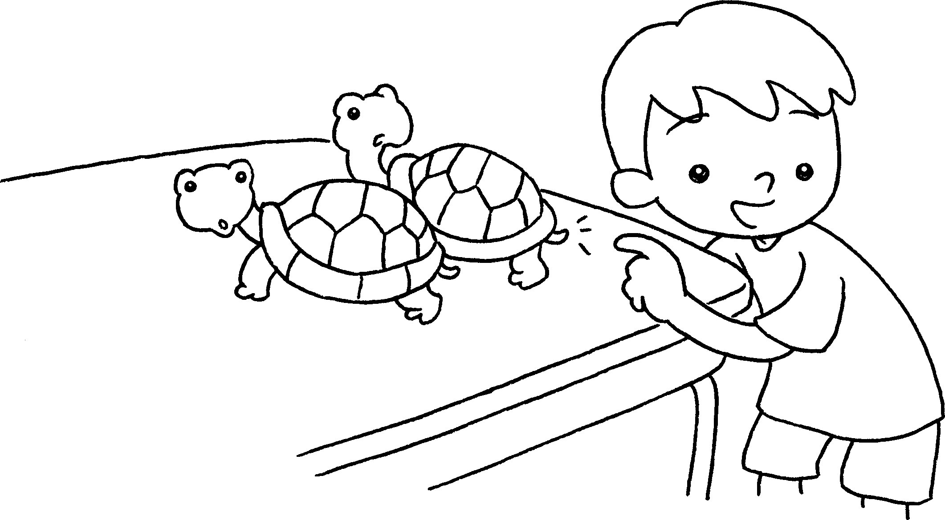  … | These are my turtles.  short tails.
4 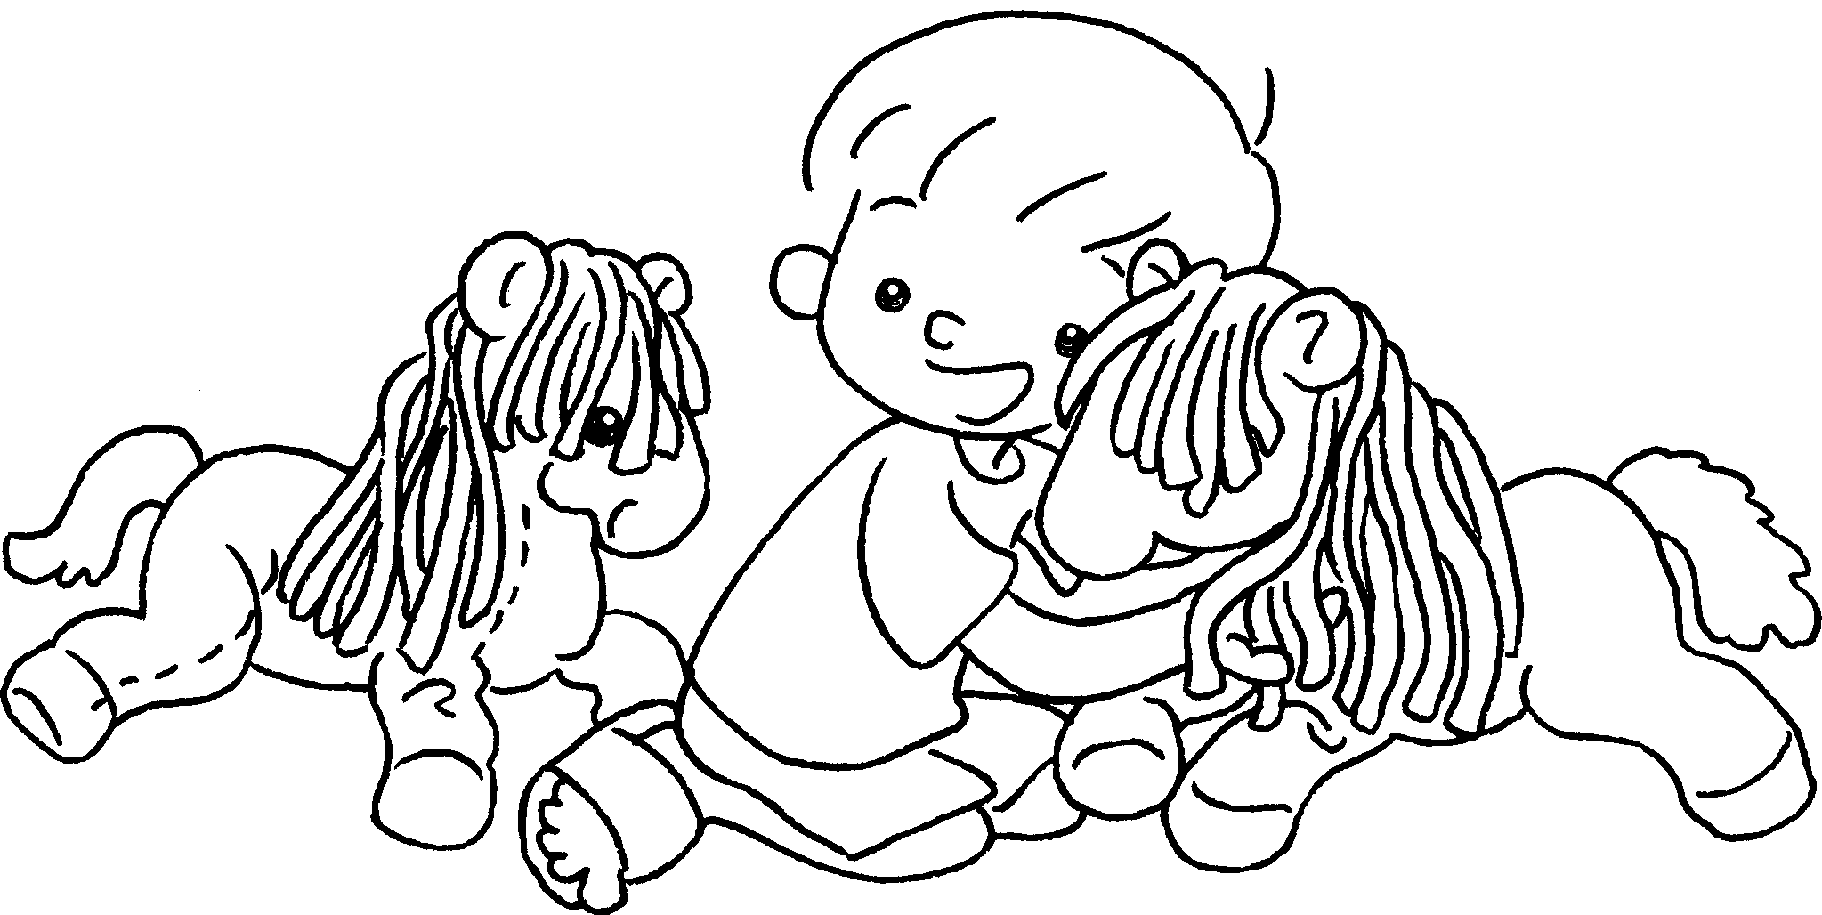  … | These are my horses.  long __________ .
5 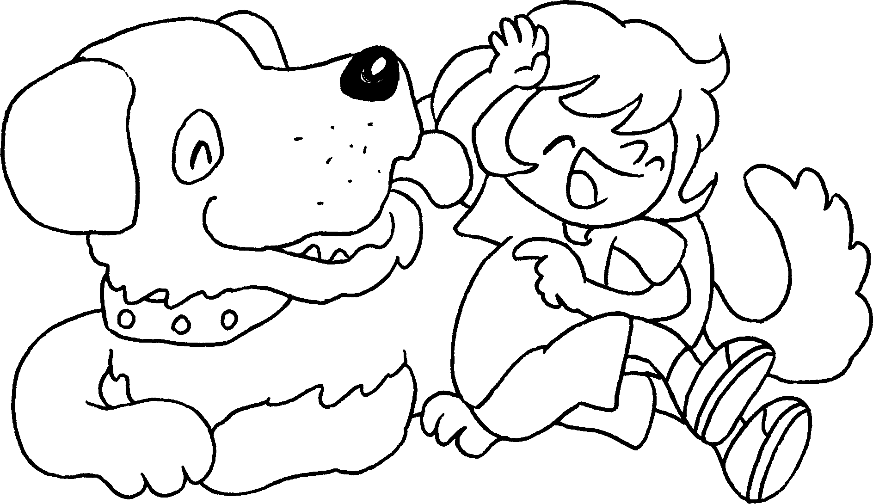  … | This is my dog.  a big __________ .


Book 1A Chapter 6 Graded Worksheets
Worksheet 3⬇⬇
- It has
- It has
- They have
- They have hair
- It has mouth

