What are the children saying? Write.

1 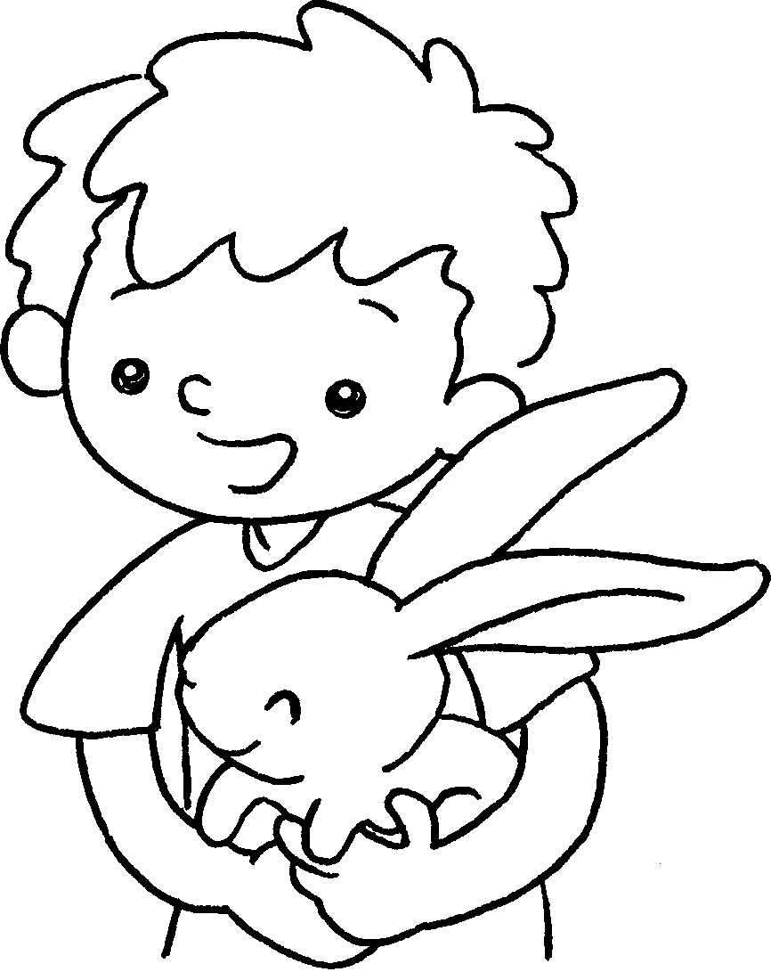  … | This is my rabbit.  It has big ears.
2 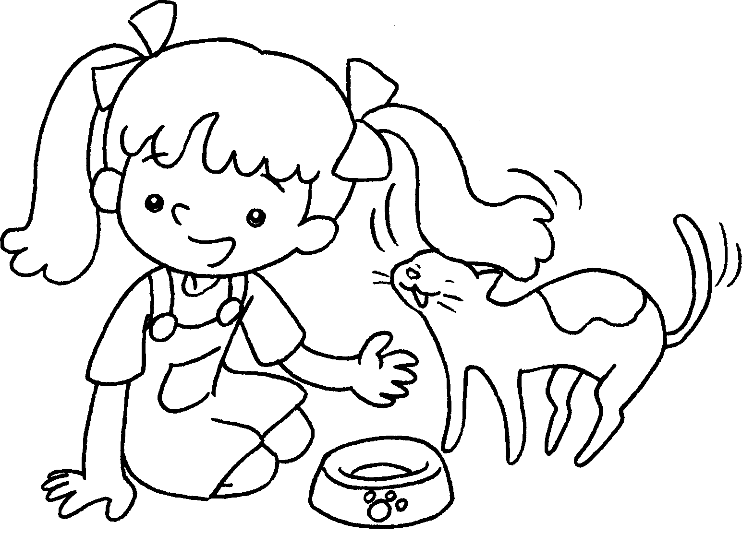  … | This is my cat.  ________ _______ small eyes.
3 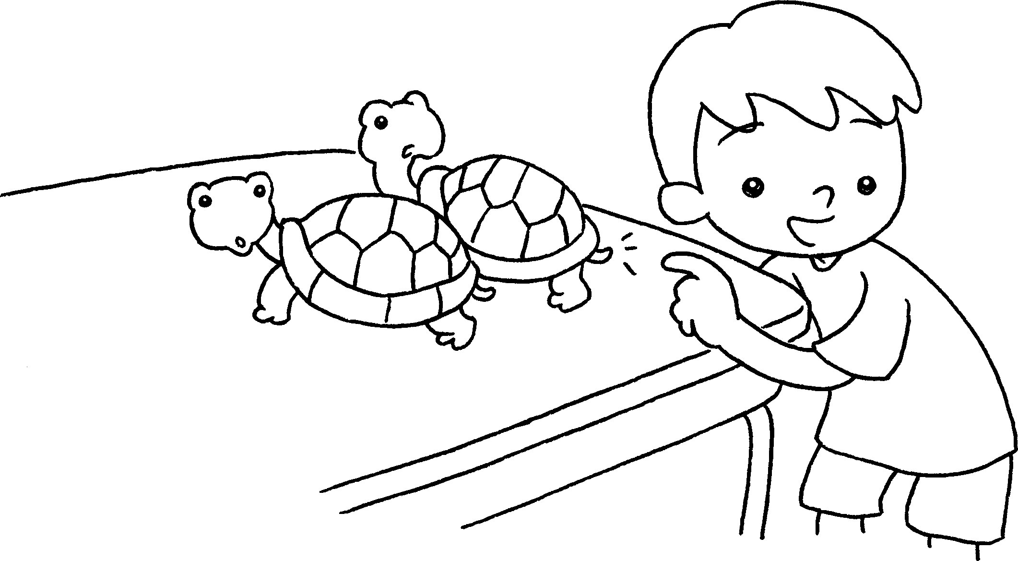  … | These are my turtles.  ________ ________ _______ tails.
4 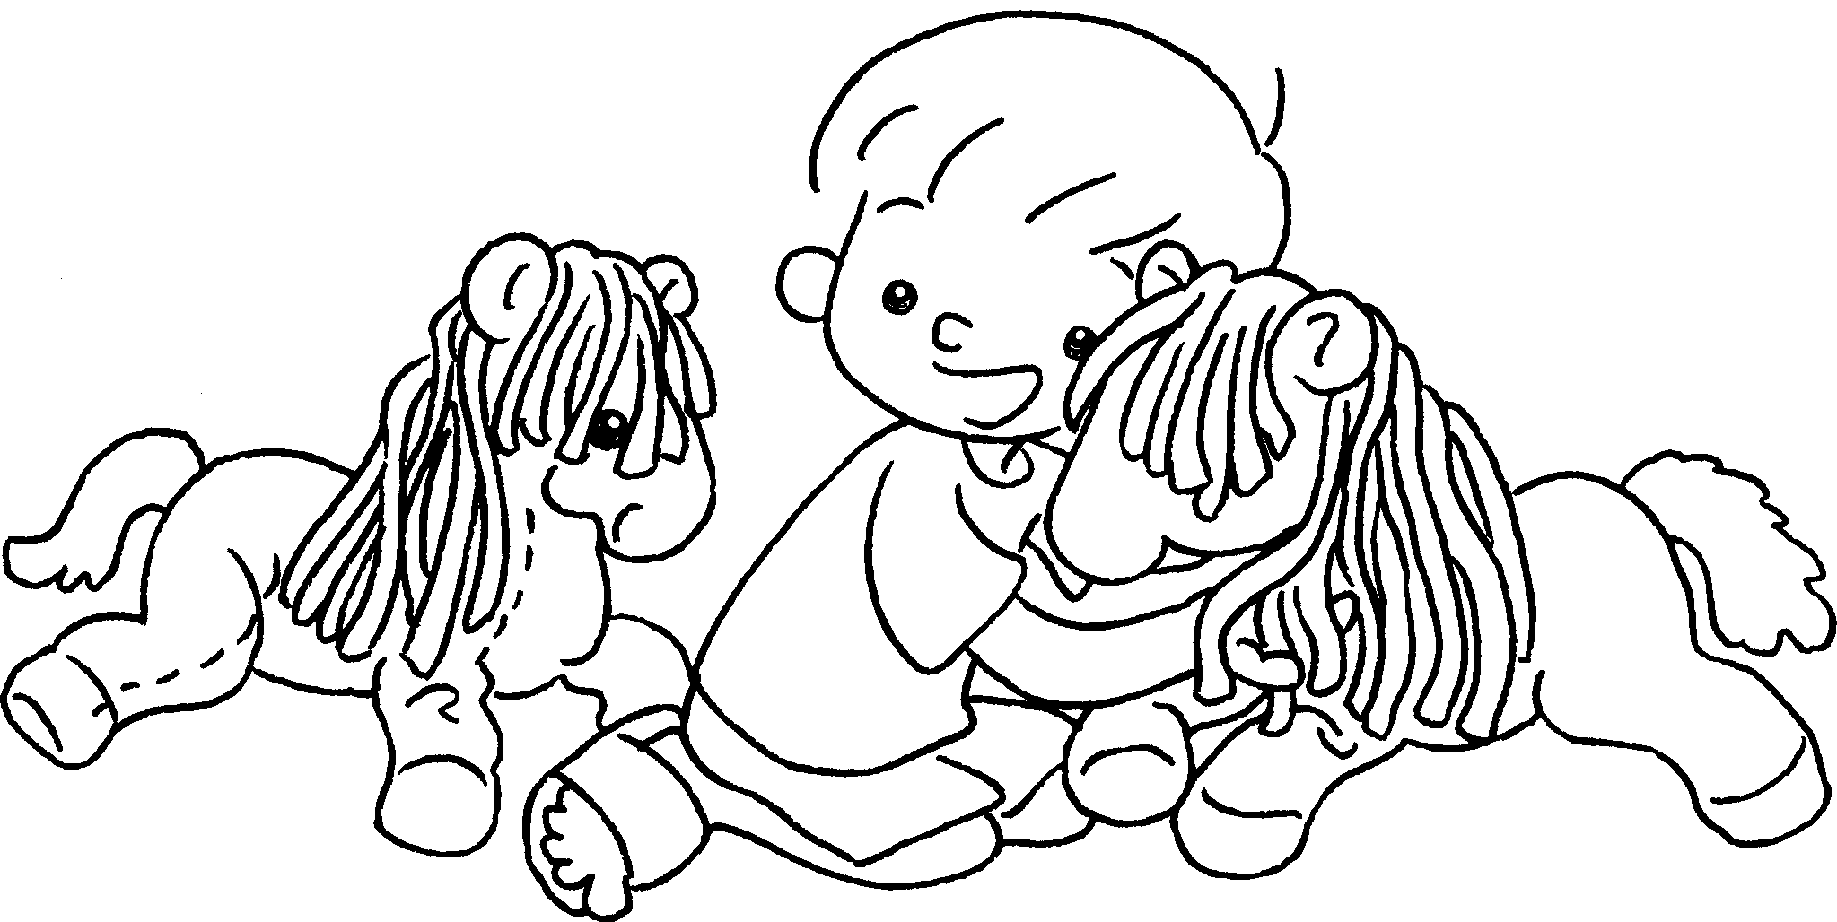  … | These are my horses.  ________ ________ _______ hair.
5 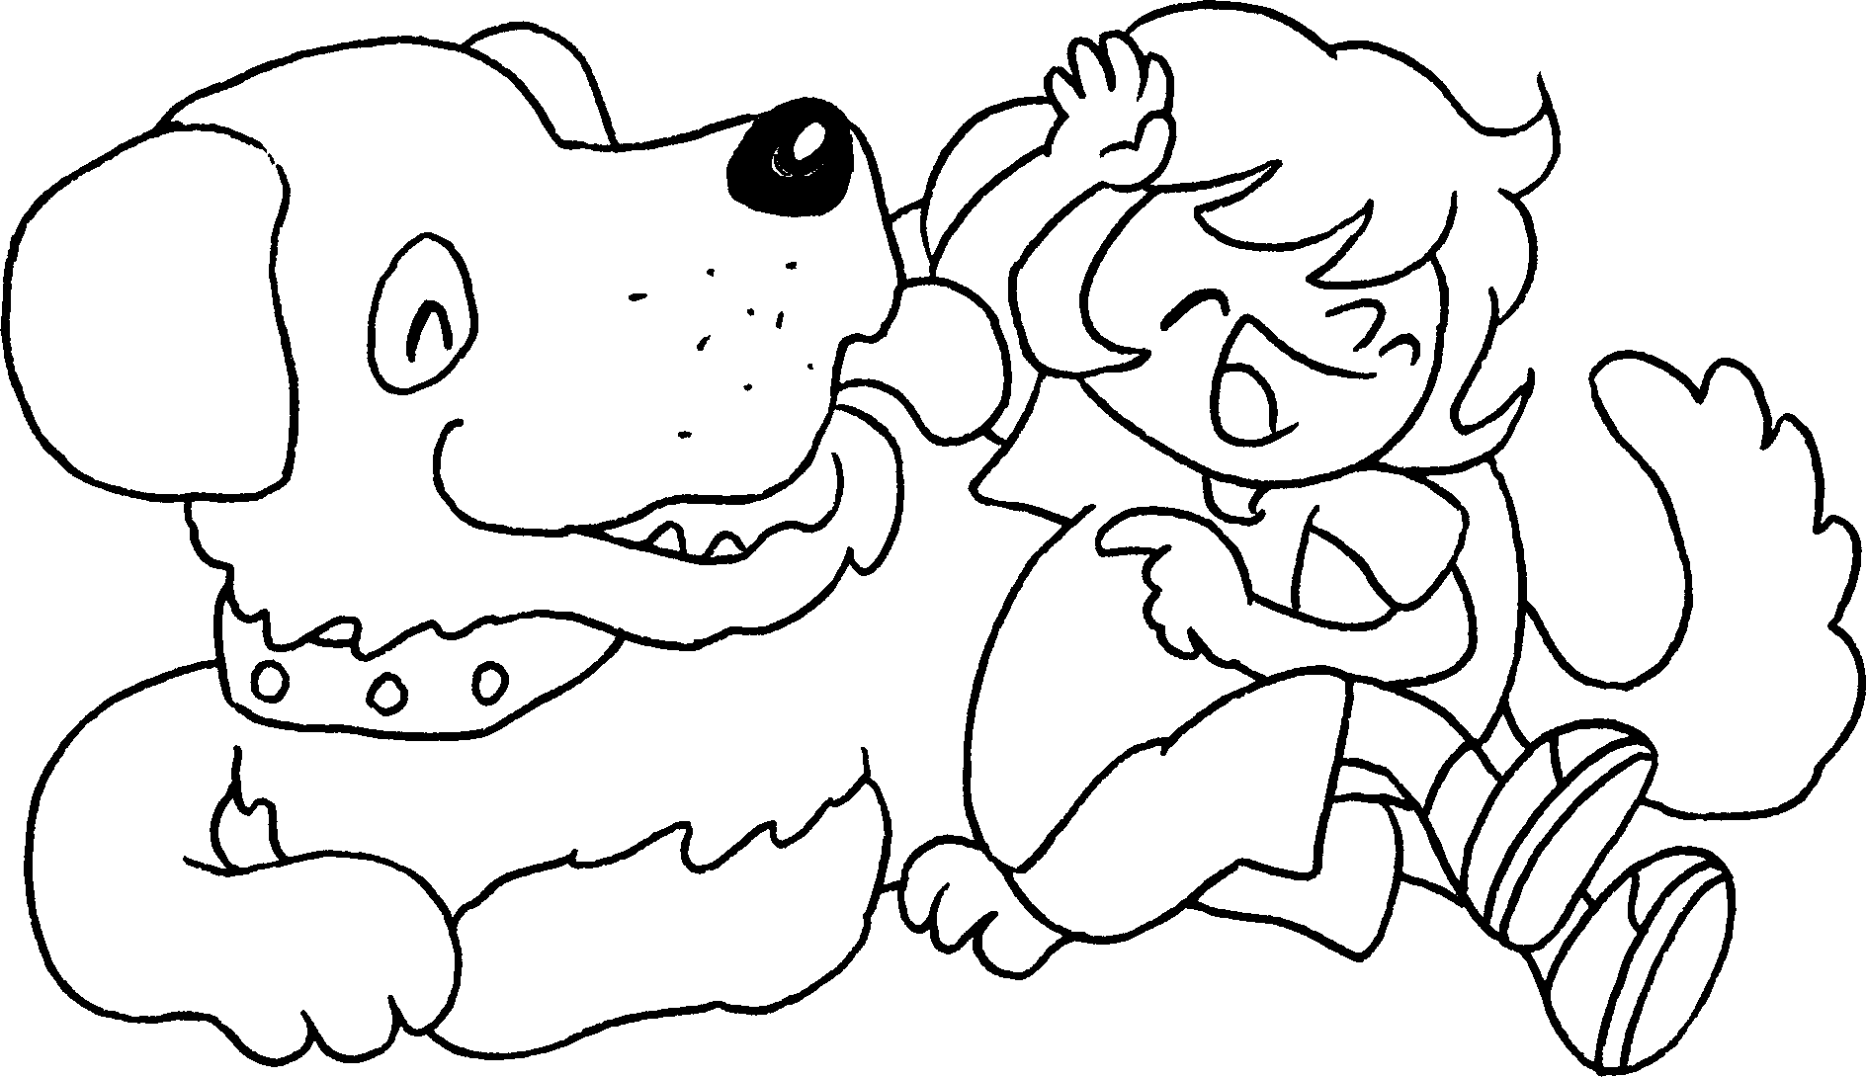  … | This is my dog.  ________ ________ _____  big ___________ .


Book 1A Chapter 6 Graded Worksheets
Worksheet 3⬇⬇⬇
- It has
- They have short
- They have long
- It has a mouth

